#### **Question 1:**

A company runs a large batch processing job at the end of every quarter. The processing job runs for 5 days and uses 15 Amazon EC2 instances. The processing must run uninterrupted for 5 hours per day. The company is investigating ways to reduce the cost of the batch processing job. Which pricing model should the company choose?

1. On-Demand Instances
2. Reserved Instance
3. Spot Instances
4. Dedicated Instances

**Answer** : On-Demand Instances

**Explanation:**

Each EC2 instance runs for 5 hours a day for 5 days per quarter or 20 days per year this time duration is insufficient to warrant reserved instances as these require a commitment of a minimum of 1 year and the discounts would not outweigh the costs of having the reservations unused for a large percentage of time. In this case, there are no options presented that can reduce the cost and therefore on-demand instances should be used.

**References:**

<https://aws.amazon.com/ec2/pricing/>

#### **Question 2:**

Amazon EC2 instances in a development environment run between 9am and 5pm Monday-Friday. Production instances run 24/7. Which pricing models should be used? (choose 2)

1. On-demand capacity reservations for the development environment
2. Use Reserved instances for the production environment
3. Use Spot instances for the development environment
4. Use Reserved instances for the development environment
5. Use On-Demand instances for the production environment

**Answer :** On-demand capacity reservations for the development environment

**Answer :** Use Reserved instances for the production environment

#### **Explanation**

Capacity reservations have no commitment and can be created and cancelled as needed. This is ideal for the development environment as it will ensure the capacity is available. There is no price advantage but none of the other options provide a price advantage whilst also ensuring capacity is available.Reserved instances are a good choice for workloads that run continuously. This is a good option for the production environment**.**

**References:**

<https://docs.aws.amazon.com/AWSEC2/latest/WindowsGuide/instance-purchasing-options.html>

<https://docs.aws.amazon.com/AWSEC2/latest/UserGuide/ec2-capacity-reservations.html>

#### **Question 3:**

A video production company is planning to move some of its workloads to the AWS Cloud. The company will require around 5 TB of storage for video processing with the maximum possible I/O performance. They also require over 400 TB of extremely durable storage for storing video files and 800 TB of storage for long-term archival.Which combinations of services should a Solutions Architect use to meet these requirements?

1. Amazon EC2 instance store for maximum performance, Amazon S3 for durable data storage, and Amazon S3 Glacier for archival storage.
2. Amazon EBS for maximum performance, Amazon S3 for durable data storage, and Amazon S3 Glacier for archival storage.
3. Amazon EC2 instance store for maximum performance, Amazon EFS for durable data storage, and Amazon S3 for archival storage.
4. Amazon EBS for maximum performance, Amazon EFS for durable data storage, and Amazon S3 Glacier for archival storage.

**Answer :** Amazon EC2 instance store for maximum performance, Amazon S3 for durable data storage, and Amazon S3 Glacier for archival storage.

#### **Explanation**

The best I/O performance can be achieved by using instance store volumes for the video processing. This is safe to use for use cases where the data can be recreated from the source files so this is a good use case.For storing data durably Amazon S3 is a good fit as it provides 99.999999999% of durability. For archival the video files can then be moved to Amazon S3 Glacier which is a low cost storage option that is ideal for long-term archival.

**References:**

<https://docs.aws.amazon.com/AWSEC2/latest/UserGuide/InstanceStorage.html>

<https://aws.amazon.com/s3/storage-classes/>

#### **Question 4:**

A company's application is running on Amazon EC2 instances in a single Region. In the event of a disaster, a solutions architect needs to ensure that the resources can also be deployed to a second Region.Which combination of actions should the solutions architect take to accomplish this? (Select TWO.)

1. Copy an Amazon Machine Image (AMI) of an EC2 instance and specify the second Region for the destination.
2. Launch a new EC2 instance from an Amazon Machine Image (AMI) in the second Region.
3. Detach a volume on an EC2 instance and copy it to an Amazon S3 bucket in the second Region.
4. Launch a new EC2 instance in the second Region and copy a volume from Amazon S3 to the new instance.
5. Copy an Amazon Elastic Block Store (Amazon EBS) volume from Amazon S3 and launch an EC2 instance in the second Region using that EBS volume.

**Answer :** Copy an Amazon Machine Image (AMI) of an EC2 instance and specify the second Region for the destination"

**Answer :** Launch a new EC2 instance from an Amazon Machine Image (AMI) in the second Region

#### **Explanation**

You can copy an Amazon Machine Image (AMI) within or across AWS Regions using the AWS Management Console, the AWS Command Line Interface or SDKs, or the Amazon EC2 API, all of which support the CopyImage action.Using the copied AMI the solutions architect would then be able to launch an instance from the same EBS volume in the second Region.

**Note:** the AMIs are stored on Amazon S3, however you cannot view them in the S3 management console or work with them programmatically using the S3 API.

**References:**

<https://docs.aws.amazon.com/AWSEC2/latest/UserGuide/CopyingAMIs.html>

#### **Question 5:**

A solutions architect needs to backup some application log files from an online ecommerce store to Amazon S3. It is unknown how often the logs will be accessed or which logs will be accessed the most. The solutions architect must keep costs as low as possible by using the appropriate S3 storage class. Which S3 storage class should be implemented to meet these requirements?

1. S3 Standard-Infrequent Access (S3 Standard-IA)
2. S3 One Zone-Infrequent Access (S3 One Zone-IA)
3. S3 Intelligent-Tiering
4. S3 Glacier

**Answer :** S3 Intelligent-Tiering

#### **Explanation**

The S3 Intelligent-Tiering storage class is designed to optimize costs by automatically moving data to the most cost-effective access tier, without performance impact or operational overhead.It works by storing objects in two access tiers: one tier that is optimized for frequent access and another lower-cost tier that is optimised for infrequent access. This is an ideal use case for intelligent-tiering as the access patterns for the log files are not known.

**References:**

<https://aws.amazon.com/s3/storage-classes/#Unknown_or_changing_access>

#### **Question 6:**

A Microsoft Windows file server farm uses Distributed File System Replication (DFSR) to synchronise data in an on-premises environment. The infrastructure is being migrated to the AWS Cloud.

Which service should the solutions architect use to replace the file server farm?

1. Amazon EFS
2. Amazon EBS
3. Amazon FSx
4. AWS Storage Gateway

**Answer :** Amazon FSx

**Explanation**

Amazon FSx for Windows file server supports DFS namespaces and DFS replication. This is the best solution for replacing the on-premises infrastructure. Note the limitations for deployment:

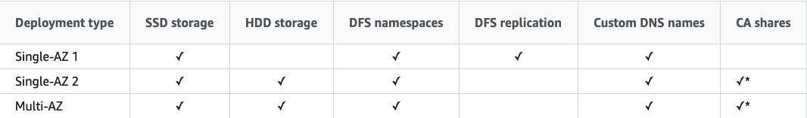

**References:**

<https://docs.aws.amazon.com/fsx/latest/WindowsGuide/high-availability-multiAZ.html>

#### **Question 7:**

A company is deploying a fleet of Amazon EC2 instances running Linux across multiple Availability Zones within an AWS Region. The application requires a data storage solution that can be accessed by all of the EC2 instances simultaneously. The solution must be highly scalable and easy to implement. The storage must be mounted using the NFS protocol. Which solution meets these requirements?

1. Create an Amazon EBS volume and use EBS Multi-Attach to mount the volume to all EC2 instances across each Availability Zone.
2. Create an Amazon EFS file system with mount targets in each Availability Zone. Configure the application instances to mount the file system.
3. Create an Amazon S3 bucket and create an S3 gateway endpoint to allow access to the file system using the NFS protocol.
4. Create an Amazon RDS database and store the data in a BLOB format. Point the application instances to the RDS endpoint.

**Answer :** Create an Amazon EFS file system with mount targets in each Availability Zone. Configure the application instances to mount the file system.

**Explanation**

Amazon EFS provides scalable file storage for use with Amazon EC2. You can use an EFS file system as a common data source for workloads and applications running on multiple instances. The EC2 instances can run in multiple AZs within a Region and the NFS protocol is used to mount the file system. With EFS you can create mount targets in each AZ for lower latency. The application instances in each AZ will mount the file system using the local mount target.

**References:**

<https://docs.aws.amazon.com/AWSEC2/latest/UserGuide/AmazonEFS.html>

#### **Question 8:**

A company is migrating from an on-premises infrastructure to the AWS Cloud. One of the company's applications stores files on a Windows file server farm that uses Distributed File System Replication (DFSR) to keep data in sync. A solutions architect needs to replace the file server farm. Which service should the solutions architect use?

a. Amazon EFS

b. Amazon EBS

c. Amazon FSx

d. AWS Storage Gateway

**Answer :** Amazon FSx

**Explanation**

Amazon FSx for Windows File Server provides fully managed, highly reliable file storage that is accessible over the industry-standard Server Message Block (SMB) protocol. Amazon FSx is built on Windows Server and provides a rich set of administrative features that include end-user file restore, user quotas, and Access Control Lists (ACLs).Additionally, Amazon FSX for Windows File Server supports Distributed File System Replication (DFSR) in Single-AZ deployments as can be seen in the feature comparison table below.

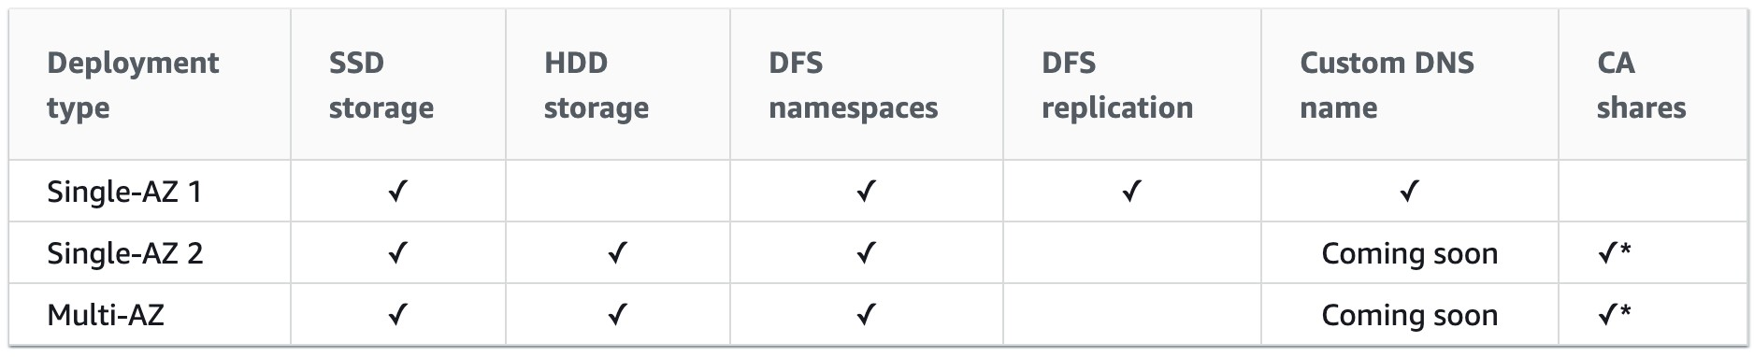

**References:**

<https://docs.aws.amazon.com/fsx/latest/WindowsGuide/high-availability-multiAZ.html>

#### **Question 9:**

A company plans to make an Amazon EC2 Linux instance unavailable outside of business hours to save costs. The instance is backed by an Amazon EBS volume. There is a requirement that the contents of the instance’s memory must be preserved when it is made unavailable. How can a solutions architect meet these requirements?

1. Stop the instance outside business hours. Start the instance again when required.
2. Use Auto Scaling to scale down the instance outside of business hours. Scale out the instance when required.
3. Hibernate the instance outside business hours. Start the instance again when required.
4. Terminate the instance outside business hours. Recover the instance again when required.

**Answer :** Hibernate the instance outside business hours. Start the instance again when required.

**Explanation**

When you hibernate an instance, Amazon EC2 signals the operating system to perform hibernation (suspend-to-disk). Hibernation saves the contents from the instance memory (RAM) to your Amazon Elastic Block Store (Amazon EBS) root volume. Amazon EC2 persists the instance's EBS root volume and any attached EBS data volumes. When you start your instance:

- The EBS root volume is restored to its previous state

- The RAM contents are reloaded

- The processes that were previously running on the instance are resumed

- Previously attached data volumes are reattached and the instance retains its instance ID

**References:**

<https://docs.aws.amazon.com/AWSEC2/latest/UserGuide/Hibernate.html>

#### **Question 10:**

A company has uploaded some highly critical data to an Amazon S3 bucket. Management are concerned about data availability and require that steps are taken to protect the data from accidental deletion. The data should still be accessible, and a user should be able to delete the data intentionally. Which combination of steps should a solutions architect take to accomplish this? (Select TWO.)

a. Create a bucket policy on the S3 bucket

b. Enable default encryption on the S3 bucket

c. Create a lifecycle policy for the objects in the S3 bucket

d. Enable MFA Delete on the S3 bucket

e. Enable versioning on the S3 bucket

**Answer :** Enable MFA Delete on the S3 bucket.

**Answer :** Enable versioning on the S3 bucket.

**Explanation**

Multi-factor authentication (MFA) delete adds an additional step before an object can be deleted from a versioning-enabled bucket. With MFA delete the bucket owner must include the x-amz-mfa request header in requests to permanently delete an object version or change the versioning state of the bucket.

**References:**

<https://docs.aws.amazon.com/AmazonS3/latest/dev/UsingMFADelete.html>

#### **Question 11:**

A team are planning to run analytics jobs on log files each day and require a storage solution. The size and number of logs is unknown and data will persist for 24 hours only. What is the MOST cost-effective solution?

a. Amazon S3 Intelligent-Tiering

b. Amazon S3 One Zone-Infrequent Access (S3 One Zone-IA)

c. Amazon S3 Glacier Deep Archive

d. Amazon S3 Standard

**Answer :** Amazon S3 Standard

**Explanation**

S3 standard is the best choice in this scenario for a short term storage solution. In this case the size and number of logs is unknown and it would be difficult to fully assess the access patterns at this stage. Therefore, using S3 standard is best as it is cost-effective, provides immediate access, and there are no retrieval fees or minimum capacity charge per object.

**References:**

<https://aws.amazon.com/s3/storage-classes/>

#### **Question 12:**

An application is being created that will use Amazon EC2 instances to generate and store data. Another set of EC2 instances will then analyze and modify the data. Storage requirements will be significant and will continue to grow over time. The application architects require a storage solution. Which actions would meet these needs?

1. Store the data in an Amazon EBS volume. Mount the EBS volume on the application instances
2. Store the data in Amazon S3 Glacier. Update the vault policy to allow access to the application instances
3. Store the data in AWS Storage Gateway. Setup AWS Direct Connect between the Gateway appliance and the EC2 instances
4. Store the data in an Amazon EFS filesystem. Mount the file system on the application instances

Answer : Store the data in an Amazon EFS filesystem. Mount the file system on the application instances.

**Explanation**

Amazon Elastic File System (Amazon EFS) provides a simple, scalable, fully managed elastic NFS file system for use with AWS Cloud services and on-premises resources. It is built to scale on-demand to petabytes without disrupting applications, growing and shrinking automatically as you add and remove files, eliminating the need to provision and manage capacity to accommodate growth.

Amazon EFS supports the Network File System version 4 (NFSv4.1 and NFSv4.0) protocol. Multiple Amazon EC2 instances can access an Amazon EFS file system at the same time, providing a common data source for workloads and applications running on more than one instance or server.For this scenario, EFS is a great choice as it will provide a scalable file system that can be mounted by multiple EC2 instances and accessed simultaneously.

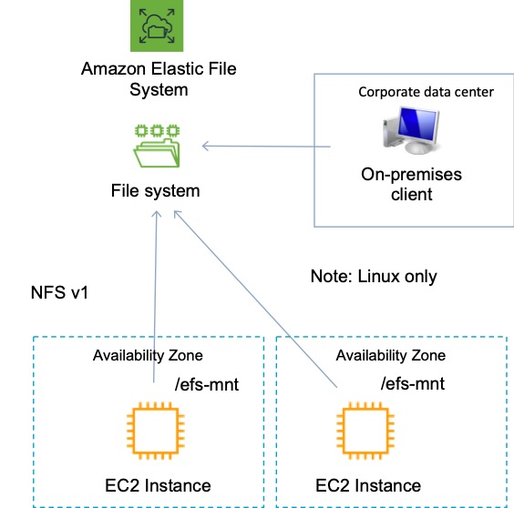

**References:**

<https://docs.aws.amazon.com/efs/latest/ug/whatisefs.html>

#### **Question 13:**

A persistent database must be migrated from an on-premises server to an Amazon EC2 instances. The database requires 64,000 IOPS and, if possible, should be stored on a single Amazon EBS volume. Which solution should a Solutions Architect recommend?

1. Create a Nitro-based Amazon EC2 instance with an Amazon EBS Provisioned IOPS SSD (i01) volume attached. Provision 64,000 IOPS for the volume.
2. Create an Amazon EC2 instance with two Amazon EBS Provisioned IOPS SSD (i01) volumes attached. Provision 32,000 IOPS per volume and create a logical volume using the OS that aggregates the capacity.
3. Create an Amazon EC2 instance with four Amazon EBS General Purpose SSD (gp2) volumes attached. Max out the IOPS on each volume and use a RAID 0 stripe set.
4. Use an instance from the I3 I/O optimized family and leverage instance store storage to achieve the IOPS requirement.

Answer : Create a Nitro-based Amazon EC2 instance with an Amazon EBS Provisioned IOPS SSD (i01) volume attached. Provision 64,000 IOPS for the volume.

**Explanation**

Amazon EC2 Nitro-based systems are not required for this solution but do offer advantages in performance that will help to maximize the usage of the EBS volume. For the data storage volume an i01 volume can support up to 64,000 IOPS so a single volume with sufficient capacity (50 IOPS per GiB) can be deliver the requirements. The current list of EBS volume types is in the table below:

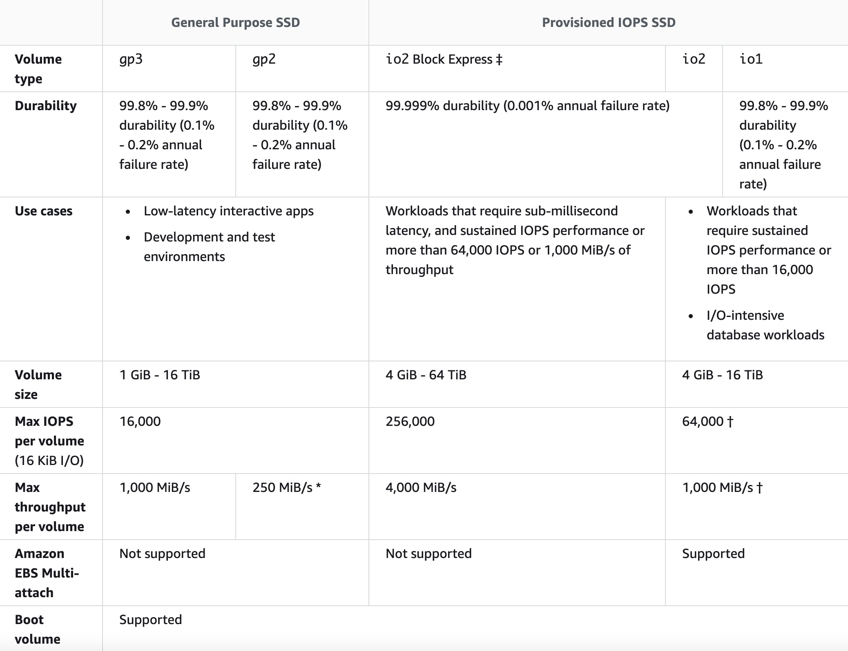

**References:**

<https://docs.aws.amazon.com/AWSEC2/latest/UserGuide/ebs-volume-types.html>

#### **Question 14:**

A solutions architect is creating a system that will run analytics on financial data for several hours a night, 5 days a week. The analysis is expected to run for the same duration and cannot be interrupted once it is started. The system will be required for a minimum of 1 year. What should the solutions architect configure to ensure the EC2 instances are available when they are needed?

1. Regional Reserved Instances
2. On-Demand Capacity Reservations
3. On-Demand Instances
4. Savings Plans

Answer : On-Demand Capacity Reservations

**Explanation**

On-Demand Capacity Reservations enable you to reserve compute capacity for your Amazon EC2 instances in a specific Availability Zone for any duration. This gives you the ability to create and manage Capacity Reservations independently from the billing discounts offered by Savings Plans or Regional Reserved Instances. By creating Capacity Reservations, you ensure that you always have access to EC2 capacity when you need it, for as long as you need it. You can create Capacity Reservations at any time, without entering a one-year or three-year term commitment, and the capacity is available immediately.

The table below shows the difference between capacity reservations and other options:

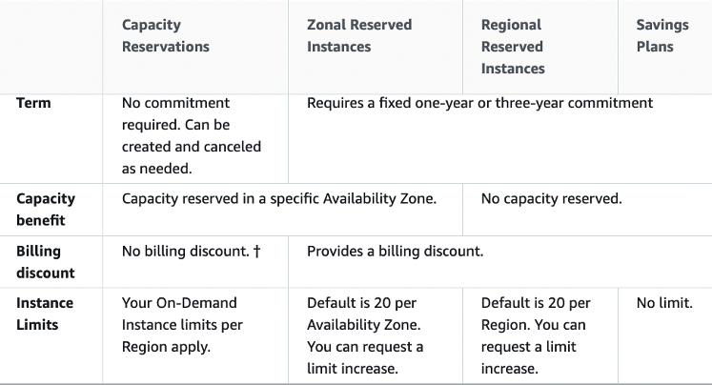

**References:**

<https://docs.aws.amazon.com/AWSEC2/latest/UserGuide/ec2-scheduled-instances.html>

#### **Question 15:**

A company runs an application on an Amazon EC2 instance the requires 250 GB of storage space. The application is not used often and has small spikes in usage on weekday mornings and afternoons. The disk I/O can vary with peaks hitting a maximum of 3,000 IOPS. A Solutions Architect must recommend the most cost-effective storage solution that delivers the performance required.

Which configuration should the Solutions Architect recommend?

Which solution should the solutions architect recommend?

1. Amazon EBS Provisioned IOPS SSD (i01)
2. Amazon EBS General Purpose SSD (gp2)
3. Amazon EBS Cold HDD (sc1)
4. Amazon EBS Throughput Optimised HDD (st1)

Answer : Amazon EBS General Purpose SSD (gp2)

**Explanation**

General Purpose SSD (gp2) volumes offer cost-effective storage that is ideal for a broad range of workloads. These volumes deliver single-digit millisecond latencies and the ability to burst to 3,000 IOPS for extended periods of time. Between a minimum of 100 IOPS (at 33.33 GiB and below) and a maximum of 16,000 IOPS (at 5,334 GiB and above), baseline performance scales linearly at 3 IOPS per GiB of volume size. AWS designs gp2 volumes to deliver their provisioned performance 99% of the time. A gp2 volume can range in size from 1 GiB to 16 TiB. In this configuration the volume will provide a baseline performance of 750 IOPS but will always be able to burst to the required 3,000 IOPS during periods of increased traffic.

**References:**

<https://docs.aws.amazon.com/AWSEC2/latest/UserGuide/ebs-volume-types.html>

#### **Question 16:**

A solutions architect is creating a document submission application for a school. The application will use an Amazon S3 bucket for storage. The solution must prevent accidental deletion of the documents and ensure that all versions of the documents are available. Users must be able to upload and modify the documents. Which combination of actions should be taken to meet these requirements? (Select TWO.)

1. Set read-only permissions on the bucket
2. Enable versioning on the bucket
3. Encrypt the bucket using AWS SSE-S3
4. Attach an IAM policy to the bucket
5. Enable MFA Delete on the bucket

Answer : Enable versioning on the bucket

Answer : Enable MFA Delete on the bucket

**Explanation**

None of the options present a good solution for specifying permissions required to write and modify objects so that requirement needs to be taken care of separately. The other requirements are to prevent accidental deletion and the ensure that all versions of the document are available. The two solutions for these requirements are versioning and MFA delete. Versioning will retain a copy of each version of the document and multi-factor authentication delete (MFA delete) will prevent any accidental deletion as you need to supply a second factor when attempting a delete.

**References:**

<https://docs.aws.amazon.com/AmazonS3/latest/dev/Versioning.html>

<https://docs.aws.amazon.com/AmazonS3/latest/dev/UsingMFADelete.html>

#### **Question 17:**

A web application that allows users to upload and share documents is running on a single Amazon EC2 instance with an Amazon EBS volume. To increase availability the architecture has been updated to use an Auto Scaling group of several instances across Availability Zones behind an Application Load Balancer. After the change users can only see a subset of the documents. What is the BEST method for a solutions architect to modify the solution so users can see all documents?

1. Copy the data from all EBS volumes to Amazon EFS. Modify the application to save new documents to Amazon EFS
2. Run a script to synchronize the data between Amazon EBS volumes
3. Use Sticky Sessions with the ALB to ensure users are directed to the same EC2 instance in a session
4. Configure the Application Load Balancer to send the request to all servers. Return each document from the correct server

Answer : Copy the data from all EBS volumes to Amazon EFS. Modify the application to save new documents to Amazon EFS

**Explanation**

The problem that is being described is that the users are uploading the documents to an individual EC2 instance with a local EBS volume. Therefore, as EBS volumes cannot be shared across AZs, the data is stored separately and the ALB will be distributing incoming connections to different instances / data sets.

The simple resolution is to implement a shared storage layer for the documents so that they can be stored in one place and seen by any user who connects no matter which instance they connect to.

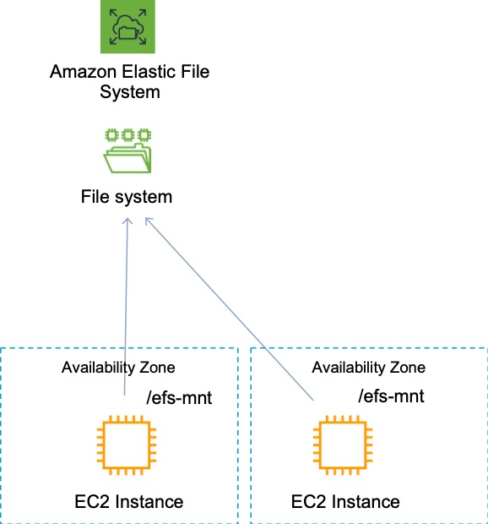

**References:**

<https://docs.aws.amazon.com/efs/latest/ug/how-it-works.html>

#### **Question 18:**

You have created a file system using Amazon Elastic File System (EFS) which will hold home directories for users. What else needs to be done to enable users to save files to the EFS file system?

1. Create a subdirectory for each user and grant read-write-execute permissions to the users. Then mount the subdirectory to the users’ home directory
2. Create a separate EFS file system for each user and grant read-write-execute permissions on the root directory to the respective user. Then mount the file system to the users’ home directory
3. Modify permissions on the root directory to grant read-write-execute permissions to the users. Then create a subdirectory and mount it to the users’ home directory
4. Instruct the users to create a subdirectory on the file system and mount the subdirectory to their home directory

Answer : Create a subdirectory for each user and grant read-write-execute permissions to the users. Then mount the subdirectory to the users’ home directory.

**Explanation**

After creating a file system, by default, only the root user (UID 0) has read-write-execute permissions. For other users to modify the file system, the root user must explicitly grant them access. One common use case is to create a “writable” subdirectory under this file system root for each user you create on the EC2 instance and mount it on the user’s home directory. All files and subdirectories the user creates in their home directory are then created on the Amazon EFS file system.

**References:**

<https://docs.aws.amazon.com/efs/latest/ug/accessing-fs-nfs-permissions-per-user-subdirs.html>

<https://docs.aws.amazon.com/efs/latest/ug/accessing-fs-nfs-permissions.html#accessing-fs-nfs-permissions-ex-scenarios>

#### **Question 19:**

A company’s Amazon EC2 instances were terminated or stopped, resulting in a loss of important data that was stored on attached EC2 instance stores. They want to avoid this happening in the future and need a solution that can scale as data volumes increase with the LEAST amount of management and configuration. Which storage is most appropriate?

1. Amazon RDS
2. Amazon EFS
3. Amazon EBS
4. Amazon S3

Answer : Amazon EFS

**Explanation**

Amazon EFS is a fully managed service that requires no changes to your existing applications and tools, providing access through a standard file system interface for seamless integration. It is built to scale on demand to petabytes without disrupting applications, growing and shrinking automatically as you add and remove files. This is an easy solution to implement and the option that requires the least management and configuration. An instance store provides temporary block-level storage for an EC2 instance. If you terminate the instance you lose all data. The alternative is to use Elastic Block Store volumes which are also block-level storage devices but the data is persistent. However, EBS is not a fully managed solution and doesn’t grow automatically as your data requirements increase – you would need to increase the volume size and then extend your filesystem.

**References:**

<https://aws.amazon.com/efs/>

#### **Question 20:**

An application upgrade caused some issues with stability. The application owner enabled logging and has generated a 5 GB log file in an Amazon S3 bucket. The log file must be securely shared with the application vendor to troubleshoot the issues. What is the MOST secure way to share the log file?

1. Create an IAM user for the vendor to provide access to the S3 bucket and the application. Enforce multi-factor authentication.
2. Generate a presigned URL and ask the vendor to download the log file before the URL expires.
3. Create access keys using an administrative account and share the access key ID and secret access key with the vendor.
4. Enable default encryption for the bucket and public access. Provide the S3 URL of the file to the vendor.

Answer : Generate a presigned URL and ask the vendor to download the log file before the URL expires.

**Explanation**

A presigned URL gives you access to the object identified in the URL. When you create a presigned URL, you must provide your security credentials and then specify a bucket name, an object key, an HTTP method (PUT for uploading objects), and an expiration date and time. The presigned URLs are valid only for the specified duration. That is, you must start the action before the expiration date and time. This is the most secure way to provide the vendor with time-limited access to the log file in the S3 bucket.

**References:**

<https://docs.aws.amazon.com/AmazonS3/latest/userguide/ShareObjectPreSignedURL.html>

#### **Question 21:**

A solutions architect is finalizing the architecture for a distributed database that will run across multiple Amazon EC2 instances. Data will be replicated across all instances so the loss of an instance will not cause loss of data. The database requires block storage with low latency and throughput that supports up to several million transactions per second per server. Which storage solution should the solutions architect use?

1. Amazon EBS
2. Amazon EFS
3. Amazon S3
4. Amazon EC2 instance store

Answer : Amazon EC2 instance store

**Explanation**

An instance store provides temporary block-level storage for your instance. This storage is located on disks that are physically attached to the host computer. Instance store is ideal for temporary storage of information that changes frequently, such as buffers, caches, scratch data, and other temporary content, or for data that is replicated across a fleet of instances, such as a load-balanced pool of web servers.

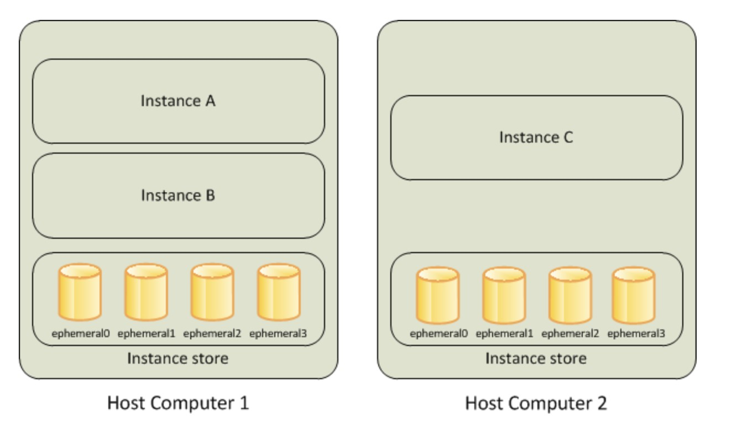

Some instance types use NVMe or SATA-based solid state drives (SSD) to deliver high random I/O performance. This is a good option when you need storage with very low latency, but you don't need the data to persist when the instance terminates or you can take advantage of fault-tolerant architectures. In this scenario the data is replicated and fault tolerant so the best option to provide the level of performance required is to use instance store volumes.

**References:**

<https://docs.aws.amazon.com/AWSEC2/latest/UserGuide/InstanceStorage.html>

#### **Question 22:**

An organization plans to deploy a higher performance computing (HPC) workload on AWS using Linux. The HPC workload will use many Amazon EC2 instances and will generate a large quantity of small output files that must be stored in persistent storage for future use. A Solutions Architect must design a solution that will enable the EC2 instances to access data using native file system interfaces and to store output files in cost-effective long-term storage. Which combination of AWS services meets these requirements?

1. Amazon EBS volumes with Amazon S3 Glacier
2. AWS DataSync with Amazon S3 Intelligent tiering
3. Amazon FSx for Windows File Server with Amazon S3
4. Amazon FSx for Lustre with Amazon S3

Answer : Amazon FSx for Lustre with Amazon S3

**Explanation**

Amazon FSx for Lustre is ideal for high performance computing (HPC) workloads running on Linux instances. FSx for Lustre provides a native file system interface and works as any file system does with your Linux operating system. When linked to an Amazon S3 bucket, FSx for Lustre transparently presents objects as files, allowing you to run your workload without managing data transfer from S3. This solution provides all requirements as it enables Linux workloads to use the native file system interfaces and to use S3 for long-term and cost-effective storage of output files.

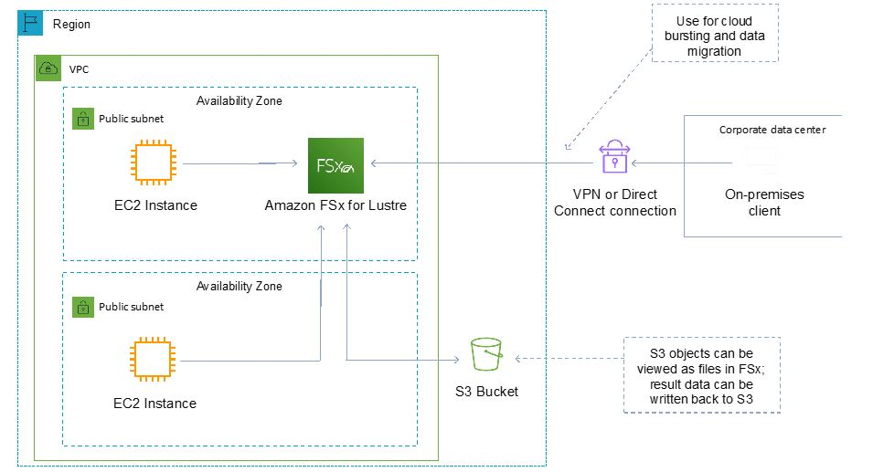

**References:**

<https://aws.amazon.com/fsx/lustre/>

#### **Question 23:**

An AWS workload in a VPC is running a legacy database on an Amazon EC2 instance. Data is stored on a 2000GB Amazon EBS (gp2) volume. At peak load times, logs show excessive wait time. What should be implemented to improve database performance using persistent storage?

1. Change the EC2 instance type to one with burstable performance
2. Change the EC2 instance type to one with EC2 instance store volumes
3. Migrate the data on the Amazon EBS volume to an SSD-backed volume
4. Migrate the data on the EBS volume to provisioned IOPS SSD (io1)

Answer : Migrate the data on the EBS volume to provisioned IOPS SSD (io1)

**Explanation**

The data is already on an SSD-backed volume (gp2), therefore to improve performance the best option is to migrate the data onto a provisioned IOPS SSD (io1) volume type which will provide improved I/O performance and therefore reduce wait times.

**References:**

<https://docs.aws.amazon.com/AWSEC2/latest/UserGuide/EBSVolumeTypes.html>

<https://docs.aws.amazon.com/AWSEC2/latest/UserGuide/burstable-performance-instances.html>

#### **Question 24:**

A data-processing application runs on an i3.large EC2 instance with a single 100 GB EBS gp2 volume. The application stores temporary data in a small database (less than 30 GB) located on the EBS root volume. The application is struggling to process the data fast enough, and a Solutions Architect has determined that the I/O speed of the temporary database is the bottleneck. What is the MOST cost-efficient way to improve the database response times?

1. Put the temporary database on a new 50-GB EBS io1 volume with a 3000 IOPS allocation.
2. Put the temporary database on a new 50-GB EBS gp2 volume
3. Enable EBS optimization on the instance and keep the temporary files on the existing volume
4. Move the temporary database onto instance storage

Answer : Move the temporary database onto instance storage

**Explanation**

EC2 Instance Stores are high-speed ephemeral storage that is physically attached to the EC2 instance. The i3.large instance type comes with a single 475GB NVMe SSD instance store so it would be a good way to lower cost and improve performance by using the attached instance store. As the files are temporary, it can be assumed that ephemeral storage (which means the data is lost when the instance is stopped) is sufficient.

**References:**

<https://docs.aws.amazon.com/AWSEC2/latest/UserGuide/InstanceStorage.html>

#### **Question 25:**

A company is planning to upload a large quantity of sensitive data to Amazon S3. The company’s security department require that the data is encrypted before it is uploaded. Which option meets these requirements?

1. Use client-side encryption with a master key stored in AWS KMS
2. Use client-side encryption with Amazon S3 managed encryption keys
3. Use server-side encryption with customer-provided encryption keys
4. Use server-side encryption with keys stored in KMS

Answer : Use client-side encryption with a master key stored in AWS KMS

**Explanation**

The requirement is that the objects must be encrypted before they are uploaded. The only option presented that meets this requirement is to use client-side encryption. You then have two options for the keys you use to perform the encryption:

• Use a customer master key (CMK) stored in AWS Key Management Service (AWS KMS).

• Use a master key that you store within your application.

In this case the correct answer is to use an AWS KMS key. Note that you cannot use client-side encryption with keys managed by Amazon S3.

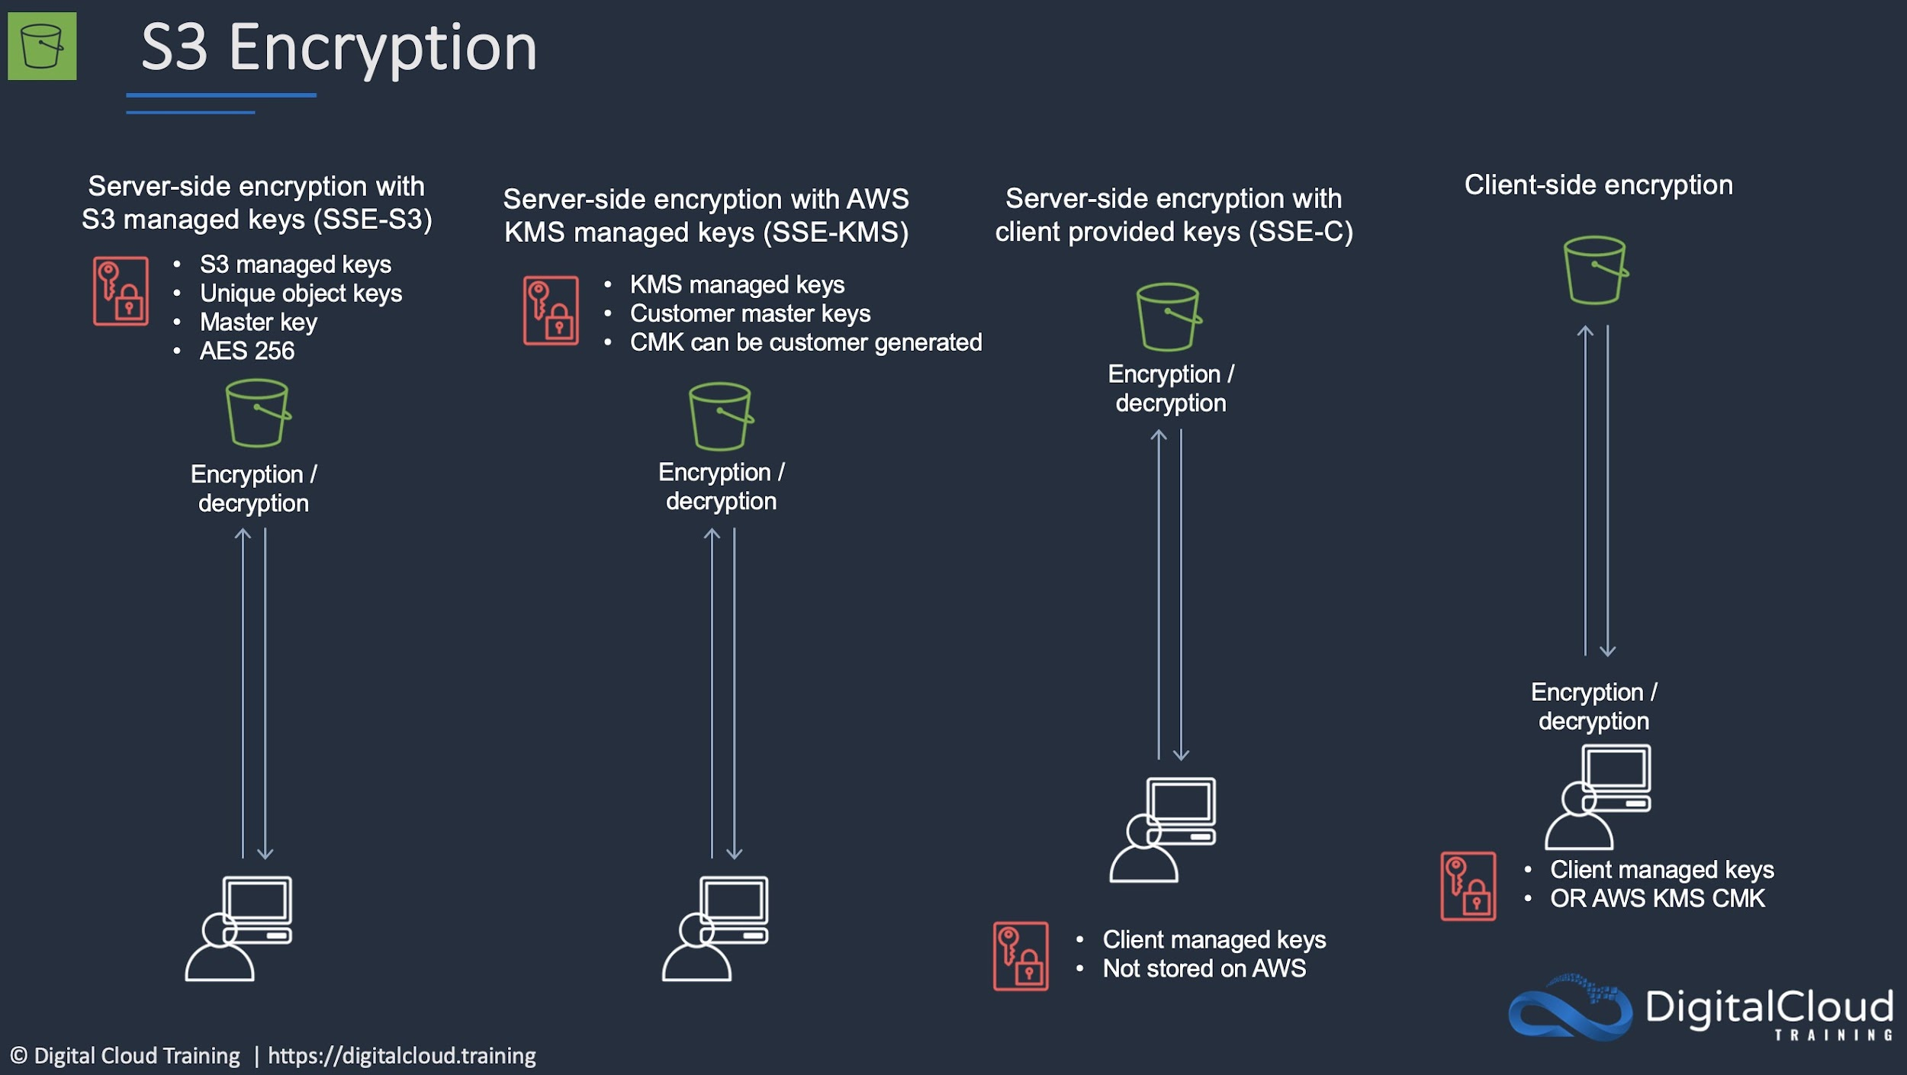

**References:**

<https://docs.aws.amazon.com/AmazonS3/latest/userguide/UsingClientSideEncryption.html>

#### **Question 26:**

A website runs on a Microsoft Windows server in an on-premises data center. The web server is being migrated to Amazon EC2 Windows instances in multiple Availability Zones on AWS. The web server currently uses data stored in an on-premises network-attached storage (NAS) device. Which replacement to the NAS file share is MOST resilient and durable?

1. Migrate the file share to Amazon Elastic File System (Amazon EFS)
2. Migrate the file share to Amazon EBS
3. Migrate the file share to AWS Storage Gateway
4. Migrate the file share to Amazon FSx for Windows File Server

Answer : Migrate the file share to Amazon FSx for Windows File Server

**Explanation**

Amazon FSx for Windows File Server provides fully managed, highly reliable file storage that is accessible over the industry-standard Server Message Block (SMB) protocol. It is built on Windows Server, delivering a wide range of administrative features such as user quotas, end-user file restore, and Microsoft Active Directory (AD) integration. It offers single-AZ and multi-AZ deployment options, fully managed backups, and encryption of data at rest and in transit.

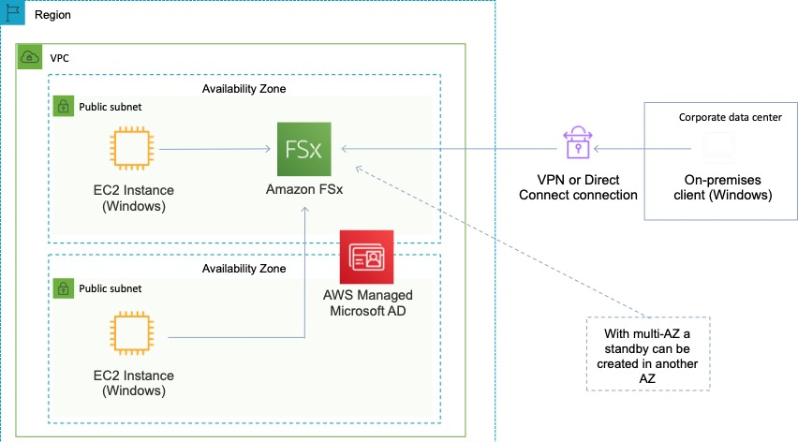

This is the only solution presented that provides resilient storage for Windows instances.

**References:**

<https://aws.amazon.com/fsx/windows/>

#### **Question 27:**

An application stores transactional data in an Amazon S3 bucket. The data is analyzed for the first week and then must remain immediately available for occasional analysis. What is the MOST cost-effective storage solution that meets the requirements?

1. Configure a lifecycle policy to transition the objects to Amazon S3 Standard-Infrequent Access (S3 Standard-IA) after 30 days
2. Configure a lifecycle policy to transition the objects to Amazon S3 One Zone-Infrequent Access (S3 One Zone-IA) after 30 days
3. Configure a lifecycle policy to transition the objects to Amazon S3 Standard-Infrequent Access (S3 Standard-IA) after 7 days
4. Configure a lifecycle policy to transition the objects to Amazon S3 One Zone-Infrequent Access (S3 One Zone-IA) after 7 days

Answer : Configure a lifecycle policy to transition the objects to Amazon S3 Standard-Infrequent Access (S3 Standard-IA) after 30 days

**Explanation**

The transition should be to Standard-IA rather than One Zone-IA. Though One Zone-IA would be cheaper, it also offers lower availability and the question states the objects “must remain immediately available”. Therefore the availability is a consideration.

Though there is no minimum duration when storing data in S3 Standard, you cannot transition to Standard IA within 30 days. This can be seen when trying to create a lifecycle rule:

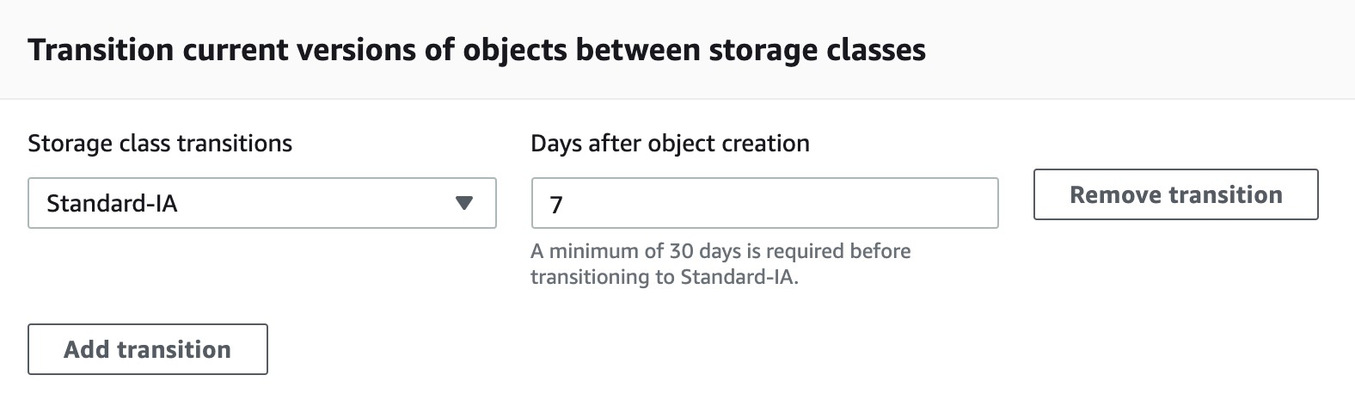

Therefore, the best solution is to transition after 30 days.

**References:**

<https://docs.aws.amazon.com/AmazonS3/latest/userguide/lifecycle-transition-general-considerations.html>

#### **Question 28:**

A Solutions Architect must design a solution that encrypts data in Amazon S3. Corporate policy mandates encryption keys be generated and managed on premises. Which solution should the Architect use to meet the security requirements?

1. SSE-S3: Server-side encryption with Amazon-managed master key
2. SSE-KMS: Server-side encryption with AWS KMS managed keys
3. SSE-C: Server-side encryption with customer-provided encryption keys
4. AWS CloudHSM

Answer : SSE-C: Server-side encryption with customer-provided encryption keys

**Explanation**

Server-side encryption is about protecting data at rest. Server-side encryption encrypts only the object data, not object metadata. Using server-side encryption with customer-provided encryption keys (SSE-C) allows you to set your own encryption keys. With the encryption key you provide as part of your request, Amazon S3 manages the encryption as it writes to disks and decryption when you access your objects. Therefore, you don't need to maintain any code to perform data encryption and decryption. The only thing you do is manage the encryption keys you provide.

When you upload an object, Amazon S3 uses the encryption key you provide to apply AES-256 encryption to your data and removes the encryption key from memory. When you retrieve an object, you must provide the same encryption key as part of your request. Amazon S3 first verifies that the encryption key you provided matches and then decrypts the object before returning the object data to you.

**References:**

[https:/docs.aws.amazon.com/AmazonS3/latest/dev/ServerSideEncryptionCustomerKeys.htm](https://docs.aws.amazon.com/AmazonS3/latest/dev/ServerSideEncryptionCustomerKeys.html)l

#### **Question 29:**

A company is deploying a new web application that will run on Amazon EC2 instances in an Auto Scaling group across multiple Availability Zones. The application requires a shared storage solution that offers strong consistency as the content will be regularly updated. Which solution requires the LEAST amount of effort?

1. Create an Amazon S3 bucket to store the web content and use Amazon CloudFront to deliver the content
2. Create a shared Amazon Block Store (Amazon EBS) volume and mount it on the individual Amazon EC2 instances
3. Create a volume gateway using AWS Storage Gateway to host the data and mount it to the Auto Scaling group
4. Create an Amazon Elastic File System (Amazon EFS) file system and mount it on the individual Amazon EC2 instances

Answer : Create an Amazon Elastic File System (Amazon EFS) file system and mount it on the individual Amazon EC2 instances

**Explanation**

Amazon EFS is a fully-managed service that makes it easy to set up, scale, and cost-optimize file storage in the Amazon Cloud. EFS file systems are accessible to Amazon EC2 instances via a file system interface (using standard operating system file I/O APIs) and support full file system access semantics (such as strong consistency and file locking). EFS is a good solution for when you need to attach a shared filesystem to multiple EC2 instances across multiple Availability Zones.

**References:**

<https://aws.amazon.com/efs/faq/>

#### **Question 30:**

A company uses a Microsoft Windows file share for storing documents and media files. Users access the share using Microsoft Windows clients and are authenticated using the company’s Active Directory. The chief information officer wants to move the data to AWS as they are approaching capacity limits. The existing user authentication and access management system should be used. How can a Solutions Architect meet these requirements?

1. Move the documents and media files to an Amazon Simple Storage Service bucket and apply bucket ACLs
2. Move the documents and media files to an Amazon Elastic File System and use POSIX permissions
3. Move the documents and media files to an Amazon FSx for Lustre file system
4. Move the documents and media files to an Amazon FSx for Windows File Server file system

Answer : Move the documents and media files to an Amazon FSx for Windows File Server file system

**Explanation**

Amazon FSx for Windows File Server makes it easy for you to launch and scale reliable, performant, and secure shared file storage for your applications and end users. With Amazon FSx, you can launch highly durable and available file systems that can span multiple availability zones (AZs) and can be accessed from up to thousands of compute instances using the industry-standard Server Message Block (SMB) protocol. It provides a rich set of administrative and security features, and integrates with Microsoft Active Directory (AD). To serve a wide spectrum of workloads, Amazon FSx provides high levels of file system throughput and IOPS and consistent sub-millisecond latencies.You can also mount FSx file systems from on-premises using a VPN or Direct Connect connection. This topology is depicted in the image below:

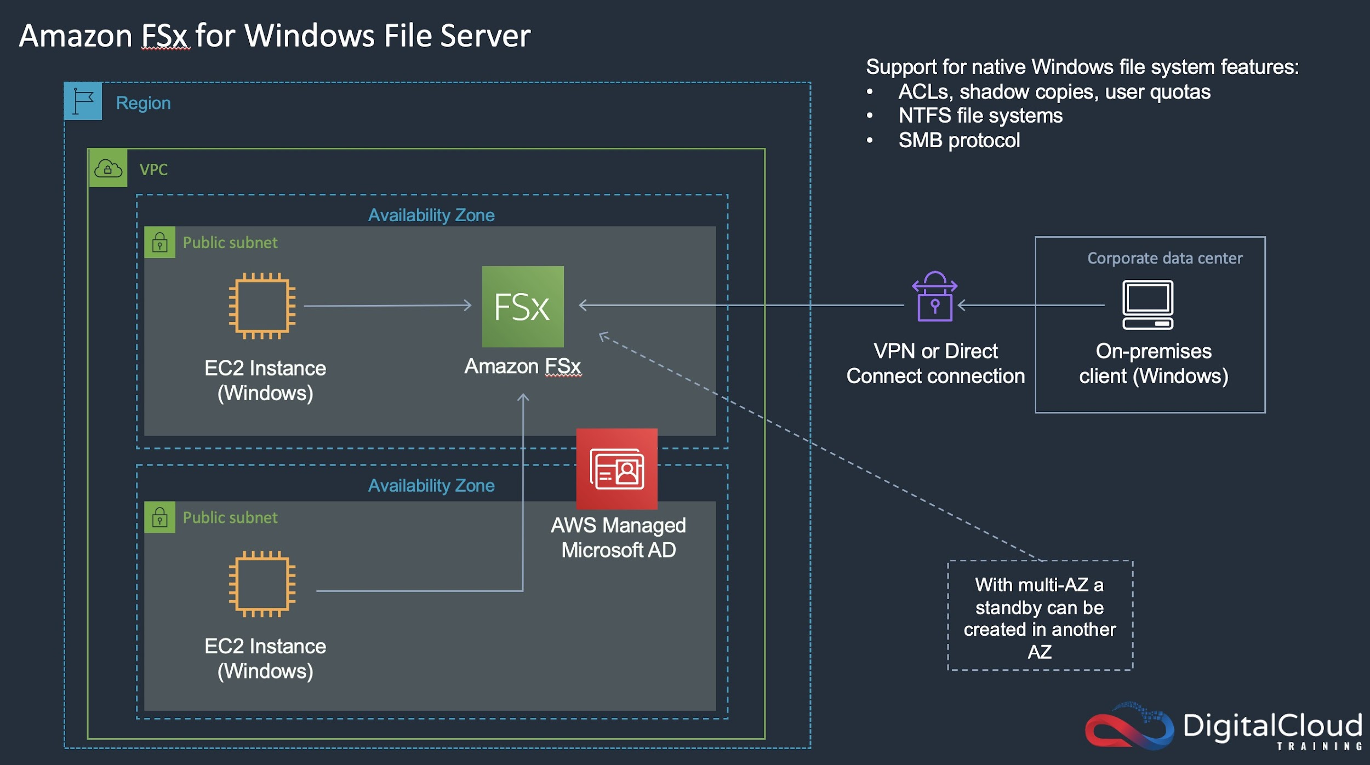

**References:**

[https://aws.amazon.com/fsx/windows/features/](https://aws.amazon.com/fsx/windows/features/?nc=sn&loc=2)

#### **Question 31:**

A Solutions Architect is designing a mobile application that will capture receipt images to track expenses. The Architect wants to store the images on Amazon S3. However, uploading the images through the web server will create too much traffic.

What is the MOST efficient method to store images from a mobile application on Amazon S3?

1. Expand the web server fleet with Spot instances to provide the resources to handle the images
2. Upload to a second bucket, and have a Lambda event copy the image to the primary bucket
3. Upload directly to S3 using a pre-signed URL
4. Upload to a separate Auto Scaling Group of server behind an ELB Classic Load Balancer, and have the server instances write to the Amazon S3 bucket

Answer : Upload directly to S3 using a pre-signed URL

**Explanation**

Uploading using a pre-signed URL allows you to upload the object without having any AWS security credentials/permissions. Pre-signed URLs can be generated programmatically and anyone who receives a valid pre-signed URL can then programmatically upload an object. This solution bypasses the web server avoiding any performance bottlenecks.

**References:**

<https://docs.aws.amazon.com/AmazonS3/latest/dev/PresignedUrlUploadObject.html>

#### **Question 32:**

A high-performance file system is required for a financial modelling application. The data set will be stored on Amazon S3 and the storage solution must have seamless integration so objects can be accessed as files. Which storage solution should be used?

1. Amazon FSx for Windows File Server
2. Amazon Elastic File System (EFS)
3. Amazon FSx for Lustre
4. Amazon Elastic Block Store (EBS)

Answer : Amazon FSx for Lustre

**Explanation**

Amazon FSx for Lustre provides a high-performance file system optimized for fast processing of workloads such as machine learning, high performance computing (HPC), video processing, financial modeling, and electronic design automation (EDA). Amazon FSx works natively with Amazon S3, letting you transparently access your S3 objects as files on Amazon FSx to run analyses for hours to months.

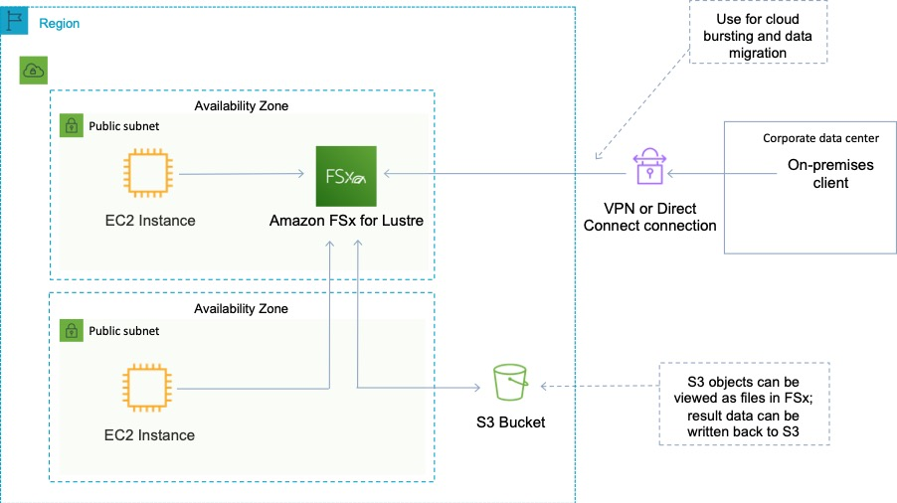

**References:**

<https://aws.amazon.com/fsx/>

#### **Question 33:**

An application currently stores all data on Amazon EBS volumes. All EBS volumes must be backed up durably across multiple Availability Zones. What is the MOST resilient way to back up volumes?

1. Mirror data across two EBS volumes
2. Create a script to copy data to an EC2 instance store
3. Take regular EBS snapshots
4. Enable EBS volume encryption

Answer : Take regular EBS snapshots

**Explanation**

You can back up the data on your Amazon EBS volumes to Amazon S3 by taking point-in-time snapshots. Snapshots are *incremental* backups, which means that only the blocks on the device that have changed after your most recent snapshot are saved. This minimizes the time required to create the snapshot and saves on storage costs by not duplicating data. When you delete a snapshot, only the data unique to that snapshot is removed. Each snapshot contains all of the information that is needed to restore your data (from the moment when the snapshot was taken) to a new EBS volume.

**References:**

<https://docs.aws.amazon.com/AWSEC2/latest/UserGuide/EBSSnapshots.html>

#### **Question 34:**

You are planning to deploy a number of EC2 instances in your VPC. The EC2 instances will be deployed across several subnets and multiple AZs. What AWS feature can act as an instance-level firewall to control traffic between your EC2 instances?

1. Security group
2. AWS WAF
3. Route table
4. Network ACL

Answer : Security group

**Explanation**

A *security group* acts as a virtual firewall for your instance to control inbound and outbound traffic. When you launch an instance in a VPC, you can assign up to five security groups to the instance. Security groups act at the instance level, not the subnet level. Therefore, each instance in a subnet in your VPC can be assigned to a different set of security groups.

**References:**

<https://docs.aws.amazon.com/vpc/latest/userguide/VPC_SecurityGroups.html>

#### **Question 35:**

A Solutions Architect is migrating a small relational database into AWS. The database will run on an EC2 instance and the DB size is around 500 GB. The database is infrequently used with small amounts of requests spread across the day. The DB is a low priority and the Architect needs to lower the cost of the solution. What is the MOST cost-effective storage type for the data volume?

1. Amazon EBS Provisioned IOPS SSD
2. Amazon EFS
3. Amazon EBS General Purpose SSD
4. Amazon EBS Throughput Optimized HDD

Answer : Amazon EBS Throughput Optimized HDD

**Explanation**

Throughput Optimized HDD is the most cost-effective storage option and for a small DB with low traffic volumes it may be sufficient. Note that the volume must be at least 500 GB in size. A breakdown of EBS volume types is provided below:

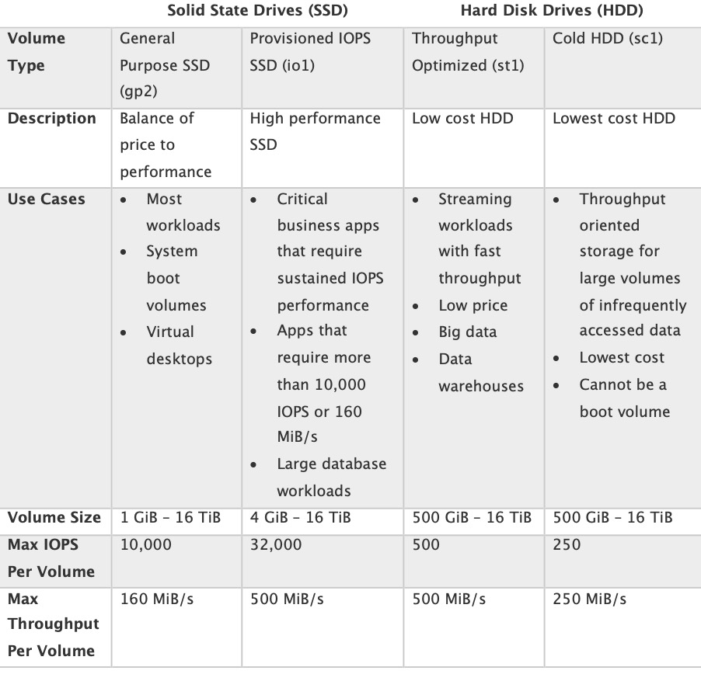

**References:**

<https://docs.aws.amazon.com/AWSEC2/latest/UserGuide/ebs-volume-types.html>

#### **Question 36:**

An application runs on Amazon EC2 Linux instances. The application generates log files which are written using standard API calls. A storage solution is required that can be used to store the files indefinitely and must allow concurrent access to all files.Which storage service meets these requirements and is the MOST cost-effective?

1. Amazon EFS
2. Amazon EBS
3. Amazon EC2 instance store
4. Amazon S3

Answer : Amazon S3

**Explanation**

The application is writing the files using API calls which means it will be compatible with Amazon S3 which uses a REST API. S3 is a massively scalable key-based object store that is well-suited to allowing concurrent access to the files from many instances.

Amazon S3 will also be the most cost-effective choice. A rough calculation using the AWS pricing calculator shows the cost differences between 1TB of storage on EBS, EFS, and S3 Standard.

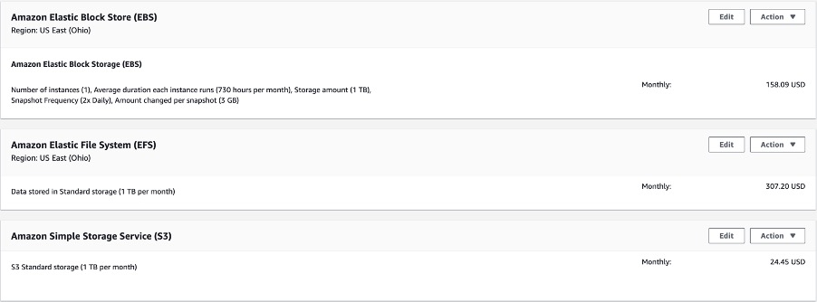

**References:**

<https://docs.aws.amazon.com/AmazonS3/latest/dev/optimizing-performance.html>

#### **Question 37:**

A new security mandate requires that all personnel data held in the cloud is encrypted at rest. Which two methods allow you to encrypt data stored in S3 buckets at rest cost-efficiently? (choose 2)

1. Use AWS S3 server-side encryption with Key Management Service keys or Customer-provided keys
2. Make use of AWS S3 bucket policies to control access to the data at res
3. Encrypt the data at the source using the client's CMK keys before transferring it to S3
4. Use CloudHSM
5. Use Multipart upload with SSL

Answer : Use AWS S3 server-side encryption with Key Management Service keys or Customer-provided keys

Answer : Encrypt the data at the source using the client's CMK keys before transferring it to S3

**Explanation**

When using S3 encryption your data is always encrypted at rest and you can choose to use KMS managed keys or customer-provided keys. If you encrypt the data at the source and transfer it in an encrypted state it will also be encrypted in-transit.

With client side encryption data is encrypted on the client side and transferred in an encrypted state and with server-side encryption data is encrypted by S3 before it is written to disk (data is decrypted when it is downloaded).

**References:**

[https://docs.aws.amazon.com/AmazonS3/latest/dev/UsingEncryption.htm](https://docs.aws.amazon.com/AmazonS3/latest/dev/UsingEncryption.html)l

#### **Question 38:**

You are designing a solution on AWS that requires a file storage layer that can be shared between multiple EC2 instances. The storage should be highly-available and should scale easily. Which AWS service can be used for this design?

1. Amazon S3
2. Amazon EC2 instance store
3. Amazon EBS
4. Amazon EFS

Answer : Amazon EFS

**Explanation**

Amazon EFS provides file storage in the AWS Cloud. With Amazon EFS, you can create a file system, mount the file system on an Amazon EC2 instance, and then read and write data to and from your file system.

You can mount an Amazon EFS file system in your VPC, through the Network File System versions 4.0 and 4.1 (NFSv4) protocol. We recommend using a current generation Linux NFSv4.1 client, such as those found in the latest Amazon Linux, Redhat, and Ubuntu AMIs, in conjunction with the Amazon EFS Mount Helper.

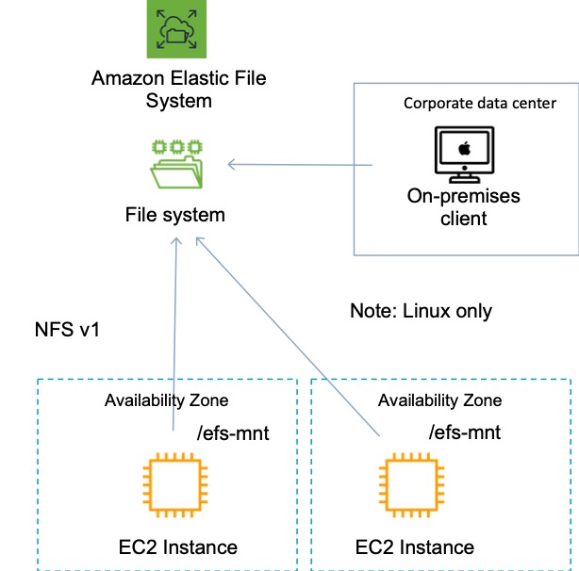

**References:**

<https://docs.aws.amazon.com/efs/latest/ug/how-it-works.html>

#### **Question 39:**

A new application will be launched on an Amazon EC2 instance with an Elastic Block Store (EBS) volume. A solutions architect needs to determine the most cost-effective storage option. The application will have infrequent usage, with peaks of traffic for a couple of hours in the morning and evening. Disk I/O is variable with peaks of up to 3,000 IOPS.Which solution should the solutions architect recommend?

1. Amazon EBS Provisioned IOPS SSD (io1)
2. Amazon EBS General Purpose SSD (gp2)
3. Amazon EBS Cold HDD (sc1)
4. Amazon EBS Throughput Optimized HDD (st1)

Answer : Amazon EBS General Purpose SSD (gp2)

**Explanation**

General Purpose SSD (gp2) volumes offer cost-effective storage that is ideal for a broad range of workloads. These volumes deliver single-digit millisecond latencies and the ability to burst to 3,000 IOPS for extended periods of time. Between a minimum of 100 IOPS (at 33.33 GiB and below) and a maximum of 16,000 IOPS (at 5,334 GiB and above), baseline performance scales linearly at 3 IOPS per GiB of volume size. AWS designs gp2 volumes to deliver their provisioned performance 99% of the time. A gp2 volume can range in size from 1 GiB to 16 TiB. In this case the volume would have a baseline performance of 3 x 200 = 600 IOPS. The volume could also burst to 3,000 IOPS for extended periods. As the I/O varies, this should be suitable.

**References:**

<https://docs.aws.amazon.com/AWSEC2/latest/UserGuide/ebs-volume-types.html>

#### **Question 40:**

A company runs a service on AWS to provide offsite backups for images on laptops and phones. The solution must support millions of customers, with thousands of images per customer. Images will be retrieved infrequently, but must be available for retrieval immediately. Which is the MOST cost-effective storage option that meets these requirements?

1. Amazon S3 Standard-Infrequent Access
2. Amazon EFS
3. Amazon Glacier with expedited retrievals
4. Amazon S3 Standard

Answer : Amazon S3 Standard-Infrequent Access

**Explanation**

S3 Standard-IA is for data that is accessed less frequently, but requires rapid access when needed. S3 Standard-IA offers the high durability, high throughput, and low latency of S3 Standard, with a low per GB storage price and per GB retrieval fee. This combination of low cost and high performance make S3 Standard-IA ideal for long-term storage, backups, and as a data store for disaster recovery files. S3 Storage Classes can be configured at the object level and a single bucket can contain objects stored across S3 Standard, S3 Intelligent-Tiering, S3 Standard-IA, and S3 One Zone-IA. You can also use S3 Lifecycle policies to automatically transition objects between storage classes without any application changes. Amazon S3 Standard-Infrequent Access is the most cost-effective choice.

**References:**

<https://aws.amazon.com/s3/storage-classes/>

#### **Question 41:**

An application allows users to upload and download files. Files older than 2 years will be accessed less frequently. A solutions architect needs to ensure that the application can scale to any number of files while maintaining high availability and durability. Which scalable solutions should the solutions architect recommend?

1. Store the files on Amazon Elastic File System (EFS) with a lifecycle policy that moves objects older than 2 years to EFS Infrequent Access (EFS IA)
2. Store the files in Amazon Elastic Block Store (EBS) volumes. Schedule snapshots of the volumes. Use the snapshots to archive data older than 2 years
3. Store the files in Amazon Elastic Block Store (EBS) volumes. Create a lifecycle policy to move files older than 2 years to Amazon S3 Glacier
4. Store the files on Amazon S3 with a lifecycle policy that moves objects older than 2 years to S3 Standard Infrequent Access (S3 Standard-IA)

Answer : Store the files on Amazon S3 with a lifecycle policy that moves objects older than 2 years to S3 Standard Infrequent Access (S3 Standard-IA)

**Explanation**

S3 Standard-IA is for data that is accessed less frequently, but requires rapid access when needed. S3 Standard-IA offers the high durability, high throughput, and low latency of S3 Standard, with a low per GB storage price and per GB retrieval fee. This combination of low cost and high performance make S3 Standard-IA ideal for long-term storage, backups, and as a data store for disaster recovery files.

**References:**

<https://aws.amazon.com/s3/storage-classes/>

#### **Question 42:**

A Solutions Architect is designing a workload that requires a high performance object-based storage system that must be shared with multiple Amazon EC2 instances. Which AWS service delivers these requirements?

1. Amazon ElastiCache
2. Amazon EFS
3. Amazon EBS
4. Amazon S3

Answer : Amazon S3

**Explanation**

Amazon S3 is an object-based storage system. Though object storage systems aren’t mounted and shared like filesystems or block based storage systems they can be shared by multiple instances as they allow concurrent access

**References:**

<https://aws.amazon.com/s3/>

#### **Question 43:**

A High Performance Computing (HPC) application needs storage that can provide 135,000 IOPS. The storage layer is replicated across all instances in a cluster.What is the optimal storage solution that provides the required performance and is cost-effective?

1. Use Amazon EBS Provisioned IOPS volume with 135,000 IOPS
2. Use Amazon S3 with byte-range fetch
3. Use Amazon EC2 Enhanced Networking with an EBS HDD Throughput Optimized volume
4. Use Amazon Instance Store

Answer : Use Amazon Instance Store

**Explanation**

Instance stores offer very high performance and low latency. As long as you can afford to lose an instance, i.e. you are replicating your data, these can be a good solution for high performance/low latency requirements. Also, the cost of instance stores is included in the instance charges so it can also be more cost-effective than EBS Provisioned IOPS.

**References:**

<https://docs.aws.amazon.com/AWSEC2/latest/UserGuide/InstanceStorage.html>

#### **Question 44:**

An EC2 status check on an EBS volume is showing as *insufficient-data*. What is the most likely explanation?

1. The checks have failed on the volume
2. The volume does not have enough data on it to check properly
3. The checks require more information to be manually entered
4. The checks may still be in progress on the volume

Answer : The checks may still be in progress on the volume

**Explanation**

The possible values are ok, impaired, warning, or insufficient-data. If all checks pass, the overall status of the volume is ok. If the check fails, the overall status is impaired. If the status is insufficient-data, then the checks may still be taking place on your volume at the time.

**References:**

[https:/docs.aws.amazon.com/AWSEC2/latest/APIReference/API_DescribeVolumeStatus.html](https://docs.aws.amazon.com/AWSEC2/latest/APIReference/API_DescribeVolumeStatus.html)

#### **Question 45:**

A company is planning to use Amazon S3 to store documents uploaded by its customers. The images must be encrypted at rest in Amazon S3. The company does not want to spend time managing and rotating the keys, but it does want to control who can access those keys. What should a solutions architect use to accomplish this?

1. Server-Side Encryption with keys stored in an S3 bucket
2. Server-Side Encryption with Customer-Provided Keys (SSE-C)
3. Server-Side Encryption with AWS KMS-Managed Keys (SSE-KMS)
4. Server-Side Encryption with Amazon S3-Managed Keys (SSE-S3)

Answer : Server-Side Encryption with AWS KMS-Managed Keys (SSE-KMS)

**Explanation**

SSE-KMS requires that AWS manage the data key but you manage the [customer master key](https://docs.aws.amazon.com/kms/latest/developerguide/concepts.html#master_keys) (CMK) in AWS KMS. You can choose a [customer managed CMK](https://docs.aws.amazon.com/kms/latest/developerguide/concepts.html#customer-cmk) or the [AWS managed CMK](https://docs.aws.amazon.com/kms/latest/developerguide/concepts.html#aws-managed-cmk) for Amazon S3 in your account. *Customer managed CMKs* are CMKs in your AWS account that you create, own, and manage. You have full control over these CMKs, including establishing and maintaining their [key policies, IAM policies, and grants](https://docs.aws.amazon.com/kms/latest/developerguide/control-access.html), [enabling and disabling](https://docs.aws.amazon.com/kms/latest/developerguide/enabling-keys.html) them, [rotating their cryptographic material](https://docs.aws.amazon.com/kms/latest/developerguide/rotate-keys.html), [adding tags](https://docs.aws.amazon.com/kms/latest/developerguide/tagging-keys.html), [creating aliases](https://docs.aws.amazon.com/kms/latest/developerguide/programming-aliases.html) that refer to the CMK, and [scheduling the CMKs for deletion](https://docs.aws.amazon.com/kms/latest/developerguide/deleting-keys.html). For this scenario, the solutions architect should use SSE-KMS with a customer managed CMK. That way KMS will manage the data key but the company can configure key policies defining who can access the keys.

**References:**

<https://docs.aws.amazon.com/kms/latest/developerguide/services-s3.html#sse>

<https://docs.aws.amazon.com/kms/latest/developerguide/concepts.html#master_keys>

#### **Question 46:**

A Solutions Architect is designing a solution to store and archive corporate documents, and has determined that Amazon Glacier is the right solution. Data must be delivered within 10 minutes of a retrieval request. Which features in Amazon Glacier can help meet this requirement?

1. Bulk retrieval
2. Vault Lock
3. Expedited retrieval
4. Standard retrieval

Answer : Expedited retrieval

**Explanation**

You can specify one of the following when initiating a job to retrieve an archive based on your access time and cost requirements.

Expedited — Expedited retrievals allow you to quickly access your data when occasional urgent requests for a subset of archives are required. For all but the largest archives (250 MB+), data accessed using Expedited retrievals are typically made available within 1–5 minutes. Provisioned Capacity ensures that retrieval capacity for Expedited retrievals is available when you need it.

Standard — Standard retrievals allow you to access any of your archives within several hours. Standard retrievals typically complete within 3–5 hours. This is the default option for retrieval requests that do not specify the retrieval option.

Bulk — Bulk retrievals are S3 Glacier’s lowest-cost retrieval option, which you can use to retrieve large amounts, even petabytes, of data inexpensively in a day. Bulk retrievals typically complete within 5–12 hours.

**References:**

<https://docs.aws.amazon.com/amazonglacier/latest/dev/downloading-an-archive-two-steps.html>

#### **Question 47:**

Health related data in Amazon S3 needs to be frequently accessed for up to 90 days. After that time the data must be retained for compliance reasons for seven years and is rarely accessed. Which storage classes should be used?

1. Store data in INTELLIGENT_TIERING for 90 days then transition to STANDARD_IA
2. Store data in STANDARD for 90 days then expire the data
3. Store data in STANDARD for 90 days then transition to REDUCED_REDUNDANCY
4. Store data in STANDARD for 90 days then transition the data to DEEP_ARCHIVE

Answer : Store data in STANDARD for 90 days then transition the data to DEEP_ARCHIVE

**Explanation**

In this case the data is frequently accessed so must be stored in standard for the first 90 days. After that the data is still to be kept for compliance reasons but is rarely accessed so is a good use case for DEEP_ARCHIVE.

**References:**

<https://docs.aws.amazon.com/AmazonS3/latest/dev/lifecycle-transition-general-considerations.html>

#### **Question 48:**

Several environments are being created in a single Amazon VPC. The Solutions Architect needs to implement a system of categorization that allows for identification of Amazon EC2 resources by business unit, owner, or environment. Which AWS feature can be used?

1. Parameters
2. Tags
3. Custom filters
4. Metadata

**Answer :** Tags

**Explanation**

A tag is a label that you assign to an AWS resource. Each tag consists of a key and an optional value, both of which you define. Tags enable you to categorize your AWS resources in different ways, for example, by purpose, owner, or environment.

**References:**

<https://docs.aws.amazon.com/AWSEC2/latest/UserGuide/Using_Tags.html>

#### **Question 49:**

A retail organization sends coupons out twice a week and this results in a predictable surge in sales traffic. The application runs on Amazon EC2 instances behind an Elastic Load Balancer. The organization is looking for ways to reduce cost without impacting performance or reliability. How can they achieve this goal?

1. Use a mixture of spot instances and on demand instances
2. Increase the instance size of the existing EC2 instances
3. Purchase scheduled reserved instances
4. Purchase Amazon EC2 dedicated hosts

**Answer :** Purchase scheduled reserved instances

**Explanation**

Scheduled Reserved Instances (Scheduled Instances) enable you to purchase capacity reservations that recur on a daily, weekly, or monthly basis, with a specified start time and duration, for a one-year term. You reserve the capacity in advance, so that you know it is available when you need it. You pay for the time that the instances are scheduled, even if you do not use them. Scheduled Instances are a good choice for workloads that do not run continuously, but do run on a regular schedule. For example, you can use Scheduled Instances for an application that runs during business hours or for batch processing that runs at the end of the week.

**References:**

<https://docs.aws.amazon.com/AWSEC2/latest/UserGuide/ec2-scheduled-instances.html>

#### **Question 50:**

An application running on Amazon EC2 requires an EBS volume for saving structured data. The application vendor suggests that the performance of the disk should be up to 3 IOPS per GB. The capacity is expected to grow to 2 TB. Taking into account cost effectiveness, which EBS volume type should be used?

1. Throughput Optimized HDD (ST1)
2. Cold HDD (SC1)
3. General Purpose (GP2)
4. Provisioned IOPS (Io1)

**Answer :** General Purpose (GP2)

**Explanation**

SSD, General Purpose (GP2) provides enough IOPS to support this requirement and is the most economical option that does. Using Provisioned IOPS would be more expensive and the other two options do not provide an SLA for IOPS.

More information on the volume types:

– SSD, General Purpose (GP2) provides 3 IOPS per GB up to 16,000 IOPS. Volume size is 1 GB to 16 TB.

– Provisioned IOPS (Io1) provides the IOPS you assign up to 50 IOPS per GiB and up to 64,000 IOPS per volume. Volume size is 4 GB to 16TB.

– Throughput Optimized HDD (ST1) provides up to 500 IOPS per volume but does not provide an SLA for IOPS.

– Cold HDD (SC1) provides up to 250 IOPS per volume but does not provide an SLA for IOPS.

**References:**

<https://docs.aws.amazon.com/AWSEC2/latest/UserGuide/EBSVolumeTypes.html?icmpid=docs_ec2_console>

#### **Question 51:**

A Solutions Architect works for a systems integrator running a platform that stores medical records. The government security policy mandates that patient data that contains personally identifiable information (PII) must be encrypted at all times, both at rest and in transit. Amazon S3 is used to back up data into the AWS cloud. How can the Solutions Architect ensure the medical records are properly secured

1. Enable Server Side Encryption with S3 managed keys on an S3 bucket using AES-128
2. Attach an encrypted EBS volume to an EC2 instance
3. Upload the data using CloudFront with an EC2 origin
4. Before uploading the data to S3 over HTTPS, encrypt the data locally using your own encryption keys
5. Enable Server Side Encryption with S3 managed keys on an S3 bucket using AES-256

**Answer :** Enable Server Side Encryption with S3 managed keys on an S3 bucket using AES-256

**Answer :** Before uploading the data to S3 over HTTPS, encrypt the data locally using your own encryption keys

**Explanation**

When data is stored in an encrypted state it is referred to as encrypted “at rest” and when it is encrypted as it is being transferred over a network it is referred to as encrypted “in transit”. You can securely upload/download your data to Amazon S3 via SSL endpoints using the HTTPS protocol (In Transit – SSL/TLS). You have the option of encrypting the data locally before it is uploaded or uploading using SSL/TLS so it is secure in transit and encrypting on the Amazon S3 side using S3 managed keys. The S3 managed keys will be AES-256 (not AES-128) bit keys Uploading data using CloudFront with an EC2 origin or using an encrypted EBS volume attached to an EC2 instance is not a solution to this problem as your company wants to backup these records onto S3 (not EC2/EBS).

**References:**

<https://docs.aws.amazon.com/AmazonS3/latest/dev/UsingEncryption.html>

#### **Question 52:**

A Solutions Architect would like to store a backup of an Amazon EBS volume on Amazon S3. What is the easiest way of achieving this?

1. Use SWF to automatically create a backup of your EBS volumes and then upload them to an S3 bucket
2. You don’t need to do anything, EBS volumes are automatically backed up by default
3. Write a custom script to automatically copy your data to an S3 bucket
4. Create a snapshot of the volume

**Answer :** Create a snapshot of the volume

**Explanation**

Snapshots capture a point-in-time state of an instance. Snapshots of Amazon EBS volumes are stored on S3 by design so you only need to take a snapshot and it will automatically be stored on Amazon S3.

**References:**

<https://docs.aws.amazon.com/AWSEC2/latest/UserGuide/EBSSnapshots.html>

#### **Question 53:**

A Solutions Architect attempted to restart a stopped EC2 instance and it immediately changed from a pending state to a terminated state. What are the most likely explanations? (choose 2)

1. You've reached your EBS volume limit
2. AWS does not currently have enough available On-Demand capacity to service your request
3. You have reached the limit on the number of instances that you can launch in a region
4. The AMI is unsupported
5. An EBS snapshot is corrupt

**Answer :** An EBS snapshot is corrupt

**Answer :** You've reached your EBS volume limit

**Explanation**

The following are a few reasons why an instance might immediately terminate:

– You’ve reached your EBS volume limit.

– An EBS snapshot is corrupt.

– The root EBS volume is encrypted and you do not have permissions to access the KMS key for decryption.

– The instance store-backed AMI that you used to launch the instance is missing a required part (an image.part.xx file).

**References:**

<https://docs.aws.amazon.com/AWSEC2/latest/UserGuide/troubleshooting-launch.html>

#### **Question 54:**

A Solutions Architect needs to run a production batch process quickly that will use several EC2 instances. The process cannot be interrupted and must be completed within a short time period. What is likely to be the MOST cost-effective choice of EC2 instance type to use for this requirement?

1. Reserved instances
2. Spot instances
3. Flexible instances
4. On-demand instances

**Answer :** On-demand instances

**Explanation**

The key requirements here are that you need to deploy several EC2 instances quickly to run the batch process and you must ensure that the job completes. The on-demand pricing model is the best for this ad-hoc requirement as though spot pricing may be cheaper you cannot afford to risk that the instances are terminated by AWS when the market price increases.

**References:**

<https://aws.amazon.com/ec2/pricing/>

#### **Question 55:**

An application uses a combination of Reserved and On-Demand instances to handle typical load. The application involves performing analytics on a set of data. A Solutions Architect needs to temporarily deploy a large number of EC2 instances. The instances must be available for a short period of time until the analytics job is completed. If job completion is not time-critical, what is likely to be the MOST cost-effective choice of EC2 instance type to use for this requirement?

1. Use On-Demand instance
2. Use Spot instances
3. Use dedicated hosts
4. Use Reserved instances

**Answer :**  Use Spot instances

**Explanation**

The key requirements here are that you need to temporarily deploy a large number of instances, can tolerate an delay (not time-critical), and need the most economical solution. In this case Spot instances are likely to be the most economical solution. You must be able to tolerate delays if using Spot instances as if the market price increases your instances will be terminated and you may have to wait for the price to lower back to your budgeted allowance. likely to be more expensive than Spot however so if delays can be tolerated it is not the best solution.

**References:**

<https://aws.amazon.com/ec2/pricing/>

#### **Question 56:**

A HR application stores employment records on Amazon S3. Regulations mandate the records are retained for seven years. Once created the records are accessed infrequently for the first three months and then must be available within 10 minutes if required thereafter. Which lifecycle action meets the requirements whilst minimizing cost?

1. Store the data in S3 Standard for 3 months, then transition to S3 Glacier
2. Store the data in S3 Standard for 3 months, then transition to S3 Standard-IA
3. Store the data in S3 Intelligent Tiering for 3 months, then transition to S3 Standard-IA
4. Store the data in S3 Standard-IA for 3 months, then transition to S3 Glacier

**Answer :** Store the data in S3 Standard-IA for 3 months, then transition to S3 Glacier

**Explanation**

The most cost-effective solution is to first store the data in S3 Standard-IA where it will be infrequently accessed for the first three months. Then, after three months expires, transition the data to S3 Glacier where it can be stored at lower cost for the remainder of the seven year period. Expedited retrieval can bring retrieval times down to 1-5 minutes.

**References:**

<https://aws.amazon.com/s3/storage-classes/>

<https://docs.aws.amazon.com/amazonglacier/latest/dev/downloading-an-archive-two-steps.html#api-downloading-an-archive-two-steps-retrieval-options>

#### **Question 57:**

The disk configuration for an Amazon EC2 instance must be finalized. The instance will be running an application that requires heavy read/write IOPS. A single volume is required that is 500 GiB in size and needs to support 20,000 IOPS. What EBS volume type should be selected?

1. EBS Throughput Optimized HDD
2. EBS General Purpose SSD in a RAID 1 configuration
3. EBS General Purpose SSD
4. EBS Provisioned IOPS SSD

**Answer :** EBS Provisioned IOPS SSD

**Explanation**

This is simply about understanding the performance characteristics of the different EBS volume types. The only EBS volume type that supports over 16,000 IOPS per volume is Provisioned IOPS SSD.

**SSD, General Purpose – gp2**

Volume size 1 GiB – 16 TiB.

Max IOPS/volume 16,000.

**SSD, Provisioned IOPS – i01**

Volume size 4 GiB – 16 TiB.

Max IOPS/volume 64,000.

**HDD, Throughput Optimized – (st1)**

Volume size 500 GiB – 16 TiB.

Throughput measured in MB/s, and includes the ability to burst up to 250 MB/s per TB, with a baseline throughput of 40 MB/s per TB and a maximum throughput of 500 MB/s per volume.

**HDD, Cold – (sc1)**

Volume size 500 GiB – 16 TiB.

Lowest cost storage – cannot be a boot volume.

These volumes can burst up to 80 MB/s per TB, with a baseline throughput of 12 MB/s per TB and a maximum throughput of 250 MB/s per volume

HDD, Magnetic – Standard – cheap, infrequently accessed storage – lowest cost storage that can be a boot volume.

**References:**

<https://docs.aws.amazon.com/AWSEC2/latest/UserGuide/ebs-volume-types.html>

#### **Question 58:**

A Solutions Architect has been assigned the task of moving some sensitive documents into the AWS cloud. The security of the documents must be maintained. Which AWS features can help ensure that the sensitive documents cannot be read even if they are compromised? (choose 2)

1. Amazon EBS snapshots
2. Amazon EBS encryption with Customer Managed Keys
3. AWS IAM Access Policy
4. Amazon S3 cross region replication
5. Amazon S3 Server-Side Encryption

**Answer :** Amazon S3 Server-Side Encryption

**Answer :** Amazon EBS encryption with Customer Managed Keys

**Explanation**

It is not specified what types of documents are being moved into the cloud or what services they will be placed on. Therefore we can assume that options include S3 and EBS. To prevent the documents from being read if they are compromised we need to encrypt them. Both of these services provide native encryption functionality to ensure security of the sensitive documents. With EBS you can use KMS-managed or customer-managed encryption keys. With S3 you can use client-side or server-side encryption.

**References:**

<https://docs.aws.amazon.com/AmazonS3/latest/dev/bucket-encryption.html>

<https://docs.aws.amazon.com/AWSEC2/latest/UserGuide/EBSEncryption.html>

#### **Question 59:**

An application that is being installed on an Amazon EC2 instance requires a persistent block storage volume. The data must be encrypted at rest and regular volume-level backups must be automated. Which solution options should be used?

1. Use an encrypted Amazon EC2 instance store and copy the data to another EC2 instance using a cron job and a batch script
2. Use an encrypted Amazon EBS volume and use Data Lifecycle Manager to automate snapshots
3. Use an encrypted Amazon EFS filesystem and use an Amazon CloudWatch Events rule to start a backup copy of data using AWS Lambda
4. Use server-side encryption on an Amazon S3 bucket and use Cross-Region-Replication to backup on a schedule

**Answer :** Use an encrypted Amazon EBS volume and use Data Lifecycle Manager to automate snapshots

**Explanation**

For block storage the Solutions Architect should use either Amazon EBS or EC2 instance store. However, the instance store is non-persistent so EBS must be used. With EBS you can encrypt your volume and automate volume-level backups using snapshots that are run by Data Lifecycle Manager.

**References:**

<https://docs.aws.amazon.com/AWSEC2/latest/UserGuide/ebs-volumes.html>

#### **Question 60:**

A Solutions Architect is creating a solution for an application that must be deployed on Amazon EC2 hosts that are dedicated to the client. Instance placement must be automatic and billing should be per instance. Which type of EC2 deployment model should be used?

1. Dedicated Instance
2. Dedicated Host
3. Reserved Instance
4. Cluster Placement Group

**Answer :** Dedicated Instance

**Explanation**

Dedicated Instances are Amazon EC2 instances that run in a VPC on hardware that’s dedicated to a single customer. Your Dedicated instances are physically isolated at the host hardware level from instances that belong to other AWS accounts. Dedicated instances allow automatic instance placement and billing is per instance.

**References:**

<https://aws.amazon.com/ec2/dedicated-hosts/>

<https://aws.amazon.com/ec2/pricing/dedicated-instances/>

#### **Question 61:**

A company has multiple AWS accounts for several environments (Prod, Dev, Test etc.). A Solutions Architect would like to copy an Amazon EBS snapshot from DEV to PROD. The snapshot is from an EBS volume that was encrypted with a custom key. What steps must be performed to share the encrypted EBS snapshot with the Prod account? (choose 2)

1. Share the custom key used to encrypt the volume
2. Modify the permissions on the encrypted snapshot to share it with the Prod account
3. Create a snapshot of the unencrypted volume and share it with the Prod account
4. Make a copy of the EBS volume and unencrypt the data in the process
5. Use CloudHSM to distribute the encryption keys use to encrypt the volume

**Answer :** Share the custom key used to encrypt the volume

**Answer :** Modify the permissions on the encrypted snapshot to share it with the Prod account

**Explanation**

When an EBS volume is encrypted with a custom key you must share the custom key with the PROD account. You also need to modify the permissions on the snapshot to share it with the PROD account. The PROD account must copy the snapshot before they can then create volumes from the snapshot. Note that you cannot share encrypted volumes created using a default CMK key and you cannot change the CMK key that is used to encrypt a volume.

**References:**

<https://aws.amazon.com/blogs/aws/new-cross-account-copying-of-encrypted-ebs-snapshots/>

#### **Question 62:**

A Solutions Architect is attempting to clean up unused EBS volumes and snapshots to save some space and cost. How many of the most recent snapshots of an EBS volume need to be maintained to guarantee that you can recreate the full EBS volume from the snapshot?

1. Two snapshots, the oldest and most recent snapshots
2. The oldest snapshot, as this references data in all other snapshots
3. You must retain all snapshots as the process is incremental and therefore data is required from each snapshot
4. Only the most recent snapshot. Snapshots are incremental, but the deletion process will ensure that no data is lost

**Answer :** Only the most recent snapshot. Snapshots are incremental, but the deletion process will ensure that no data is lost

**Explanation**

Snapshots capture a point-in-time state of an instance. If you make periodic snapshots of a volume, the snapshots are incremental, which means that only the blocks on the device that have changed after your last snapshot are saved in the new snapshot.Even though snapshots are saved incrementally, the snapshot deletion process is designed so that you need to retain only the most recent snapshot in order to restore the volume.

**References:**

<https://docs.aws.amazon.com/AWSEC2/latest/UserGuide/ebs-deleting-snapshot.html>

#### **Question 63:**

A Solutions Architect needs a storage solution for a fleet of Linux web application servers. The solution should provide a file system interface and be able to support millions of files. Which AWS service should the Architect choose?

1. Amazon EFS
2. Amazon S3
3. Amazon EBS
4. Amazon ElastiCache

**Answer :** Amazon EFS

**Explanation**

The Amazon Elastic File System (EFS) is the only storage solution in the list that provides a file system interface. It also supports millions of files as requested.

**References:**

<https://docs.aws.amazon.com/efs/latest/ug/how-it-works.html>

#### **Question 64:**

A Solutions Architect needs to create a file system that can be concurrently accessed by multiple Amazon EC2 instances across multiple availability zones. The file system needs to support high throughput and the ability to burst. As the data that will be stored on the file system will be sensitive, it must be encrypted at rest and in transit. Which storage solution should the Solutions Architect use for the shared file system?

1. Use the Elastic Block Store (EBS) and mount the file system at the block level
2. Use the Elastic File System (EFS) and mount the file system using NFS
3. Add EBS volumes to each EC2 instance and configure data replication
4. Add EBS volumes to each EC2 instance and use an ELB to distribute data evenly between the volumes

**Answer :** Use the Elastic File System (EFS) and mount the file system using NFS

**Explanation**

EFS is a fully-managed service that makes it easy to set up and scale file storage in the Amazon Cloud. EFS file systems are mounted using the NFSv4.1 protocol. EFS is designed to burst to allow high throughput levels for periods of time. EFS also offers the ability to encrypt data at rest and in transit.

**References:**

<https://docs.aws.amazon.com/efs/latest/ug/how-it-works.html>

#### **Question 65:**

Encrypted Amazon Elastic Block Store (EBS) volumes are attached to some Amazon EC2 instances. Which statements are correct about using encryption with Amazon EBS volumes? (choose 2)

1. Volumes created from encrypted snapshots are unencrypted
2. Data is only encrypted at rest
3. Data in transit between an instance and an encrypted volume is also encrypted
4. Encryption is supported on all Amazon EBS volume types
5. You cannot mix encrypted with unencrypted volumes on an instance

**Answer :** Encryption is supported on all Amazon EBS volume types

**Answer :** Data in transit between an instance and an encrypted volume is also encrypted

**Explanation**

Some facts about Amazon EBS encrypted volumes and snapshots:

All EBS types support encryption and all instance families now support encryption.

Not all instance types support encryption.

Data in transit between an instance and an encrypted volume is also encrypted (data is encrypted in trans.

You can have encrypted an unencrypted EBS volumes attached to an instance at the same time.

Snapshots of encrypted volumes are encrypted automatically.

EBS volumes restored from encrypted snapshots are encrypted automatically.

EBS volumes created from encrypted snapshots are also encrypted.

**References:**

<https://docs.aws.amazon.com/AWSEC2/latest/UserGuide/EBSEncryption.html>

#### **Question 66:**

A large quantity of data is stored on a NAS device on-premises and accessed using the SMB protocol. The company require a managed service for hosting the filesystem and a tool to automate the migration. Which actions should a Solutions Architect take?

1. Migrate the data to Amazon EFS using the AWS Server Migration Service (SMS)
2. Migrate the data to Amazon FSx for Lustre using AWS DataSync
3. Migrate the data to Amazon S3 using and AWS Snowball Edge device
4. Migrate the data to Amazon FSx for Windows File Server using AWS DataSync

**Answer :** Migrate the data to Amazon FSx for Windows File Server using AWS DataSync

**Explanation**

Amazon FSx for Windows File Server provides fully managed, highly reliable, and scalable file storage that is accessible over the industry-standard Server Message Block (SMB) protocol. This is the most suitable destination for this use case.

AWS DataSync can be used to move large amounts of data online between on-premises storage and Amazon S3, Amazon EFS, or Amazon FSx for Windows File Server. The source datastore can be Server Message Block (SMB) file servers.

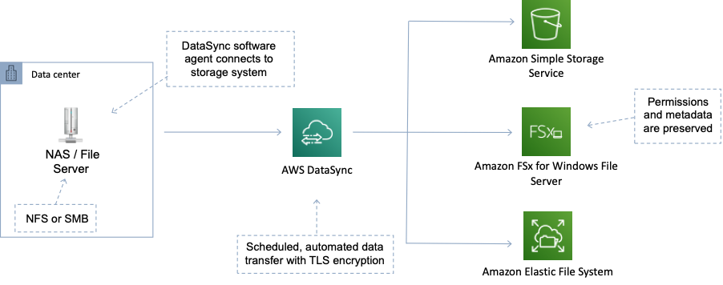

**References:**

<https://aws.amazon.com/fsx/windows/>

<https://aws.amazon.com/datasync/features/>

#### **Question 67:**

A security officer has requested that all data associated with a specific customer is encrypted. The data resides on Elastic Block Store (EBS) volumes. Which of the following statements about using EBS encryption are correct? (choose 2)

1. All instance types support encryption
2. There is no direct way to change the encryption state of a volume
3. All attached EBS volumes must share the same encryption state
4. Not all EBS types support encryption
5. Data in transit between an instance and an encrypted volume is also encrypted

**Answer :** Data in transit between an instance and an encrypted volume is also encrypted

**Answer :** There is no direct way to change the encryption state of a volume

**Explanation**

All EBS types and all instance *families* support encryption but not all instance *types* support encryption. There is no direct way to change the encryption state of a volume. Data in transit between an instance and an encrypted volume is also encrypted.

**References:**

<https://docs.aws.amazon.com/AWSEC2/latest/UserGuide/EBSEncryption.html>

#### **Question 68:**

A legacy application is being migrated into AWS. The application has a large amount of data that is rarely accessed. When files are accessed they are retrieved sequentially. The application will be migrated onto an Amazon EC2 instance. What is the LEAST expensive EBS volume type for this use case?

1. General Purpose SSD (gp2)
2. Throughput Optimized HDD (st1)
3. Cold HDD (sc1)
4. Provisioned IOPS SSD (io1)

**Answer :** Cold HDD (sc1)

**Explanation**

The cold HDD (sc1) EBS volume type is the lowest cost option that is suitable for this use case. The sc1 volume type is suitable for infrequently accessed data and use cases that are oriented towards throughput like sequential data access.

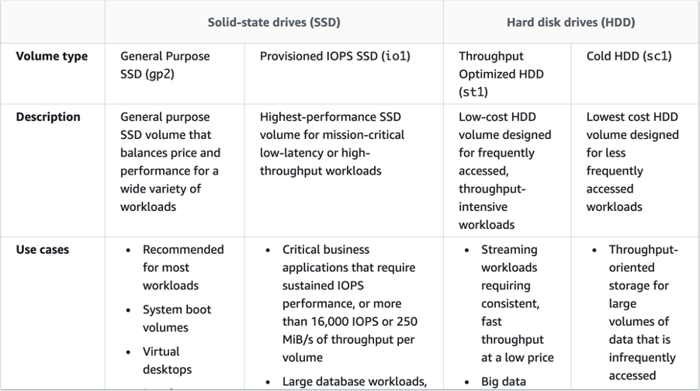

**References:**

<https://docs.aws.amazon.com/AWSEC2/latest/UserGuide/ebs-volume-types.html>

#### **Question 69:**

A Solutions Architect has logged into an Amazon EC2 Linux instance using SSH and needs to determine a few pieces of information including what IAM role is assigned, the instance ID and the names of the security groups that are assigned to the instance.From the options below, what would be the best source of this information?

1. Tags
2. Metadata
3. User data
4. Parameters

**Answer :** Metadata

**Explanation**

*Instance metadata* is data about your instance that you can use to configure or manage the running instance. Instance metadata is divided into categories, for example, host name, events, and security groups.

Instance metadata is available at http://169.254.169.254/latest/meta-data.

**References:**

<https://docs.aws.amazon.com/AWSEC2/latest/UserGuide/ec2-instance-metadata.html>

#### **Question 70:**

An Amazon EBS-backed EC2 instance has been launched. A requirement has come up for some high-performance ephemeral storage. How can a Solutions Architect add a new instance store volume?

1. You must use an Elastic Network Adapter (ENA) to add instance store volumes. First, attach an ENA, and then attach the instance store volume
2. You can specify the instance store volumes for your instance only when you launch an instance
3. You can use a block device mapping to specify additional instance store volumes when you launch your instance, or you can attach additional instance store volumes after your instance is running
4. You must shutdown the instance in order to be able to add the instance store volume

**Answer :** You can specify the instance store volumes for your instance only when you launch an instance

**Explanation**

You can specify the instance store volumes for your instance only when you launch an instance. You can’t attach instance store volumes to an instance after you’ve launched it.

**References:**

<https://docs.aws.amazon.com/AWSEC2/latest/UserGuide/add-instance-store-volumes.html>

#### **Question 71:**

A development team needs to run up a few lab servers on a weekend for a new project. The servers will need to run uninterrupted for a few hours. Which EC2 pricing option would be most suitable?

1. Reserved
2. Dedicated instances
3. Spot
4. On-Demand

**Answer :** On-Demand

**Explanation**

On-Demand pricing ensures that instances will not be terminated and is the most economical option. Use on-demand for ad-hoc requirements where you cannot tolerate interruption.

**References:**

<https://aws.amazon.com/ec2/pricing/>

#### **Question 72:**

A Solutions Architect is designing the disk configuration for an Amazon EC2 instance. The instance needs to support a MapReduce process that requires high throughput for a large dataset with large I/O sizes. Which Amazon EBS volume is the MOST cost-effective solution for these requirements?

1. EBS Throughput Optimized HDD
2. EBS General Purpose SSD
3. EBS General Purpose SSD in a RAID 1 configuration
4. EBS Provisioned IOPS SSD

**Answer :** EBS Throughput Optimized HDD

**Explanation**

EBS Throughput Optimized HDD is good for the following use cases (and is the most cost-effective option:Frequently accessed, throughput intensive workloads with large datasets and large I/O sizes, such as MapReduce, Kafka, log processing, data warehouse, and ETL workloads.Throughput is measured in MB/s, and includes the ability to burst up to 250 MB/s per TB, with a baseline throughput of 40 MB/s per TB and a maximum throughput of 500 MB/s per volume.

**References:**

<https://docs.aws.amazon.com/AWSEC2/latest/UserGuide/ebs-volume-types.html>

#### **Question 73:**

A Solutions Architect is deploying a production application that will use several Amazon EC2 instances and run constantly on an ongoing basis. The application cannot be interrupted or restarted. Which EC2 pricing model would be best for this workload?

1. Flexible instances
2. Reserved instances
3. Spot instances
4. On-demand instances

**Answer :** Reserved instances

**Explanation**

In this scenario for a stable process that will run constantly on an ongoing basis RIs will be the most affordable solution. RIs provide you with a significant discount (up to 75%) compared to On-Demand instance pricing. You have the flexibility to change families, OS types, and tenancies while benefitting from RI pricing when you use Convertible RIs.

**References:**

<https://aws.amazon.com/ec2/pricing/reserved-instances/>

#### **Question 74:**

The load on a MySQL database running on Amazon EC2 is increasing and performance has been impacted. Which of the options below would help to increase storage performance? (choose 2)

1. Use EBS optimized instances
2. Use HDD, Cold (SC1) EBS volumes
3. Use a larger instance size within the instance family
4. Create a RAID 1 array from multiple EBS volumes
5. Use Provisioned IOPS (I01) EBS volumes

**Answer :** Use EBS optimized instances

**Answer :** Use Provisioned IOPS (I01) EBS volumes

**Explanation**

EBS optimized instances provide dedicated capacity for Amazon EBS I/O. EBS optimized instances are designed for use with all EBS volume types. Provisioned IOPS EBS volumes allow you to specify the amount of IOPS you require up to 50 IOPS per GB. Within this limitation you can therefore choose to select the IOPS required to improve the performance of your volume.

RAID can be used to increase IOPS, however RAID 1 does not. For example:

– RAID 0 = 0 striping – data is written across multiple disks and increases performance but no redundancy.

– RAID 1 = 1 mirroring – creates 2 copies of the data but does not increase performance, only redundancy.

HDD, Cold – (SC1) provides the lowest cost storage and low performance

**References:**

<https://docs.aws.amazon.com/AWSEC2/latest/UserGuide/ebs-volume-types.html>

#### **Question 75:**

One of the departments in a company has been generating a large amount of data on Amazon S3 and costs are increasing. Data older than 90 days is rarely accessed but must be retained for several years. If this data does need to be accessed at least 24 hours notice is provided. How can a Solutions Architect optimize the costs associated with storage of this data whilst ensuring it is accessible if required?

1. Use S3 lifecycle policies to move data to GLACIER after 90 days
2. Use S3 lifecycle policies to move data to the STANDARD_IA storage class
3. Implement archival software that automatically moves the data to tape
4. Select the older data and manually migrate it to GLACIER

**Answer :** Use S3 lifecycle policies to move data to GLACIER after 90 days

**Explanation**

To manage your objects so that they are stored cost effectively throughout their lifecycle, configure their lifecycle. A lifecycle configuration is a set of rules that define actions that Amazon S3 applies to a group of objects. Transition actions define when objects transition to another storage class.

For example, you might choose to transition objects to the STANDARD_IA storage class 30 days after you created them, or archive objects to the GLACIER storage class one year after creating them.

GLACIER retrieval times:

- Standard retrieval is 3-5 hours which is well within the requirements here.

- You can use Expedited retrievals to access data in 1 – 5 minutes.

- You can use Bulk retrievals to access up to petabytes of data in approximately 5 – 12 hours.

**References:**

<https://docs.aws.amazon.com/AmazonS3/latest/dev/object-lifecycle-mgmt.html>

<https://aws.amazon.com/about-aws/whats-new/2016/11/access-your-amazon-glacier-data-in-minutes-with-new-retrieval-options/>

#### **Question 76:**

The Solutions Architect in charge of a critical application must ensure the Amazon EC2 instances are able to be launched in another AWS Region in the event of a disaster. What steps should the Solutions Architect take? (Select TWO.)

1. Launch instances in the second Region from the AMIs
2. Create AMIs of the instances and copy them to another Region
3. Enable cross-region snapshots for the Amazon EC2 instances
4. Launch instances in the second Region using the S3 API
5. Copy the snapshots using Amazon S3 cross-region replication

**Answer :** Create AMIs of the instances and copy them to another Region

**Answer :** Launch instances in the second Region from the AMIs

**Explanation**

You can create AMIs of the EC2 instances and then copy them across Regions. This provides a point-in-time copy of the state of the EC2 instance in the remote Region. Once you’ve created AMIs of EC2 instances and copied them to the second Region, you can then launch the EC2 instances from the AMIs in that Region. This is a good DR strategy as you have moved stateful EC2 instances to another Region.

**References:**

<https://aws.amazon.com/blogs/aws/ebs-snapshot-copy/>

#### **Question 77:**

A Solutions Architect has created an AWS account and selected the Asia Pacific (Sydney) region. Within the default VPC there is a default security group. What settings are configured within this security group by default? (choose 2)

1. There is an outbound rule that allows all traffic to the security group itself
2. There is an outbound rule that allows traffic to the VPC router
3. There is an inbound rule that allows all traffic from the security group itself
4. There is an outbound rule that allows all traffic to all addresses
5. There is an inbound rule that allows all traffic from any address

**Answer :** There is an inbound rule that allows all traffic from the security group itself

**Answer :** There is an outbound rule that allows all traffic to all addresses

**Explanation**

Default security groups have inbound allow rules (allowing traffic from within the group) whereas custom security groups do not have inbound allow rules (all inbound traffic is denied by default). All outbound traffic is allowed by default in custom and default security groups.

**References:**

<https://docs.aws.amazon.com/vpc/latest/userguide/VPC_SecurityGroups.html>

#### **Question 78:**

A Solutions Architect is launching an Amazon EC2 instance with multiple attached volumes by modifying the block device mapping. Which block device can be specified in a block device mapping to be used with an EC2 instance? (choose 2)

1. EFS volume
2. Snapshot
3. EBS volume
4. S3 bucket
5. Instance store volume

**Answer :** EBS volume

**Answer :** Instance store volume

**Explanation**

Each instance that you launch has an associated root device volume, either an Amazon EBS volume or an instance store volume.

You can use block device mapping to specify additional EBS volumes or instance store volumes to attach to an instance when it’s launched. You can also attach additional EBS volumes to a running instance. You cannot use a block device mapping to specify a snapshot, EFS volume or S3 bucket.

**References:**

<https://docs.aws.amazon.com/AWSEC2/latest/UserGuide/block-device-mapping-concepts.html>

#### **Question 79:**

A Solutions Architect needs to upload a large (2GB) file to an S3 bucket. What is the recommended way to upload a single large file to an S3 bucket?

1. Use AWS Import/Export
2. Use a single PUT request to upload the large file
3. Use Multipart Upload
4. Use Amazon Snowball

**Answer :** Use Multipart Upload

**Explanation**

In general, when your object size reaches 100 MB, you should consider using multipart uploads instead of uploading the object in a single operation.

**References:**

<https://docs.aws.amazon.com/AmazonS3/latest/dev/uploadobjusingmpu.html>

#### **Question 80:**

A large quantity of data that is rarely accessed is being archived onto Amazon Glacier. Your CIO wants to understand the resilience of the service. Which of the statements below is correct about Amazon Glacier storage? (choose 2)

1. Data is resilient in the event of one entire region destruction
2. Data is replicated globally
3. Provides 99.999999999% durability of archives
4. Provides 99.9% availability of archives
5. Data is resilient in the event of one entire Availability Zone destruction

**Answer :** Provides 99.999999999% durability of archives

**Answer :** Data is resilient in the event of one entire Availability Zone destruction

**Explanation**

Glacier is designed for durability of 99.999999999% of objects across multiple Availability Zones. Data is resilient in the event of one entire Availability Zone destruction. Glacier supports SSL for data in transit and encryption of data at rest. Glacier is extremely low cost and is ideal for long-term archival.

**References:**

<https://aws.amazon.com/s3/storage-classes/>

#### **Question 81:**

An application uses a MySQL database running on an Amazon EC2 instance. The application generates high I/O and constant writes to a single table on the database. Which Amazon EBS volume type will provide the MOST consistent performance and low latency?

1. Cold HDD (sc1)
2. Provisioned IOPS SSD (io1)
3. General Purpose SSD (gp2)
4. Throughput Optimized HDD (st1)

**Answer :** Provisioned IOPS SSD (io1)

**Explanation**

The Provisioned IOPS SSD (io1) volume type will offer the most consistent performance and can be configured with the amount of IOPS required by the application. It will also provide the lowest latency of the options presented.

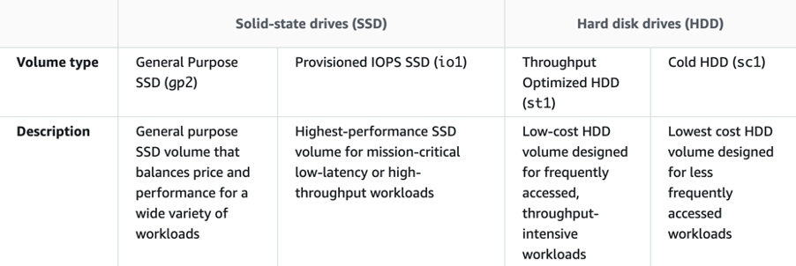

**References:**

<https://docs.aws.amazon.com/AWSEC2/latest/UserGuide/ebs-volume-types.html>

#### **Question 82:**

A company is deploying a new two-tier web application that uses EC2 web servers and a DynamoDB database backend. An Internet facing ELB distributes connections between the web servers.The Solutions Architect has created a security group for the web servers and needs to create a security group for the ELB. What rules should be added? (choose 2)

1. Add an Outbound rule that allows ALL TCP, and specify the destination as the Internet Gateway
2. Add an Outbound rule that allows HTTP/HTTPS, and specify the destination as VPC CIDR
3. Add an Inbound rule that allows HTTP/HTTPS, and specify the source as 0.0.0.0/0
4. Add an Outbound rule that allows HTTP/HTTPS, and specify the destination as the web server security group
5. Add an Inbound rule that allows HTTP/HTTPS, and specify the source as 0.0.0.0/32

**Answer :** Add an Outbound rule that allows HTTP/HTTPS, and specify the destination as the web server security group

**Answer :** Add an Inbound rule that allows HTTP/HTTPS, and specify the source as 0.0.0.0/0

**Explanation**

An inbound rule should be created for the relevant protocols (HTTP/HTTPS) and the source should be set to any address (0.0.0.0/0). The outbound rule should forward the relevant protocols (HTTP/HTTPS) and the destination should be set to the web server security group. Note that on the web server security group you’d want to add an Inbound rule allowing HTTP/HTTPS from the ELB security group.

**References:**

<https://docs.aws.amazon.com/vpc/latest/userguide/VPC_SecurityGroups.html>

#### **Question 83:**

A Solutions Architect has created a new security group in an Amazon VPC. No rules have been created. Which of the statements below are correct regarding the default state of the security group? (choose 2)

1. There is an outbound rule that allows all traffic to all IP addresses
2. There are is an inbound rule that allows traffic from the Internet Gateway
3. There is an inbound rule allowing traffic from the Internet to port 22 for management
4. There are no inbound rules and traffic will be implicitly denied
5. There is an outbound rule allowing traffic to the Internet Gateway

**Answer :** There is an outbound rule that allows all traffic to all IP addresses

**Answer :** There are no inbound rules and traffic will be implicitly denied

**Explanation**

Custom security groups do not have inbound allow rules (all inbound traffic is denied by default) whereas default security groups do have inbound allow rules (allowing traffic from within the group). All outbound traffic is allowed by default in both custom and default security groups. Security groups act like a stateful firewall at the instance level. Specifically security groups operate at the network interface level of an EC2 instance. You can only assign permit rules in a security group, you cannot assign deny rules and there is an implicit deny rule at the end of the security group. All rules are evaluated until a permit is encountered or continues until the implicit deny. You can create ingress and egress rules.

**References:**

<https://docs.aws.amazon.com/vpc/latest/userguide/VPC_SecurityGroups.html>

#### **Question 84:**

A fleet of Amazon EC2 instances running Linux will be launched in an Amazon VPC. An application development framework and some custom software must be installed on the instances. The installation will be initiated using some scripts. What feature enables a Solutions Architect to specify the scripts the software can be installed during the EC2 instance launch?

1. Run command
2. Metadata
3. AWS Config
4. User data

**Answer :** User data

**Explanation**

When you launch an instance in Amazon EC2, you have the option of passing user data to the instance that can be used to perform common automated configuration tasks and even run scripts after the instance starts. You can pass two types of user data to Amazon EC2: shell scripts and cloud-init directives User data is data that is supplied by the user at instance launch in the form of a script and is limited to 16KB.

**References:**

<https://docs.aws.amazon.com/AWSEC2/latest/UserGuide/user-data.html>

#### **Question 85:**

A company has a fleet of Amazon EC2 instances behind an Elastic Load Balancer (ELB) that are a mixture of c4.2xlarge instance types and c5.large instances. The load on the CPUs on the c5.large instances has been very high, often hitting 100% utilization, whereas the c4.2xlarge instances have been performing well. What should a Solutions Architect recommend to resolve the performance issues?

1. Add all of the instances into a Placement Group
2. Add more c5.large instances to spread the load more evenly
3. Change the configuration to use only c4.2xlarge instance types
4. Enable the weighted routing policy on the ELB and configure a higher weighting for the c4.2xlarge instances

**Answer :** Change the configuration to use only c4.2xlarge instance types

**Explanation**

The 2xlarge instance type provides more CPUs. The best answer is to use this instance type for all instances as the CPU utilization has been lower.

**References:**

<https://aws.amazon.com/ec2/instance-types/>

#### **Question 86:**

An Amazon EC2 instance has been launched into an Amazon VPC. A Solutions Architect needs to ensure that instances have both a private and public DNS hostnames. Assuming settings were not changed during creation of the VPC, how will DNS hostnames be assigned by default? (choose 2)

1. In a non-default VPC instances will be assigned a private but not a public DNS hostname
2. In a default VPC instances will be assigned a public and private DNS hostname
3. In all VPCs instances no DNS hostnames will be assigned
4. In a non-default VPC instances will be assigned a public and private DNS hostname
5. In a default VPC instances will be assigned a private but not a public DNS hostname

**Answer :**In a default VPC instances will be assigned a public and private DNS hostname

**Answer :**In a non-default VPC instances will be assigned a private but not a public DNS hostname

**Explanation**

When you launch an instance into a default VPC, we provide the instance with public and private DNS hostnames that correspond to the public IPv4 and private IPv4 addresses for the instance. When you launch an instance into a nondefault VPC, we provide the instance with a private DNS hostname and we might provide a public DNS hostname, depending on the DNS attributes you specify for the VPC and if your instance has a public IPv4 address. All other statements are incorrect with default settings.

**References:**

<https://docs.aws.amazon.com/vpc/latest/userguide/vpc-dns.html>

#### **Question 87:**

A surveying team is using a fleet of drones to collect images of construction sites. The surveying team's laptops lack the inbuilt storage and compute capacity to transfer the images and process the data. While the team has Amazon EC2 instances for processing and Amazon S3 buckets for storage, network connectivity is intermittent and unreliable. The images need to be processed to evaluate the progress of each construction site.

What should a solutions architect recommend?

1. Cache the images locally on a hardware appliance pre-installed with AWS Storage Gateway to process the images when connectivity is restored.
2. Configure Amazon Kinesis Data Firehose to create multiple delivery streams aimed separately at the S3 buckets for storage and the EC2 instances for processing the images.
3. During intermittent connectivity to EC2 instances, upload images to Amazon SQS.
4. Process and store the images using AWS Snowball Edge devices.

**Answer :** Process and store the images using AWS Snowball Edge devices

**Explanation**

AWS physical Snowball Edge device will provide much more inbuilt compute and storage compared to the current team’s laptops. This negates the need to rely on a stable connection to process any images and solves the team's problems easily and efficiently.

**References:**

<https://docs.aws.amazon.com/snowball/latest/developer-guide/whatisedge.html>

#### **Question 88:**

A company has two accounts for perform testing and each account has a single VPC: VPC-TEST1 and VPC-TEST2. The operations team require a method of securely copying files between Amazon EC2 instances in these VPCs. The connectivity should not have any single points of failure or bandwidth constraints. Which solution should a Solutions Architect recommend?

1. Create a VPC gateway endpoint for each EC2 instance and update route tables.
2. Create a VPC peering connection between VPC-TEST1 and VPC-TEST2.
3. Attach a Direct Connect gateway to VPC-TEST1 and VPC-TEST2 and enable routing.
4. Attach a virtual private gateway to VPC-TEST1 and VPC-TEST2 and enable routing.

**Answer :** Create a VPC peering connection between VPC-TEST1 and VPC-TEST2

**Explanation**

A VPC peering connection is a networking connection between two VPCs that enables you to route traffic between them using private IPv4 addresses or IPv6 addresses. Instances in either VPC can communicate with each other as if they are within the same network. You can create a VPC peering connection between your own VPCs, or with a VPC in another AWS account. The VPCs can be in different regions (also known as an inter-region VPC peering connection).

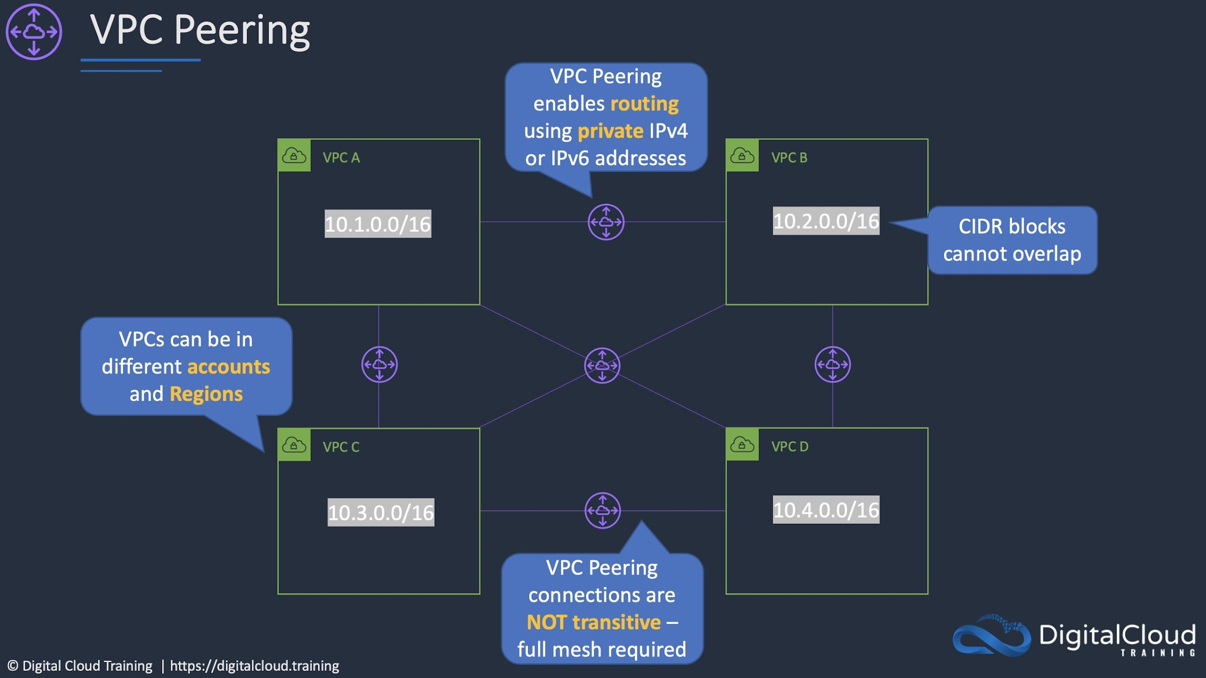

**References:**

<https://docs.aws.amazon.com/vpc/latest/peering/what-is-vpc-peering.html>

#### **Question 89:**

An Amazon VPC contains several Amazon EC2 instances. The instances need to make API calls to Amazon DynamoDB. A solutions architect needs to ensure that the API calls do not traverse the internet. How can this be accomplished? (Select TWO.)

1. Create a new DynamoDB table that uses the endpoint
2. Create an ENI for the endpoint in each of the subnets of the VPC
3. Create a gateway endpoint for DynamoDB
4. Create a VPC peering connection between the VPC and DynamoDB
5. Create a route table entry for the endpoint

**Answer :** Create a gateway endpoint for DynamoDB

**Answer :** Create a route table entry for the endpoint

**Explanation**

Amazon DynamoDB and Amazon S3 support gateway endpoints, not interface endpoints. With a gateway endpoint you create the endpoint in the VPC, attach a policy allowing access to the service, and then specify the route table to create a route table entry in.

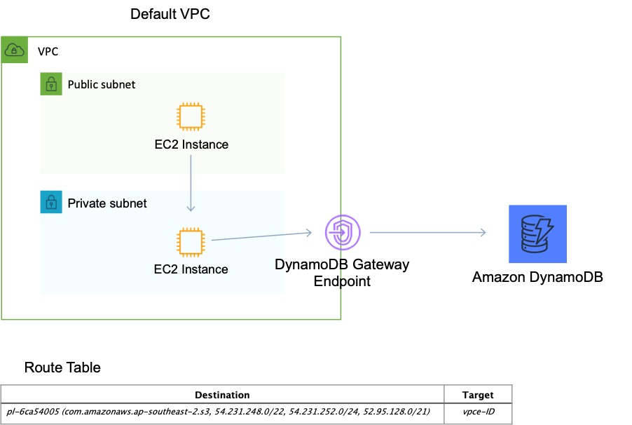

**References:**

<https://docs.aws.amazon.com/vpc/latest/userguide/vpce-gateway.html>

#### **Question 90:**

A company requires that all AWS IAM user accounts have specific complexity requirements and minimum password length. How should a Solutions Architect accomplish this?

1. Set a password policy for the entire AWS account.
2. Use an AWS Config rule to enforce the requirements when creating user accounts.
3. Set a password policy for each IAM user in the AWS account.
4. Create an IAM policy that enforces the requirements and apply it to all users.

**Answer :** Set a password policy for the entire AWS account

**Explanation**

The easiest way to enforce this requirement is to update the password policy that applies to the entire AWS account. When you create or change a password policy, most of the password policy settings are enforced the next time your users change their passwords. However, some of the settings are enforced immediately such as the password expiration period.

**References:**

[https://docs.aws.amazon.com/IAM/latest/UserGuide/id_credentials_passwords_account-policy.html](https://docs.aws.amazon.com/IAM/latest/UserGuide/id_credentials_passwords_account-policy.html?icmpid=docs_iam_console)

#### **Question 91:**

A company wishes to restrict access to their Amazon DynamoDB table to specific, private source IP addresses from their VPC. What should be done to secure access to the table?

1. Create a gateway VPC endpoint and add an entry to the route table
2. Create the Amazon DynamoDB table in the VPC
3. Create an AWS VPN connection to the Amazon DynamoDB endpoint
4. Create an interface VPC endpoint in the VPC with an Elastic Network Interface (ENI)

**Answer :** Create a gateway VPC endpoint and add an entry to the route table

**Explanation**

There are two different types of VPC endpoint: interface endpoint, and gateway endpoint. With an interface endpoint you use an ENI in the VPC. With a gateway endpoint you configure your route table to point to the endpoint. Amazon S3 and DynamoDB use gateway endpoints. This solution means that all traffic will go through the VPC endpoint straight to DynamoDB using private IP addresses.

#### **Question 92:**

A solutions architect is designing a two-tier web application. The application consists of a public-facing web tier hosted on Amazon EC2 in public subnets. The database tier consists of Microsoft SQL Server running on Amazon EC2 in a private subnet. Security is a high priority for the company. How should security groups be configured in this situation? (Select TWO.)

1. Configure the security group for the web tier to allow inbound traffic on port 443 from 0.0.0.0/0
2. Configure the security group for the database tier to allow inbound traffic on port 1433 from the security group for the web tier
3. Configure the security group for the web tier to allow outbound traffic on port 443 from 0.0.0.0/0
4. Configure the security group for the database tier to allow inbound traffic on ports 443 and 1433 from the security group for the web tier
5. Configure the security group for the database tier to allow outbound traffic on ports 443 and 1433 to the security group for the web tier

**Answer :** Configure the security group for the web tier to allow inbound traffic on port 443 from 0.0.0.0/0

**Answer :** Configure the security group for the database tier to allow inbound traffic on port 1433 from the security group for the web tier

**Explanation**

In this scenario an inbound rule is required to allow traffic from any internet client to the web front end on SSL/TLS port 443. The source should therefore be set to 0.0.0.0/0 to allow any inbound traffic. To secure the connection from the web frontend to the database tier, an outbound rule should be created from the public EC2 security group with a destination of the private EC2 security group. The port should be set to 1433 for MySQL. The private EC2 security group will also need to allow inbound traffic on 1433 from the public EC2 security group.

This configuration can be seen in the diagram:

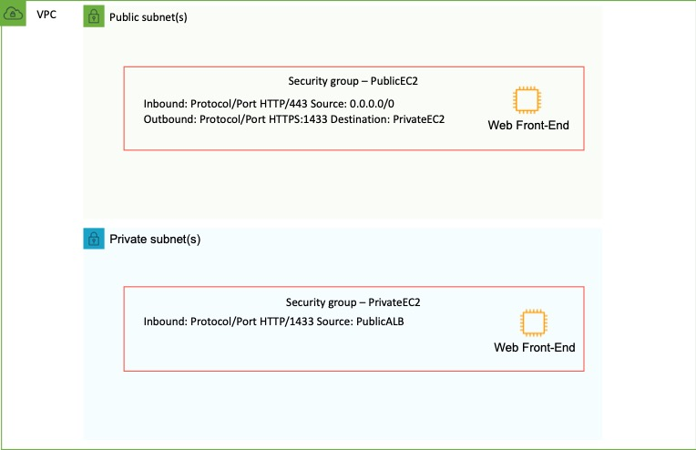

**References:**

<https://docs.aws.amazon.com/vpc/latest/userguide/VPC_SecurityGroups.html>

#### **Question 93:**

A company runs a number of core enterprise applications in an on-premises data center. The data center is connected to an Amazon VPC using AWS Direct Connect. The company will be creating additional AWS accounts and these accounts will also need to be quickly, and cost-effectively connected to the on-premises data center in order to access the core applications. What deployment changes should a Solutions Architect implement to meet these requirements with the LEAST operational overhead?

1. Configure AWS Transit Gateway between the accounts. Assign Direct Connect to the transit gateway and route network traffic to the on-premises servers.
2. Create a VPN connection between each new account and the Direct Connect VPC. Route the network traffic to the on-premises servers.
3. Configure VPC endpoints in the Direct Connect VPC for all required services. Route the network traffic to the on-premises servers.
4. Create a Direct Connect connection in each new account. Route the network traffic to the on-premises servers.

**Answer :** Configure AWS Transit Gateway between the accounts. Assign Direct Connect to the transit gateway and route network traffic to the on-premises servers

**Explanation**

AWS Transit Gateway connects VPCs and on-premises networks through a central hub. With AWS Transit Gateway, you can quickly add Amazon VPCs, AWS accounts, VPN capacity, or AWS Direct Connect gateways to meet unexpected demand, without having to wrestle with complex connections or massive routing tables. This is the operationally least complex solution and is also cost-effective.

The image below depicts how transit gateway can assist with simplifying network deployments:

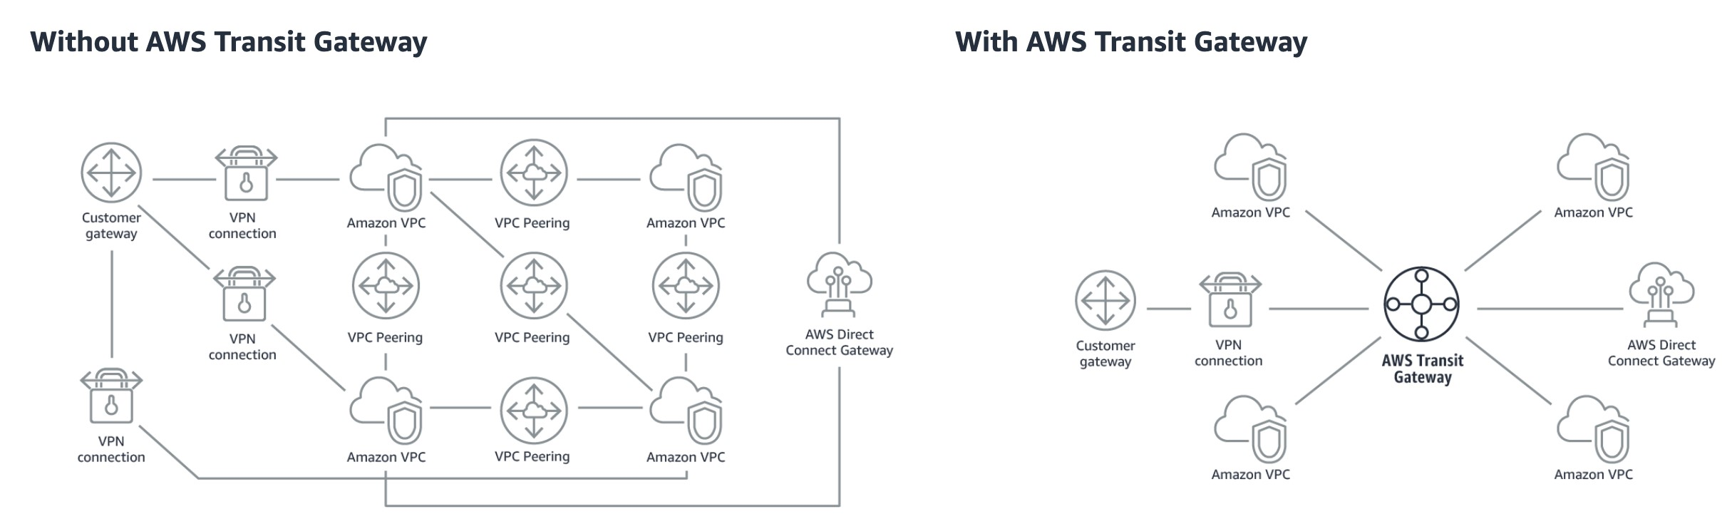

**References:**

<https://aws.amazon.com/transit-gateway/>

#### **Question 94:**

A solutions architect has created a new AWS account and must secure AWS account root user access. Which combination of actions will accomplish this? (Select TWO.)

1. Enable multi-factor authentication for the root user
2. Delete the root user account
3. Add the root user to a group containing administrative permissions
4. Ensure the root user uses a strong password
5. Store root user access keys in an encrypted Amazon S3 bucket

**Answer :** Ensure the root user uses a strong password

**Answer :** Enable multi-factor authentication to the root user

**Explanation**

There are several security best practices for securing the root user account:

· Lock away root user access keys OR delete them if possible

· Use a strong password

· Enable multi-factor authentication (MFA)

The root user automatically has full privileges to the account and these privileges cannot be restricted so it is extremely important to follow best practice advice about securing the root user account.

**References:**

<https://docs.aws.amazon.com/IAM/latest/UserGuide/best-practices.html>

#### **Question 95:**

A company is storing a large quantity of small files in an Amazon S3 bucket. An application running on an Amazon EC2 instance needs permissions to access and process the files in the S3 bucket. Which action will MOST securely grant the EC2 instance access to the S3 bucket?

1. Create an IAM user for the application with specific permissions to the S3 bucket.
2. Create an IAM role with least privilege permissions and attach it to the EC2 instance profile.
3. Generate access keys and store the credentials on the EC2 instance for use in making API calls.
4. Create a bucket ACL on the S3 bucket and configure the EC2 instance ID as a grantee.

**Answer :** Create an IAM role with least privilege permissions and attach it to the EC2 instance profile

**Explanation**

IAM roles should be used in place of storing credentials on Amazon EC2 instances. This is the most secure way to provide permissions to EC2 as no credentials are stored and short-lived credentials are obtained using AWS STS. Additionally, the policy attached to the role should provide least privilege permissions.

**References:**

<https://docs.aws.amazon.com/AWSEC2/latest/UserGuide/iam-roles-for-amazon-ec2.html>

#### **Question 96:**

A company runs an application on Amazon EC2 instances which requires access to sensitive data in an Amazon S3 bucket. All traffic between the EC2 instances and the S3 bucket must not traverse the internet and must use private IP addresses. Additionally, the bucket must only allow access from services in the VPC. Which combination of actions should a Solutions Architect take to meet these requirements? (Select TWO.)

1. Enable default encryption on the bucket.
2. Apply an IAM policy to a VPC peering connection.
3. Create a peering connection to the S3 bucket VPC.
4. Apply a bucket policy to restrict access to the S3 endpoint.
5. Create a VPC endpoint for Amazon S3.

**Answer :** Create a VPC endpoint for Amazon S3

**Answer :** Apply a bucket policy to restrict access to the S3 endpoint

**Explanation**

Private access to public services such as Amazon S3 can be achieved by creating a VPC endpoint in the VPC. For S3 this would be a gateway endpoint. The bucket policy can then be configured to restrict access to the S3 endpoint only which will ensure that only services originating from the VPC will be granted access.

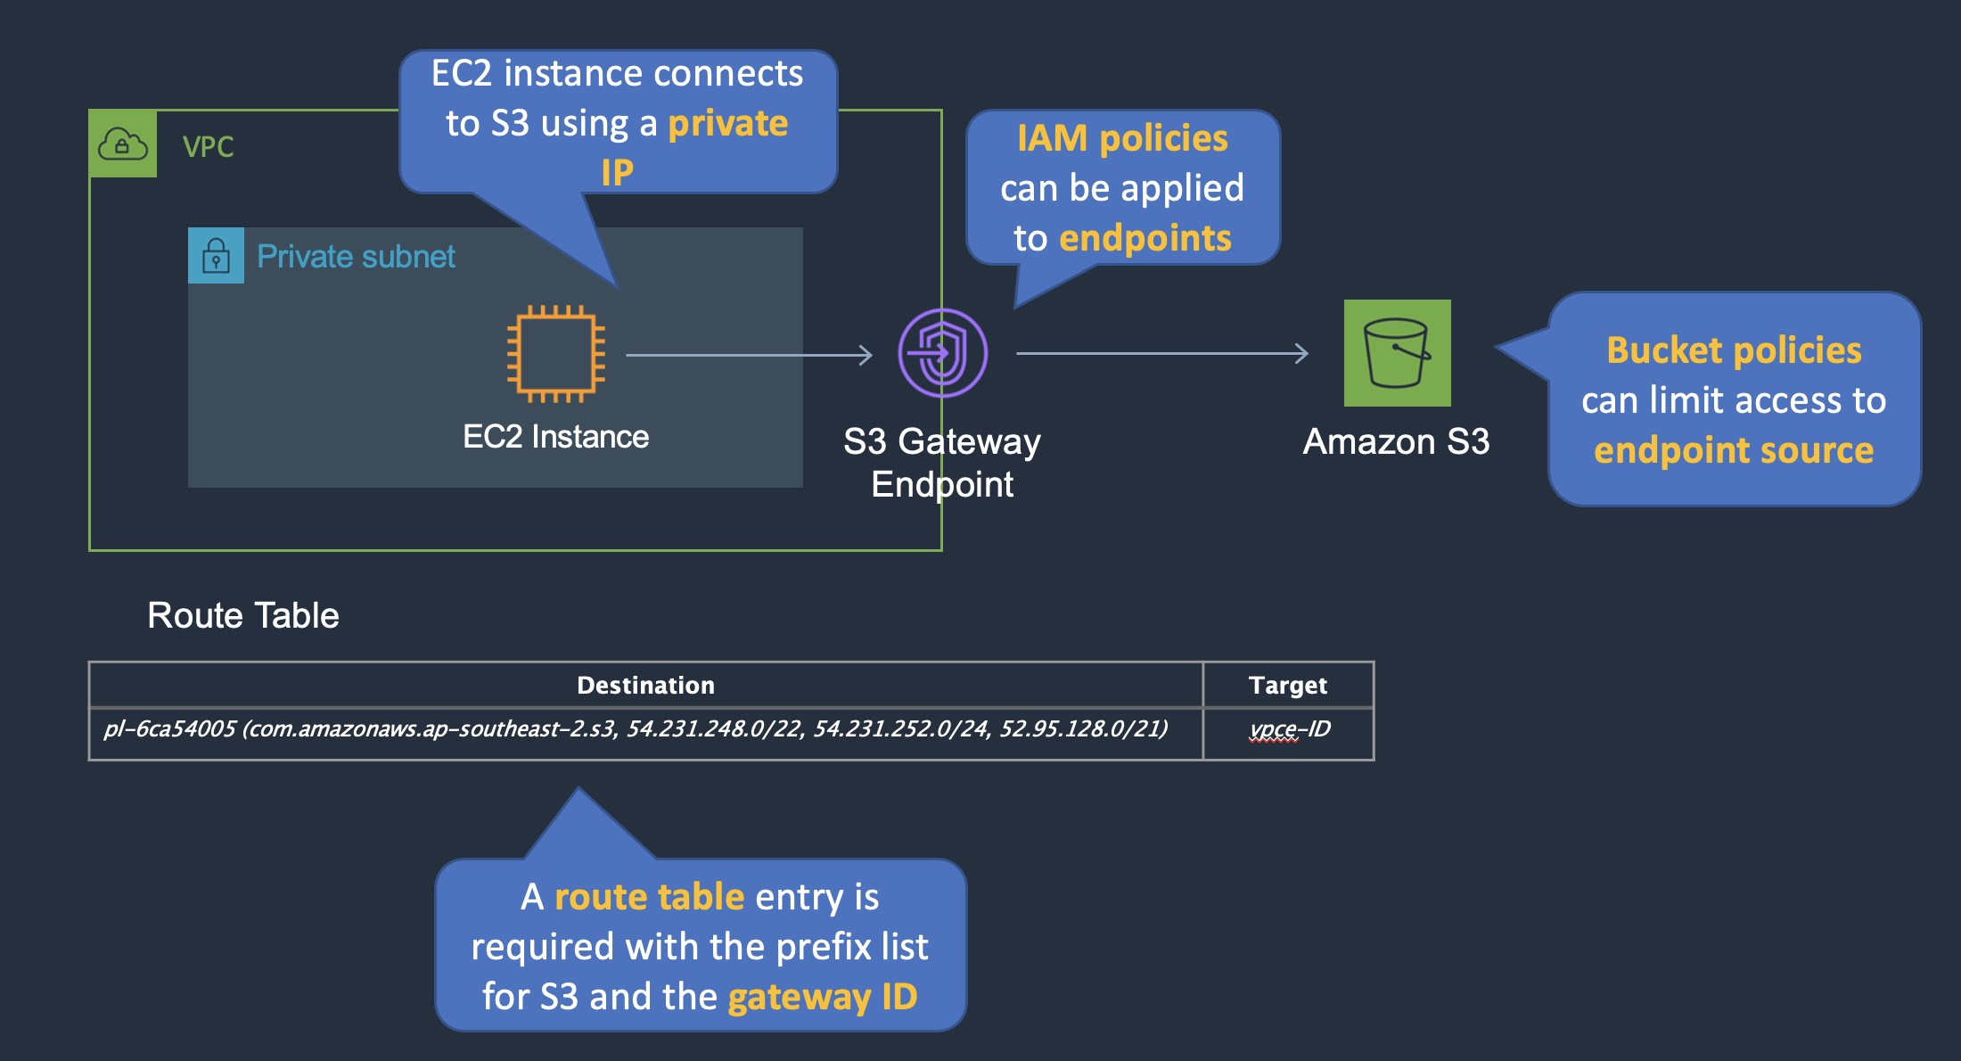

**References:**

<https://docs.aws.amazon.com/vpc/latest/userguide/vpce-gateway.html>

#### **Question 97:**

A company have 500 TB of data in an on-premises file share that needs to be moved to Amazon S3 Glacier. The migration must not saturate the company’s low-bandwidth internet connection and the migration must be completed within a few weeks. What is the MOST cost-effective solution?

1. Create an AWS Direct Connect connection and migrate the data straight into Amazon Glacier
2. Use AWS Global Accelerator to accelerate upload and optimize usage of the available bandwidth
3. Order 7 AWS Snowball appliances and select an S3 Glacier vault as the destination. Create a bucket policy to enforce a VPC endpoint
4. Order 7 AWS Snowball appliances and select an Amazon S3 bucket as the destination. Create a lifecycle policy to transition the S3 objects to Amazon S3 Glacier

**Answer :** Order 7 AWS Snowball appliances and select an Amazon S3 bucket as the destination. Create a lifecycle policy to transition the S3 objects to Amazon S3 Glacier

**Explanation**

As the company’s internet link is low-bandwidth uploading directly to Amazon S3 (ready for transition to Glacier) would saturate the link. The best alternative is to use AWS Snowball appliances. The Snowball edge appliance can hold up to 80 TB of data so 7 devices would be required to migrate 500 TB of data. Snowball moves data into AWS using a hardware device and the data is then copied into an Amazon S3 bucket of your choice. From there, lifecycle policies can transition the S3 objects to Amazon S3 Glacier.

**References:**

<https://docs.aws.amazon.com/snowball/latest/developer-guide/specifications.html>

#### **Question 98:**

A solutions architect has been tasked with designing a highly resilient hybrid cloud architecture connecting an on-premises data center and AWS. The network should include AWS Direct Connect (DX). Which DX configuration offers the HIGHEST resiliency?

1. Configure a DX connection with an encrypted VPN on top of it.
2. Configure multiple public VIFs on top of a DX connection.
3. Configure multiple private VIFs on top of a DX connection.
4. Configure DX connections at multiple DX locations.

**Answer :** Configure DX connections at multiple DX locations

**Explanation**

The most resilient solution is to configure DX connections at multiple DX locations. This ensures that any issues impacting a single DX location do not affect availability of the network connectivity to AWS.

Take note of the following AWS recommendations for resiliency:

AWS recommends connecting from multiple data centers for physical location redundancy. When designing remote connections, consider using redundant hardware and telecommunications providers. Additionally, it is a best practice to use dynamically routed, active/active connections for automatic load balancing and failover across redundant network connections. Provision sufficient network capacity to ensure that the failure of one network connection does not overwhelm and degrade redundant connections.

The diagram below is an example of an architecture that offers high resiliency:

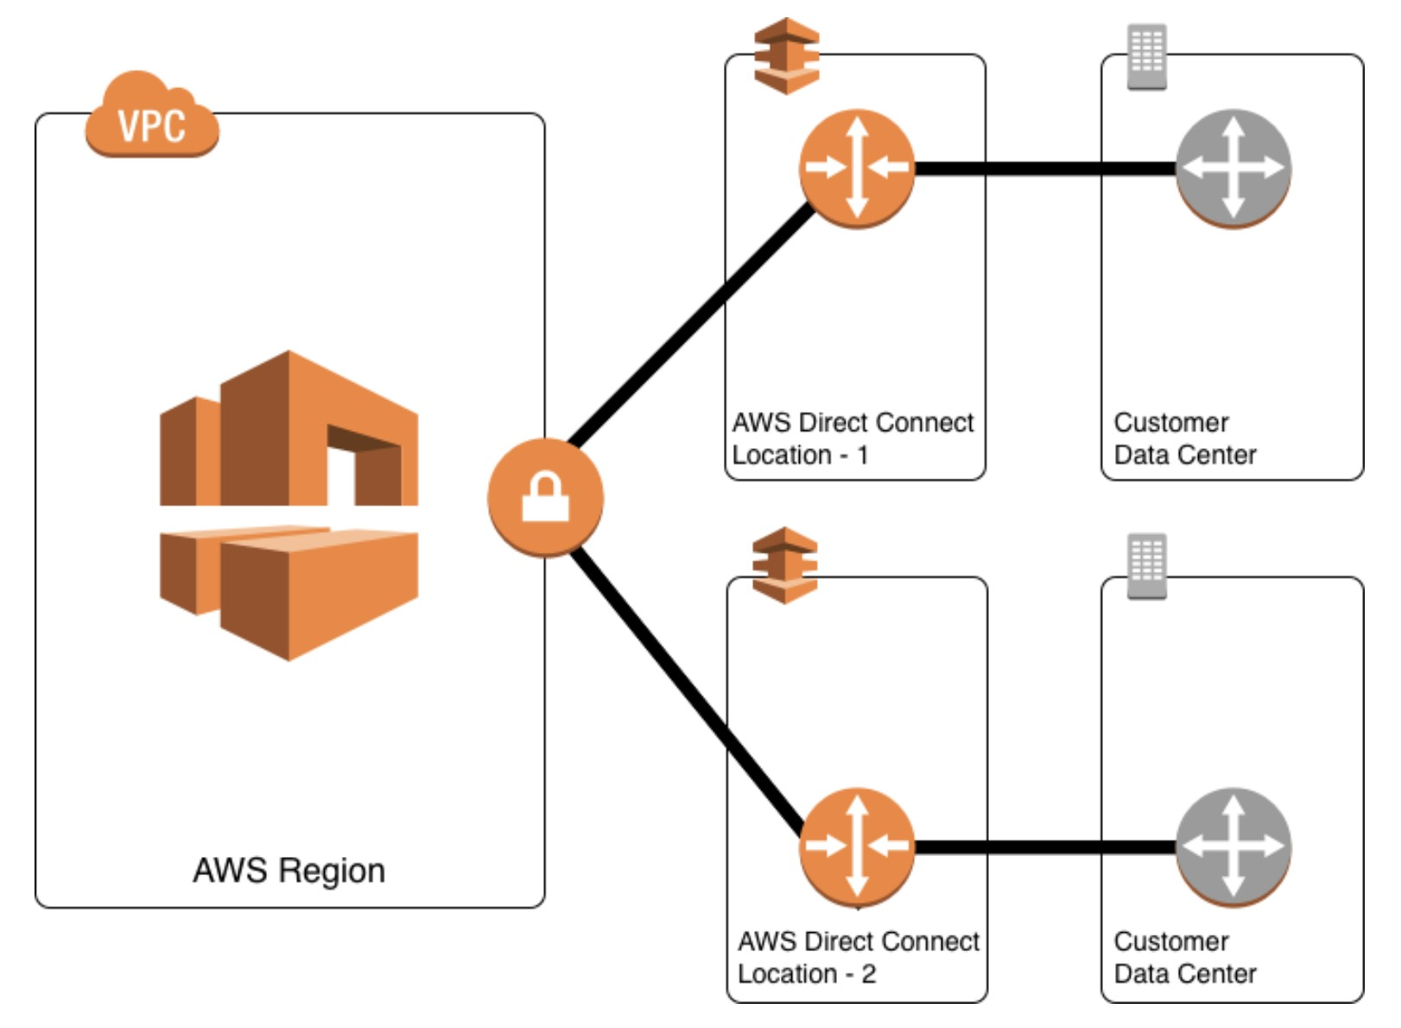

**References:**

<https://aws.amazon.com/directconnect/resiliency-recommendation/>

#### **Question 99:**

A company has acquired another business and needs to migrate their 50TB of data into AWS within 1 month. They also require a secure, reliable and private connection to the AWS cloud. How are these requirements best accomplished?

1. Provision an AWS Direct Connect connection and migrate the data over the link
2. Migrate data using AWS Snowball. Provision an AWS VPN initially and order a Direct Connect link
3. Provision an AWS VPN CloudHub connection and migrate the data over redundant links
4. Launch a Virtual Private Gateway (VPG) and migrate the data over the AWS VPN

**Answer :** Migrate data using AWS Snowball. Provision an AWS VPN initially and order a Direct Connect link

**Explanation**

AWS Direct Connect provides a secure, reliable and private connection. However, lead times are often longer than 1 month so it cannot be used to migrate data within the timeframes. Therefore, it is better to use AWS Snowball to move the data and order a Direct Connect connection to satisfy the other requirement later on. In the meantime the organization can use an AWS VPN for secure, private access to their VPC.

**References:**

<https://aws.amazon.com/snowball/>

<https://aws.amazon.com/directconnect/>

#### **Question 100:**

A Solutions Architect needs to monitor application logs and receive a notification whenever a specific number of occurrences of certain HTTP status code errors occur. Which tool should the Architect use?

1. CloudWatch Events
2. CloudWatch Metrics
3. CloudWatch Logs
4. CloudTrail Trails

**Answer :** CloudWatch Logs

**Explanation**

You can use CloudWatch Logs to monitor applications and systems using log data. For example, CloudWatch Logs can track the number of errors that occur in your application logs and send you a notification whenever the rate of errors exceeds a threshold you specify. This is the best tool for this requirement.

**References:**

<https://docs.aws.amazon.com/AmazonCloudWatch/latest/logs/WhatIsCloudWatchLogs.html>

#### **Question 101:**

An organization is extending a secure development environment into AWS. They have already secured the VPC including removing the Internet Gateway and setting up a Direct Connect connection. What else needs to be done to add encryption?

1. Setup a Virtual Private Gateway (VPG)
2. Setup the Border Gateway Protocol (BGP) with encryption
3. Configure an AWS Direct Connect Gateway
4. Enable IPSec encryption on the Direct Connect connection

**Answer :** Setup a Virtual Private Gateway (VPG)

**Explanation**

A VPG is used to setup an AWS VPN which you can use in combination with Direct Connect to encrypt all data that traverses the Direct Connect link. This combination provides an IPsec-encrypted private connection that also reduces network costs, increases bandwidth throughput, and provides a more consistent network experience than internet-based VPN connections.

**References:**

<https://docs.aws.amazon.com/whitepapers/latest/aws-vpc-connectivity-options/aws-direct-connect-plus-vpn-network-to-amazon.html>

<https://docs.aws.amazon.com/directconnect/latest/UserGuide/direct-connect-gateways-intro.html>

#### **Question 102:**

You work for Digital Cloud Training and have just created a number of IAM users in your AWS account. You need to ensure that the users are able to make API calls to AWS services. What else needs to be done?

1. Enable Multi-Factor Authentication for the users
2. Create a set of Access Keys for the users
3. Create a group and add the users to it
4. Set a password for each user

**Answer :** Create a set of Access Keys for the users

**Explanation**

Access keys are a combination of an access key ID and a secret access key and you can assign two active access keys to a user at a time. These can be used to make programmatic calls to AWS when using the API in program code or at a command prompt when using the AWS CLI or the AWS PowerShell tools.

**References:**

<https://docs.aws.amazon.com/IAM/latest/UserGuide/id_credentials_access-keys.html>

#### **Question 103:**

A Solutions Architect is determining the best method for provisioning Internet connectivity for a data-processing application that will pull large amounts of data from an object storage system via the Internet. The solution must be redundant and have no constraints on bandwidth. Which option satisfies these requirements?

1. Create a VPC endpoint
2. Attach an Internet Gateway
3. Use a NAT Gateway
4. Deploy NAT Instances in a public subnet

**Answer :**  Attach an Internet Gateway

**Explanation**

An internet gateway is a horizontally scaled, redundant, and highly available VPC component that allows communication between your VPC and the internet. An internet gateway serves two purposes: to provide a target in your VPC route tables for internet-routable traffic, and to perform network address translation (NAT) for instances that have been assigned public IPv4 addresses. An internet gateway supports IPv4 and IPv6 traffic. It does not cause availability risks or bandwidth constraints on your network traffic.

**References:**

<https://docs.aws.amazon.com/vpc/latest/userguide/VPC_Internet_Gateway.html>

#### **Question 104:**

A company has deployed an API in a VPC behind an internal Network Load Balancer (NLB). An application that consumes the API as a client is deployed in a second account in private subnets. Which architectural configurations will allow the API to be consumed without using the public Internet? (Select TWO.)

1. Configure an AWS Resource Access Manager connection between the two accounts. Access the API using the private address
2. Configure a VPC peering connection between the two VPCs. Access the API using the private address
3. Configure an AWS Direct Connect connection between the two VPCs. Access the API using the private address
4. Configure a PrivateLink connection for the API into the client VPC. Access the API using the PrivateLink address
5. Configure a ClassicLink connection for the API into the client VPC. Access the API using the ClassicLink address

**Answer :** Configure a VPC peering connection between the two VPCs. Access the API using the private address

**Answer :** Configure a PrivateLink connection for the API into the client VPC. Access the API using the PrivateLink address

**Explanation**

You can create your own application in your VPC and configure it as an AWS PrivateLink-powered service (referred to as an *endpoint service*). Other AWS principals can create a connection from their VPC to your endpoint service using an [interface VPC endpoint](https://docs.aws.amazon.com/vpc/latest/userguide/vpce-interface.html). You are the *service provider*, and the AWS principals that create connections to your service are service consumers.

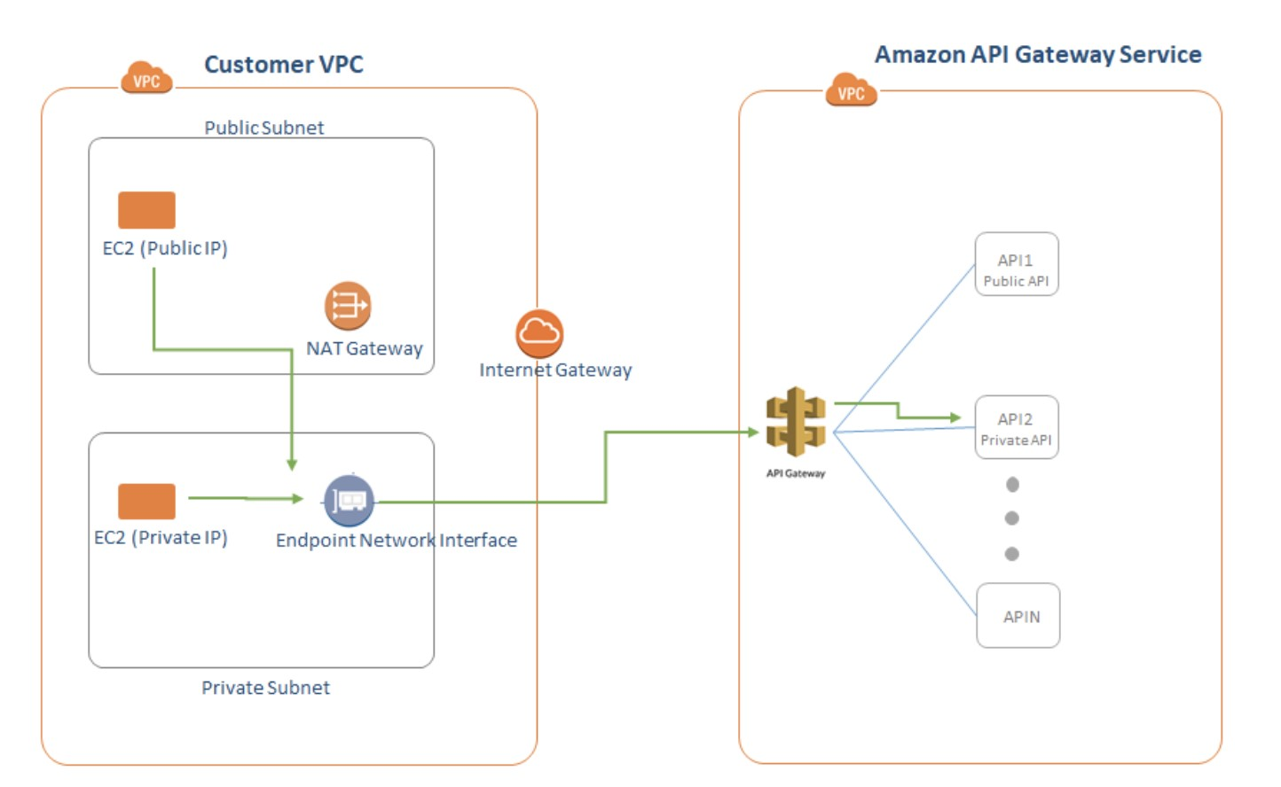

This configuration is powered by AWS PrivateLink and clients do not need to use an internet gateway, NAT device, VPN connection or AWS Direct Connect connection, nor do they require public IP addresses. Another option is to use a VPC Peering connection. A VPC peering connection is a networking connection between two VPCs that enables you to route traffic between them using private IPv4 addresses or IPv6 addresses. Instances in either VPC can communicate with each other as if they are within the same network. You can create a VPC peering connection between your own VPCs, or with a VPC in another AWS account.

**References:**

<https://docs.aws.amazon.com/vpc/latest/userguide/endpoint-service.html>

<https://docs.aws.amazon.com/vpc/latest/peering/what-is-vpc-peering.html>

#### **Question 105:**

A company has experienced malicious traffic from some suspicious IP addresses. The security team discovered the requests are from different IP addresses under the same CIDR range. What should a solutions architect recommend to the team?

1. Add a rule in the outbound table of the security group to deny the traffic from that CIDR range
2. Add a rule in the inbound table of the security group to deny the traffic from that CIDR range
3. Add a deny rule in the inbound table of the network ACL with a lower rule number than other rules
4. Add a deny rule in the outbound table of the network ACL with a lower rule number than other rules

**Answer :** Add a deny rule in the inbound table of the network ACL with a lower rule number than other rules

**Explanation**

You can only create deny rules with network ACLs, it is not possible with security groups. Network ACLs process rules in order from the lowest numbered rules to the highest until they reach and allow or deny. The following table describes some of the differences between security groups and network ACLs:

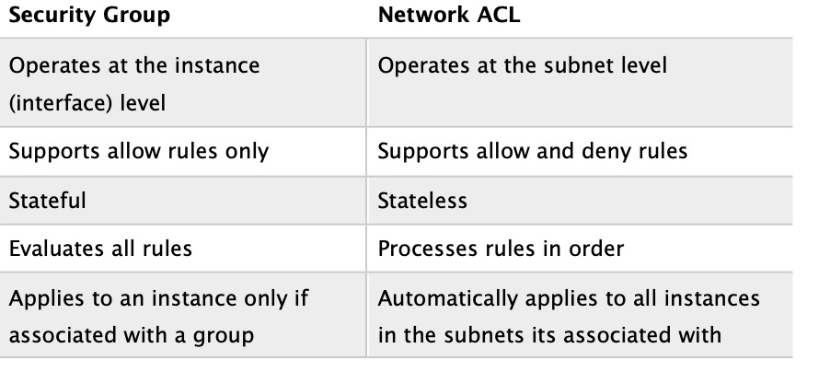

Therefore, the solutions architect should add a deny rule in the inbound table of the network ACL with a lower rule number than other rules.

**References:**

<https://docs.aws.amazon.com/vpc/latest/userguide/vpc-network-acls.html>

#### **Question 106:**

You are deploying an application on Amazon EC2 that must call AWS APIs. Which method of securely passing credentials to the application should you use?

1. Assign IAM roles to the EC2 instances
2. Store the API credentials on the instance using instance metadata
3. Embed the API credentials into your application files
4. Store API credentials as an object in Amazon S3

**Answer :**Assign IAM roles to the EC2 instances

**Explanation**

Applications must sign their API requests with AWS credentials. Therefore, if you are an application developer, you need a strategy for managing credentials for your applications that run on EC2 instances. For example, you can securely distribute your AWS credentials to the instances, enabling the applications on those instances to use your credentials to sign requests, while protecting your credentials from other users.

However, it's challenging to securely distribute credentials to each instance, especially those that AWS creates on your behalf, such as Spot Instances or instances in Auto Scaling groups. You must also be able to update the credentials on each instance when you rotate your AWS credentials.IAM roles enable your applications to securely make API requests from your instances, without requiring you to manage the security credentials that the applications use. Instead of creating and distributing your AWS credentials, you can delegate permission to make API requests using IAM roles.

**References:**

<https://docs.aws.amazon.com/AWSEC2/latest/UserGuide/iam-roles-for-amazon-ec2.html>

#### **Question 107:**

A web application in a three-tier architecture runs on a fleet of Amazon EC2 instances. Performance issues have been reported and investigations point to insufficient swap space. The operations team requires monitoring to determine if this is correct. What should a solutions architect recommend?

1. Use EC2 metadata to collect information, then publish it to Amazon CloudWatch custom metrics. Monitor SwapUsage metrics in CloudWatch
2. Configure an Amazon CloudWatch SwapUsage metric dimension. Monitor the SwapUsage dimension in the EC2 metrics in CloudWatch
3. Install an Amazon CloudWatch agent on the instances. Run an appropriate script on a set schedule. Monitor SwapUtilization metrics in CloudWatch
4. Enable detailed monitoring in the EC2 console. Create an Amazon CloudWatch SwapUtilization custom metric. Monitor SwapUtilization metrics in CloudWatch

**Answer :** Install an Amazon CloudWatch agent on the instances. Run an appropriate script on a set schedule. Monitor SwapUtilization metrics in CloudWatch

**Explanation**

You can use the CloudWatch agent to collect both system metrics and log files from Amazon EC2 instances and on-premises servers. The agent supports both Windows Server and Linux, and enables you to select the metrics to be collected, including sub-resource metrics such as per-CPU core. There is now a unified agent and previously there were monitoring scripts. Both of these tools can capture SwapUtilization metrics and send them to CloudWatch. This is the best way to get memory utilization metrics from Amazon EC2 instnaces.

**References:**

<https://docs.aws.amazon.com/AmazonCloudWatch/latest/monitoring/Install-CloudWatch-Agent.html>

#### **Question 108:**

You have created an application in a VPC that uses a Network Load Balancer (NLB). The application will be offered in a service provider model for AWS principals in other accounts within the region to consume. Based on this model, what AWS service will be used to offer the service for consumption?

1. VPC Endpoint Services using AWS PrivateLink
2. Route 53
3. API Gateway
4. IAM Role Based Access Control

**Answer :** VPC Endpoint Services using AWS PrivateLink

**Explanation**

An Interface endpoint uses AWS PrivateLink and is an elastic network interface (ENI) with a private IP address that serves as an entry point for traffic destined to a supported service. Using PrivateLink you can connect your VPC to supported AWS services, services hosted by other AWS accounts (VPC endpoint services), and supported AWS Marketplace partner services.

**References:**

<https://docs.aws.amazon.com/vpc/latest/userguide/endpoint-service.html>

#### **Question 109:**

A Solutions Architect is designing a web page for event registrations, and needs a managed service to send a text message to users every time users sign up for an event. Which AWS service should the Architect use to achieve this?

1. Amazon STS
2. AWS Lambda
3. Amazon SNS
4. Amazon SQS

**Answer :** Amazon SNS

**Explanation**

Amazon Simple Notification Service (SNS) is a web service that makes it easy to set up, operate, and send notifications from the cloud and supports notifications over multiple transports including HTTP/HTTPS, Email/Email-JSON, SQS and SMS.

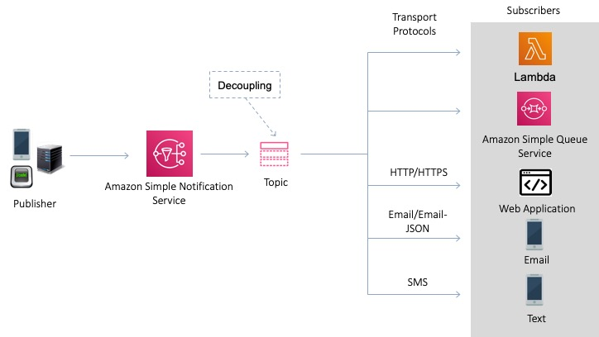

**References:**

<https://docs.aws.amazon.com/sns/latest/dg/welcome.html>

#### **Question 110:**

A pharmaceutical company uses a strict process for release automation that involves building and testing services in 3 separate VPCs. A peering topology is configured with VPC-A peered with VPC-B and VPC-B peered with VPC-C. The development team wants to modify the process so that they can release code directly from VPC-A to VPC-C. How can this be accomplished?

1. Update VPC-Bs route table with peering targets for VPC-A and VPC-C and enable route propagation
2. Update VPC-As route table with an entry using the VPC peering as a target
3. Create a new VPC peering connection between VPC-A and VPC-C
4. Update the CIDR blocks to match to enable inter-VPC routing

**Answer :** Create a new VPC peering connection between VPC-A and VPC-C

**Explanation**

A VPC peering connection is a networking connection between two VPCs that enables you to route traffic between them using private IPv4 addresses or IPv6 addresses. Instances in either VPC can communicate with each other as if they are within the same network. You can create a VPC peering connection between your own VPCs, or with a VPC in another AWS account. The VPCs can be in different regions (also known as an inter-region VPC peering connection). It is not possible to use transitive peering relationships with VPC peering and therefore you must create an additional VPC peering connection between VPC-A and VPC-C.

**References:**

<https://docs.aws.amazon.com/vpc/latest/peering/what-is-vpc-peering.html>

#### **Question 111:**

A customer has a public-facing web application hosted on a single Amazon Elastic Compute Cloud (EC2) instance serving videos directly from an Amazon S3 bucket. Which of the following will restrict third parties from directly accessing the video assets in the bucket?

1. Use a bucket policy to only allow the public IP address of the Amazon EC2 instance hosting the customer website
2. Restrict access to the bucket to the public CIDR range of the company locations
3. Use a bucket policy to only allow referrals from the main website URL
4. Launch the website Amazon EC2 instance using an IAM role that is authorized to access the videos

**Answer :** Use a bucket policy to only allow referrals from the main website URL

**Explanation**

To allow read access to the S3 video assets from the public-facing web application, you can add a bucket policy that allows s3:GetObject permission with a condition, using the aws:referer key, that the get request must originate from specific webpages. This is a good answer as it fully satisfies the objective of ensuring the that EC2 instance can access the videos but direct access to the videos from other sources is prevented.

**References:**

<https://docs.aws.amazon.com/AmazonS3/latest/dev/example-bucket-policies.html#example-bucket-policies-use-case-4>

#### **Question 112:**

An application in a private subnet needs to query data in an Amazon DynamoDB table. Use of the DynamoDB public endpoints must be avoided. What is the most EFFICIENT and secure method of enabling access to the table?

1. Create a gateway VPC endpoint and add an entry to the route table
2. Create an interface VPC endpoint in the VPC with an Elastic Network Interface (ENI)
3. Create a software VPN between DynamoDB and the application in the private subnet
4. Create a private Amazon DynamoDB endpoint and connect to it using an AWS VPN

**Answer :** Create a gateway VPC endpoint and add an entry to the route table

**Explanation**

A VPC endpoint enables you to privately connect your VPC to supported AWS services and VPC endpoint services powered by AWS PrivateLink without requiring an internet gateway, NAT device, VPN connection, or AWS Direct Connect connection. Instances in your VPC do not require public IP addresses to communicate with resources in the service. Traffic between your VPC and the other service does not leave the Amazon network. With a gateway endpoint you configure your route table to point to the endpoint. Amazon S3 and DynamoDB use gateway endpoints.

The table below helps you to understand the key differences between the two different types of VPC endpoint:

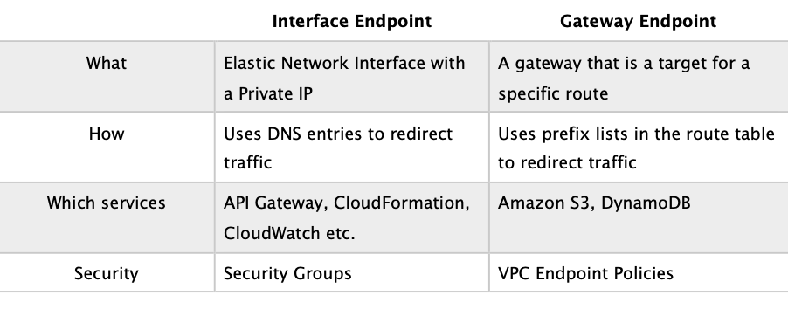

**References:**

<https://docs.aws.amazon.com/vpc/latest/userguide/vpc-endpoints.html>

#### **Question 113:**

An application is being monitored using Amazon GuardDuty. A Solutions Architect needs to be notified by email of medium to high severity events. How can this be achieved?

1. Create an Amazon CloudWatch events rule that triggers an Amazon SNS topic
2. Configure an Amazon CloudTrail alarm the triggers based on GuardDuty API activity
3. Create an Amazon CloudWatch Logs rule that triggers an AWS Lambda function
4. Configure an Amazon CloudWatch alarm that triggers based on a GuardDuty metric

**Answer :** Create an Amazon CloudWatch events rule that triggers an Amazon SNS topic

**Explanation**

A CloudWatch Events rule can be used to set up automatic email notifications for Medium to High Severity findings to the email address of your choice. You simply create an Amazon SNS topic and then associate it with an Amazon CloudWatch events rule.

Note: step by step procedures for how to set this up can be found in the article linked in the references below.

**References:**

<https://docs.aws.amazon.com/guardduty/latest/ug/guardduty_findings_cloudwatch.html>

#### **Question 114:**

An application will gather data from a website hosted on an EC2 instance and write the data to an S3 bucket. The application will use API calls to interact with the EC2 instance and S3 bucket. Which Amazon S3 access control method will be the MOST operationally efficient? (choose 2)

1. Create an IAM policy
2. Use key pairs
3. Grant programmatic access
4. Grant AWS Management Console access
5. Create a bucket policy

**Answer :** Grant programmatic access

**Answer :** Create an IAM policy

**Explanation**

Policies are documents that define permissions and can be applied to users, groups and roles. Policy documents are written in JSON (key value pair that consists of an attribute and a value). Within an IAM policy you can grant either programmatic access or AWS Management Console access to Amazon S3 resources.

**References:**

<https://aws.amazon.com/blogs/security/writing-iam-policies-how-to-grant-access-to-an-amazon-s3-bucket/>

#### **Question 115:**

A Solutions Architect has setup a VPC with a public subnet and a VPN-only subnet. The public subnet is associated with a custom route table that has a route to an Internet Gateway. The VPN-only subnet is associated with the main route table and has a route to a virtual private gateway. The Architect has created a new subnet in the VPC and launched an EC2 instance in it. However, the instance cannot connect to the Internet. What is the MOST likely reason?

1. The new subnet has not been associated with a route table
2. The subnet has been automatically associated with the main route table which does not have a route to the Internet
3. There is no NAT Gateway available in the new subnet so Internet connectivity is not possible
4. The Internet Gateway is experiencing connectivity problems

**Answer :** The subnet has been automatically associated with the main route table which does not have a route to the Internet

**Explanation**

When you create a new subnet, it is automatically associated with the main route table. Therefore, the EC2 instance will not have a route to the Internet. The Architect should associate the new subnet with the custom route table.

**References:**

<https://docs.aws.amazon.com/vpc/latest/userguide/VPC_Route_Tables.html>

#### **Question 116:**

A Solutions Architect is considering the best approach to enabling Internet access for EC2 instances in a private subnet. What advantages do NAT Gateways have over NAT Instances? (choose 2)

1. Can be used as a bastion host
2. Can be assigned to security groups
3. Managed for you by AWS
4. Highly available within each AZ
5. Can be scaled up manually

**Answer :** Managed for you by AWS

**Answer :** Highly available within each AZ

**Explanation**

NAT gateways are managed for you by AWS. NAT gateways are highly available in each AZ into which they are deployed. They are not associated with any security groups and can scale automatically up to 45Gbps. NAT instances are managed by you. They must be scaled manually and do not provide HA. NAT Instances can be used as bastion hosts and can be assigned to security groups.

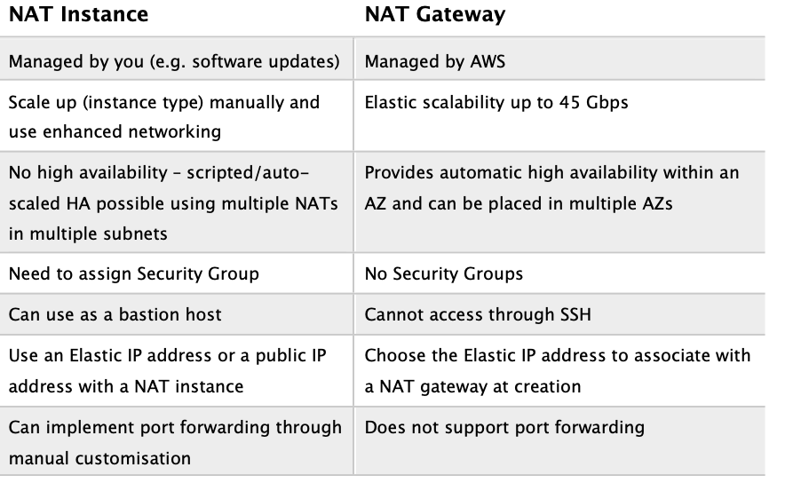

**References:**

<https://docs.aws.amazon.com/vpc/latest/userguide/vpc-nat-comparison.html>

#### **Question 117:**

A Solutions Architect needs to work programmatically with IAM. Which feature of IAM allows direct access to the IAM web service using HTTPS to call service actions and what is the method of authentication that must be used? (choose 2)

1. API Gateway
2. Access key ID and secret access key
3. IAM role
4. Query API
5. OpenID Connect

**Answer :** Query API

**Answer :** Access key ID and secret access key

**Explanation**

AWS recommend that you use the AWS SDKs to make programmatic API calls to IAM. However, you can also use the IAM Query API to make direct calls to the IAM web service. An access key ID and secret access key must be used for authentication when using the Query API.

**References:**

<https://docs.aws.amazon.com/IAM/latest/APIReference/iam-api.pdf>

#### **Question 118:**

Three Amazon VPCs are used by a company in the same region. The company has two AWS Direct Connect connections to two separate company offices and wishes to share these with all three VPCs. A Solutions Architect has created an AWS Direct Connect gateway. How can the required connectivity be configured?

1. Create a transit virtual interface between the Direct Connect gateway and each VPC
2. Create a VPC peering connection between the VPCs and route entries for the Direct Connect Gateway
3. Associate the Direct Connect gateway to a virtual private gateway in each VPC
4. Associate the Direct Connect gateway to a transit gateway

**Answer :** Associate the Direct Connect gateway to a transit gateway

**Explanation**

You can manage a single connection for multiple VPCs or VPNs that are in the same Region by associating a Direct Connect gateway to a transit gateway. The solution involves the following components:

- A transit gateway that has VPC attachments.

- A Direct Connect gateway.

- An association between the Direct Connect gateway and the transit gateway.

- A transit virtual interface that is attached to the Direct Connect gateway.

The following diagram depicts this configuration:

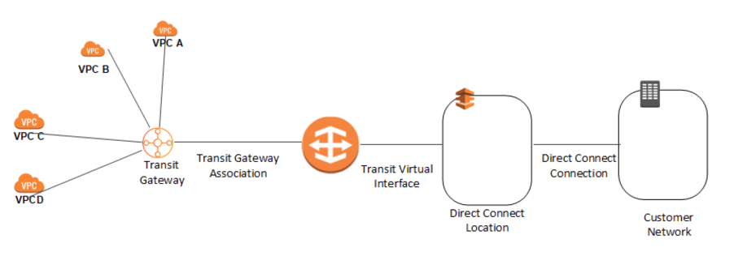

**References:**

<https://docs.aws.amazon.com/directconnect/latest/UserGuide/direct-connect-gateways-intro.html>

#### **Question 119:**

A Solutions Architect needs to connect from an office location to a Linux instance that is running in a public subnet in an Amazon VPC using the Internet. Which of the following items are required to enable this access? (choose 2)

1. A Public or Elastic IP address on the EC2 instance
2. An IPSec VPN
3. An Internet Gateway attached to the VPC and a route table attached to the public subnet pointing to it
4. A bastion host
5. A NAT Gateway

**Answer :** A Public or Elastic IP address on the EC2 instance

**Answer :** An Internet Gateway attached to the VPC and route table attached to the public subnet pointing to it

**Explanation**

A public subnet is a subnet that has an Internet Gateway attached and “Enable auto-assign public IPv4 address” enabled. Instances require a public IP or Elastic IP address. It is also necessary to have the subnet route table updated to point to the Internet Gateway and security groups and network ACLs must be configured to allow the SSH traffic on port 22.

**References:**

<https://docs.aws.amazon.com/AWSEC2/latest/UserGuide/AccessingInstances.html>

#### **Question 120:**

A Solutions Architect created a new subnet in an Amazon VPC and launched an Amazon EC2 instance into it. The Solutions Architect needs to directly access the EC2 instance from the Internet and cannot connect. Which steps should be undertaken to troubleshoot the issue? (choose 2)

1. Check that the instance has a public IP address
2. Check that there is a NAT Gateway configured for the subnet
3. Check that you can ping the instance from another subnet
4. Check that the route table associated with the subnet has an entry for an Internet Gateway
5. Check that Security Group has a rule for outbound traffic

**Answer :** Check that the instance has a public IP address

**Answer :** Check that the route table associated with the subnet has an entry for an Internet Gateway

**Explanation**

A public subnet is a subnet that's associated with a route table that has a route to an Internet gateway.

Public subnets are subnets that have:

- “Auto-assign public IPv4 address” set to “Yes”.

- The subnet route table has an attached Internet Gateway.

**References:**

<https://docs.aws.amazon.com/vpc/latest/userguide/VPC_Scenario2.html>

#### **Question 121:**

An Amazon VPC contains a mixture of Amazon EC2 instances in production and non-production environments. A Solutions Architect needs to devise a way to segregate access permissions to different sets of users for instances in different environments. How can this be achieved? (choose 2)

1. Attach an Identity Provider (IdP) and delegate access to the instances to the relevant groups
2. Create an IAM policy that grants access to any instances with the specific tag
3. Add a specific tag to the instances you want to grant the users or groups access to
4. Add an environment variable to the instances using user data
5. Create an IAM policy with a conditional statement that matches the environment variables

**Answer :**  Create an IAM policy that grants access to any instances with the specific tag and attach to the users and groups

**Answer :**  Add a specific tag to the instances you want to grant the users or groups access to

**Explanation**

You can use the condition checking in IAM policies to look for a specific tag. IAM checks that the tag attached to the principal making the request matches the specified key name and value.

**References:**

<https://aws.amazon.com/premiumsupport/knowledge-center/iam-ec2-resource-tags/>

<https://docs.aws.amazon.com/IAM/latest/UserGuide/reference_policies_condition-keys.html>

#### **Question 122:**

A large multinational retail company has a presence in AWS in multiple regions. The company has established a new office and needs to implement a high-bandwidth, low-latency connection to multiple VPCs in multiple regions within the same account. The VPCs each have unique CIDR ranges. What would be the optimum solution design using AWS technology? (choose 2)

1. Implement a Direct Connect connection to the closest AWS region
2. Configure AWS VPN CloudHub
3. Create a Direct Connect gateway, and create private VIFs to each region
4. Provision an MPLS network
5. Implement Direct Connect connections to each AWS region

**Answer :** Create a Direct Connect gateway, and create private VIFs to each region

**Answer :** Implement a Direct Connect connection to the closest AWS region

**Explanation**

The company should implement an AWS Direct Connect connection to the closest region. A Direct Connect gateway can then be used to create private virtual interfaces (VIFs) to each AWS region. Direct Connect gateway provides a grouping of Virtual Private Gateways (VGWs) and Private Virtual Interfaces (VIFs) that belong to the same AWS account and enables you to interface with VPCs in any AWS Region (except AWS China Region). You can share a private virtual interface to interface with more than one Virtual Private Cloud (VPC) reducing the number of BGP sessions required.

**References:**

<https://docs.aws.amazon.com/directconnect/latest/UserGuide/direct-connect-gateways.html>

#### **Question 123:**

An operations team would like to be notified if an RDS database exceeds certain metric thresholds. How can a Solutions Architect automate this process for the operations team?

1. Create a CloudWatch alarm and associate an SNS topic with it that sends an email notification
2. Create a CloudWatch alarm and associate an SQS with it that delivers a message to SES
3. Create a CloudTrail alarm and configure a notification event to send an SMS
4. Setup an RDS alarm and associate an SNS topic with it that sends an email

**Answer :** Create a CloudWatch alarm and associate an SNS topic with it that sends an email notification

**Explanation**

You can create a CloudWatch alarm that watches a single CloudWatch metric or the result of a math expression based on CloudWatch metrics. The alarm performs one or more actions based on the value of the metric or expression relative to a threshold over a number of time periods. The action can be an Amazon EC2 action, an Amazon EC2 Auto Scaling action, or a notification sent to an Amazon SNS topic. SNS can be configured to send an email notification

**References:**

<https://docs.aws.amazon.com/AmazonCloudWatch/latest/monitoring/AlarmThatSendsEmail.html>

#### **Question 124:**

An application is running on EC2 instances in a private subnet of an Amazon VPC. A Solutions Architect would like to connect the application to Amazon API Gateway. For security reasons, it is necessary to ensure that no traffic traverses the Internet and to ensure all traffic uses private IP addresses only. How can this be achieved?

1. Add the API gateway to the subnet the EC2 instances are located in
2. Create a private API using an interface VPC endpoint
3. Create a NAT gateway
4. Create a public VIF on a Direct Connect connection

**Answer :** Create a private API using an interface VPC endpoint

**Explanation**

An Interface endpoint uses AWS PrivateLink and is an elastic network interface (ENI) with a private IP address that serves as an entry point for traffic destined to a supported service. Using PrivateLink you can connect your VPC to supported AWS services, services hosted by other AWS accounts (VPC endpoint services), and supported AWS Marketplace partner services.

**References:**

<https://aws.amazon.com/blogs/compute/introducing-amazon-api-gateway-private-endpoints/>

#### **Question 125:**

A Solutions Architect must enable an application to download software updates from the internet. The application runs on a series of EC2 instances in an Auto Scaling group running in a private subnet. The solution must involve minimal ongoing systems management effort. How should the Solutions Architect proceed?

1. Attach Elastic IP addresses
2. Launch a NAT instance
3. Create a Virtual Private Gateway
4. Implement a NAT gateway

**Answer :** Implement a NAT gateway

**Explanation**

Both a NAT gateway or a NAT instance can be used for this use case. Both services enable internet access for instances in private subnets. However, the NAT instance runs on an EC2 instance you must launch, configure and manage and therefore involves more ongoing systems management effort.

**References:**

<https://docs.aws.amazon.com/vpc/latest/userguide/vpc-nat-gateway.html>

#### **Question 126:**

An application has been migrated from on-premises to an Amazon EC2 instance. The migration has failed to an unknown dependency that the application must communicate with an on-premises server using private IP addresses. Which action should a solutions architect take to quickly provision the necessary connectivity?

1. Setup an AWS Direct Connect connection
2. Create an AWS Transit Gateway
3. Create an Amazon CloudFront distribution
4. Configure a Virtual Private Gateway

**Answer :** Configure a Virtual Private Gateway

**Explanation**

A virtual private gateway is a logical, fully redundant distributed edge routing function that sits at the edge of your VPC. You must create a VPG in your VPC before you can establish an AWS Managed site-to-site VPN connection. The other end of the connection is the customer gateway which must be established on the customer side of the connection.

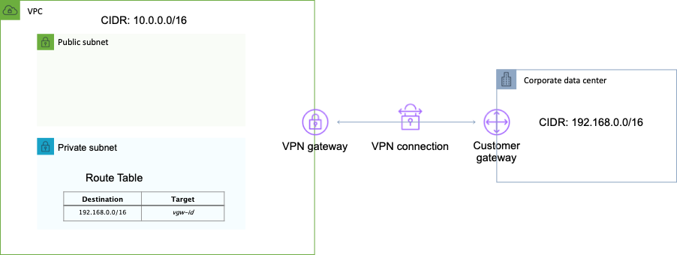

**References:**

<https://docs.aws.amazon.com/vpn/latest/s2svpn/VPC_VPN.html>

#### **Question 127:**

An application regularly uploads files from an Amazon EC2 instance to an Amazon S3 bucket. The files can be a couple of gigabytes in size and sometimes the uploads are slower than desired. What method can be used to increase throughput and reduce upload times?

1. Use Amazon S3 multipart upload
2. Turn off versioning on the destination bucket
3. Upload the files using the S3 Copy SDK or REST API
4. Randomize the object names when uploading

**Answer :** Use Amazon S3 multipart upload

**Explanation**

Multipart upload can be used to speed up uploads to S3. Multipart upload uploads objects in parts independently, in parallel and in any order. It is performed using the S3 Multipart upload API and is recommended for objects of 100MB or larger. It can be used for objects from 5MB up to 5TB and must be used for objects larger than 5GB.

**References:**

<https://docs.aws.amazon.com/AmazonS3/latest/dev/mpuoverview.html>

#### **Question 128:**

A company has several AWS accounts each with multiple Amazon VPCs. The company must establish routing between all private subnets. The architecture should be simple and allow transitive routing to occur. How should the network connectivity be configured?

1. Create a transitive VPC peering connection between each Amazon VPC and configure route tables
2. Create a hub-and-spoke topology with AWS App Mesh and use AWS Resource Access Manager to share route tables
3. Create an AWS Managed VPN between each Amazon VPC and configure route tables
4. Create an AWS Transit Gateway and share it with each account using AWS Resource Access Manager

**Answer :** Create an AWS Transit Gateway and share it with each account using AWS Resource Access Manager

**Explanation**

You can build a hub-and-spoke topology with AWS Transit Gateway that supports transitive routing. This simplifies the network topology and adds additional features over VPC peering. AWS Resource Access Manager can be used to share the connection with the other AWS accounts.

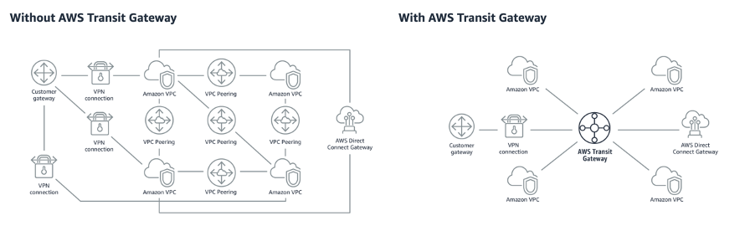

**References:**

<https://aws.amazon.com/blogs/aws/new-use-an-aws-transit-gateway-to-simplify-your-network-architecture/>

#### **Question 129:**

A company has over 2000 users and is planning to migrate data into the AWS Cloud. Some of the data is user’s home folders on an existing file share and the plan is to move this data to Amazon S3. Each user will have a folder in a shared bucket under the folder structure: bucket/home/%username%. What steps should a Solutions Architect take to ensure that each user can access their own home folder and no one else’s? (choose 2)

1. Attach an S3 ACL sub-resource that grants access based on the %username% variable
2. Create an IAM policy that applies folder-level permissions
3. Create an IAM policy that applies object-level S3 ACLs
4. Create an IAM group and attach the IAM policy
5. Create a bucket policy that applies access permissions based on username

**Answer :** Create an IAM policy that applies folder-level permissions

**Answer :** Create an IAM group and attach the IAM policy, add IAM users to the group

**Explanation**

The AWS blog URL below explains how to construct an IAM policy for a similar scenario. Please refer to the article for detailed instructions.

**References:**

<https://aws.amazon.com/blogs/security/writing-iam-policies-grant-access-to-user-specific-folders-in-an-amazon-s3-bucket/>

#### **Question 130:**

An application running a private subnet of an Amazon VPC must have outbound internet access for downloading updates. The Solutions Architect does not want the application exposed to inbound connection attempts. Which steps should be taken?

1. Attach an internet gateway to the private subnet and create a NAT gateway
2. Attach an internet gateway to the VPC but do not create a NAT gateway
3. Create a NAT gateway but do not create attach an internet gateway to the VPC
4. Create a NAT gateway and attach an internet gateway to the VPC

**Answer :**Create a NAT gateway and attach an internet gateway to the VPC

**Explanation**

To enable outbound connectivity for instances in private subnets a NAT gateway can be created. The NAT gateway is created in a public subnet and a route must be created in the private subnet pointing to the NAT gateway for internet-bound traffic. An internet gateway must be attached to the VPC to facilitate outbound connections.

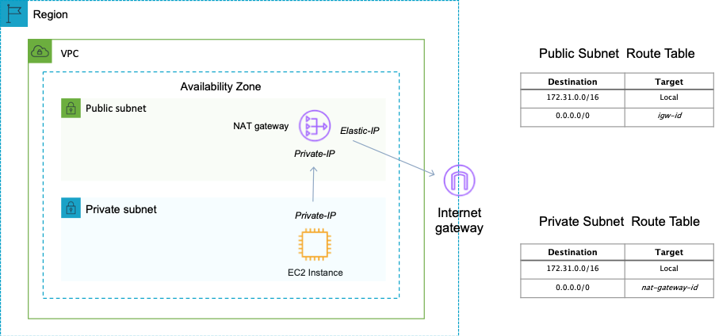

You cannot directly connect to an instance in a private subnet from the internet. You would need to use a bastion/jump host. Therefore, the application will not be exposed to inbound connection attempts.

**References:**

<https://docs.aws.amazon.com/vpc/latest/userguide/vpc-nat-gateway.html>

#### **Question 131:**

A new department will begin using AWS services an AWS account and a Solutions Architect needs to create an authentication and authorization strategy. Select the correct statements regarding IAM groups? (choose 2)

1. IAM groups can temporarily assume a role to take on permissions for a specific task
2. IAM groups can be used to assign permissions to users
3. IAM groups can be nested up to 4 levels
4. An IAM group is not an identity and cannot be identified as a principal in an IAM policy
5. IAM groups can be used to group EC2 instances

**Answer :** IAM groups can be used to assign permissions to users

**Answer :** An IAM group is not an identity and cannot be identified as a principal in an IAM policy

**Explanation**

An IAM group is a collection of IAM users. Groups let you specify permissions for multiple users, which can make it easier to manage the permissions for those users.

The following facts apply to IAM Groups:

- Groups are collections of users and have policies attached to them.

- A group is not an identity and cannot be identified as a principal in an IAM policy.

- Use groups to assign permissions to users.

- IAM groups cannot be used to group EC2 instances.

- Only users and services can assume a role to take on permissions (not groups).

**References:**

<https://docs.aws.amazon.com/IAM/latest/UserGuide/id_groups.html>

#### **Question 132:**

A Solutions Architect is creating a multi-tier application that includes loosely-coupled, distributed application components and needs to determine a method of sending notifications instantaneously. Using Amazon SNS which transport protocols are supported? (choose 2)

1. Email-JSON
2. Lambda
3. FTP
4. HTTPS
5. SWF

**Answer :** HTTPS

**Answer :** Email-JSON

**Explanation**

Note that the questions asks you which transport protocols are supported, NOT which subscribers – therefore AWS Lambda is not supported.

Amazon SNS supports notifications over multiple transport protocols:

- HTTP/HTTPS – subscribers specify a URL as part of the subscription registration.

- Email/Email-JSON – messages are sent to registered addresses as email (text-based or JSON-object).

- SQS – users can specify an SQS standard queue as the endpoint.

- SMS – messages are sent to registered phone numbers as SMS text messages.

**References:**

<https://aws.amazon.com/sns/faqs/>

#### **Question 133:**

A company runs an application on-premises that must consume a REST API running on Amazon API Gateway. The company has an AWS Direct Connect connection to their Amazon VPC. The solutions architect wants all API calls to use private addressing only and avoid the internet. How can this be achieved?

1. Use a transit virtual interface and an AWS VPN to create a secure tunnel to Amazon API Gateway
2. Use a private virtual interface and create a VPC Endpoint for Amazon API Gateway
3. Use a hosted virtual interface and create a VPC Endpoint for Amazon API Gateway
4. Use a public virtual interface and an AWS VPN to create a secure tunnel to Amazon API Gateway

**Answer :** Use a private virtual interface and create a VPC Endpoint for Amazon API Gateway

**Explanation**

The requirements are to avoid the internet and use private IP addresses only. The best solution is to use a private virtual interface across the Direct Connect connection to connect to the VPC using private IP addresses. A VPC endpoint for Amazon API Gateway can be created and this will provide access to API Gateway using private IP addresses and avoids the internet completely.

**References:**

<https://docs.aws.amazon.com/directconnect/latest/UserGuide/WorkingWithVirtualInterfaces.html>

<https://docs.aws.amazon.com/vpc/latest/userguide/vpc-endpoints.html>

#### **Question 134:**

An application runs on EC2 instances in a private subnet behind an Application Load Balancer in a public subnet. The application is highly available and distributed across multiple AZs. The EC2 instances must make API calls to an internet-based service. How can the Solutions Architect enable highly available internet connectivity?

1. Create a NAT gateway in the public subnet of each AZ. Update the route tables for each private subnet to direct internet-bound traffic to the NAT gateway
2. Configure an internet gateway. Add a route to the gateway to each private subnet route table
3. Create a NAT instance in the private subnet of each AZ. Update the route tables for each private subnet to direct internet-bound traffic to the NAT instance
4. Create a NAT gateway and attach it to the VPC. Add a route to the gateway to each private subnet route table

**Answer :** Create a NAT gateway in the public subnet of each AZ. Update the route tables for each private subnet to direct internet-bound traffic to the NAT gateway

**Explanation**

The only solution presented that actually works is to create a NAT gateway in the public subnet of each AZ. They must be created in the public subnet as they gain public IP addresses and use an internet gateway for internet access.

The route tables in the private subnets must then be configured with a route to the NAT gateway and then the EC2 instances will be able to access the internet (subject to security group configuration).

**References:**

<https://docs.aws.amazon.com/vpc/latest/userguide/vpc-nat-gateway.html>

#### **Question 135:**

A customer has requested some advice on how to implement security measures in their Amazon VPC. The client has recently been the victim of some hacking attempts. The client wants to implement measures to mitigate further threats. The client has explained that the attacks always come from the same small block of IP addresses. What would be a quick and easy measure to help prevent further attacks?

1. Use a Security Group rule that denies connections from the block of IP addresses
2. Use a Network ACL rule that denies connections from the block of IP addresses
3. Use CloudFront’s DDoS prevention features
4. Create a Bastion Host restrict all connections to the Bastion Host only

**Answer :** Use a Network ACL rule that denies connections from the block of IP addresses

**Explanation**

With NACLs you can have permit and deny rules. Network ACLs contain a numbered list of rules that are evaluated in order from the lowest number until the explicit deny. Network ACLs have separate inbound and outbound rules and each rule can allow or deny traffic.

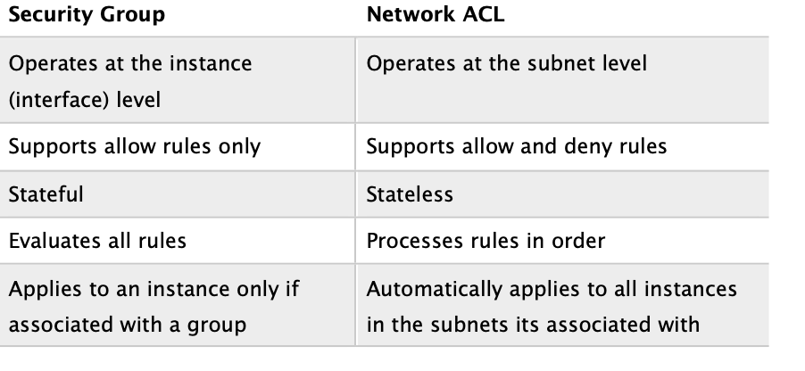

**References:**

<https://docs.aws.amazon.com/vpc/latest/userguide/vpc-network-acls.html>

#### **Question 136:**

An Amazon Elastic File System (EFS) has been created to store data that will be accessed by a large number of Amazon EC2 instances. The data is sensitive and a Solutions Architect is creating a design for security measures to protect the data. It is required that network traffic is restricted correctly based on firewall rules and access from hosts is restricted by user or group. How can this be achieved with Amazon EFS? (choose 2)

1. Use AWS Web Application Firewall (WAF) to protect EFS
2. Use IAM groups to control access by user or group
3. Use EFS Security Groups to control network traffic
4. Use Network ACLs to control the traffic
5. Use POSIX permissions to control access from hosts by user or group

**Answer :** Use POSIX permissions to control access from hosts by user or group

**Answer :** Use EFS Security Groups to control network traffic

**Explanation**

You can control who can administer your file system using IAM. You can control access to files and directories with POSIX-compliant user and group-level permissions. POSIX permissions allows you to restrict access from hosts by user and group. EFS Security Groups act as a firewall, and the rules you add define the traffic flow.

**References:**

<https://aws.amazon.com/efs/features/>

#### **Question 137:**

A Solutions Architect has created a new Network ACL in an Amazon VPC. No rules have been created. Which of the statements below are correct regarding the default state of the Network ACL? (choose 2)

1. There is a default inbound rule allowing traffic from the VPC CIDR block
2. There is a default outbound rule allowing traffic to the Internet Gateway
3. There is a default outbound rule allowing all traffic
4. There is a default outbound rule denying all traffic
5. There is a default inbound rule denying all traffic

**Answer :** There is a default inbound rule denying all traffic

**Answer :** There is a default outbound rule denying all traffic

**Explanation**

A VPC automatically comes with a default network ACL which allows all inbound/outbound traffic. A custom NACL denies all traffic both inbound and outbound by default.

Network ACL’s function at the subnet level and you can have permit and deny rules. Network ACLs have separate inbound and outbound rules and each rule can allow or deny traffic.

Network ACLs are stateless so responses are subject to the rules for the direction of traffic. NACLs only apply to traffic that is ingress or egress to the subnet not to traffic within the subnet.

**References:**

<https://docs.aws.amazon.com/vpc/latest/userguide/vpc-network-acls.html>

#### **Question 138:**

A Solutions Architect needs to run a PowerShell script on a fleet of Amazon EC2 instances running Microsoft Windows. The instances have already been launched in an Amazon VPC. What tool can be run from the AWS Management Console that to execute the script on all target EC2 instances?

1. AWS Config
2. AWS CodeDeploy
3. Run Command
4. AWS OpsWorks

**Answer :** Run Command

**Explanation**

Run Command is designed to support a wide range of enterprise scenarios including installing software, running ad hoc scripts or Microsoft PowerShell commands, configuring Windows Update settings, and more.

Run Command can be used to implement configuration changes across Windows instances on a consistent yet ad hoc basis and is accessible from the AWS Management Console, the AWS Command Line Interface (CLI), the AWS Tools for Windows PowerShell, and the AWS SDKs.

**References:**

<https://aws.amazon.com/blogs/aws/new-ec2-run-command-remote-instance-management-at-scale/>

#### **Question 139:**

A company has multiple Amazon VPCs that are peered with each other. The company would like to use a single Elastic Load Balancer (ELB) to route traffic to multiple EC2 instances in peered VPCs within the same region. How can this be achieved?

1. This is possible using the Classic Load Balancer (CLB) if using Instance IDs
2. This is not possible, the instances that an ELB routes traffic to must be in the same VPC
3. This is not possible with ELB, you would need to use Route 53
4. This is possible using the Network Load Balancer (NLB) and Application Load Balancer (ALB) if using IP addresses as targets

**Answer :** This is possible using the Network Load Balancer (NLB) and Application Load Balancer (ALB) if using IP addresses as targets

**Explanation**

With ALB and NLB IP addresses can be used to register:

- Instances in a peered VPC.

- AWS resources that are addressable by IP address and port.

- On-premises resources linked to AWS through Direct Connect or a VPN connection.

**References:**

<https://aws.amazon.com/blogs/aws/new-application-load-balancing-via-ip-address-to-aws-on-premises-resources/>

#### **Question 140:**

A company requires an Elastic Load Balancer (ELB) for an application they are planning to deploy on AWS. The application requires extremely high throughput and extremely low latencies. The connections will be made using the TCP protocol and the ELB must support load balancing to multiple ports on an instance. Which ELB would should the company use?

1. Application Load Balancer
2. Classic Load Balancer
3. Network Load Balancer
4. Route 53

**Answer :** Network Load Balancer

**Explanation**

The Network Load Balancer operates at the connection level (Layer 4), routing connections to targets – Amazon EC2 instances, containers and IP addresses based on IP protocol data. It is architected to handle millions of requests/sec, sudden volatile traffic patterns and provides extremely low latencies.

The NLB provides high throughput and extremely low latencies and is designed to handle traffic as it grows and can load balance millions of requests/second. NLB also supports load balancing to multiple ports on an instance.

**References:**

<https://docs.aws.amazon.com/elasticloadbalancing/latest/network/introduction.html>

#### **Question 141:**

An application uses an Amazon RDS database and Amazon EC2 instances in a web tier. The web tier instances must not be directly accessible from the internet to improve security. How can a Solutions Architect meet these requirements?

1. Launch the EC2 instances in a public subnet and use AWS WAF to protect the instances from internet-based attacks
2. Launch the EC2 instances in a public subnet and create an Application Load Balancer in a public subnet
3. Launch the EC2 instances in a private subnet and create an Application Load Balancer in a public subnet
4. Launch the EC2 instances in a private subnet with a NAT gateway and update the route table

**Answer :** Launch the EC2 instances in a private subnet and create an Application Load Balancer in a public subnet

**Explanation**

To prevent direct connectivity to the EC2 instances from the internet you can deploy your EC2 instances in a private subnet and have the ELB in a public subnet. To configure this you must enable a public subnet in the ELB that is in the same AZ as the private subnet.

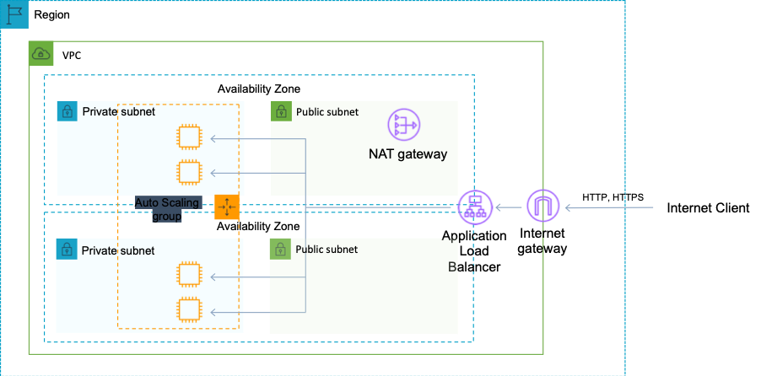

**References:**

<https://aws.amazon.com/premiumsupport/knowledge-center/public-load-balancer-private-ec2/>

#### **Question 142:**

A Solutions Architect created a new IAM user account for a temporary employee who recently joined the company. The user does not have permissions to perform any actions, which statement is true about newly created users in IAM?

1. They are created with user privileges
2. They are created with no permissions
3. They are created with full permissions
4. They are created with limited permissions

**Answer :**  They are created with no permissions

**Explanation**

Every IAM user starts with no permissions.. In other words, by default, users can do nothing, not even view their own access keys. To give a user permission to do something, you can add the permission to the user (that is, attach a policy to the user). Or you can add the user to a group that has the intended permission.

**References:**

<https://docs.aws.amazon.com/IAM/latest/UserGuide/access_controlling.html>

#### **Question 143:**

Three AWS accounts are owned by the same company but in different regions. Account Z has two AWS Direct Connect connections to two separate company offices. Accounts A and B require the ability to route across account Z’s Direct Connect connections to each company office. A Solutions Architect has created an AWS Direct Connect gateway in account Z. How can the required connectivity be configured?

1. Create a VPC Endpoint to the Direct Connect gateway in account A and B
2. Create a PrivateLink connection in Account Z and ENIs in accounts A and B
3. Associate the Direct Connect gateway to a transit gateway in each region
4. Associate the Direct Connect gateway to a virtual private gateway in account A and B

**Answer :** Associate the Direct Connect gateway to a virtual private gateway in account A and B

**Explanation**

You can associate an AWS Direct Connect gateway with either of the following gateways:

- A transit gateway when you have multiple VPCs in the same Region.

- A virtual private gateway.

In this case account Z owns the Direct Connect gateway so a VPG in accounts A and B must be associated with it to enable this configuration to work. After Account Z accepts the proposals, Account A and Account B can route traffic from their virtual private gateway to the Direct Connect gateway.

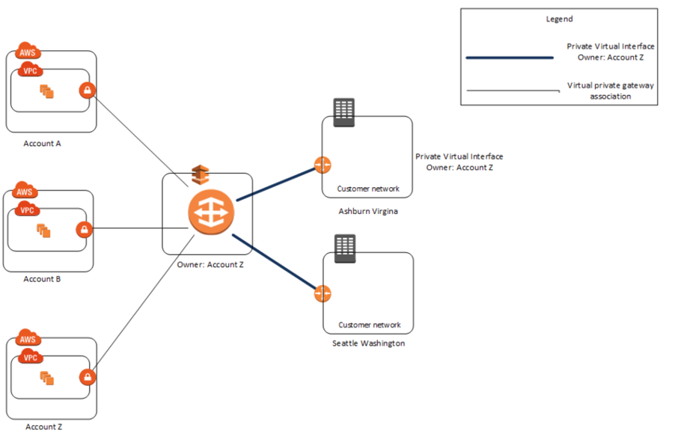**References:**

<https://docs.aws.amazon.com/directconnect/latest/UserGuide/direct-connect-gateways-intro.html>

#### **Question 144:**

A company runs a web-based application that uses Amazon EC2 instances for the web front-end and Amazon RDS for the database back-end. The web application writes transaction log files to an Amazon S3 bucket and the quantity of files is becoming quite large. It is acceptable to retain the most recent 60 days of log files and permanently delete the rest. Which action can a Solutions Architect take to enable this to happen automatically?

1. Use an S3 lifecycle policy with object expiration configured to automatically remove objects that are more than 60 days old
2. Use an S3 lifecycle policy to move the log files that are more than 60 days old to the GLACIER storage class
3. Use an S3 bucket policy that deletes objects that are more than 60 days old
4. Write a Ruby script that checks the age of objects and deletes any that are more than 60 days old

**Answer :** Use an S3 lifecycle policy with object expiration configured to automatically remove objects that are more than 60 days old

**Explanation**

To manage your objects so that they are stored cost effectively throughout their lifecycle, configure their Amazon S3 Lifecycle. An S3 Lifecycle configuration is a set of rules that define actions that Amazon S3 applies to a group of objects. There are two types of actions:

- Transition actions—Define when objects transition to another [storage class](https://docs.aws.amazon.com/AmazonS3/latest/dev/storage-class-intro.html). For example, you might choose to transition objects to the S3 Standard-IA storage class 30 days after you created them, or archive objects to the S3 Glacier storage class one year after creating them.

- Expiration actions—Define when objects expire. Amazon S3 deletes expired objects on your behalf.

**References:**

<https://docs.aws.amazon.com/AmazonS3/latest/dev/object-lifecycle-mgmt.html>

#### **Question 145:**

A customer is deploying services in a hybrid cloud model. The customer has mandated that data is transferred directly between cloud data centers, bypassing ISPs. Which AWS service can be used to enable hybrid cloud connectivity?

1. Amazon VPC
2. IPSec VPN
3. Amazon Route 53
4. AWS Direct Connect

**Answer :** AWS Direct Connect

**Explanation**

With AWS Direct Connect, you can connect to all your AWS resources in an AWS Region, transfer your business-critical data directly from your datacenter, office, or colocation environment into and from AWS, bypassing your Internet service provider and removing network congestion.

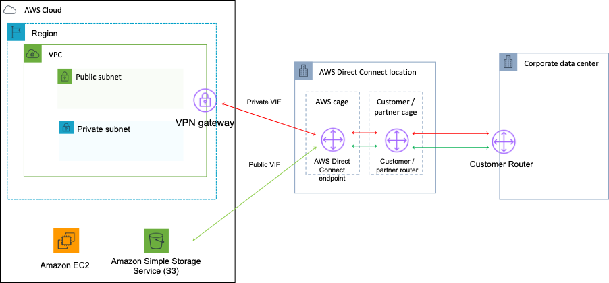

**References:**

<https://aws.amazon.com/directconnect/>

#### **Question 146:**

A web application runs on a series of Amazon EC2 instances behind an Application Load Balancer (ALB). A Solutions Architect is updating the configuration with a health check and needs to select the protocol to use. What options are available? (choose 2)

1. HTTPS
2. ICMP
3. TCP
4. SSL
5. HTTP

**Answer :** HTTP

**Answer :** HTTPS

**Explanation**

An Application Load Balancer periodically sends requests to its registered targets to test their status. These tests are called health checks. Each load balancer node routes requests only to the healthy targets in the enabled Availability Zones for the load balancer. Each load balancer node checks the health of each target, using the health check settings for the target groups with which the target is registered. After your target is registered, it must pass one health check to be considered healthy. After each health check is completed, the load balancer node closes the connection that was established for the health check. If a target group contains only unhealthy registered targets, the load balancer nodes route requests across its unhealthy targets. For an ALB the possible protocols are HTTP and HTTPS. The default is the HTTP protocol.

**References:**

<https://docs.aws.amazon.com/elasticloadbalancing/latest/network/target-group-health-checks.html>

#### **Question 147:**

An on-premise data center will be connected to an Amazon VPC by a hardware VPN that has public and VPN-only subnets. The security team has requested that traffic hitting public subnets on AWS that’s destined to on-premise applications must be directed over the VPN to the corporate firewall. How can this be achieved?

1. In the public subnet route table, add a route for your remote network and specify the customer gateway as the target
2. In the public subnet route table, add a route for your remote network and specify the virtual private gateway as the target
3. Configure a NAT Gateway and configure all traffic to be directed via the virtual private gateway
4. In the VPN-only subnet route table, add a route that directs all Internet traffic to the virtual private gateway

**Answer :** In the public subnet route table, add a route for your remote network and specify the virtual private gateway as the target

**Explanation**

Route tables determine where network traffic is directed. In your route table, you must add a route for your remote network and specify the virtual private gateway as the target. This enables traffic from your VPC that’s destined for your remote network to route via the virtual private gateway and over one of the VPN tunnels. You can enable route propagation for your route table to automatically propagate your network routes to the table for you.

**References:**

<https://docs.aws.amazon.com/vpc/latest/userguide/VPC_VPN.html>

<https://docs.aws.amazon.com/vpc/latest/userguide/VPC_Scenario3.html>

#### **Question 148:**

A Solutions Architect needs to capture information about the traffic that reaches an Amazon Elastic Load Balancer. The information should include the source, destination, and protocol. What is the most secure and reliable method for gathering this data?

1. Use Amazon CloudWatch Logs to review detailed logging information
2. Create a VPC flow log for each network interface associated with the ELB
3. Enable Amazon CloudTrail logging and configure packet capturing
4. Create a VPC flow log for the subnets in which the ELB is running

**Answer :** Create a VPC flow log for each network interface associated with the ELB

**Explanation**

You can use VPC Flow Logs to capture detailed information about the traffic going to and from your Elastic Load Balancer. Create a flow log for each network interface for your load balancer. There is one network interface per load balancer subnet.

**References:**

<https://docs.aws.amazon.com/vpc/latest/userguide/flow-logs.html>

<https://docs.aws.amazon.com/elasticloadbalancing/latest/network/load-balancer-monitoring.html>

#### **Question 149:**

A company needs to capture detailed information about all HTTP requests that are processed by their Internet facing Application Load Balancer (ALB). The company requires information on the requester, IP address, and request type for analyzing traffic patterns to better understand their customer base. Which actions should a Solutions Architect recommend?

1. Use CloudTrail to capture all API calls made to the ALB
2. Configure metrics in CloudWatch for the ALB
3. Enable Access Logs and store the data on S3
4. Enable EC2 detailed monitoring

**Answer :** Enable Access Logs and store the data on S3

**Explanation**

You can enable access logs on the ALB and this will provide the information required including requester, IP, and request type. Access logs are not enabled by default. You can optionally store and retain the log files on S3.

**References:**

<https://docs.aws.amazon.com/elasticloadbalancing/latest/application/load-balancer-access-logs.html>

#### **Question 150:**

A company's web application is using multiple Amazon EC2 Linux instances and storing data on Amazon EBS volumes. The company is looking for a solution to increase the resiliency of the application in case of a failure. What should a solutions architect do to meet these requirements?

1. Create an Application Load Balancer with Auto Scaling groups across multiple Availability Zones. Mount an instance store on each EC2 instance
2. Create an Application Load Balancer with Auto Scaling groups across multiple Availability Zones. Store data on Amazon EFS and mount a target on each instance
3. Create an Application Load Balancer with Auto Scaling groups across multiple Availability Zones. Store data using Amazon S3 One Zone-Infrequent Access (S3 One Zone-A)
4. Launch the application on EC2 instances in each Availability Zone. Attach EBS volumes to each EC2 instance

**Answer :** Create an Application Load Balancer with Auto Scaling groups across multiple Availability Zones. Store data on Amazon EFS and mount a target on each instance

**Explanation**

To increase the resiliency of the application the solutions architect can use Auto Scaling groups to launch and terminate instances across multiple availability zones based on demand. An application load balancer (ALB) can be used to direct traffic to the web application running on the EC2 instances. Lastly, the Amazon Elastic File System (EFS) can assist with increasing the resilience of the application by providing a shared file system that can be mounted by multiple EC2 instances from multiple availability zones.

**References:**

<https://docs.aws.amazon.com/efs/>

#### **Question 151:**

A company offers an online product brochure that is delivered from a static website running on Amazon S3. The company’s customers are mainly in the United States, Canada, and Europe. The company is looking to cost-effectively reduce the latency for users in these regions. What is the most cost-effective solution to these requirements?

1. Create an Amazon CloudFront distribution that uses origins in U.S, Canada and Europe.
2. Create an Amazon CloudFront distribution and set the price class to use only U.S, Canada and Europe.
3. Create an Amazon CloudFront distribution and use Lambda@Edge to run the website's data processing closer to the users.
4. Create an Amazon CloudFront distribution and set the price class to use all Edge Locations for best performance.

**Answer :** Create an Amazon CloudFront distribution and set the price class to use only U.S, Canada and Europe.

**Explanation**

With Amazon CloudFront you can set the price class to determine where in the world the content will be cached. One of the price classes is “U.S, Canada and Europe” and this is where the company’s users are located. Choosing this price class will result in lower costs and better performance for the company’s users.

**References:**

<https://docs.aws.amazon.com/AmazonCloudFront/latest/DeveloperGuide/PriceClass.html>

#### **Question 152:**

A company runs an application on six web application servers in an Amazon EC2 Auto Scaling group in a single Availability Zone. The application is fronted by an Application Load Balancer (ALB). A Solutions Architect needs to modify the infrastructure to be highly available without making any modifications to the application. Which architecture should the Solutions Architect choose to enable high availability?

1. Create an Auto Scaling group to launch three instances across each of two Regions.
2. Create a launch template that can be used to quickly create more instances in another Region.
3. Modify the Auto Scaling group to use two instances across each of three Availability Zones.
4. Create an Amazon CloudFront distribution with a custom origin across multiple Regions.

**Answer :** Modify the Auto Scaling group to use two instances across each of three Availability Zones

**Explanation**

The only thing that needs to be changed in this scenario to enable HA is to split the instances across multiple Availability Zones. The architecture already uses Auto Scaling and Elastic Load Balancing so there is plenty of resilience to failure. Once the instances are running across multiple AZs there will be AZ-level fault tolerance as well.

**References:**

<https://docs.aws.amazon.com/autoscaling/ec2/userguide/as-add-availability-zone.html>

#### **Question 153:**

A Solutions Architect has deployed an application on several Amazon EC2 instances across three private subnets. The application must be made accessible to internet-based clients with the least amount of administrative effort. How can the Solutions Architect make the application available on the internet?

1. Create an Amazon Machine Image (AMI) of the instances in the private subnet and launch new instances from the AMI in public subnets. Create an Application Load Balancer and add the public instances to the ALB.
2. Create an Application Load Balancer and associate three public subnets from the same Availability Zones as the private instances. Add the private instances to the ALB.
3. Create an Application Load Balancer and associate three private subnets from the same Availability Zones as the private instances. Add the private instances to the ALB.
4. Create a NAT gateway in a public subnet. Add a route to the NAT gateway to the route tables of the three private subnets.

**Answer :** Create an Application Load Balancer and associate three public subnets from the same Availability Zones as the private instances. Add the private instances to the ALB

**Explanation**

To make the application instances accessible on the internet the Solutions Architect needs to place them behind an internet-facing Elastic Load Balancer. The way you add instances in private subnets to a public facing ELB is to add public subnets in the same AZs as the private subnets to the ELB. You can then add the instances and to the ELB and they will become targets for load balancing.

An example of this architecture is shown below:

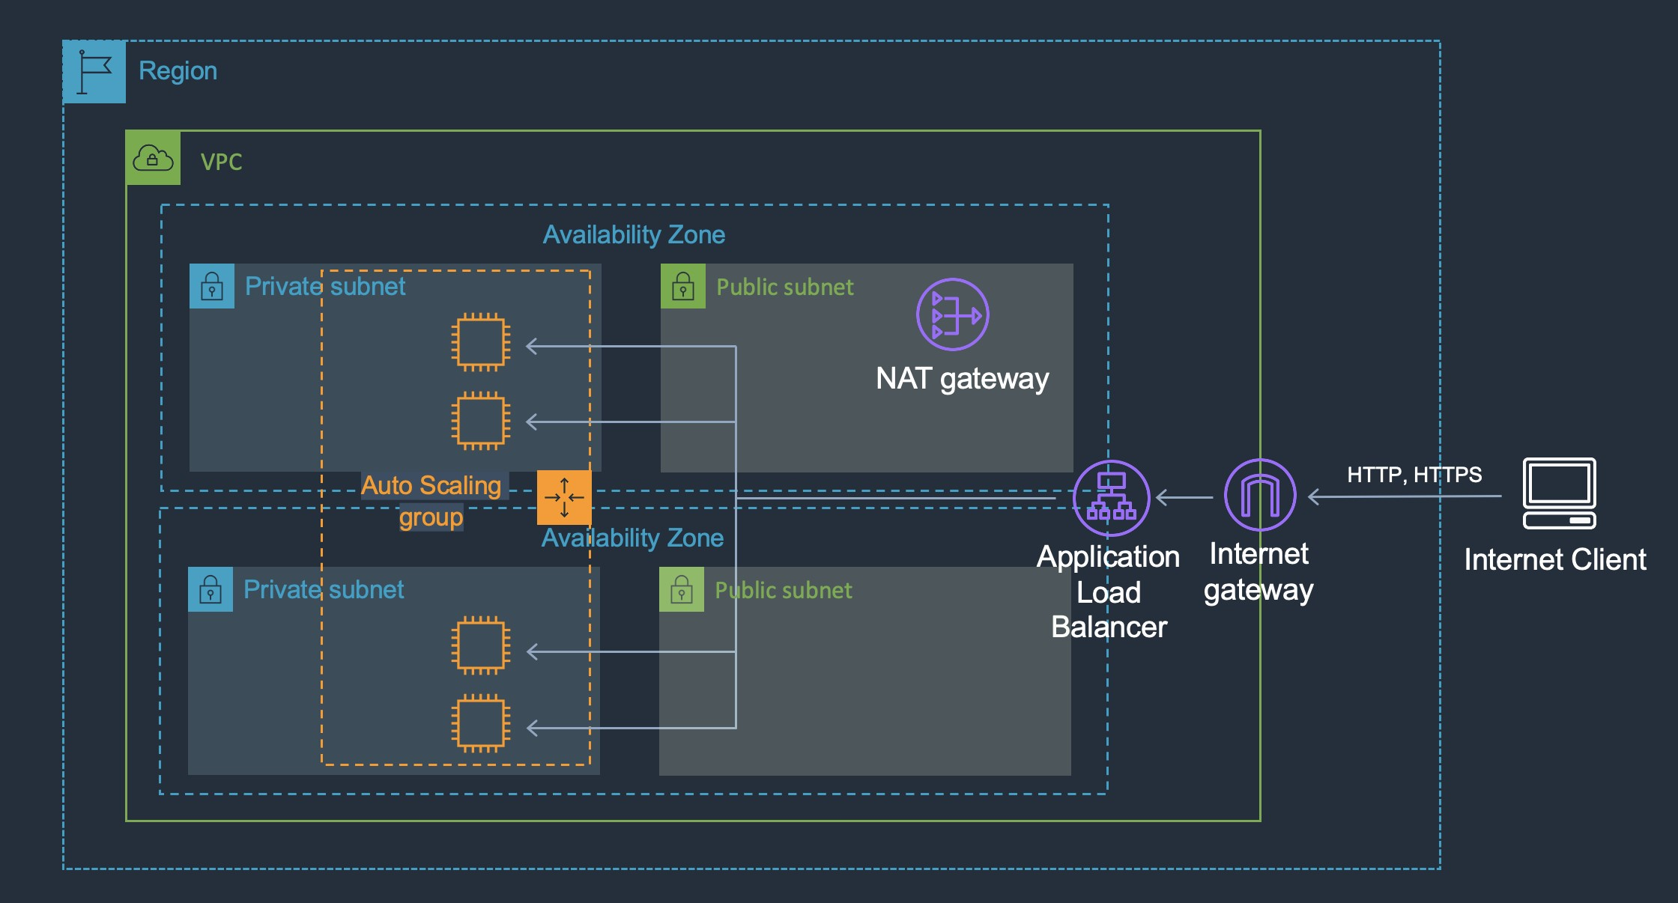

**References:**

[https://aws.amazon.com/premiumsupport/knowledge-center/public-load-balancer-private-ec2](https://aws.amazon.com/premiumsupport/knowledge-center/public-load-balancer-private-ec2/)

#### **Question 154:**

A company hosts an application on Amazon EC2 instances behind Application Load Balancers in several AWS Regions. Distribution rights for the content require that users in different geographies must be served content from specific regions. Which configuration meets these requirements?

1. Create Amazon Route 53 records with a geolocation routing policy.
2. Create Amazon Route 53 records with a geoproximity routing policy.
3. Configure Amazon CloudFront with multiple origins and AWS WAF.
4. Configure Application Load Balancers with multi-Region routing.

**Answer :** Create Amazon Route 53 records with a geolocation routing policy

**Explanation**

To protect the distribution rights of the content and ensure that users are directed to the appropriate AWS Region based on the location of the user, the geolocation routing policy can be used with Amazon Route 53. Geolocation routing lets you choose the resources that serve your traffic based on the geographic location of your users, meaning the location that DNS queries originate from. When you use geolocation routing, you can localize your content and present some or all of your website in the language of your users. You can also use geolocation routing to restrict distribution of content to only the locations in which you have distribution rights.

**References:**

<https://docs.aws.amazon.com/Route53/latest/DeveloperGuide/routing-policy.html>

#### **Question 155:**

A company delivers content to subscribers distributed globally from an application running on AWS. The application uses a fleet of Amazon EC2 instance in a private subnet behind an Application Load Balancer (ALB). Due to an update in copyright restrictions, it is necessary to block access for specific countries. What is the EASIEST method to meet this requirement?

1. Use Amazon CloudFront to serve the application and deny access to blocked countries
2. Modify the ALB security group to deny incoming traffic from blocked countries
3. Use a network ACL to block the IP address ranges associated with the specific countries
4. Modify the security group for EC2 instances to deny incoming traffic from blocked countries

**Answer :** Use Amazon CloudFront to serve the application and deny access to blocked countries

**Explanation**

When a user requests your content, CloudFront typically serves the requested content regardless of where the user is located. If you need to prevent users in specific countries from accessing your content, you can use the CloudFront geo restriction feature to do one of the following: Allow your users to access your content only if they're in one of the countries on a whitelist of approved countries. Prevent your users from accessing your content if they're in one of the countries on a blacklist of banned countries. For example, if a request comes from a country where, for copyright reasons, you are not authorized to distribute your content, you can use CloudFront geo restriction to block the request. This is the easiest and most effective way to implement a geographic restriction for the delivery of content.

**References:**

<https://docs.aws.amazon.com/AmazonCloudFront/latest/DeveloperGuide/georestrictions.html>

#### **Question 156:**

A company has deployed a new website on Amazon EC2 instances behind an Application Load Balancer (ALB). Amazon Route 53 is used for the DNS service. The company has asked a Solutions Architect to create a backup website with support contact details that users will be directed to automatically if the primary website is down. How should the Solutions Architect deploy this solution cost-effectively?

1. Deploy the backup website on EC2 and ALB in another Region and use Route 53 health checks for failover routing.
2. Configure a static website using Amazon S3 and create a Route 53 failover routing policy.
3. Configure a static website using Amazon S3 and create a Route 53 weighted routing policy.
4. Create the backup website on EC2 and ALB in another Region and create an AWS Global Accelerator endpoint.

**Answer :** Configure a static website using Amazon S3 and create a Route 53 failover routing policy

**Explanation**

The most cost-effective solution is to create a static website using an Amazon S3 bucket and then use a failover routing policy in Amazon Route 53. With a failover routing policy users will be directed to the main website as long as it is responding to health checks successfully. If the main website fails to respond to health checks (its down), Route 53 will begin to direct users to the backup website running on the Amazon S3 bucket. It’s important to set the TTL on the Route 53 records appropriately to ensure that users resolve the failover address within a short time.

**References:**

<https://docs.aws.amazon.com/AmazonS3/latest/userguide/WebsiteHosting.html>

<https://docs.aws.amazon.com/Route53/latest/DeveloperGuide/dns-failover-configuring.html>

#### **Question 157:**

A solutions architect is designing the infrastructure to run an application on Amazon EC2 instances. The application requires high availability and must dynamically scale based on demand to be cost efficient. What should the solutions architect do to meet these requirements?

1. Configure an Application Load Balancer in front of an Auto Scaling group to deploy instances to multiple Availability Zones
2. Configure an Amazon API Gateway API in front of an Auto Scaling group to deploy instances to multiple Availability Zones
3. Configure an Application Load Balancer in front of an Auto Scaling group to deploy instances to multiple Regions
4. Configure an Amazon CloudFront distribution in front of an Auto Scaling group to deploy instances to multiple Regions

**Answer :** Configure an Application Load Balancer in front of an Auto Scaling group to deploy instances to multiple Availability Zones

**Explanation**

The Amazon EC2-based application must be highly available and elastically scalable. Auto Scaling can provide the elasticity by dynamically launching and terminating instances based on demand. This can take place across availability zones for high availability. Incoming connections can be distributed to the instances by using an Application Load Balancer (ALB).

**References:**

<https://docs.aws.amazon.com/autoscaling/ec2/userguide/what-is-amazon-ec2-auto-scaling.html>

<https://aws.amazon.com/elasticloadbalancing/>

#### **Question 158:**

Storage capacity has become an issue for a company that runs application servers on-premises. The servers are connected to a combination of block storage and NFS storage solutions. The company requires a solution that supports local caching without re-architecting its existing applications. Which combination of changes can the company make to meet these requirements? (Select TWO.)

1. Use Amazon Elastic File System (EFS) volumes to replace the block storage.
2. Use the mount command on servers to mount Amazon S3 buckets using NFS.
3. Use an AWS Storage Gateway volume gateway to replace the block storage.
4. Use an AWS Storage Gateway file gateway to replace the NFS storage.
5. Use AWS Direct Connect and mount an Amazon FSx for Windows File Server using iSCSI.

**Answer :** Use an AWS Storage Gateway file gateway to replace the NFS storage

**Answer :** Use an AWS Storage Gateway volume gateway to replace the block storage

**Explanation**

In this scenario the company should use cloud storage to replace the existing storage solutions that are running out of capacity. The on-premises servers mount the existing storage using block protocols (iSCSI) and file protocols (NFS). As there is a requirement to avoid re-architecting existing applications these protocols must be used in the revised solution. The AWS Storage Gateway volume gateway should be used to replace the block-based storage systems as it is mounted over iSCSI and the file gateway should be used to replace the NFS file systems as it uses NFS.

**References:**

<https://docs.aws.amazon.com/storagegateway/>

#### **Question 159:**

An organization want to share regular updates about their charitable work using static webpages. The pages are expected to generate a large amount of views from around the world. The files are stored in an Amazon S3 bucket. A solutions architect has been asked to design an efficient and effective solution. Which action should the solutions architect take to accomplish this?

1. Use cross-Region replication to all Regions
2. Use Amazon CloudFront with the S3 bucket as its origin
3. Use the geoproximity feature of Amazon Route 53
4. Generate presigned URLs for the files

**Answer :** Use Amazon CloudFront with the S3 bucket as its origin

**Explanation**

Amazon CloudFront can be used to cache the files in edge locations around the world and this will improve the performance of the webpages. To serve a static website hosted on Amazon S3, you can deploy a CloudFront distribution using one of these configurations: Using a REST API endpoint as the origin with access restricted by an [origin access identity (OAI)](https://docs.aws.amazon.com/AmazonCloudFront/latest/DeveloperGuide/private-content-restricting-access-to-s3.html)

Using a website endpoint as the origin with anonymous (public) access allowed

Using a website endpoint as the origin with access restricted by a Referer header

**References:**

<https://aws.amazon.com/premiumsupport/knowledge-center/cloudfront-serve-static-website/>

#### **Question 160:**

A developer created an application that uses Amazon EC2 and an Amazon RDS MySQL database instance. The developer stored the database user name and password in a configuration file on the root EBS volume of the EC2 application instance. A Solutions Architect has been asked to design a more secure solution. What should the Solutions Architect do to achieve this requirement?

1. Attach an additional volume to the EC2 instance with encryption enabled. Move the configuration file to the encrypted volume.
2. Install an Amazon-trusted root certificate on the application instance and use SSL/TLS encrypted connections to the database.
3. Move the configuration file to an Amazon S3 bucket. Create an IAM role with permission to the bucket and attach it to the EC2 instance.
4. Create an IAM role with permission to access the database. Attach this IAM role to the EC2 instance.

**Answer :** Create an IAM role with permission to access the database. Attach this IAM role to the EC2 instance

**Explanation**

The key problem here is having plain text credentials stored in a file. Even if you encrypt the volume there is still as security risk as the credentials are loaded by the application and passed to RDS. The best way to secure this solution is to get rid of the credentials completely by using an IAM role instead. The IAM role can be assigned permissions to the database instance and can be attached to the EC2 instance. The instance will then obtain temporary security credentials from AWS STS which is much more secure.

**References:**

<https://docs.aws.amazon.com/AWSEC2/latest/UserGuide/iam-roles-for-amazon-ec2.html>

#### **Question 161:**

An AWS Organization has an OU with multiple member accounts in it. The company needs to restrict the ability to launch only specific Amazon EC2 instance types. How can this policy be applied across the accounts with the least effort?

1. Create an SCP with an allow rule that allows launching the specific instance types
2. Create an SCP with a deny rule that denies all but the specific instance types
3. Create an IAM policy to deny launching all but the specific instance types
4. Use AWS Resource Access Manager to control which launch types can be used

**Answer :** Create an SCP with a deny rule that denies all but the specific instance types

**Explanation**

To apply the restrictions across multiple member accounts you must use a Service Control Policy (SCP) in the AWS Organization. The way you would do this is to create a deny rule that applies to anything that does not equal the specific instance type you want to allow. The following architecture could be used to achieve this goal:

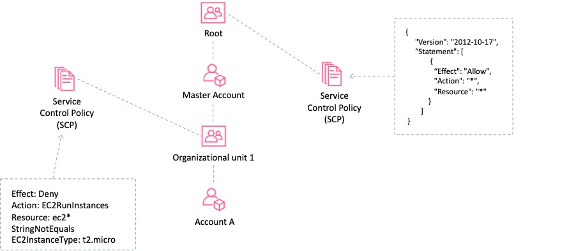

**References:**

<https://docs.aws.amazon.com/organizations/latest/userguide/orgs_manage_policies_example-scps.html#example-ec2-instances>

#### **Question 162:**

An Amazon S3 bucket in the us-east-1 Region hosts the static website content of a company. The content is made available through an Amazon CloudFront origin pointing to that bucket. A second copy of the bucket is created in the ap-southeast-1 Region using cross-region replication. The chief solutions architect wants a solution that provides greater availability for the website. Which combination of actions should a solutions architect take to increase availability? (Select TWO.)

1. Using us-east-1 bucket as the primary bucket and ap-southeast-1 bucket as the secondary bucket, create a CloudFront origin group.
2. Set up failover routing in Amazon Route 53.
3. Add an origin for ap-southeast-1 to CloudFront.
4. Point Amazon Route 53 to the replica bucket by creating a record.
5. Create an origin for CloudFront for both buckets.

**Answer :** Add an origin for ap-southeast-1 to CloudFront

**Answer :** Using us-east-1 bucket as the primary bucket and ap-southeast-1 bucket as the secondary bucket, create a CloudFront origin group

**Explanation**

You can set up CloudFront with origin failover for scenarios that require high availability. To get started, you create an *origin group* with two origins: a primary and a secondary. If the primary origin is unavailable or returns specific HTTP response status codes that indicate a failure, CloudFront automatically switches to the secondary origin.

**References:**

<https://docs.aws.amazon.com/AmazonCloudFront/latest/DeveloperGuide/high_availability_origin_failover.html>

#### **Question 163:**

A company hosts a multiplayer game on AWS. The application uses Amazon EC2 instances in a single Availability Zone and users connect over Layer 4. Solutions Architect has been tasked with making the architecture highly available and also more cost-effective. How can the solutions architect best meet these requirements? (Select TWO.)

1. Configure a Network Load Balancer in front of the EC2 instances
2. Configure an Application Load Balancer in front of the EC2 instances
3. Increase the number of instances and use smaller EC2 instance types
4. Configure an Auto Scaling group to add or remove instances in multiple Availability Zones automatically
5. Configure an Auto Scaling group to add or remove instances in the Availability Zone automatically

**Answer :** Configure a Network Load Balancer in front of the EC2 instances

**Answer :** Configure an Auto Scaling group to add or remove instances in multiple Availability Zones automatically

**Explanation**

The solutions architect must enable high availability for the architecture and ensure it is cost-effective. To enable high availability an Amazon EC2 Auto Scaling group should be created to add and remove instances across multiple availability zones. In order to distribute the traffic to the instances the architecture should use a Network Load Balancer which operates at Layer 4. This architecture will also be cost-effective as the Auto Scaling group will ensure the right number of instances are running based on demand.

**References:**

[https://docsaws.amazon.com/autoscaling/ec2/userguide/autoscaling-load-balancer.html](https://docs.aws.amazon.com/autoscaling/ec2/userguide/autoscaling-load-balancer.html)

#### **Question 164:**

A large media site has multiple applications running on Amazon ECS. A Solutions Architect needs to use content metadata to route traffic to specific services. What is the MOST efficient method to fulfil this requirement?

1. Use the AWS CLI to update an Amazon Route 53 hosted zone to route traffic as services get updated
2. Use Amazon CloudFront to manage and route traffic to the correct service
3. Use an AWS Classic Load Balancer with a host-based routing rule to route traffic to the correct service
4. Use an AWS Application Load Balancer with a path-based routing rule to route traffic to the correct service

**Answer :** Use an AWS Application Load Balancer with a path-based routing rule to route traffic to the correct service

**Explanation**

The ELB Application Load Balancer can route traffic based on data included in the request including the host name portion of the URL as well as the path in the URL. Creating a rule to route traffic based on information in the path will work for this solution and ALB works well with Amazon ECS. The diagram below depicts a configuration where a listener directs traffic that comes in with /orders in the URL to the second target group and all other traffic to the first target group:

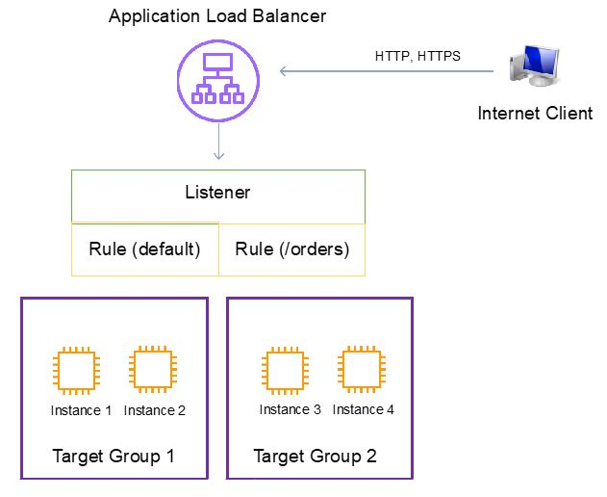

**References:**

<https://docs.aws.amazon.com/elasticloadbalancing/latest/application/tutorial-load-balancer-routing.html>

#### **Question 165:**

An application launched on Amazon EC2 instances needs to publish personally identifiable information (PII) about customers using Amazon SNS. The application is launched in private subnets within an Amazon VPC. Which is the MOST secure way to allow the application to access service endpoints in the same region?

1. Use a NAT gateway
2. Use AWS PrivateLink
3. Use a proxy instance
4. Use an Internet Gateway

**Answer :** Use AWS PrivateLink

**Explanation**

To publish messages to Amazon SNS topics from an Amazon VPC, create an interface VPC endpoint. Then, you can publish messages to SNS topics while keeping the traffic within the network that you manage with the VPC. This is the most secure option as traffic does not need to traverse the Internet.

**References:**

<https://docs.aws.amazon.com/sns/latest/dg/sns-vpc-endpoint.html>

#### **Question 166:**

A Solutions Architect needs to design a solution that will allow Website Developers to deploy static web content without managing server infrastructure. All web content must be accessed over HTTPS with a custom domain name. The solution should be scalable as the company continues to grow. Which of the following will provide the MOST cost-effective solution?

1. Amazon CloudFront with an Amazon S3 bucket origin
2. Amazon EC2 instance with Amazon EBS
3. AWS Lambda function with Amazon API Gateway
4. Amazon S3 with a static website

**Answer :** Amazon CloudFront with an Amazon S3 bucket origin

**Explanation**

You can create an Amazon CloudFront distribution that uses an S3 bucket as the origin. This will allow you to serve the static content using the HTTPS protocol. To serve a static website hosted on Amazon S3, you can deploy a CloudFront distribution using one of these configurations:

Using a REST API endpoint as the origin with access restricted by an [origin access identity (OAI)](https://docs.aws.amazon.com/AmazonCloudFront/latest/DeveloperGuide/private-content-restricting-access-to-s3.html).

Using a website endpoint as the origin with anonymous (public) access allowed.

Using a website endpoint as the origin with access restricted by a Referer header.

**References:**

<https://docs.aws.amazon.com/AmazonS3/latest/dev/WebsiteHosting.html>

#### **Question 167:**

A Solutions Architect is designing a web application that runs on Amazon EC2 instances behind an Elastic Load Balancer. All data in transit must be encrypted. Which solution options meet the encryption requirement? (choose 2)

1. Use an Application Load Balancer (ALB) with an HTTPS listener, then install SSL certificates on the ALB and EC2 instances
2. Use an Application Load Balancer (ALB) in passthrough mode, then terminate SSL on EC2 instances
3. Use an Application Load Balancer (ALB) with a TCP listener, then terminate SSL on EC2 instances
4. Use a Network Load Balancer (NLB) with a TCP listener, then terminate SSL on EC2 instances
5. Use a Network Load Balancer (NLB) with an HTTPS listener, then install SSL certificates on the NLB and EC2 instances

**Answer :** Use a Network Load Balancer (NLB) with a TCP listener, then terminate SSL on EC2 instances

**Answer :** Use an Application Load Balancer (ALB) with an HTTPS listener, then install SSL certificates on the ALB and EC2 instances

**Explanation**

You can passthrough encrypted traffic with an NLB and terminate the SSL on the EC2 instances, so this is a valid answer. You can use a HTTPS listener with an ALB and install certificates on both the ALB and EC2 instances. This does not use passthrough, instead it will terminate the first SSL connection on the ALB and then re-encrypt the traffic and connect to the EC2 instances.

**References:** <https://docs.aws.amazon.com/elasticloadbalancing/latest/userguide/what-is-load-balancing.html>

#### **Question 168:**

An application running video-editing software is using significant memory on an Amazon EC2 instance. How can a user track memory usage on the Amazon EC2 instance?

1. Use an instance type that supports memory usage reporting to a metric by default
2. Install the CloudWatch agent on the EC2 instance to push memory usage to an Amazon CloudWatch custom metric
3. Call Amazon CloudWatch to retrieve the memory usage metric data that exists for the EC2 instance
4. Assign an IAM role to the EC2 instance with an IAM policy granting access to the desired metric

**Answer :** Install the CloudWatch agent on the EC2 instance to push memory usage to an Amazon CloudWatch custom metric

**Explanation**

There is no standard metric in CloudWatch for collecting EC2 memory usage. However, you can use the CloudWatch agent to collect both system metrics and log files from Amazon EC2 instances and on-premises servers. The metrics can be pushed to a CloudWatch custom metric.

**References:**

<https://docs.aws.amazon.com/AWSEC2/latest/UserGuide/mon-scripts.html>

#### **Question 169:**

A solutions architect is optimizing a website for real-time streaming and on-demand videos. The website’s users are located around the world and the solutions architect needs to optimize the performance for both the real-time and on-demand streaming. Which service should the solutions architect choose?

1. Amazon CloudFront
2. Amazon S3 Transfer Acceleration
3. Amazon Route 53
4. AWS Global Accelerator

**Answer :** Amazon CloudFront

**Explanation**

Amazon CloudFront can be used to stream video to users across the globe using a wide variety of protocols that are layered on top of HTTP. This can include both on-demand video as well as real time streaming video.

**References:**

<https://aws.amazon.com/cloudfront/streaming/>

<https://docs.aws.amazon.com/AmazonCloudFront/latest/DeveloperGuide/on-demand-streaming-video.html>

#### **Question 170:**

A company runs an application in an Amazon VPC that requires access to an Amazon Elastic Container Service (Amazon ECS) cluster that hosts an application in another VPC. The company’s security team requires that all traffic must not traverse the internet. Which solution meets this requirement?

1. Create a Network Load Balancer and AWS PrivateLink endpoint for Amazon ECS in the VPC that hosts the ECS cluster.
2. Configure an Amazon Route 53 private hosted zone for each VPC. Use private records to resolve internal IP addresses in each VPC.
3. Configure a gateway endpoint for Amazon ECS. Update the route table to include an entry pointing to the ECS cluster.
4. Create a Network Load Balancer in one VPC and an AWS PrivateLink endpoint for Amazon ECS in another VPC.

**Answer :** Create a Network Load Balancer in one VPC and an AWS PrivateLink endpoint for Amazon ECS in another VPC

**Explanation**

The correct solution is to use AWS PrivateLink in a service provider model. In this configuration a network load balancer will be implemented in the service provider VPC (the one with the ECS cluster in this example), and a PrivateLink endpoint will be created in the consumer VPC (the one with the company’s application).

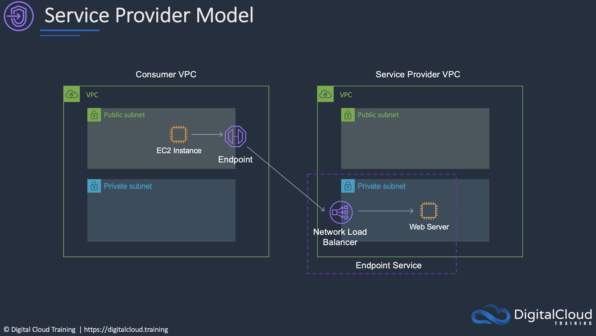

**References:**

<https://aws.amazon.com/privatelink/>

#### **Question 171:**

A company allows its developers to attach existing IAM policies to existing IAM roles to enable faster experimentation and agility. However, the security operations team is concerned that the developers could attach the existing administrator policy, which would allow the developers to circumvent any other security policies. How should a solutions architect address this issue?

1. Prevent the developers from attaching any policies and assign all IAM duties to the security operations team
2. Create an Amazon SNS topic to send an alert every time a developer creates a new policy
3. Use service control policies to disable IAM activity across all accounts in the organizational unit
4. Set an IAM permissions boundary on the developer IAM role that explicitly denies attaching the administrator policy

**Answer :** Set an IAM permissions boundary on the developer IAM role that explicitly denies attaching the administrator policy

**Explanation**

The permissions boundary for an IAM entity (user or role) sets the maximum permissions that the entity can have. This can change the effective permissions for that user or role. The effective permissions for an entity are the permissions that are granted by all the policies that affect the user or role. Within an account, the permissions for an entity can be affected by identity-based policies, resource-based policies, permissions boundaries, Organizations SCPs, or session policies. Therefore, the solutions architect can set an IAM permissions boundary on the developer IAM role that explicitly denies attaching the administrator policy.

**References:**

<https://docs.aws.amazon.com/IAM/latest/UserGuide/access_policies_boundaries.html>

#### **Question 172:**

A web application is being deployed on an Amazon ECS cluster using the Fargate launch type. The application is expected to receive a large volume of traffic initially. The company wishes to ensure that performance is good for the launch and that costs reduce as demand decreases What should a solutions architect recommend?

1. Use an AWS Lambda function to scale Amazon ECS based on metric breaches that trigger an Amazon CloudWatch alarm.
2. Use Amazon EC2 Auto Scaling with simple scaling policies to scale when an Amazon CloudWatch alarm is breached.
3. Use Amazon EC2 Auto Scaling to scale out on a schedule and back in once the load decreases.
4. Use Amazon ECS Service Auto Scaling with target tracking policies to scale when an Amazon CloudWatch alarm is breached.

**Answer :** Use Amazon ECS Service Auto Scaling with target tracking policies to scale when an Amazon CloudWatch alarm is breached

**Explanation**

Amazon ECS uses the AWS Application Auto Scaling service to scales tasks. This is configured through Amazon ECS using Amazon ECS Service Auto Scaling.

A Target Tracking Scaling policy increases or decreases the number of tasks that your service runs based on a target value for a specific metric. For example, in the image below the tasks will be scaled when the average CPU breaches 80% (as reported by CloudWatch):

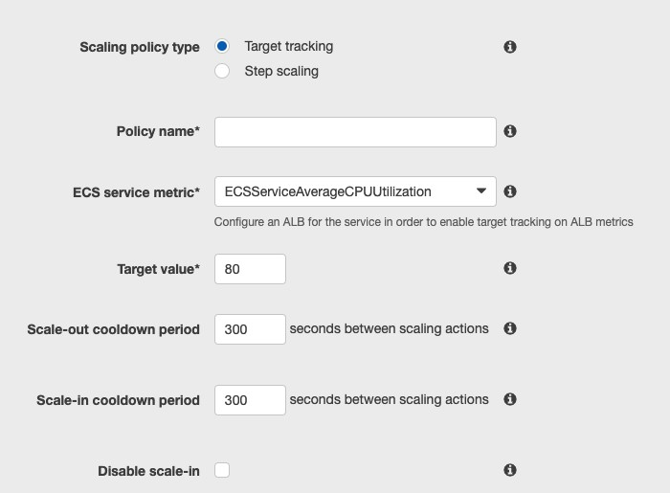

**References:**

<https://docs.aws.amazon.com/AmazonECS/latest/developerguide/service-auto-scaling.html>

#### **Question 173:**

A company runs an internal browser-based application. The application runs on Amazon EC2 instances behind an Application Load Balancer. The instances run in an Amazon EC2 Auto Scaling group across multiple Availability Zones. The Auto Scaling group scales up to 20 instances during work hours, but scales down to 2 instances overnight. Staff are complaining that the application is very slow when the day begins, although it runs well by midmorning How should the scaling be changed to address the staff complaints and keep costs to a minimum?

1. Implement a step scaling action triggered at a lower CPU threshold, and decrease the cooldown period
2. Implement a target tracking action triggered at a lower CPU threshold, and decrease the cooldown period
3. Implement a scheduled action that sets the desired capacity to 20 shortly before the office opens
4. Implement a scheduled action that sets the minimum and maximum capacity to 20 shortly before the office opens

**Answer :** Implement a target tracking action triggered at a lower CPU threshold, and decrease the cooldown period

**Explanation**

Though this sounds like a good use case for scheduled actions, both answers using scheduled actions will have 20 instances running regardless of actual demand. A better option to be more cost effective is to use a target tracking action that triggers at a lower CPU threshold. With this solution the scaling will occur before the CPU utilization gets to a point where performance is affected. This will result in resolving the performance issues whilst minimizing costs. Using a reduced cooldown period will also more quickly terminate unneeded instances, further reducing costs.

**References:**

<https://docs.aws.amazon.com/autoscaling/ec2/userguide/as-scaling-target-tracking.html>

#### **Question 174:**

An application running on Amazon ECS processes data and then writes objects to an Amazon S3 bucket. The application requires permissions to make the S3 API calls. How can a Solutions Architect ensure the application has the required permissions?

1. Update the S3 policy in IAM to allow read/write access from Amazon ECS, and then relaunch the container.
2. Create an IAM role that has read/write permissions to the bucket and update the task definition to specify the role as the taskRoleArn.
3. Create a set of Access Keys with read/write permissions to the bucket and update the task credential ID.
4. Attach an IAM policy with read/write permissions to the bucket to an IAM group and add the container instances to the group.

**Answer :** Create an IAM role that has read/write permissions to the bucket and update the task definition to specify the role as the taskRoleArn

**Explanation**

With IAM roles for Amazon ECS tasks, you can specify an IAM role that can be used by the containers in a task. Applications must sign their AWS API requests with AWS credentials, and this feature provides a strategy for managing credentials for your applications to use, similar to the way that Amazon EC2 instance profiles provide credentials to EC2 instances. You define the IAM role to use in your task definitions, or you can use a taskRoleArn override when running a task manually with the RunTask API operation. Note that there are instances roles and task roles that you can assign in ECS when using the EC2 launch type. The task role is better when you need to assign permissions for just that specific task:

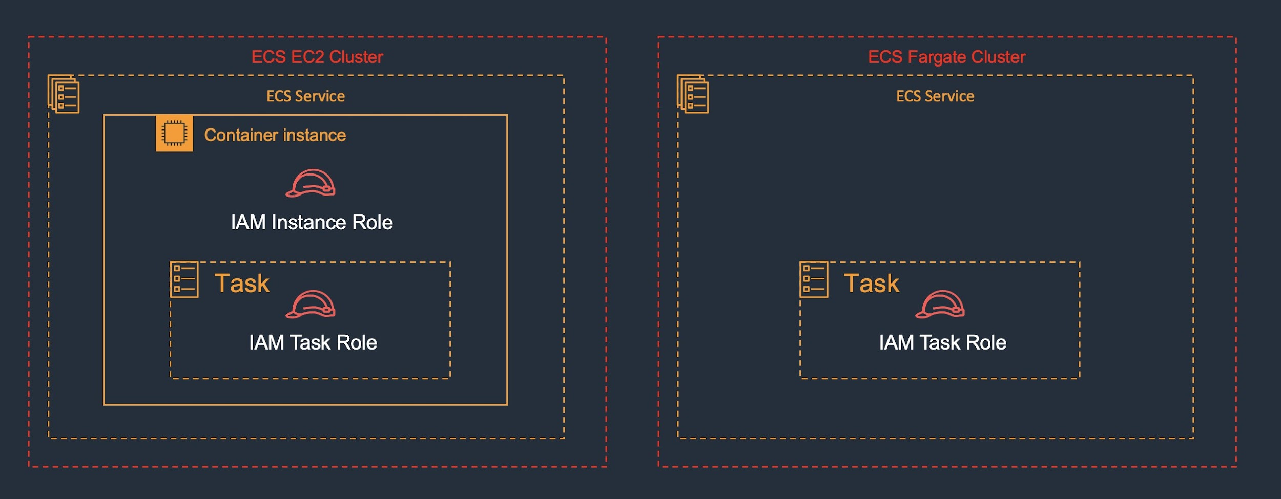

**References:**

<https://docs.aws.amazon.com/AmazonECS/latest/developerguide/task-iam-roles.html>

#### **Question 175:**

A company has divested a single business unit and needs to move the AWS account owned by the business unit to another AWS Organization. How can this be achieved?

1. Create a new account in the destination AWS Organization and migrate resources
2. Create a new account in the destination AWS Organization and share the original resources using AWS Resource Access Manager
3. Migrate the account using AWS CloudFormation
4. Migrate the account using the AWS Organizations console

**Answer :** Migrate the account using the AWS Organizations console

**Explanation**

Accounts can be migrated between organizations. To do this you must have root or IAM access to both the member and master accounts. Resources will remain under the control of the migrated account.

**References:**

<https://aws.amazon.com/premiumsupport/knowledge-center/organizations-move-accounts/>

#### **Question 176:**

A shared services VPC is being setup for use by several AWS accounts. An application needs to be securely shared from the shared services VPC. The solution should not allow consumers to connect to other instances in the VPC. How can this be setup with the least administrative effort? (choose 2)

1. Create a Network Load Balancer (NLB)
2. Use AWS ClassicLink to expose the application as an endpoint service
3. Use AWS PrivateLink to expose the application as an endpoint service
4. Configure security groups to restrict access
5. Setup VPC peering between each AWS VPC

**Answer :** Create a Network Load Balancer (NLB)

**Answer :** Use AWS PrivateLink to expose the application as an endpoint service

**Explanation**

VPCs can be shared among multiple AWS accounts. Resources can then be shared amongst those accounts. However, to restrict access so that consumers cannot connect to other instances in the VPC the best solution is to use PrivateLink to create an endpoint for the application. The endpoint type will be an interface endpoint and it uses an NLB in the shared services VPC.

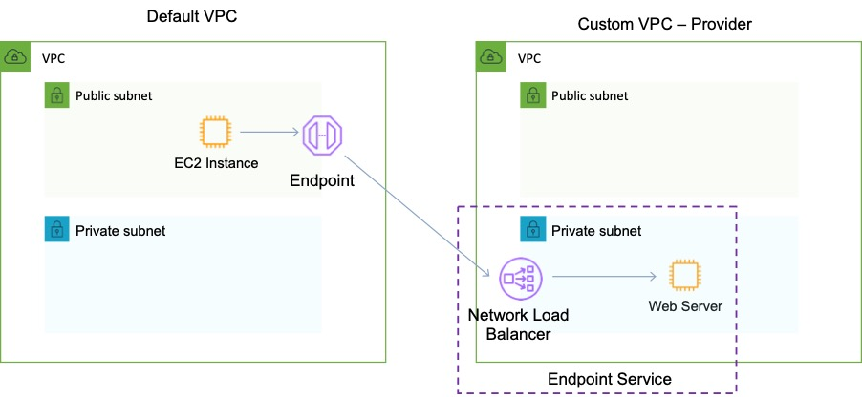

**References:**

<https://aws.amazon.com/about-aws/whats-new/2018/12/amazon-virtual-private-clouds-can-now-be-shared-with-other-aws-accounts/>

<https://aws.amazon.com/blogs/networking-and-content-delivery/vpc-sharing-a-new-approach-to-multiple-accounts-and-vpc-management/>

<https://d1.awsstatic.com/whitepapers/aws-privatelink.pdf>

#### **Question 177:**

An application is running on Amazon EC2 behind an Elastic Load Balancer (ELB). Content is being published using Amazon CloudFront and you need to restrict the ability for users to circumvent CloudFront and access the content directly through the ELB. How can you configure this solution?

1. Create a VPC Security Group for the ELB and use AWS Lambda to automatically update the CloudFront internal service IP addresses when they change
2. Use signed URLs or signed cookies to limit access to the content
3. Use a Network ACL to restrict access to the ELB
4. Create an Origin Access Identity (OAI) and associate it with the distribution

**Answer :** Create a VPC Security Group for the ELB and use AWS Lambda to automatically update the CloudFront internal service IP addresses when they change

**Explanation**

The only way to get this working is by using a VPC Security Group for the ELB that is configured to allow only the internal service IP ranges associated with CloudFront. As these are updated from time to time, you can use AWS Lambda to automatically update the addresses. This is done using a trigger that is triggered when AWS issues an SNS topic update when the addresses are changed.

**References:**

<https://aws.amazon.com/blogs/security/how-to-automatically-update-your-security-groups-for-amazon-cloudfront-and-aws-waf-by-using-aws-lambda/>

#### **Question 178:**

A company is planning a migration for a high performance computing (HPC) application and associated data from an on-premises data center to the AWS Cloud. The company uses tiered storage on premises with hot high-performance parallel storage to support the application during periodic runs of the application, and more economical cold storage to hold the data when the application is not actively running. Which combination of solutions should a solutions architect recommend to support the storage needs of the application? (Select TWO.)

1. Amazon S3 for high-performance parallel storage
2. Amazon FSx for Lustre for high-performance parallel storage
3. Amazon FSx for Windows for high-performance parallel storage
4. Amazon S3 for cold data storage
5. Amazon EFS for cold data storage

**Answer :** Amazon S3 for cold data storage

**Answer :** Amazon FSx for Lustre for high-performance parallel storage

**Explanation**

Amazon FSx for Lustre provides a high-performance file system optimized for fast processing of workloads such as machine learning, high-performance computing (HPC), video processing, financial modeling, and electronic design automation (EDA). These workloads commonly require data to be presented via a fast and scalable file system interface, and typically have data sets stored on long-term data stores like Amazon S3.

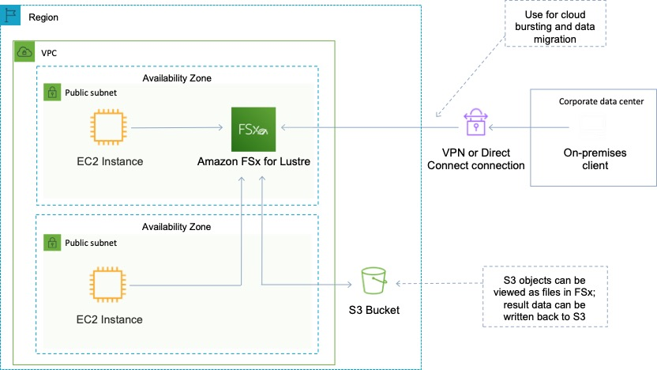

Amazon FSx works natively with Amazon S3, making it easy to access your S3 data to run data processing workloads. Your S3 objects are presented as files in your file system, and you can write your results back to S3. This lets you run data processing workloads on FSx for Lustre and store your long-term data on S3 or on-premises data stores. Therefore, the best combination for this scenario is to use S3 for cold data and FSx for Lustre for the parallel HPC job.

**References:**

<https://aws.amazon.com/fsx/lustre/>

#### **Question 179:**

A company's web application is using multiple Amazon EC2 Linux instances and storing data on Amazon EBS volumes. The company is looking for a solution to increase the resiliency of the application in case of a failure. What should a solutions architect do to meet these requirements?

1. Create an Application Load Balancer with Auto Scaling groups across multiple Availability Zones. Store data using Amazon S3 One Zone-Infrequent Access (S3 One Zone-A)
2. Create an Application Load Balancer with Auto Scaling groups across multiple Availability Zones. Mount an instance store on each EC2 instance
3. Create an Application Load Balancer with Auto Scaling groups across multiple Availability Zones. Store data on Amazon EFS and mount a target on each instance
4. Launch the application on EC2 instances in each Availability Zone. Attach EBS volumes to each EC2 instance

**Answer :** Create an Application Load Balancer with Auto Scaling groups across multiple Availability Zones. Store data on Amazon EFS and mount a target on each instance

**Explanation**

To increase the resiliency of the application the solutions architect can use Auto Scaling groups to launch and terminate instances across multiple availability zones based on demand. An application load balancer (ALB) can be used to direct traffic to the web application running on the EC2 instances. Lastly, the Amazon Elastic File System (EFS) can assist with increasing the resilience of the application by providing a shared file system that can be mounted by multiple EC2 instances from multiple availability zones.

**References:**

<https://docs.aws.amazon.com/efs/>

#### **Question 180:**

A company requires a solution to allow customers to customize images that are stored in an online catalog. The image customization parameters will be sent in requests to Amazon API Gateway. The customized image will then be generated on-demand and can be accessed online. The solutions architect requires a highly available solution. Which solution will be MOST cost-effective?

1. Use AWS Lambda to manipulate the original images to the requested customization. Store the original images in Amazon S3 and the manipulated images in Amazon DynamoDB. Configure an Elastic Load Balancer in front of the Amazon EC2 instances
2. Use Amazon EC2 instances to manipulate the original images into the requested customization. Store the original images in Amazon S3 and the manipulated images in Amazon DynamoDB. Configure an Amazon CloudFront distribution with the S3 bucket as the origin
3. Use AWS Lambda to manipulate the original images to the requested customization. Store the original and manipulated images in Amazon S3. Configure an Amazon CloudFront distribution with the S3 bucket as the origin
4. Use Amazon EC2 instances to manipulate the original images into the requested customization. Store the original and manipulated images in Amazon S3. Configure an Elastic Load Balancer in front of the EC2 instances

**Answer :** Use AWS Lambda to manipulate the original images to the requested customization. Store the original and manipulated images in Amazon S3. Configure an Amazon CloudFront distribution with the S3 bucket as the origin

**Explanation**

All solutions presented are highly available. The key requirement that must be satisfied is that the solution should be cost-effective and you must choose the most cost-effective option. Therefore, it’s best to eliminate services such as Amazon EC2 and ELB as these require ongoing costs even when they’re not used. Instead, a fully serverless solution should be used. AWS Lambda, Amazon S3 and CloudFront are the best services to use for these requirements.

**References:**

<https://aws.amazon.com/serverless/>

#### **Question 181:**

A website runs on Amazon EC2 instances behind an Application Load Balancer (ALB). The website has a mix of dynamic and static content. Customers around the world are reporting performance issues with the website. Which set of actions will improve website performance for users worldwide?

1. Create an Amazon CloudFront distribution and configure the ALB as an origin. Then update the Amazon Route 53 record to point to the CloudFront distribution
2. Migrate the website to an Amazon S3 bucket in the Regions closest to the users. Then create an Amazon Route 53 geolocation record to point to the S3 buckets
3. Launch new EC2 instances hosting the same web application in different Regions closer to the users. Use an AWS Transit Gateway to connect customers to the closest region
4. Create a latency-based Amazon Route 53 record for the ALB. Then launch new EC2 instances with larger instance sizes and register the instances with the ALB

**Answer :** Create an Amazon CloudFront distribution and configure the ALB as an origin. Then update the Amazon Route 53 record to point to the CloudFront distribution

**Explanation**

Amazon CloudFront is a content delivery network (CDN) that improves website performance by caching content at edge locations around the world. It can serve both dynamic and static content. This is the best solution for improving the performance of the website.

**References:**

<https://aws.amazon.com/cloudfront/dynamic-content/>

#### **Question 182:**

A multi-tier application runs with eight front-end web servers in an Amazon EC2 Auto Scaling group in a single Availability Zone behind an Application Load Balancer. A solutions architect needs to modify the infrastructure to be highly available without modifying the application. Which architecture should the solutions architect choose that provides high availability?

1. Modify the Auto Scaling group to use four instances across each of two Availability Zones
2. Create an Auto Scaling group that uses four instances across each of two Regions
3. Create an Auto Scaling group that uses four instances across each of two subnets
4. Create an Auto Scaling template that can be used to quickly create more instances in another Region

**Answer :** Modify the Auto Scaling group to use four instances across each of two Availability Zones

**Explanation**

High availability can be enabled for this architecture quite simply by modifying the existing Auto Scaling group to use multiple availability zones. The ASG will automatically balance the load so you don’t actually need to specify the instances per AZ. The architecture for the web tier will look like the one below:

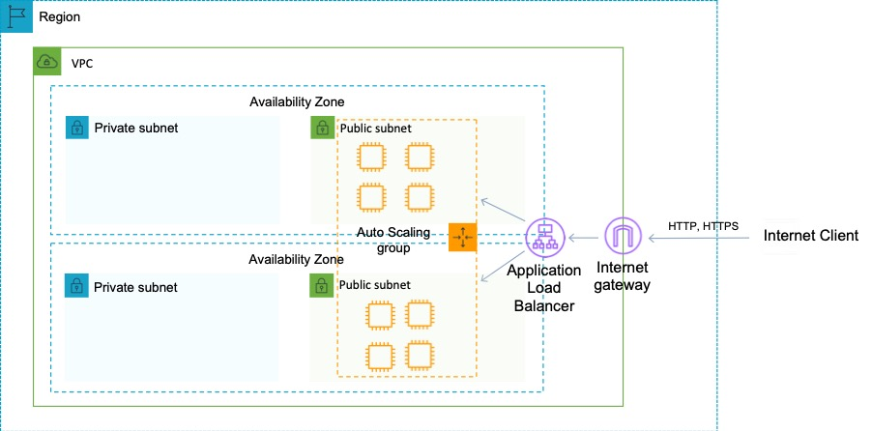

**References:**

<https://aws.amazon.com/ec2/autoscaling/>

#### **Question 183:**

You have been asked to deploy a new High-Performance Computing (HPC) cluster. You need to create a design for the EC2 instances that ensures close proximity, low latency and high network throughput. Which AWS features will help you to achieve this requirement whilst considering cost? (choose 2)

1. Use dedicated hosts
2. Use Placement groups
3. Use Provisioned IOPS EBS volumes
4. Launch I/O Optimized EC2 instances in one private subnet in an AZ
5. Use EC2 instances with Enhanced Networking

**Answer :** Use EC2 instances with Enhanced Networking

**Answer :** Use Placement groups

**Explanation**

When you launch a new EC2 instance, the EC2 service attempts to place the instance in such a way that all of your instances are spread out across underlying hardware to minimize correlated failures. You can use placement groups to influence the placement of a group of interdependent instances to meet the needs of your workload. Depending on the type of workload, you can create a placement group using one of the following placement strategies:

Cluster – packs instances close together inside an Availability Zone. This strategy enables workloads to achieve the low-latency network performance necessary for tightly-coupled node-to-node communication that is typical of HPC applications.

Partition – spreads your instances across logical partitions such that groups of instances in one partition do not share the underlying hardware with groups of instances in different partitions. This strategy is typically used by large distributed and replicated workloads, such as Hadoop, Cassandra, and Kafka.

Spread – strictly places a small group of instances across distinct underlying hardware to reduce correlated failures.

Cluster placement groups are recommended for applications that benefit from low network latency, high network throughput, or both. They are also recommended when the majority of the network traffic is between the instances in the group. To provide the lowest latency and the highest packet-per-second network performance for your placement group, choose an instance type that supports enhanced networking.

**References:**

<https://docs.aws.amazon.com/AWSEC2/latest/UserGuide/placement-groups.html>

#### **Question 184:**

A solutions architect is designing a high performance computing (HPC) application using Amazon EC2 Linux instances. All EC2 instances need to communicate to each other with low latency and high throughput network performance. Which EC2 solution BEST meets these requirements?

1. Launch the EC2 instances in an Auto Scaling group in two Regions. Place a Network Load Balancer in front of the instances
2. Launch the EC2 instances in a cluster placement group in one Availability Zone
3. Launch the EC2 instances in an Auto Scaling group spanning multiple Availability Zones
4. Launch the EC2 instances in a spread placement group in one Availability Zone

**Answer :** Launch the EC2 instances in a cluster placement group in one Availability Zone

**Explanation**

When you launch a new EC2 instance, the EC2 service attempts to place the instance in such a way that all of your instances are spread out across underlying hardware to minimize correlated failures. You can use placement groups to influence the placement of a group of interdependent instances to meet the needs of your workload. Depending on the type of workload, you can create a placement group using one of the following placement strategies:

• Cluster – packs instances close together inside an Availability Zone. This strategy enables workloads to achieve the low-latency network performance necessary for tightly-coupled node-to-node communication that is typical of HPC applications.

• Partition – spreads your instances across logical partitions such that groups of instances in one partition do not share the underlying hardware with groups of instances in different partitions. This strategy is typically used by large distributed and replicated workloads, such as Hadoop, Cassandra, and Kafka.

• Spread – strictly places a small group of instances across distinct underlying hardware to reduce correlated failures.

For this scenario, a cluster placement group should be used as this is the best option for providing low-latency network performance for a HPC application.

**References:**

<https://docs.aws.amazon.com/AWSEC2/latest/UserGuide/placement-groups.html>

#### **Question 185:**

You have implemented API Gateway and enabled a cache for a specific stage. How can you control the cache to enhance performance and reduce load on back-end services?

1. Enable bursting
2. Using time-to-live (TTL) settings
3. Configure the throttling feature
4. Using CloudFront controls

**Answer :**  Using time-to-live (TTL) settings

**Explanation**

You can enable API caching in Amazon API Gateway to cache your endpoint's responses. With caching, you can reduce the number of calls made to your endpoint and also improve the latency of requests to your API. When you enable caching for a stage, API Gateway caches responses from your endpoint for a specified time-to-live (TTL) period, in seconds. API Gateway then responds to the request by looking up the endpoint response from the cache instead of making a request to your endpoint. The default TTL value for API caching is 300 seconds. The maximum TTL value is 3600 seconds. TTL=0 means caching is disabled.

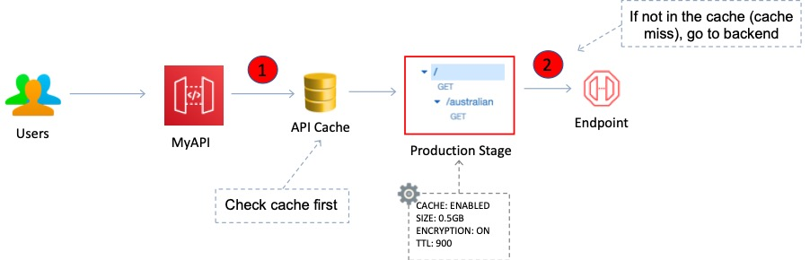

**References:**

<https://docs.aws.amazon.com/apigateway/latest/developerguide/api-gateway-caching.html>

#### **Question 186:**

A company runs a financial application using an Amazon EC2 Auto Scaling group behind an Application Load Balancer (ALB). When running month-end reports on a specific day and time each month the application becomes unacceptably slow. Amazon CloudWatch metrics show the CPU utilization hitting 100%. What should a solutions architect recommend to ensure the application is able to handle the workload and avoid downtime?

1. Configure an Amazon CloudFront distribution in front of the ALB
2. Configure Amazon ElastiCache to remove some of the workload from the EC2 instances
3. Configure an EC2 Auto Scaling scheduled scaling policy based on the monthly schedule
4. Configure an EC2 Auto Scaling simple scaling policy based on CPU utilization

**Answer :** Configure an EC2 Auto Scaling scheduled scaling policy based on the monthly schedule

**Explanation**

Scheduled scaling allows you to set your own scaling schedule. In this case the scaling action can be scheduled to occur just prior to the time that the reports will be run each month. Scaling actions are performed automatically as a function of time and date. This will ensure that there are enough EC2 instances to serve the demand and prevent the application from slowing down.

**References:**

<https://docs.aws.amazon.com/autoscaling/ec2/userguide/schedule_time.html>

#### **Question 187:**

An application runs on Amazon EC2 instances across multiple Availability Zones. The instances run in an Amazon EC2 Auto Scaling group behind an Application Load Balancer. The application performs best when the CPU utilization of the EC2 instances is at or near 40%. What should a solutions architect do to maintain the desired performance across all instances in the group?

1. Use a target tracking policy to dynamically scale the Auto Scaling group
2. Use an AWS Lambda function to update the desired Auto Scaling group capacity
3. Use a simple scaling policy to dynamically scale the Auto Scaling group
4. Use scheduled scaling actions to scale up and scale down the Auto Scaling group

**Answer :** Use a target tracking policy to dynamically scale the Auto Scaling group

**Explanation**

With target tracking scaling policies, you select a scaling metric and set a target value. Amazon EC2 Auto Scaling creates and manages the CloudWatch alarms that trigger the scaling policy and calculates the scaling adjustment based on the metric and the target value. The scaling policy adds or removes capacity as required to keep the metric at, or close to, the specified target value. In addition to keeping the metric close to the target value, a target tracking scaling policy also adjusts to the changes in the metric due to a changing load pattern.

**References:**

<https://docs.aws.amazon.com/autoscaling/ec2/userguide/as-scaling-target-tracking.html>

#### **Question 188:**

A company is serving videos to their customers from us-east-1 from an Amazon S3 bucket. The company's customers are located around the world and there is high demand during peak hours. Customers in Asia complain about slow download speeds during peak hours and customers in all locations have reported experiencing HTTP 500 errors. How can a Solutions Architect address the issues?

1. Place an Amazon ElastiCache cluster in front of the S3 bucket
2. Use an Amazon Route 53 weighted routing policy for the CloudFront domain name to distribute GET requests between CloudFront and the S3 bucket
3. Cache the web content using Amazon CloudFront and use all Edge locations for content delivery
4. Replicate the bucket in us-east-1 and use Amazon Route 53 failover routing to determine which bucket to serve the content from

**Answer :** Cache the web content using Amazon CloudFront and use all Edge locations for content delivery

**Explanation**

The most straightforward solution is to use CloudFront to cache the content in the Edge locations around the world that are close to users. This is easy to implement and will solve the issues reported. CloudFront has many edge locations around the world for caching the content as can be seen in the graphic below:

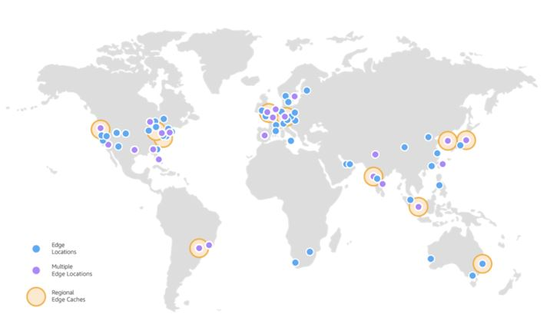References:

<https://aws.amazon.com/cloudfront/features/>

#### **Question 189:**

A solutions architect is designing a microservices architecture. AWS Lambda will store data in an Amazon DynamoDB table named Orders. The solutions architect needs to apply an IAM policy to the Lambda function’s execution role to allow it to put, update, and delete items in the Orders table. No other actions should be allowed. Which of the following code snippets should be included in the IAM policy to fulfill this requirement whilst providing the LEAST privileged access?

A. "Sid": "PutUpdateDeleteOnOrders",

* + "Effect": "Allow",
  + "Action": [
  + "dynamodb:PutItem",
  + "dynamodb:UpdateItem",
  + "dynamodb:DeleteItem"
  + ],
  + "Resource": "arn:aws:dynamodb:us-east-1:227392126428:table/*"

B. "Sid": "PutUpdateDeleteOnOrders",

* + "Effect": "Deny",
  + "Action": "dynamodb:* ",
  + "Resource": "arn:aws:dynamodb:us-east-1:227392126428:table/Orders"

C. "Sid": "PutUpdateDeleteOnOrders",

* + "Effect": "Allow",
  + "Action": [
  + "dynamodb:PutItem",
  + "dynamodb:UpdateItem",
  + "dynamodb:DeleteItem"
  + ],
  + "Resource": "arn:aws:dynamodb:us-east-1:227392126428:table/Orders"

D. "Sid": "PutUpdateDeleteOnOrders",

* + "Effect": "Allow",
  + "Action": "dynamodb:* ",
  + "Resource": "arn:aws:dynamodb:us-east-1:227392126428:table/Orders"

**Answer :** "Sid": "PutUpdateDeleteOnOrders",

* "Effect": "Allow",
* "Action": [
* "dynamodb:PutItem",
* "dynamodb:UpdateItem",
* "dynamodb:DeleteItem"
* ],
* "Resource": "arn:aws:dynamodb:us-east-1:227392126428:table/Orders"

This code snippet specifies the exact actions to allow and also specified the resource to apply those permissions to.

**Explanation**

The key requirements are to allow the Lambda function the put, update, and delete actions on a single table. Using the principle of least privilege the answer should not allow any other access.

**References:**

<https://docs.aws.amazon.com/IAM/latest/UserGuide/reference_policies_elements.html>

#### **Question 190:**

A company is planning to migrate a large quantity of important data to Amazon S3. The data will be uploaded to a versioning enabled bucket in the us-west-1 Region. The solution needs to include replication of the data to another Region for disaster recovery purposes. How should a solutions architect configure the replication?

1. Create an additional S3 bucket in another Region and configure cross-origin resource sharing (CORS)
2. Create an additional S3 bucket with versioning in another Region and configure cross-Region replication
3. Create an additional S3 bucket with versioning in another Region and configure cross-origin resource sharing (CORS)
4. Create an additional S3 bucket in another Region and configure cross-Region replication

**Answer :** Create an additional S3 bucket with versioning in another Region and configure cross-Region replication

**Explanation**

Replication enables automatic, asynchronous copying of objects across Amazon S3 buckets. Buckets that are configured for object replication can be owned by the same AWS account or by different accounts. You can copy objects between different AWS Regions or within the same Region. Both source and destination buckets must have versioning enabled.

**References:**

<https://docs.aws.amazon.com/AmazonS3/latest/dev/replication.html>

#### **Question 191:**

A web application is running on a fleet of Amazon EC2 instances using an Auto Scaling Group. It is desired that the CPU usage in the fleet is kept at 40%. How should scaling be configured?

1. Use a step scaling policy that uses the PercentChangeInCapacity value to adjust the group size as required
2. Use a custom CloudWatch alarm to monitor CPU usage and notify the ASG using Amazon SNS
3. Use a simple scaling policy that launches instances when the average CPU hits 40%
4. Use a target tracking policy that keeps the average aggregate CPU utilization at 40%

**Answer :** Use a target tracking policy that keeps the average aggregate CPU utilization at 40%

**Explanation**

This is a perfect use case for a target tracking scaling policy. With target tracking scaling policies, you select a scaling metric and set a target value. In this case you can just set the target value to 40% average aggregate CPU utilization.

**References:**

<https://docs.aws.amazon.com/autoscaling/ec2/userguide/as-scaling-target-tracking.html>

<https://docs.aws.amazon.com/autoscaling/ec2/userguide/as-scaling-simple-step.html>

#### **Question 192:**

A company has created a duplicate of its environment in another AWS Region. The application is running in warm standby mode. There is an Application Load Balancer (ALB) in front of the application. Currently, failover is manual and requires updating a DNS alias record to point to the secondary ALB. How can a solutions architect automate the failover process?

1. Enable an ALB health check
2. Create a CNAME record on Amazon Route 53 pointing to the ALB endpoint
3. Create a latency based routing policy on Amazon Route 53
4. Enable an Amazon Route 53 health check

**Answer :** Enable an Amazon Route 53 health check

**Explanation**

You can use Route 53 to check the health of your resources and only return healthy resources in response to DNS queries. There are three types of DNS failover configurations:

1. Active-passive: Route 53 actively returns a primary resource. In case of failure, Route 53 returns the backup resource. Configured using a failover policy.

2. Active-active: Route 53 actively returns more than one resource. In case of failure, Route 53 fails back to the healthy resource. Configured using any routing policy besides failover.

3. Combination: Multiple routing policies (such as latency-based, weighted, etc.) are combined into a tree to configure more complex DNS failover.

In this case an alias already exists for the secondary ALB. Therefore, the solutions architect just needs to enable a failover configuration with an Amazon Route 53 health check.

The configuration would look something like this:

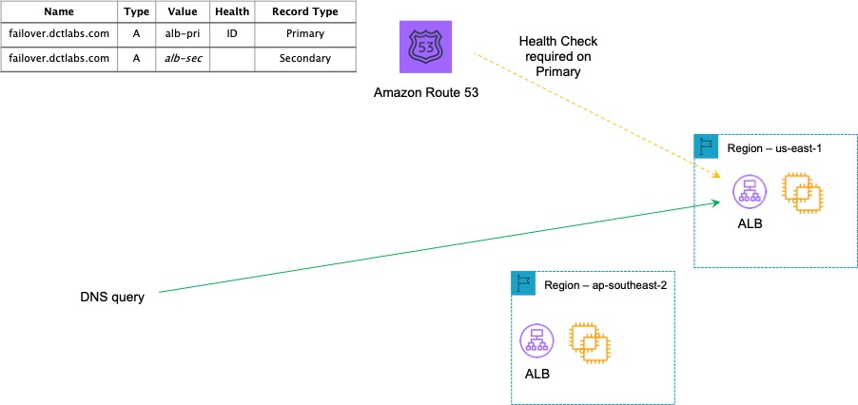

**References:**

<https://aws.amazon.com/premiumsupport/knowledge-center/route-53-dns-health-checks/>

#### **Question 193:**

An Architect is designing a serverless application that will accept images uploaded by users from around the world. The application will make API calls to back-end services and save the session state data of the user to a database. Which combination of services would provide a solution that is cost-effective while delivering the least latency?

1. API Gateway, Amazon S3, AWS Lambda, DynamoDB
2. Amazon CloudFront, API Gateway, Amazon S3, AWS Lambda, Amazon RDS
3. Amazon S3, API Gateway, AWS Lambda, Amazon RDS
4. Amazon CloudFront, API Gateway, Amazon S3, AWS Lambda, DynamoDB

**Answer :** Amazon CloudFront, API Gateway, Amazon S3, AWS Lambda, DynamoDB

**Explanation**

Amazon CloudFront caches content closer to users at Edge locations around the world. This is the lowest latency option for uploading content. API Gateway and AWS Lambda are present in all options. DynamoDB can be used for storing session state data. This is a 100% serverless application.

**References:**

<https://aws.amazon.com/blogs/aws/amazon-cloudfront-content-uploads-post-put-other-methods/>

#### **Question 194:**

An issue has been reported whereby Amazon EC2 instances are not being terminated from an Auto Scaling Group behind an ELB when traffic volumes are low. How can this be fixed?

1. Modify the scale down increment
2. Modify the scaling settings on the ELB
3. Modify the lower threshold settings on the ASG
4. Modify the upper threshold settings on the ASG

**Answer :** Modify the lower threshold settings on the ASG

**Explanation**

The lower threshold may be set too high. With the lower threshold if the metric falls below this number for the breach duration, a scaling operation is triggered. If it’s set too high you may find that your Auto Scaling group does not scale-in when required.

**References:**

<https://docs.aws.amazon.com/elasticbeanstalk/latest/dg/environments-cfg-autoscaling-triggers.html>

#### **Question 195:**

A security team wants to limit access to specific services or actions in all of the team's AWS accounts. All accounts belong to a large organization in AWS Organizations. The solution must be scalable and there must be a single point where permissions can be maintained. What should a solutions architect do to accomplish this?

1. Create a security group to allow accounts and attach it to user groups
2. Create an ACL to provide access to the services or actions
3. Create a service control policy in the root organizational unit to deny access to the services or actions
4. Create cross-account roles in each account to deny access to the services or actions

**Answer :** Create a service control policy in the root organizational unit to deny access to the services or actions

**Explanation**

Service control policies (SCPs) offer central control over the maximum available permissions for all accounts in your organization, allowing you to ensure your accounts stay within your organization’s access control guidelines.

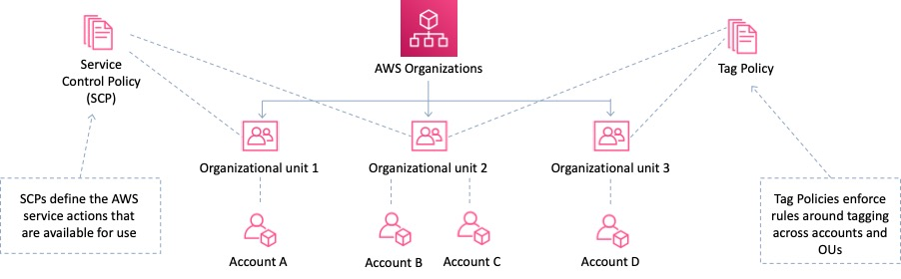

SCPs alone are not sufficient for allowing access in the accounts in your organization. Attaching an SCP to an AWS Organizations entity (root, OU, or account) defines a guardrail for what actions the principals can perform. You still need to attach [identity-based or resource-based policies](https://docs.aws.amazon.com/IAM/latest/UserGuide/access_policies_identity-vs-resource.html) to principals or resources in your organization's accounts to actually grant permissions to them.

**References:**

<https://docs.aws.amazon.com/organizations/latest/userguide/orgs_manage_policies_scp.html>

#### **Question 196:**

An application is deployed on multiple AWS regions and accessed from around the world. The application exposes static public IP addresses. Some users are experiencing poor performance when accessing the application over the Internet. What should a solutions architect recommend to reduce internet latency?

1. Set up an Amazon CloudFront distribution to access an application
2. Set up AWS Direct Connect locations in multiple Regions
3. Set up AWS Global Accelerator and add endpoints
4. Set up an Amazon Route 53 geoproximity routing policy to route traffic

**Answer :** Set up AWS Global Accelerator and add endpoints

**Explanation**

AWS Global Accelerator is a service in which you create *accelerators* to improve availability and performance of your applications for local and global users. Global Accelerator directs traffic to optimal endpoints over the AWS global network. This improves the availability and performance of your internet applications that are used by a global audience. Global Accelerator is a global service that supports endpoints in multiple AWS Regions, which are listed in the [AWS Region Table](https://aws.amazon.com/about-aws/global-infrastructure/regional-product-services/).

By default, Global Accelerator provides you with two static IP addresses that you associate with your accelerator. (Or, instead of using the IP addresses that Global Accelerator provides, you can configure these entry points to be IPv4 addresses from your own IP address ranges that you bring to Global Accelerator.)

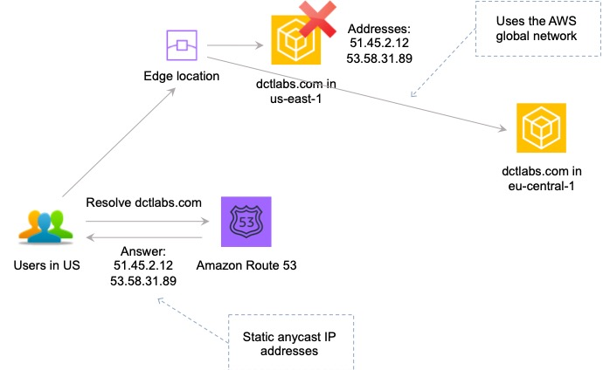

The static IP addresses are anycast from the AWS edge network and distribute incoming application traffic across multiple endpoint resources in multiple AWS Regions, which increases the availability of your applications. Endpoints can be Network Load Balancers, Application Load Balancers, EC2 instances, or Elastic IP addresses that are located in one AWS Region or multiple Regions.

**References:**

<https://docs.aws.amazon.com/global-accelerator/latest/dg/what-is-global-accelerator.html>

#### **Question 197:**

A Solutions Architect is designing a static website that will use the zone apex of a DNS domain (e.g. example.com). The Architect wants to use the Amazon Route 53 service. Which steps should the Architect take to implement a scalable and cost-effective solution? (choose 2)

1. Host the website on an Amazon EC2 instance with ELB and Auto Scaling, and map a Route 53 Alias record to the ELB endpoint
2. Serve the website from an Amazon S3 bucket, and map a Route 53 Alias record to the website endpoint
3. Host the website using AWS Elastic Beanstalk, and map a Route 53 Alias record to the Beanstalk stack
4. Create a Route 53 hosted zone, and set the NS records of the domain to use Route 53 name servers
5. Host the website on an Amazon EC2 instance, and map a Route 53 Alias record to the public IP address of the EC2 instance

**Answer :** Create a Route 53 hosted zone, and set the NS records of the domain to use Route 53 name servers

**Answer :** Serve the website from an Amazon S3 bucket, and map a Route 53 Alias record to the website endpoint

**Explanation**

To use Route 53 for an existing domain the Architect needs to change the NS records to point to the Amazon Route 53 name servers. This will direct name resolution to Route 53 for the domain name. The most cost-effective solution for hosting the website will be to use an Amazon S3 bucket. To do this you create a bucket using the same name as the domain name (e.g. example.com) and use a Route 53 Alias record to map to it.

**References:**

<https://aws.amazon.com/premiumsupport/knowledge-center/cloudfront-serve-static-website/>

#### **Question 198:**

You need a service that can provide you with control over which traffic to allow or block to your web applications by defining customizable web security rules. You need to block common attack patterns, such as SQL injection and cross-site scripting, as well as creating custom rules for your own applications. Which AWS service fits these requirements?

1. Route 53
2. Security Groups
3. AWS WAF
4. CloudFront

**Answer :** AWS WAF

**Explanation**

AWS WAF is a web application firewall that helps detect and block malicious web requests targeted at your web applications. AWS WAF allows you to create rules that can help protect against common web exploits like SQL injection and cross-site scripting. With AWS WAF you first identify the resource (either an Amazon CloudFront distribution or an Application Load Balancer) that you need to protect. You then deploy the rules and filters that will best protect your applications. The other services listed do not enable you to create custom web security rules that can block known malicious attacks.

**References:**

<https://aws.amazon.com/waf/details/>

#### **Question 199:**

A company has some statistical data stored in an Amazon RDS database. The company wants to allow users to access this information using an API. A solutions architect must create a solution that allows sporadic access to the data, ranging from no requests to large bursts of traffic. Which solution should the solutions architect suggest?

1. Set up an Amazon API Gateway and use AWS Elastic Beanstalk
2. Set up an Amazon API Gateway and use AWS Lambda functions
3. Set up an Amazon API Gateway and use Amazon EC2 with Auto Scaling
4. Set up an Amazon API Gateway and use Amazon ECS

**Answer :** Set up an Amazon API Gateway and use AWS Lambda functions

**Explanation**

This question is simply asking you to work out the best compute service for the stated requirements. The key requirements are that the compute service should be suitable for a workload that can range quite broadly in demand from no requests to large bursts of traffic.

AWS Lambda is an ideal solution as you pay only when requests are made and it can easily scale to accommodate the large bursts in traffic. Lambda works well with both API Gateway and Amazon RDS.

**References:**

<https://docs.aws.amazon.com/lambda/latest/dg/invocation-scaling.html>

#### **Question 200:**

An application stack includes an Elastic Load Balancer in a public subnet, a fleet of Amazon EC2 instances in an Auto Scaling Group, and an Amazon RDS MySQL cluster. Users connect to the application from the Internet. The application servers and database must be secure. What is the most appropriate architecture for the application stack?

1. Create a public subnet for the Amazon EC2 instances and a public subnet for the Amazon RDS cluster
2. Create a public subnet for the Amazon EC2 instances and a private subnet for the Amazon RDS cluster
3. Create a private subnet for the Amazon EC2 instances and a private subnet for the Amazon RDS cluster
4. Create a private subnet for the Amazon EC2 instances and a public subnet for the Amazon RDS cluster

**Answer :** Create a private subnet for the Amazon EC2 instances and a private subnet for the Amazon RDS cluster

**Explanation**

Typically, the nodes of an Internet-facing load balancer have public IP addresses and must therefore be in a public subnet. To keep your back-end instances secure you can place them in a private subnet. To do this you must associate a corresponding public and private subnet for each availability zone the ELB/instances are in).

For RDS, you create a DB subnet group which is a collection of subnets (typically private) that you create in a VPC and that you then designate for your DB instances.

**References:**

<https://docs.aws.amazon.com/elasticloadbalancing/latest/userguide/how-elastic-load-balancing-works.html>

<https://docs.aws.amazon.com/AmazonRDS/latest/UserGuide/USER_VPC.WorkingWithRDSInstanceinaVPC.html#USER_VPC.Subnets>

#### **Question 201:**

An Architect needs to find a way to automatically and repeatably create many member accounts within an AWS Organization. The accounts also need to be moved into an OU and have VPCs and subnets created. What is the best way to achieve this?

1. Use the AWS Management Console
2. Use the AWS Organizations API
3. Use the AWS CLI
4. Use CloudFormation with scripts

**Answer :** Use CloudFormation with scripts

**Explanation**

The best solution is to use a combination of scripts and AWS CloudFormation. You will also leverage the AWS Organizations API. This solution can provide all of the requirements.

**References:**

<https://aws.amazon.com/blogs/security/how-to-use-aws-organizations-to-automate-end-to-end-account-creation/>

#### **Question 202:**

An application allows users to upload and download files. Files older than 2 years will be accessed less frequently. A solutions architect needs to ensure that the application can scale to any number of files while maintaining high availability and durability. Which scalable solutions should the solutions architect recommend?

1. Store the files on Amazon S3 with a lifecycle policy that moves objects older than 2 years to S3 Standard Infrequent Access (S3 Standard-IA)
2. Store the files on Amazon Elastic File System (EFS) with a lifecycle policy that moves objects older than 2 years to EFS Infrequent Access (EFS IA)
3. Store the files in Amazon Elastic Block Store (EBS) volumes. Schedule snapshots of the volumes. Use the snapshots to archive data older than 2 years
4. Store the files in Amazon Elastic Block Store (EBS) volumes. Create a lifecycle policy to move files older than 2 years to Amazon S3 Glacier

**Answer :** Store the files on Amazon S3 with a lifecycle policy that moves objects older than 2 years to S3 Standard Infrequent Access (S3 Standard-IA)

**Explanation**

S3 Standard-IA is for data that is accessed less frequently, but requires rapid access when needed. S3 Standard-IA offers the high durability, high throughput, and low latency of S3 Standard, with a low per GB storage price and per GB retrieval fee. This combination of low cost and high performance make S3 Standard-IA ideal for long-term storage, backups, and as a data store for disaster recovery files.

**References:**

<https://aws.amazon.com/s3/storage-classes/>

#### **Question 203:**

A security officer requires that access to company financial reports is logged. The reports are stored in an Amazon S3 bucket. Additionally, any modifications to the log files must be detected. Which actions should a solutions architect take?

1. Use S3 server access logging on the bucket that houses the reports with the read and write management events and log file validation options enabled
2. Use AWS CloudTrail to create a new trail. Configure the trail to log read and write management events on the S3 bucket that houses the reports. Log these events to a new bucket, and enable log file validation
3. Use S3 server access logging on the bucket that houses the reports with the read and write data events and the log file validation options enabled
4. Use AWS CloudTrail to create a new trail. Configure the trail to log read and write data events on the S3 bucket that houses the reports. Log these events to a new bucket, and enable log file validation

**Answer :** Use AWS CloudTrail to create a new trail. Configure the trail to log read and write data events on the S3 bucket that houses the reports. Log these events to a new bucket, and enable log file validation

**Explanation**

Amazon CloudTrail can be used to log activity on the reports. The key difference between the two answers that include CloudTrail is that one references data events whereas the other references management events.

Data events provide visibility into the resource operations performed on or within a resource. These are also known as data plane operations. Data events are often high-volume activities.

Example data events include:

• Amazon S3 object-level API activity (for example, GetObject, DeleteObject, and PutObject API operations).

• AWS Lambda function execution activity (the Invoke API).

Management events provide visibility into management operations that are performed on resources in your AWS account. These are also known as control plane operations. Example management events include:

• Configuring security (for example, IAM AttachRolePolicy API operations)

• Registering devices (for example, Amazon EC2 CreateDefaultVpc API operations).

Therefore, to log data about access to the S3 objects the solutions architect should log read and write data events.

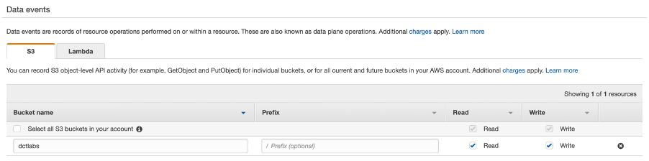

Log file validation can also be enabled on the destination bucket:

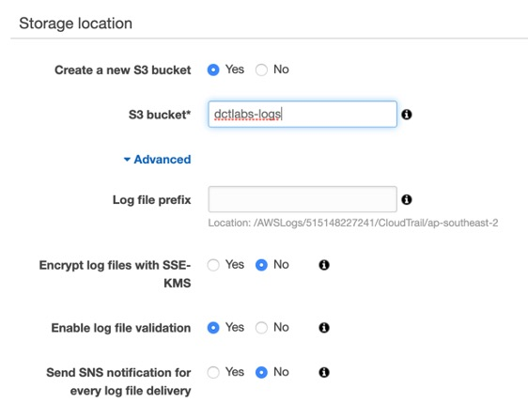

**References:**

<https://docs.aws.amazon.com/awscloudtrail/latest/userguide/logging-data-events-with-cloudtrail.html>

#### **Question 204:**

You are developing an application that uses Lambda functions. You need to store some sensitive data that includes credentials for accessing the database tier. You are planning to store this data as environment variables within Lambda. How can you ensure this sensitive information is properly secured?

1. There is no need to make any changes as all environment variables are encrypted by default with AWS Lambda
2. Use encryption helpers that leverage AWS Key Management Service to store the sensitive information as Ciphertext
3. Store the environment variables in an encrypted DynamoDB table and configure Lambda to retrieve them as required
4. This cannot be done, only the environment variables that relate to the Lambda function itself can be encrypted

**Answer :** Use encryption helpers that leverage AWS Key Management Service to store the sensitive information as Ciphertext

**Explanation**

Environment variables for Lambda functions enable you to dynamically pass settings to your function code and libraries, without making changes to your code. Environment variables are key-value pairs that you create and modify as part of your function configuration, using either the AWS Lambda Console, the AWS Lambda CLI or the AWS Lambda SDK. You can use environment variables to help libraries know what directory to install files in, where to store outputs, store connection and logging settings, and more.

**References:**

<https://docs.aws.amazon.com/lambda/latest/dg/env_variables.html>

#### **Question 205:**

A large MongoDB database running on-premises must be migrated to Amazon DynamoDB within the next few weeks. The database is too large to migrate over the company’s limited internet bandwidth so an alternative solution must be used. What should a Solutions Architect recommend?

1. Use the AWS Database Migration Service (DMS) to extract and load the data to an AWS Snowball Edge device. Complete the migration to Amazon DynamoDB using AWS DMS in the AWS Cloud
2. Use the Schema Conversion Tool (SCT) to extract and load the data to an AWS Snowball Edge device. Use the AWS Database Migration Service (DMS) to migrate the data to Amazon DynamoDB
3. Setup an AWS Direct Connect and migrate the database to Amazon DynamoDB using the AWS Database Migration Service (DMS)
4. Enable compression on the MongoDB database and use the AWS Database Migration Service (DMS) to directly migrate the database to Amazon DynamoDB

**Answer :** Use the Schema Conversion Tool (SCT) to extract and load the data to an AWS Snowball Edge device. Use the AWS Database Migration Service (DMS) to migrate the data to Amazon DynamoDB

**Explanation**

Larger data migrations with AWS DMS can include many terabytes of information. This process can be cumbersome due to network bandwidth limits or just the sheer amount of data. AWS DMS can use Snowball Edge and Amazon S3 to migrate large databases more quickly than by other methods.

When you're using an Edge device, the data migration process has the following stages:

1. You use the AWS Schema Conversion Tool (AWS SCT) to extract the data locally and move it to an Edge device.

2. You ship the Edge device or devices back to AWS.

3. After AWS receives your shipment, the Edge device automatically loads its data into an Amazon S3 bucket.

4. AWS DMS takes the files and migrates the data to the target data store. If you are using change data capture (CDC), those updates are written to the Amazon S3 bucket and then applied to the target data store.

**References:**

<https://docs.aws.amazon.com/dms/latest/userguide/CHAP_LargeDBs.html>

<https://docs.aws.amazon.com/dms/latest/userguide/CHAP_Target.DynamoDB.html>

#### **Question 206:**

There is a problem with an EC2 instance that was launched by Amazon EC2 Auto Scaling. The EC2 status checks have reported that the instance is “Impaired”. What action will EC2 Auto Scaling take?

1. Auto Scaling performs its own status checks and does not integrate with EC2 status checks
2. It will wait a few minutes for the instance to recover and if it does not it will mark the instance for termination, terminate it, and then launch a replacement
3. Auto Scaling will perform Availability Zone rebalancing
4. It will launch a new instance immediately and then mark the impaired one for replacement

**Answer :** It will wait a few minutes for the instance to recover and if it does not it will mark the instance for termination, terminate it, and then launch a replacement

**Explanation**

If any health check returns an unhealthy status the instance will be terminated. For the “impaired” status, the ASG will wait a few minutes to see if the instance recovers before taking action. If the “impaired” status persists, termination occurs. Unlike AZ rebalancing, termination of unhealthy instances happens first, then Auto Scaling attempts to launch new instances to replace terminated instances.

**References:**

<https://aws.amazon.com/premiumsupport/knowledge-center/auto-scaling-terminate-instance/>

#### **Question 207:**

You recently noticed that your Network Load Balancer (NLB) in one of your VPCs is not distributing traffic evenly between EC2 instances in your AZs. There are an odd number of EC2 instances spread across two AZs. The NLB is configured with a TCP listener on port 80 and is using active health checks. What is the most likely problem?

1. Health checks are failing in one AZ due to latency
2. Cross-zone load balancing is disabled
3. NLB can only load balance within a single AZ
4. There is no HTTP listener

**Answer :** Cross-zone load balancing is disabled

**Explanation**

Without cross-zone load balancing enabled, the NLB will distribute traffic 50/50 between AZs. As there are an odd number of instances across the two AZs some instances will not receive any traffic. Therefore enabling cross-zone load balancing will ensure traffic is distributed evenly between available instances in all AZs.

The diagram below shows an ELB with cross-zone load balancing enabled:

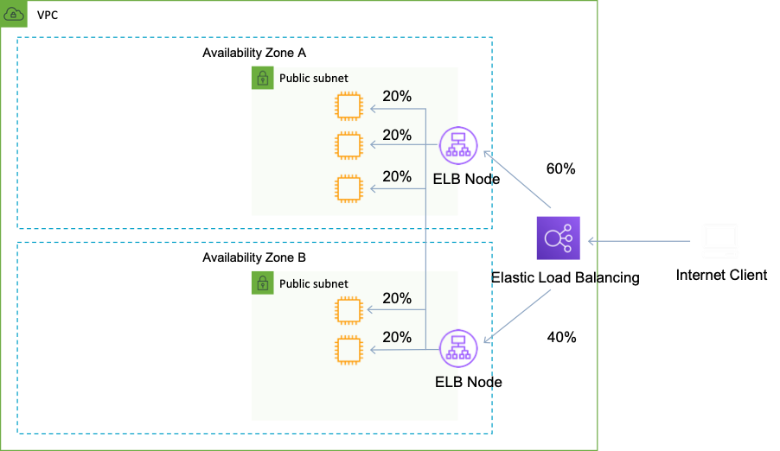

**References:**

<https://docs.aws.amazon.com/elasticloadbalancing/latest/userguide/how-elastic-load-balancing-works.html>

#### **Question 208:**

A Solutions Architect created a new VPC and setup an Auto Scaling Group to maintain a desired count of 2 Amazon EC2 instances. The security team has requested that the EC2 instances be located in a private subnet. To distribute load, an Internet-facing Application Load Balancer (ALB) is also required. With the security team,’s requirements in mind, what else needs to be done to get this configuration to work? (choose 2)

1. Add a NAT gateway to the private subnet
2. Attach an Internet Gateway to the private subnets
3. Add an Elastic IP address to each EC2 instance in the private subnet
4. Associate the public subnets with the ALB
5. For each private subnet create a corresponding public subnet in the same AZ

**Answer :** Associate the public subnets with the ALB

**Answer :** For each private subnet create a corresponding public subnet in the same AZ

**Explanation**

ELB nodes have public IPs and route traffic to the private IP addresses of the EC2 instances. You need one public subnet in each AZ where the ELB is defined and the private subnets are located.

**References:**

<https://aws.amazon.com/premiumsupport/knowledge-center/public-load-balancer-private-ec2/>

#### **Question 209:**

A retail organization sends coupons out twice a week and this results in a predictable surge in sales traffic. The application runs on Amazon EC2 instances behind an Elastic Load Balancer. The organization is looking for ways to reduce cost without impacting performance or reliability. How can they achieve this goal?

1. Purchase Amazon EC2 dedicated hosts
2. Increase the instance size of the existing EC2 instances
3. Use a mixture of spot instances and on demand instances
4. Purchase scheduled reserved instances

**Answer :** Purchase scheduled reserved instances

**Explanation**

Scheduled Reserved Instances (Scheduled Instances) enable you to purchase capacity reservations that recur on a daily, weekly, or monthly basis, with a specified start time and duration, for a one-year term. You reserve the capacity in advance, so that you know it is available when you need it. You pay for the time that the instances are scheduled, even if you do not use them.

Scheduled Instances are a good choice for workloads that do not run continuously, but do run on a regular schedule. For example, you can use Scheduled Instances for an application that runs during business hours or for batch processing that runs at the end of the week.

**References:**

<https://docs.aws.amazon.com/AWSEC2/latest/UserGuide/ec2-scheduled-instances.html>

#### **Question 210:**

An EC2 instance in an Auto Scaling group is having some issues that are causing it to launch new instances based on the dynamic scaling policy. A Solutions Architect needs to troubleshoot the EC2 instance and prevent the Auto Scaling group from launching new instances temporarily. What is the best method to accomplish this? (choose 2)

1. Remove the EC2 instance from the Target Group
2. Suspend the scaling processes responsible for launching new instances
3. Disable the launch configuration associated with the EC2 instance
4. Place the EC2 instance that is experiencing issues into the Standby state
5. Disable the dynamic scaling policy

**Answer :** Place the EC2 instance that is experiencing issues into the Standby state

**Answer :** Suspend the scaling processes responsible for launching new instances

**Explanation**

You can suspend and then resume one or more of the scaling processes for your Auto Scaling group. This can be useful when you want to investigate a configuration problem or other issue with your web application and then make changes to your application, without invoking the scaling processes. You can manually move an instance from an ASG and put it in the standby state.

Instances in standby state are still managed by Auto Scaling, are charged as normal, and do not count towards available EC2 instance for workload/application use. Auto scaling does not perform health checks on instances in the standby state. Standby state can be used for performing updates/changes/troubleshooting etc. without health checks being performed or replacement instances being launched.

**References:**

<https://docs.aws.amazon.com/autoscaling/ec2/userguide/as-suspend-resume-processes.html>

#### **Question 211:**

A Solutions Architect is creating a URL that lets users who sign in to the organization’s network securely access the AWS Management Console. The URL will include a sign-in token that authenticates the user to AWS. Microsoft Active Directory Federation Services is being used as the identity provider (IdP). Which of the steps below will the Solutions Architect need to include when developing the custom identity broker? (choose 2)

1. Generate a pre-signed URL programmatically using the AWS SDK for Java or the AWS SDK for .NET
2. Call the AWS federation endpoint and supply the temporary security credentials to request a sign-in token
3. Call the AWS Security Token Service (AWS STS) AssumeRole or GetFederationToken API operations to obtain temporary security credentials for the user
4. Assume an IAM Role through the console or programmatically with the AWS CLI, Tools for Windows PowerShell or API
5. Delegate access to the IdP through the "Configure Provider" wizard in the IAM console

**Answer:** Call the AWS federation endpoint and supply the temporary security credentials to request a sign-in token

**Answer:** Call the AWS Security Token Service (AWS STS) AssumeRole or GetFederationToken API operations to obtain temporary security credentials for the user

**Explanation**

The aim of this solution is to create a single sign-on solution that enables users signed in to the organization’s Active Directory service to be able to connect to AWS resources. When developing a custom identity broker you use the AWS STS service.

The AWS Security Token Service (STS) is a web service that enables you to request temporary, limited-privilege credentials for IAM users or for users that you authenticate (federated users). The steps performed by the custom identity broker to sign users into the AWS management console are:

- Verify that the user is authenticated by your local identity system

- Call the AWS Security Token Service (AWS STS) AssumeRole or GetFederationToken API operations to obtain temporary security credentials for the user

- Call the AWS federation endpoint and supply the temporary security credentials to request a sign-in token

- Construct a URL for the console that includes the token

- Give the URL to the user or invoke the URL on the user’s behalf

**References:**

<https://docs.aws.amazon.com/IAM/latest/UserGuide/id_roles_providers_enable-console-custom-url.html>

#### **Question 212:**

A Solutions Architect is designing a new retail website for a high-profile company. The company has previously been the victim of targeted distributed denial-of-service (DDoS) attacks and has requested that the design includes mitigation techniques. Which of the following are the BEST techniques to help ensure the availability of the services is not compromised in an attack? (choose 2)

1. Configure Auto Scaling with a high maximum number of instances to ensure it can scale accordingly
2. Use encryption on your EBS volumes
3. Use Spot instances to reduce the cost impact in case of attack
4. Use Placement Groups to ensure high bandwidth and low latency
5. CloudFront for distributing both static and dynamic content

**Answer :** Configure Auto Scaling with a high maximum number of instances to ensure it can scale accordingly

**Answer :** Use CloudFront for distributing both static and dynamic content

**Explanation**

CloudFront distributes traffic across multiple edge locations and filters requests to ensure that only valid HTTP(S) requests will be forwarded to backend hosts. CloudFront also supports geoblocking, which you can use to prevent requests from particular geographic locations from being served.

Auto Scaling helps to maintain a desired count of EC2 instances running at all times and setting a high maximum number of instances allows your fleet to grow and absorb some of the impact of the attack.

**References:**

<https://aws.amazon.com/answers/networking/aws-ddos-attack-mitigation/>

<https://docs.aws.amazon.com/waf/latest/developerguide/tutorials-ddos-cross-service.html>

<https://docs.aws.amazon.com/AmazonRDS/latest/UserGuide/USER_VPC.Scenarios.html>

#### **Question 213:**

A Solutions Architect regularly launches EC2 instances manually from the console and wants to streamline the process to reduce administrative overhead. Which feature of EC2 enables storing of settings such as AMI ID, instance type, key pairs and Security Groups?

1. Launch Configurations
2. Launch Templates
3. Placement Groups
4. Run Command

**Answer :** Launch Templates

**Explanation**

Launch templates enable you to store launch parameters so that you do not have to specify them every time you launch an instance. When you launch an instance using the Amazon EC2 console, an AWS SDK, or a command line tool, you can specify the launch template to use.

**References:**

<https://docs.aws.amazon.com/AWSEC2/latest/UserGuide/ec2-launch-templates.html>

#### **Question 214:**

The Systems Administrators in a company currently use Chef for configuration management of on-premise servers. Which AWS service can a Solutions Architect use that will provide a fully-managed configuration management service that will enable the use of existing Chef cookbooks?

1. CloudFormation
2. Opsworks Stacks
3. OpsWorks for Chef Automate
4. Elastic Beanstalk

**Answer :** OpsWorks for Chef Automate

**Explanation**

AWS OpsWorks is a configuration management service that provides managed instances of Chef and Puppet. AWS OpsWorks for Chef Automate is a fully-managed configuration management service that hosts Chef Automate, a suite of automation tools from Chef for configuration management, compliance and security, and continuous deployment. OpsWorks for Chef Automate is completely compatible with tooling and cookbooks from the Chef community and automatically registers new nodes with your Chef server.

**References:**

<https://aws.amazon.com/opsworks/>

#### **Question 215:**

A company is migrating a decoupled application to AWS. The application uses a message broker based on the MQTT protocol. The application will be migrated to Amazon EC2 instances and the solution for the message broker must not require rewriting application code. Which AWS service can be used for the migrated message broker?

1. Amazon MQ
2. Amazon SQS
3. AWS Step Functions
4. Amazon SNS

**Answer :** Amazon MQ

**Explanation**

Amazon MQ is a managed message broker service for Apache ActiveMQ that makes it easy to set up and operate message brokers in the cloud. Connecting current applications to Amazon MQ is easy because it uses industry-standard APIs and protocols for messaging, including JMS, NMS, AMQP, STOMP, MQTT, and WebSocket. Using standards means that in most cases, there’s no need to rewrite any messaging code when you migrate to AWS.

**References:**

<https://aws.amazon.com/amazon-mq/>

#### **Question 216:**

A Solutions Architect is designing a three-tier web application that includes an Auto Scaling group of Amazon EC2 Instances running behind an Elastic Load Balancer. The security team requires that all web servers must be accessible only through the Elastic Load Balancer and that none of the web servers are directly accessible from the Internet. How should the Architect meet these requirements?

1. Configure the web tier security group to allow only traffic from the Elastic Load Balancer
2. Create an Amazon CloudFront distribution in front of the Elastic Load Balancer
3. Configure the web servers' security group to deny traffic from the Internet
4. Install a Load Balancer on an Amazon EC2 instance

**Answer :** Configure the web tier security group to allow only traffic from the Elastic Load Balancer

**Explanation**

The web servers must be kept private so they will be not have public IP addresses. The ELB is Internet-facing so it will be publicly accessible via it’s DNS address (and corresponding public IP). To restrict web servers to be accessible only through the ELB you can configure the web tier security group to allow only traffic from the ELB. You would normally do this by adding the ELBs security group to the rule on the web tier security group

**References:**

<https://docs.aws.amazon.com/elasticloadbalancing/latest/application/load-balancer-update-security-groups.html>

#### **Question 217:**

A highly elastic application consists of three tiers. The application tier runs in an Auto Scaling group and processes data and writes it to an Amazon RDS MySQL database. The Solutions Architect wants to restrict access to the database tier to only accept traffic from the instances in the application tier. However, instances in the application tier are being constantly launched and terminated. How can the Solutions Architect configure secure access to the database tier?

1. Configure the database security group to allow traffic only from port 3306
2. Configure the database security group to allow traffic only from the application security group
3. Configure a Network ACL on the database subnet to deny all traffic to ports other than 3306
4. Configure a Network ACL on the database subnet to allow all traffic from the application subnet

**Answer :** Configure the database security group to allow traffic only from the application security group

**Explanation**

The best option is to configure the database security group to only allow traffic that originates from the application security group. You can also define the destination port as the database port. This setup will allow any instance that is launched and attached to this security group to connect to the database.

**References:**

<https://docs.aws.amazon.com/vpc/latest/userguide/VPC_SecurityGroups.html>

#### **Question 218:**

An Amazon VPC has been deployed with private and public subnets. A MySQL database server running on an Amazon EC2 instance will soon be launched. According to AWS best practice, which subnet should the database server be launched into?

1. It doesn’t matter
2. The subnet that is mapped to the primary AZ in the region
3. The private subnet
4. The public subnet

**Answer :** The private subnet

**Explanation**

AWS best practice is to deploy databases into private subnets wherever possible. You can then deploy your web front-ends into public subnets and configure these, or an additional application tier to write data to the database.

**References:**

<https://d1.awsstatic.com/whitepapers/Security/AWS_Security_Best_Practices.pdf>

#### **Question 219:**

A Solutions Architect must design a solution for providing single sign-on to existing staff in a company. The staff manage on-premise web applications and also need access to the AWS management console to manage resources in the AWS cloud. Which combination of services are BEST suited to delivering these requirements?

1. Use the AWS Secure Token Service (STS) and SAML
2. Use your on-premise LDAP directory with IAM
3. Use IAM and Amazon Cognito
4. Use IAM and MFA

**Answer :** Use the AWS Secure Token Service (STS) and SAML

**Explanation**

Single sign-on using federation allows users to login to the AWS console without assigning IAM credentials. The AWS Security Token Service (STS) is a web service that enables you to request temporary, limited-privilege credentials for IAM users or for users that you authenticate (such as federated users from an on-premise directory). Federation (typically Active Directory) uses SAML 2.0 for authentication and grants temporary access based on the users AD credentials. The user does not need to be a user in IAM.

**References:**

<https://aws.amazon.com/identity/federation/>

#### **Question 220:**

An application running AWS uses an Elastic Load Balancer (ELB) to distribute connections between EC2 instances. A Solutions Architect needs to record information on the requester, IP, and request type for connections made to the ELB. Additionally, the Architect will also need to perform some analysis on the log files. Which AWS services and configuration options can be used to collect and then analyze the logs? (choose 2)

1. Update the application to use DynamoDB for storing log files
2. Enable Access Logs on the EC2 instances and store the log files on S3
3. Use EMR for analyzing the log files
4. Enable Access Logs on the ELB and store the log files on S3
5. Use Elastic Transcoder to analyze the log files

**Answer :** Use EMR for analyzing the log files

**Answer :** Enable Access Logs on the ELB and store the log files on S3

**Explanation**

The best way to deliver these requirements is to enable access logs on the ELB and then use EMR for analyzing the log files Access Logs on ELB are disabled by default. Information includes information about the clients (not included in CloudWatch metrics) such as the identity of the requester, IP, request type etc. Logs can be optionally stored and retained in S3.

Amazon EMR is a web service that enables businesses, researchers, data analysts, and developers to easily and cost-effectively process vast amounts of data. EMR utilizes a hosted Hadoop framework running on Amazon EC2 and Amazon S3.

**References:**

<https://aws.amazon.com/blogs/aws/access-logs-for-elastic-load-balancers/>

#### **Question 221:**

A website uses web servers behind an Internet-facing Elastic Load Balancer. What record set should be created to point the customer’s DNS zone apex record at the ELB?

1. Create a PTR record pointing to the DNS name of the load balancer
2. Create an A record that is an Alias, and select the ELB DNS as a target
3. Create a CNAME record that is an Alias, and select the ELB DNS as a target
4. Create an A record pointing to the DNS name of the load balancer

**Answer :** Create an A record that is an Alias, and select the ELB DNS as a target

**Explanation**

An Alias record can be used for resolving apex or naked domain names (e.g. example.com). You can create an A record that is an Alias that uses the customer’s website zone apex domain name and map it to the ELB DNS name.

**References:**

<https://docs.aws.amazon.com/Route53/latest/DeveloperGuide/ResourceRecordTypes.html>

#### **Question 222:**

A Solutions Architect is creating the business process workflows associated with an order fulfilment system. What AWS service can assist with coordinating tasks across distributed application components?

1. Amazon SWF
2. Amazon SQS
3. Amazon SNS
4. AWS STS

**Answer :** Amazon SWF

**Explanation**

Amazon Simple Workflow Service (SWF) is a web service that makes it easy to coordinate work across distributed application components. SWF enables applications for a range of use cases, including media processing, web application back-ends, business process workflows, and analytics pipelines, to be designed as a coordination of tasks.

**References:**

<https://aws.amazon.com/swf/>

#### **Question 223:**

A Solutions Architect is designing a web-facing application. The application will run on Amazon EC2 instances behind Elastic Load Balancers in multiple regions in an active/passive configuration. The website address the application runs on is example.com. AWS Route 53 will be used to perform DNS resolution for the application. How should the Solutions Architect configure AWS Route 53 in this scenario based on AWS best practices? (choose 2)

1. Connect the ELBs using Alias records
2. Use a Weighted Routing Policy
3. Set Evaluate Target Health to “No” for the primary
4. Connect the ELBs using CNAME records
5. Use a Failover Routing Policy

**Answer :** Use a Failover Routing Policy

**Answer :** Connect the ELBs using Alias records

**Explanation**

The failover routing policy is used for active/passive configurations. Alias records can be used to map the domain apex (example.com) to the Elastic Load Balancers. Failover routing lets you route traffic to a resource when the resource is healthy or to a different resource when the first resource is unhealthy. The primary and secondary records can route traffic to anything from an Amazon S3 bucket that is configured as a website to a complex tree of records.

**References:**

<https://docs.aws.amazon.com/Route53/latest/DeveloperGuide/routing-policy.html#routing-policy-failover>

#### **Question 224:**

A mobile app uploads usage information to a database. Amazon Cognito is being used for authentication, authorization and user management and users sign-in with Facebook IDs.

In order to securely store data in DynamoDB, the design should use temporary AWS credentials. What feature of Amazon Cognito is used to obtain temporary credentials to access AWS services?

1. Identity Pools
2. User Pools
3. Key Pairs
4. SAML Identity Providers

**Answer :** Identity Pools

**Explanation**

Amazon Cognito identity pools provide temporary AWS credentials for users who are guests (unauthenticated) and for users who have been authenticated and received a token. An identity pool is a store of user identity data specific to your account. With an identity pool, users can obtain temporary AWS credentials to access AWS services, such as Amazon S3 and DynamoDB.

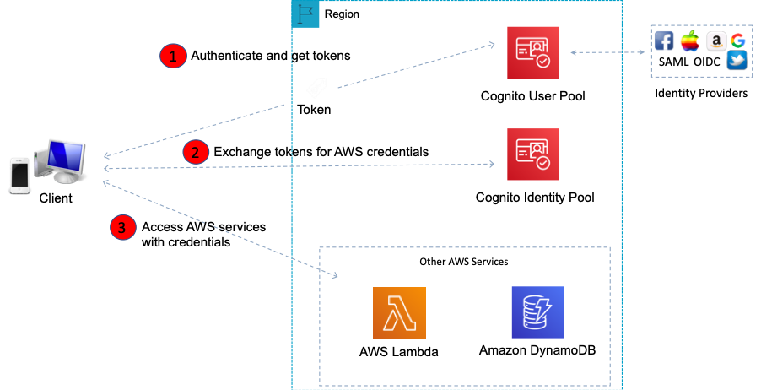

**References:**

<https://docs.aws.amazon.com/cognito/latest/developerguide/identity-pools.html>

#### **Question 225:**

A Solutions Architect attempted to restart a stopped EC2 instance and it immediately changed from a pending state to a terminated state. What are the most likely explanations? (choose 2)

1. The AMI is unsupported
2. AWS does not currently have enough available On-Demand capacity to service your request
3. An EBS snapshot is corrupt
4. You've reached your EBS volume limit
5. You have reached the limit on the number of instances that you can launch in a region

**Answer :** You've reached your EBS volume limit

**Answer :** An EBS snapshot is corrupt

**Explanation**

The following are a few reasons why an instance might immediately terminate:

– You’ve reached your EBS volume limit.

– An EBS snapshot is corrupt.

– The root EBS volume is encrypted and you do not have permissions to access the KMS key for decryption.

– The instance store-backed AMI that you used to launch the instance is missing a required part (an image.part.xx file).

**References:**

<https://docs.aws.amazon.com/AWSEC2/latest/UserGuide/troubleshooting-launch.html>

#### **Question 226:**

A Solutions Architect would like to implement a method of automating the creation, retention, and deletion of backups for the Amazon EBS volumes in an Amazon VPC. What is the easiest way to automate these tasks using AWS tools?

1. Create a scheduled job and run the AWS CLI command “create-backup”
2. Configure EBS volume replication to create a backup on Amazon S3
3. Create a scheduled job and run the AWS CLI command “create-snapshot”
4. Use the EBS Data Lifecycle Manager (DLM) to manage snapshots of the volumes

**Answer :** Use the EBS Data Lifecycle Manager (DLM) to manage snapshots of the volumes

**Explanation**

You backup EBS volumes by taking snapshots. This can be automated via the AWS CLI command “create-snapshot”. However the question is asking for a way to automate not just the creation of the snapshot but the retention and deletion too. The EBS Data Lifecycle Manager (DLM) can automate all of these actions for you and this can be performed centrally from within the management console.

**References:**

<https://docs.aws.amazon.com/AWSEC2/latest/UserGuide/snapshot-lifecycle.html>

<https://docs.aws.amazon.com/cli/latest/reference/ec2/create-snapshot.html>

#### **Question 227:**

When using throttling controls with API Gateway what happens when request submissions exceed the steady-state request rate and burst limits?

1. API Gateway drops the requests and does not return a response to the client
2. API Gateway fails the limit-exceeding requests and returns “500 Internal Server Error” error responses to the client
3. The requests will be buffered in a cache until the load reduces
4. API Gateway fails the limit-exceeding requests and returns “429 Too Many Requests” error responses to the client

**Answer :** API Gateway fails the limit-exceeding requests and returns “429 Too Many Requests

**Explanation**

You can throttle and monitor requests to protect your backend. Resiliency through throttling rules based on the number of requests per second for each HTTP method (GET, PUT). Throttling can be configured at multiple levels including Global and Service Call. When request submissions exceed the steady-state request rate and burst limits, API Gateway fails the limit-exceeding requests and returns 429 Too Many Requests error responses to the client.

**References:**

<https://docs.aws.amazon.com/apigateway/latest/developerguide/api-gateway-request-throttling.html>

#### **Question 228:**

A Solutions Architect needs to select a low-cost, short-term option for adding resilience to an AWS Direct Connect connection. What is the MOST cost-effective solution to provide a backup for the Direct Connect connection?

1. Implement a second AWS Direct Connection
2. Configure an IPSec VPN connection over the Direct Connect link
3. Configure AWS Transit Gateway with an IPSec VPN backup
4. Implement an IPSec VPN connection and use the same BGP prefix

**Answer :** Implement an IPSec VPN connection and use the same BGP prefix

**Explanation**

This is the most cost-effective solution. With this option both the Direct Connect connection and IPSec VPN are active and being advertised using the Border Gateway Protocol (BGP). The Direct Connect link will always be preferred unless it is unavailable.

**References:**

<https://aws.amazon.com/premiumsupport/knowledge-center/configure-vpn-backup-dx/>

#### **Question 229:**

A Solutions Architect is designing an application that will run on an Amazon EC2 instance. The application must asynchronously invoke an AWS Lambda function to analyze thousands of .CSV files. The services should be decoupled. Which service can be used to decouple the compute services?

1. Amazon SNS
2. Amazon OpsWorks
3. Amazon Kinesis
4. Amazon SWF

**Answer :** Amazon SNS

**Explanation**

You can use a Lambda function to process Amazon Simple Notification Service notifications. Amazon SNS supports Lambda functions as a target for messages sent to a topic. This solution decouples the Amazon EC2 application from Lambda and ensures the Lambda function is invoked.

**References:**

<https://docs.aws.amazon.com/lambda/latest/dg/with-sns.html>

#### **Question 230:**

An application in an Amazon VPC uses an Auto Scaling Group that spans 3 AZs and there are currently 4 Amazon EC2 instances running in the group. What actions will Auto Scaling take, by default, if it needs to terminate an EC2 instance? (choose 2)

1. Terminate the instance with the least active network connections. If multiple instances meet this criterion, one will be randomly selected
2. Send an SNS notification, (if configured)
3. Terminate an instance in the AZ which currently has 2 running EC2 instances
4. Randomly select one of the 3 AZs, and then terminate an instance in that AZ
5. Wait for the cooldown period and then terminate the instance that has been running the longest

**Answer :** Send an SNS notification, if configured to do so

**Answer :** Terminate an instance in the AZ which currently has 2 running EC2 instances

**Explanation**

Auto Scaling can perform rebalancing when it finds that the number of instances across AZs is not balanced. Auto Scaling rebalances by launching new EC2 instances in the AZs that have fewer instances first, only then will it start terminating instances in AZs that had more instances

Auto Scaling can be configured to send an SNS email when:

– An instance is launched.

– An instance is terminated.

– An instance fails to launch.

– An instance fails to terminate.

**References:**

<https://docs.aws.amazon.com/autoscaling/ec2/userguide/as-instance-termination.html>

#### **Question 231:**

A Solutions Architect is building a new Amazon Elastic Container Service (ECS) cluster. The ECS instances are running the EC2 launch type and load balancing is required to distribute connections to the tasks. It is required that the mapping of ports is performed dynamically and connections are routed to different groups of servers based on the path in the URL. Which AWS service should the Solutions Architect choose to fulfil these requirements?

1. Classic Load Balancer
2. An Amazon ECS Service
3. Application Load Balancer
4. Network Load Balancer

**Answer :** Application Load Balancer

**Explanation**

An ALB allows containers to use dynamic host port mapping so that multiple tasks from the same service are allowed on the same container host. An ALB can also route requests based on the content of the request in the host field: host-based or path-based.

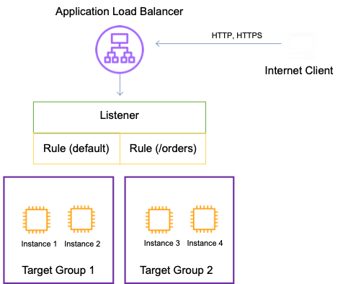

The NLB and CLB types of Elastic Load Balancer do not support path-based routing or host-based routing so they cannot be used for this use case.

**References:**

<https://aws.amazon.com/premiumsupport/knowledge-center/dynamic-port-mapping-ecs/>

<https://docs.aws.amazon.com/elasticloadbalancing/latest/application/tutorial-load-balancer-routing.html>

#### **Question 232:**

A Solutions Architect is creating a design for a multi-tiered serverless application. Which two services form the application facing services from the AWS serverless infrastructure? (choose 2)

1. AWS Cognito
2. Elastic Load Balancer
3. API Gateway
4. Amazon ECS
5. AWS Lambda

**Answer :** API Gateway

**Answer :** AWS Lambda

**Explanation**

The only application services here are API Gateway and Lambda and these are considered to be serverless services.

**References:**

<https://aws.amazon.com/serverless/>

#### **Question 233:**

An Amazon ElastiCache for Redis cluster runs across multiple Availability Zones. A solutions architect is concerned about the security of sensitive data as it is replicated between nodes. How can the solutions architect protect the sensitive data?

1. Set up MFA and API logging
2. Issue a Redis AUTH command
3. Enable in-transit encryption
4. Enable at-rest encryption

**Answer :** Enable in-transit encryption

**Explanation**

Amazon ElastiCache in-transit encryption is an optional feature that allows you to increase the security of your data at its most vulnerable points—when it is in transit from one location to another. Because there is some processing needed to encrypt and decrypt the data at the endpoints, enabling in-transit encryption can have some performance impact. You should benchmark your data with and without in-transit encryption to determine the performance impact for your use cases. ElastiCache in-transit encryption implements the following features:

- **Encrypted connections**—both the server and client connections are Secure Socket Layer (SSL) encrypted.

- **Encrypted replication—**data moving between a primary node and replica nodes is encrypted.

- **Server authentication**—clients can authenticate that they are connecting to the right server.

- **Client authentication**—using the Redis AUTH feature, the server can authenticate the clients.

**References:**

<https://docs.aws.amazon.com/AmazonElastiCache/latest/red-ug/at-rest-encryption.html>

#### **Question 234:**

A Solutions Architect has deployed an API using Amazon API Gateway and created usage plans and API keys for several customers. Requests from one particular customer have been excessive and the solutions architect needs to limit the rate of requests. Other customers should not be affected. How should the solutions architect proceed?

1. Configure the per-method throttling limits
2. Configure per-client throttling limits
3. Configure a server-side throttling limit
4. Configure the account-level throttling limits

**Answer :** Configure per-client throttling limits

**Explanation**

Per-client throttling limits are applied to clients that use API keys associated with your usage policy as client identifier. This can be applied to the single customer that is issuing excessive API requests. This is the best option to ensure that only one customer is affected.

In the diagram below, per-client throttling limits are set in a usage plan:

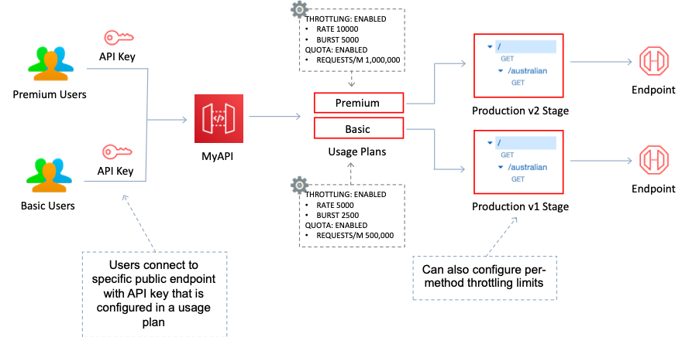

**References:**

<https://docs.aws.amazon.com/apigateway/latest/developerguide/api-gateway-request-throttling.html>

#### **Question 235:**

A Solutions Architect is designing an application for processing and extracting data from log files. The log files are generated by an application and the number and frequency of updates varies. The files are up to 1 GB in size and processing will take around 40 seconds for each file. Which solution is the most cost-effective?

1. Write the log files to an Amazon EC2 instance with an attached EBS volume. After processing, save the files to an Amazon S3 bucket
2. Write the log files to an Amazon SQS queue. Use AWS Lambda to process the files from the queue and save to an Amazon S3 bucket
3. Write the log files to an Amazon S3 bucket. Create an event notification to invoke an Amazon ECS task to process the files and save to an Amazon S3 bucket
4. Write the log files to an Amazon S3 bucket. Create an event notification to invoke an AWS Lambda function that will process the files

**Answer :** Write the log files to an Amazon S3 bucket. Create an event notification to invoke an AWS Lambda function that will process the files

**Explanation**

The question asks for the most cost-effective solution and therefor a serverless and automated solution will be the best choice. AWS Lambda can run custom code in response to Amazon S3 bucket events. You upload your custom code to AWS Lambda and create a function. When Amazon S3 detects an event of a specific type (for example, an object created event), it can publish the event to AWS Lambda and invoke your function in Lambda. In response, AWS Lambda executes your function.

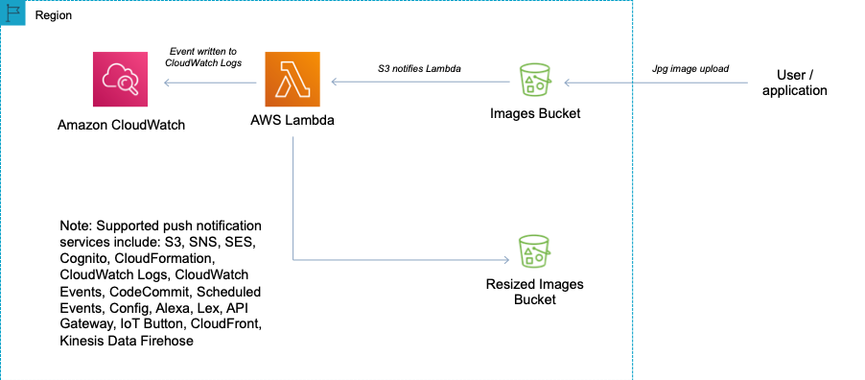

**References:**

<https://docs.aws.amazon.com/AmazonS3/latest/dev/NotificationHowTo.html>

#### **Question 236:**

Amazon CloudWatch is being used to monitor the performance of AWS Lambda. Which metrics does Lambda track? (choose 2)

1. Total number of requests
2. Total number of connections
3. Latency per request
4. Total number of transactions
5. Number of users

**Answer :** Total number of requests

**Answer :** Latency per request

**Explanation**

AWS Lambda automatically monitors Lambda functions and reports metrics through Amazon CloudWatch. Lambda tracks the number of requests, the latency per request, and the number of requests resulting in an error. You can view the request rates and error rates using the AWS Lambda Console, the CloudWatch console, and other AWS resources.

**References:**

<https://docs.aws.amazon.com/lambda/latest/dg/monitoring-metrics.html>

#### **Question 237:**

An event in CloudTrail is the record of an activity in an AWS account. What are the two types of events that can be logged in CloudTrail? (choose 2)

1. Platform Events which are also known as hardware level operations
2. System Events which are also known as instance level operations
3. Control Events which are also known as data plane operations
4. Management Events which are also known as control plane operations
5. Data Events which are also known as data plane operations

**Answer :** Data Events which are also known as data plane operations

**Answer :** Management Events which are also known as control plane operations

**Explanation**

Trails can be configured to log Data events and management events:

**Data events:** These events provide insight into the resource operations performed on or within a resource. These are also known as data plane operations

**Management events:** Management events provide insight into management operations that are performed on resources in your AWS account. These are also known as control plane operations. Management events can also include non-API events that occur in your account

**References:**

<https://docs.aws.amazon.com/awscloudtrail/latest/userguide/logging-management-and-data-events-with-cloudtrail.html>

#### **Question 238:**

An application running in an on-premise data center writes data to a MySQL database. A Solutions Architect is re-architecting the application and plans to move the database layer into the AWS cloud on Amazon RDS. The application layer will run in the on-premise data center. What must be done to connect the application to the RDS database via the Internet? (choose 2)

1. Create a DB subnet group that is publicly accessible
2. Select a public IP within the DB subnet group to assign to the RDS instance
3. Create a security group allowing access from the on-premise public IP to the RDS instance and assign to the RDS instance
4. Configure a NAT Gateway and attach the RDS database
5. Choose to make the RDS instance publicly accessible and place it in a public subnet

**Answer :** Choose to make the RDS instance publicly accessible and place it in a public subnet

**Answer :** Create a security group allowing access from the on-premise public IP to the RDS instance and assign to the RDS instance

**Explanation**

When you create the RDS instance, you need to select the option to make it publicly accessible. A security group will need to be created and assigned to the RDS instance to allow access from the public IP address of your application (or firewall).

**References:**

<https://docs.aws.amazon.com/AmazonRDS/latest/UserGuide/USER_VPC.Scenarios.html#USER_VPC.Scenario4>

#### **Question 239:**

An application analyzes images of people that are uploaded to an Amazon S3 bucket. The application determines demographic data which is then saved to a .CSV file in another S3 bucket. The data must be encrypted at rest and then queried using SQL. The solution should be fully serverless. Which actions should a Solutions Architect take to encrypt and query the data?

1. Use AWS KMS encryption keys for the S3 bucket and use Amazon Athena to query the data
2. Use AWS KMS encryption keys for the S3 bucket and use Amazon Kinesis Data Analytics to query the data
3. Use Amazon S3 server-side encryption and Amazon QuickSight to query the data
4. Use Amazon S3 server-side encryption and use Amazon RedShift Spectrum to query the data

**Answer :** Use AWS KMS encryption keys for the S3 bucket and use Amazon Athena to query the data

**Explanation**

Amazon Athena is an interactive query service that makes it easy to analyze data in Amazon S3 using standard SQL. Athena is serverless, so there is no infrastructure to manage, and you pay only for the queries that you run. Amazon Athena supports encrypted data for both the source data and query results, for example, using Amazon S3 with AWS KMS.

**References:**

<https://d1.awsstatic.com/whitepapers/architecture/wellarchitected-Machine-Learning-Lens.pdf>

<https://aws.amazon.com/athena/>

#### **Question 240:**

An existing Auto Scaling group is running with eight Amazon EC2 instances. A Solutions Architect has attached an Elastic Load Balancer (ELB) to the Auto Scaling group by connecting a Target Group. The ELB is in the same region and already has ten EC2 instances running in the Target Group. When attempting to attach the ELB the request immediately fails, what is the MOST likely cause?

1. You cannot attach running EC2 instances to an ASG
2. Adding the 10 EC2 instances to the ASG would exceed the maximum capacity configured
3. One or more of the instances are unhealthy
4. ASGs cannot be edited once defined, you would need to recreate it

**Answer :** Adding the 10 EC2 instances to the ASG would exceed the maximum capacity configured

**Explanation**

You can attach one or more Target Groups to your ASG to include instances behind an ALB and the ELBs must be in the same region. Once you do this any EC2 instance existing or added by the ASG will be automatically registered with the ASG defined ELBs. If adding an instance to an ASG would result in exceeding the maximum capacity of the ASG the request will fail.

**References:**

<https://docs.aws.amazon.com/autoscaling/ec2/userguide/attach-load-balancer-asg.html>

#### **Question 241:**

A client has made some updates to their web application. The application uses an Auto Scaling Group to maintain a group of several EC2 instances. The application has been modified and a new AMI must be used for launching any new instances. What does a Solutions Architect need to do to add the new AMI?

1. Create a new launch configuration that uses the AMI and update the ASG to use the new launch configuration
2. Suspend Auto Scaling and replace the existing AMI
3. Modify the existing launch configuration to add the new AMI
4. Create a new target group that uses a new launch configuration with the new AMI

**Answer :** Create a new launch configuration that uses the AMI and update the ASG to use the new launch configuration

**Explanation**

A launch configuration is the template used to create new EC2 instances and includes parameters such as instance family, instance type, AMI, key pair and security groups. You cannot edit a launch configuration once defined. In this case you can create a new launch configuration that uses the new AMI and any new instances that are launched by the ASG will use the new AMI.

**References:**

<https://docs.aws.amazon.com/autoscaling/ec2/userguide/LaunchConfiguration.html>

#### **Question 242:**

There is new requirement for a database that will store a large number of records for an online store. You are evaluating the use of DynamoDB. Which of the following are AWS best practices for DynamoDB? (choose 2)

1. Use large files
2. Store objects larger than 400KB in S3 and use pointers in DynamoDB
3. Use for BLOB data use cases
4. Store more frequently and less frequently accessed data in separate tables
5. Use separate local secondary indexes for each item

**Answer :** Store objects larger than 400KB in S3 and use pointers in DynamoDB

**Answer :** Store more frequently and less frequently accessed data in separate tables

**Explanation**

DynamoDB best practices include:

- Keep item sizes small.

- If you are storing serial data in DynamoDB that will require actions based on data/time use separate tables for days, weeks, months.

- Store more frequently and less frequently accessed data in separate tables.

- If possible compress larger attribute values.

- Store objects larger than 400KB in S3 and use pointers (S3 Object ID) in DynamoDB.

**References:**

<https://docs.aws.amazon.com/amazondynamodb/latest/developerguide/best-practices.html>

#### **Question 243:**

A Solutions Architect is designing the messaging and streaming layers of a serverless application. The messaging layer will manage communications between components and the streaming layer will manage real-time analysis and processing of streaming data. The Architect needs to select the most appropriate AWS services for these functions. Which services should be used for the messaging and streaming layers? (choose 2)

1. Use Amazon Kinesis for collecting, processing and analyzing real-time streaming data
2. Use Amazon SWF for providing a fully managed messaging service
3. Use Amazon EMR for collecting, processing and analyzing real-time streaming data
4. Use AWS CloudTrail for collecting, processing and analyzing real-time streaming data
5. Use Amazon SNS for providing a fully managed messaging service

**Answer :** Use Amazon Kinesis for collecting, processing and analyzing real-time streaming data

**Answer :** Use Amazon SNS for providing a fully managed messaging service

**Explanation**

Amazon Kinesis makes it easy to collect, process, and analyze real-time streaming data. With Amazon Kinesis Analytics, you can run standard SQL or build entire streaming applications using SQL

Amazon Simple Notification Service (Amazon SNS) provides a fully managed messaging service for pub/sub patterns using asynchronous event notifications and mobile push notifications for microservices, distributed systems, and serverless applications.

**References:**

<https://aws.amazon.com/kinesis/>

<https://aws.amazon.com/sns/>

#### **Question 244:**

A Solutions Architect is designing a migration strategy for a company moving to the AWS Cloud. The company use a shared Microsoft filesystem that uses Distributed File System Namespaces (DFSN). What will be the MOST suitable migration strategy for the filesystem?

1. Use AWS DataSync to migrate to Amazon FSx for Windows File Server
2. Use the AWS Server Migration Service to migrate to Amazon FSx for Lustre
3. Use AWS DataSync to migrate to an Amazon EFS filesystem
4. Use the AWS Server Migration Service to migrate to an Amazon S3 bucket

**Answer :** Use AWS DataSync to migrate to Amazon FSx for Windows File Server

**Explanation**

The destination filesystem should be Amazon FSx for Windows File Server. This supports DFSN and is the most suitable storage solution for Microsoft filesystems. AWS DataSync supports migrating to the Amazon FSx and automates the process.

**References:**

<https://aws.amazon.com/blogs/storage/migrate-to-amazon-fsx-for-windows-file-server-using-aws-datasync/>

<https://docs.aws.amazon.com/fsx/latest/WindowsGuide/migrate-files-fsx.html>

#### **Question 245:**

A company has deployed an API using Amazon API Gateway. There are many repeat requests and a solutions architect has been asked to implement measures to reduce request latency and the number of calls to the Amazon EC2 endpoint. How can this be most easily achieved?

1. Configure a private endpoint place ElastiCache in front
2. Configure an edge-optimized endpoint with CloudFront
3. Create a cache for a method and configure a TTL
4. Create a cache for a stage and configure a TTL

**Answer :** Create a cache for a stage and configure a TTL

**Explanation**

You can enable API caching in Amazon API Gateway to cache your endpoint's responses. With caching, you can reduce the number of calls made to your endpoint and also improve the latency of requests to your API. When you enable caching for a stage, API Gateway caches responses from your endpoint for a specified time-to-live (TTL) period, in seconds. API Gateway then responds to the request by looking up the endpoint response from the cache instead of making a request to your endpoint. The default TTL value for API caching is 300 seconds. The maximum TTL value is 3600 seconds. TTL=0 means caching is disabled.

**References:**

<https://docs.aws.amazon.com/apigateway/latest/developerguide/api-gateway-caching.html>

#### **Question 246:**

A new application runs on Amazon EC2 instances and uses API Gateway and AWS Lambda. The company is planning on running an advertising campaign that will likely result in significant hits to the application after each ad is run. A Solutions Architect is concerned about the impact this may have on the application and would like to put in place some controls to limit the number of requests per second that hit the application. What controls should the Solutions Architect implement?

1. Enable Lambda continuous scaling
2. Enable caching on the API Gateway and specify a size in gigabytes
3. API Gateway and Lambda scale automatically to handle any load so there’s no need to implement controls
4. Implement throttling rules on the API Gateway

**Answer :** Implement throttling rules on the API Gateway

**Explanation**

The key requirement is to limit the number of requests per second that hit the application. This can only be done by implementing throttling rules on the API Gateway. Throttling enables you to throttle the number of requests to your API which in turn means less traffic will be forwarded to your application server.

**References:**

<https://docs.aws.amazon.com/apigateway/latest/developerguide/api-gateway-request-throttling.html>

#### **Question 247:**

A Solutions Architect is creating an application design with several components that will be publicly addressable. The Architect would like to use Alias records. Using Route 53 Alias records what targets can you specify? (choose 2)

1. Elastic BeanStalk environment
2. On-premise web server
3. EFS filesystem
4. ElastiCache cluster
5. CloudFront distribution

**Answer :** CloudFront distribution

**Answer :** Elastic Beanstalk environment

**Explanation**

Alias records are used to map resource record sets in your hosted zone to Amazon Elastic Load Balancing load balancers, API Gateway custom regional APIs and edge-optimized APIs, CloudFront Distributions, AWS Elastic Beanstalk environments, Amazon S3 buckets that are configured as website endpoints, Amazon VPC interface endpoints, and to other records in the same Hosted Zone.

**References:**

<https://docs.aws.amazon.com/Route53/latest/DeveloperGuide/resource-record-sets-choosing-alias-non-alias.html>

#### **Question 248:**

A Solutions Architect is building a small web application running on Amazon EC2 that will be serving static content. The user base is spread out globally and speed is important. Which AWS service can deliver the best user experience cost-effectively and reduce the load on the web server?

1. Amazon S3
2. Amazon RedShift
3. Amazon EBS volume
4. Amazon CloudFront

**Answer :** Amazon CloudFront

**Explanation**

This is a good use case for Amazon CloudFront as the user base is spread out globally and CloudFront can cache the content closer to users and also reduce the load on the web server running on EC2.

**References:**

<https://docs.aws.amazon.com/AmazonCloudFront/latest/DeveloperGuide/Introduction.html>

#### **Question 249:**

A new financial platform has been re-architected to use Docker containers in a micro-services architecture. The new architecture will be implemented on AWS and a Solutions Architect must recommend the solution configuration. For operational reasons, it will be necessary to access the operating system of the instances on which the containers run. Which solution delivery option should the Architect select?

1. ECS with the EC2 launch type
2. ECS with the Fargate launch type
3. ECS with a default cluster
4. EKS with Kubernetes managed infrastructure

**Answer :** ECS with the EC2 launch type

**Explanation**

Amazon Elastic Container Service (ECS) is a highly scalable, high performance container management service that supports Docker containers and allows you to easily run applications on a managed cluster of Amazon EC2 instances. The EC2 Launch Type allows you to run containers on EC2 instances that you manage so you will be able to access the operating system instances.

**References:**

<https://aws.amazon.com/ecs/features/>

#### **Question 250:**

A manager is concerned that the default service limits my soon be reached for several AWS services. Which AWS tool can a Solutions Architect use to display current usage and limits?

1. AWS Systems Manager
2. Amazon CloudWatch
3. AWS Dashboard
4. AWS Trusted Advisor

**Answer :** AWS Trusted Advisor

**Explanation**

Trusted Advisor is an online resource to help you reduce cost, increase performance, and improve security by optimizing your AWS environment. Trusted Advisor provides real time guidance to help you provision your resources following AWS best practices. AWS Trusted Advisor offers a Service Limits check (in the Performance category) that displays your usage and limits for some aspects of some services.

**References:**

<https://docs.aws.amazon.com/general/latest/gr/aws_service_limits.html>

<https://aws.amazon.com/premiumsupport/technology/trusted-advisor/>

#### **Question 251:**

A Solutions Architect needs to migrate an Oracle database running on RDS onto Amazon RedShift to improve performance and reduce cost. Which combination of tasks using AWS services should be used to execute the migration? (choose 2)

1. Enable log shipping from the Oracle database to RedShift
2. Take a snapshot of the Oracle database and restore the snapshot onto RedShift
3. Convert the schema using the AWS Schema Conversion Tool
4. Migrate the database using the AWS Database Migration Service (DMS)
5. Configure API Gateway to extract, transform and load the data into RedShift

**Answer :** Migrate the database using the AWS Database Migration Service (DMS)

**Answer :** Convert the schema using the AWS Schema Conversion Tool

**Explanation**

Convert the data warehouse schema and code from the Oracle database running on RDS using the AWS Schema Conversion Tool (AWS SCT) then migrate data from the Oracle database to Amazon Redshift using the AWS Database Migration Service (AWS DMS)

**References:**

<https://aws.amazon.com/getting-started/projects/migrate-oracle-to-amazon-redshift/>

#### **Question 252:**

An organization is planning their disaster recovery solution. They plan to run a scaled down version of a fully functional environment. In a DR situation the recovery time must be minimized. Which DR strategy should a Solutions Architect recommend?

1. Warm standby
2. Pilot light
3. Backup and restore
4. Multi-site

**Answer :** Warm standby

**Explanation**

The term warm standby is used to describe a DR scenario in which a scaled-down version of a fully functional environment is always running in the cloud. A warm standby solution extends the pilot light elements and preparation. It further decreases the recovery time because some services are always running. By identifying your business-critical systems, you can fully duplicate these systems on AWS and have them always on.

**References:**

<https://aws.amazon.com/blogs/publicsector/rapidly-recover-mission-critical-systems-in-a-disaster/>

#### **Question 253:**

The application development team in a company have created a new application written in .NET. A Solutions Architect is looking for a way to easily deploy the application whilst maintaining full control of the underlying resources. Which PaaS service provided by AWS would BEST suit this requirement?

1. CloudFront
2. EC2 Placement Groups
3. Elastic Beanstalk
4. CloudFormation

**Answer :** Elastic Beanstalk

**Explanation**

AWS Elastic Beanstalk can be used to quickly deploy and manage applications in the AWS Cloud. Developers upload applications and Elastic Beanstalk handles the deployment details of capacity provisioning, load balancing, auto-scaling, and application health monitoring. It is considered to be a Platform as a Service (PaaS) solution and allows full control of the underlying resources.

**References:**

<https://aws.amazon.com/elasticbeanstalk/>

#### **Question 254:**

A Solutions Architect is designing the compute layer of a serverless application. The compute layer will manage requests from external systems, orchestrate serverless workflows, and execute the business logic. The Architect needs to select the most appropriate AWS services for these functions. Which services should be used for the compute layer? (choose 2)

1. Use Amazon ECS for executing the business logic
2. Use AWS Elastic Beanstalk for executing the business logic
3. Use Amazon API Gateway with AWS Lambda for executing the business logic
4. Use AWS CloudFormation for orchestrating serverless workflows
5. Use AWS Step Functions for orchestrating serverless workflows

**Answer :** Use AWS Step Functions for orchestrating serverless workflows

**Answer :** Use Amazon API Gateway with AWS Lambda for executing the business logics

**Explanation**

With Amazon API Gateway, you can run a fully managed REST API that integrates with Lambda to execute your business logic and includes traffic management, authorization and access control, monitoring, and API versioning. AWS Step Functions orchestrates serverless workflows including coordination, state, and function chaining as well as combining long-running executions not supported within Lambda execution limits by breaking into multiple steps or by calling workers running on Amazon Elastic Compute Cloud (Amazon EC2) instances or on-premises.

**References:**

<https://aws.amazon.com/step-functions/>

#### **Question 255:**

An Amazon EC2 instance running a video on demand web application has been experiencing high CPU utilization. A Solutions Architect needs to take steps to reduce the impact on the EC2 instance and improve performance for consumers. Which of the steps below would help?

1. Create a CloudFront RTMP distribution and point it at the EC2 instance
2. Use ElastiCache as the web front-end and forward connections to EC2 for cache misses
3. Create an ELB and place it in front of the EC2 instance
4. Create a CloudFront distribution and configure a custom origin pointing at the EC2 instance

**Answer :** Create a CloudFront distribution and configure a custom origin pointing at the EC2 instance

**Explanation**

This is a good use case for CloudFront which is a content delivery network (CDN) that caches content to improve performance for users who are consuming the content. This will take the load off of the EC2 instances as CloudFront has a cached copy of the video files. An origin is the origin of the files that the CDN will distribute. Origins can be either an S3 bucket, an EC2 instance, and Elastic Load Balancer, or Route 53 – can also be external (non-AWS).

**References:**

<https://docs.aws.amazon.com/cloudfront/latest/APIReference/API_Origin.html>

Gbrfg

#### **Question 256:**

A Solutions Architect is deploying a high performance computing (HPC) application on Amazon EC2 instances. The application requires extremely low inter-instance latency. How should the instances be deployed for BEST performance?

1. Use an Elastic Fabric Adapter (EFA) and deploy instances in a cluster placement group
2. Use an EBS-optimized instance with 10 Gigabit networking and deploy to a single subnet
3. Add multiple Elastic Network Adapters (ENAs) to each instance and create a NIC team
4. Use an instance with enhanced networking and deploy the instances in a partition placement group

**Answer :** Use an Elastic Fabric Adapter (EFA) and deploy instances in a cluster placement group

**Explanation**

It is recommended to use either enhanced networking or an Elastic Fabric Adapter (EFA) for the nodes of an HPC application. This will assist with decreasing latency. Additionally, a cluster placement group packs instances close together inside an Availability Zone. Using a cluster placement group enables workloads to achieve the low-latency network performance necessary for tightly-coupled node-to-node communication that is typical of HPC applications.

The table below helps you to understand the key differences between the different placement group options:

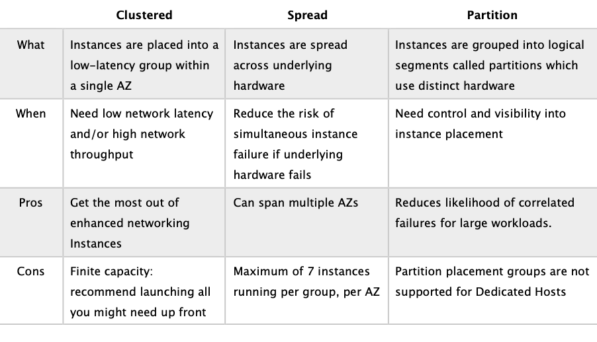

**References:**

<https://docs.aws.amazon.com/AWSEC2/latest/UserGuide/placement-groups.html>

<https://docs.aws.amazon.com/AWSEC2/latest/UserGuide/efa.html>

#### **Question 257:**

A company runs an API on a Linux server in their on-premises data center. The company are planning to migrate the API to the AWS cloud. The company require a highly available, scalable and cost-effective solution. What should a Solutions Architect recommend?

1. Migrate the API to Amazon API Gateway and use AWS Lambda as the backend
2. Migrate the API to Amazon CloudFront and use AWS Lambda as the origin
3. Migrate the API to Amazon API Gateway and migrate the backend to Amazon EC2
4. Migrate the API server to Amazon EC2 instances in an Auto Scaling group and attach an Application Load Balancer

**Answer :** Migrate the API to Amazon API Gateway and use AWS Lambda as the backend

**Explanation**

The best option is to use a fully serverless solution. This will provide high availability, scalability and be cost-effective. The components for this would be Amazon API Gateway for hosting the API and AWS Lambda for running the backend. As you can see in the image below, API Gateway can be the frontend for multiple backend services:

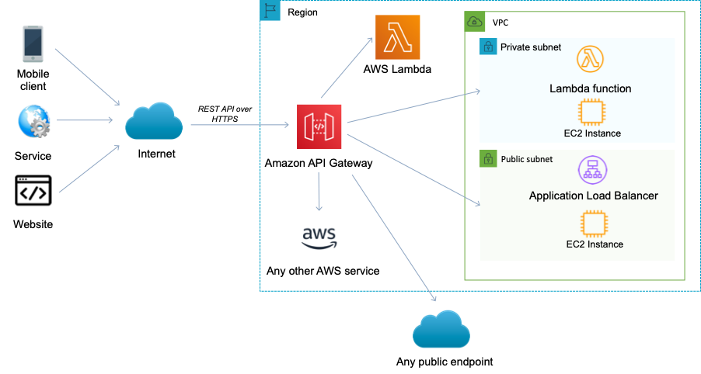

**References:**

<https://docs.aws.amazon.com/apigateway/latest/developerguide/getting-started-with-lambda-integration.html>

#### **Question 258:**

A Solutions Architect is creating a design for a two-tier application with a MySQL RDS back-end. The performance requirements of the database tier are hard to quantify until the application is running and the Architect is concerned about right-sizing the database. What methods of scaling are possible after the MySQL RDS database is deployed? (choose 2)

1. Horizontal scaling for read and write by enabling Multi-Master RDS DB
2. Vertical scaling for read and write by using Transfer Acceleration
3. Vertical scaling for read and write by choosing a larger instance size
4. Horizontal scaling for write capacity by enabling Multi-AZ
5. Horizontal scaling for read capacity by creating a read-replica

**Answer :** Vertical scaling for read and write by choosing a larger instance size

**Answer :** Horizontal scaling for read capacity by creating a read-replica

**Explanation**

To handle a higher load in your database, you can vertically scale up your master database with a simple push of a button. In addition to scaling your master database vertically, you can also improve the performance of a read-heavy database by using read replicas to horizontally scale your database.

**References:**

<https://aws.amazon.com/blogs/database/scaling-your-amazon-rds-instance-vertically-and-horizontally/>

#### **Question 259:**

A Solutions Architect is conducting an audit and needs to query several properties of EC2 instances in a VPC. What two methods are available for accessing and querying the properties of an EC2 instance such as instance ID, public keys and network interfaces? (choose 2)

1. Run the command “curl http://169.254.169.254/latest/meta-data/”
2. Download and run the Instance Metadata Query Tool
3. Use the EC2 Config service
4. Runthe command “curl http://169.254.169.254/latest/dynamic/instance-identity/”
5. Use the Batch command

**Answer :** Run the command “curl <http://169.254.169.254/latest/meta-data/>”

**Answer :** Download and run the Instance Metadata Query Tool

**Explanation**

This information is stored in the instance metadata on the instance. You can access the instance metadata through a URI or by using the Instance Metadata Query tool. The instance metadata is available at <http://169.254.169.254/latest/meta-data>. The Instance Metadata Query tool allows you to query the instance metadata without having to type out the full URI or category names.

**References:**

<https://docs.aws.amazon.com/AWSEC2/latest/UserGuide/ec2-instance-metadata.html>

#### **Question 260:**

A Solutions Architect is writing some code that uses an AWS Lambda function and would like to enable the function to connect to an Amazon ElastiCache cluster within an Amazon VPC in the same AWS account. What VPC-specific information must be included in the function to enable this configuration? (choose 2)

1. VPC Logical IDs
2. VPC Route Table IDs
3. VPC Subnet IDs
4. VPC Peering IDs
5. VPC Security Group IDs

**Answer :** VPC Subnet IDs

**Answer :** VPC Security Group IDs

**Explanation**

To enable your Lambda function to access resources inside your private VPC, you must provide additional VPC-specific configuration information that includes VPC subnet IDs and security group IDs. AWS Lambda uses this information to set up elastic network interfaces (ENIs) that enable your function.

Please see the AWS article linked below for more details on the requirements

**References:**

<https://docs.aws.amazon.com/lambda/latest/dg/vpc.html>

#### **Question 261:**

A Solutions Architect just completed the implementation of a 2-tier web application for a client. The application uses Amazon EC2 instances, Amazon ELB and Auto Scaling across two subnets. After deployment the Solutions Architect noticed that only one subnet has EC2 instances running in it. What might be the cause of this situation?

1. The AMI is missing from the ASG’s launch configuration
2. The Auto Scaling Group has not been configured with multiple subnets
3. Cross-zone load balancing is not enabled on the ELB
4. The ELB is configured as an internal-only load balancer

**Answer :** The Auto Scaling Group has not been configured with multiple subnets

**Explanation**

You can specify which subnets Auto Scaling will launch new instances into. Auto Scaling will try to distribute EC2 instances evenly across AZs. If only one subnet has EC2 instances running in it the first thing to check is that you have added all relevant subnets to the configuration.

**References:**

<https://docs.aws.amazon.com/autoscaling/ec2/userguide/asg-in-vpc.html>

#### **Question 262:**

A Solutions Architect manages multiple Amazon RDS MySQL databases. To improve security, the Solutions Architect wants to enable secure user access with short-lived credentials. How can these requirements be met?

1. Configure the MySQL databases to use the AWS Security Token Service (STS)
2. Configure the MySQL databases to use AWS KMS data encryption keys
3. Configure the application to use the AUTH command to send a unique password
4. Create the MySQL user accounts to use the AWSAuthenticationPlugin with IAM

**Answer :** Create the MySQL user accounts to use the AWSAuthenticationPlugin with IAM

**Explanation**

With MySQL, authentication is handled by AWSAuthenticationPlugin—an AWS-provided plugin that works seamlessly with IAM to authenticate your IAM users. Connect to the DB instance and issue the CREATE USER statement, as shown in the following example.

* CREATE USER jane_doe IDENTIFIED WITH AWSAuthenticationPlugin AS 'RDS';

The IDENTIFIED WITH clause allows MySQL to use the AWSAuthenticationPlugin to authenticate the database account (jane_doe). The AS 'RDS' clause refers to the authentication method, and the specified database account should have the same name as the IAM user or role. In this example, both the database account and the IAM user or role are named jane_doe.

**References:**

<https://docs.aws.amazon.com/AmazonRDS/latest/UserGuide/UsingWithRDS.IAMDBAuth.DBAccounts.html>

#### **Question 263:**

A customer runs an application on-premise that stores large media files. The data is mounted to different servers using either the SMB or NFS protocols. The customer is having issues with scaling the storage infrastructure on-premise and is looking for a way to offload the data set into the cloud whilst retaining a local cache for frequently accessed content. Which of the following is the best solution?

1. Establish a VPN and use the Elastic File System (EFS)
2. Use the AWS Storage Gateway File Gateway
3. Create a script that migrates infrequently used data to S3 using multi-part upload
4. Use the AWS Storage Gateway Volume Gateway in cached volume mode

**Answer :**  Use the AWS Storage Gateway File Gateway

**Explanation**

File gateway provides a virtual on-premises file server, which enables you to store and retrieve files as objects in Amazon S3. It can be used for on-premises applications, and for Amazon EC2-resident applications that need file storage in S3 for object based workloads. Used for flat files only, stored directly on S3. File gateway offers SMB or NFS-based access to data in Amazon S3 with local caching.

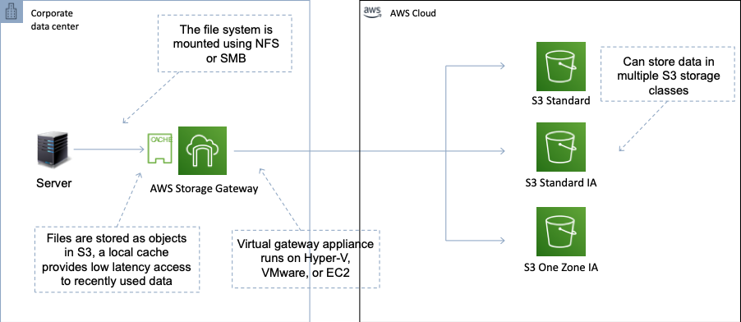

**References:**

<https://aws.amazon.com/storagegateway/file/>

#### **Question 264:**

A financial services company regularly runs an analysis of the day’s transaction costs, execution reporting, and market performance. The company currently uses third-party commercial software for provisioning, managing, monitoring, and scaling the computing jobs which utilize a large fleet of EC2 instances. The company is seeking to reduce costs and utilize AWS services. Which AWS service could be used in place of the third-party software?

1. AWS Batch
2. Amazon Lex
3. Amazon Athena
4. AWS Systems Manager

**Answer :** AWS Batch

**Explanation**

AWS Batch eliminates the need to operate third-party commercial or open source batch processing solutions. There is no batch software or servers to install or manage. AWS Batch manages all the infrastructure for you, avoiding the complexities of provisioning, managing, monitoring, and scaling your batch computing jobs.

**References:**

<https://aws.amazon.com/batch/>

#### **Question 265:**

A company runs an application on premises that stores a large quantity of semi-structured data using key-value pairs. The application code will be migrated to AWS Lambda and a highly scalable solution is required for storing the data. Which datastore will be the best fit for these requirements?

1. Amazon EFS
2. Amazon DynamoDB
3. Amazon EBS
4. Amazon RDS MySQL

**Answer :** Amazon DynamoDB

**Explanation**

Amazon DynamoDB is a no-SQL database that stores data using key-value pairs. It is ideal for storing large amounts of semi-structured data and is also highly scalable. This is the best solution for storing this data based on the requirements in the scenario.

**References:**

<https://aws.amazon.com/dynamodb/features/>

#### **Question 266:**

An application is generating a large amount of clickstream events data that is being stored on S3. The business needs to understand customer behaviour and want to run complex analytics queries against the data. Which AWS service can be used for this requirement?

1. Amazon RedShift
2. Amazon RDS
3. Amazon Kinesis Firehose
4. Amazon Neptune

**Answer :** Amazon RedShift

**Explanation**

Amazon Redshift is a fast, fully managed data warehouse that makes it simple and cost-effective to analyze all your data using standard SQL and existing Business Intelligence (BI) tools. RedShift is used for running complex analytic queries against petabytes of structured data, using sophisticated query optimization, columnar storage on high-performance local disks, and massively parallel query execution. With RedShift you can load data from Amazon S3 and perform analytics queries. RedShift Spectrum can analyze data directly in Amazon S3, but was not presented as an option.

**References:**

<https://aws.amazon.com/redshift/>

#### **Question 267:**

A government agency is using CloudFront for a web application that receives personally identifiable information (PII) from citizens. What feature of CloudFront applies an extra level of encryption at CloudFront edge locations to ensure the PII data is secured end-to-end?

1. Field-level encryption
2. Object invalidation
3. Origin access identity
4. RTMP distribution

**Answer :** Field-level encryption

**Explanation**

With Amazon CloudFront, you can enforce secure end-to-end connections to origin servers by using HTTPS. Field-level encryption adds an additional layer of security that lets you protect specific data throughout system processing so that only certain applications can see it. Field-level encryption allows you to enable your users to securely upload sensitive information to your web servers. The sensitive information provided by your users is encrypted at the edge, close to the user, and remains encrypted throughout your entire application stack. This encryption ensures that only applications that need the data—and have the credentials to decrypt it—are able to do so.

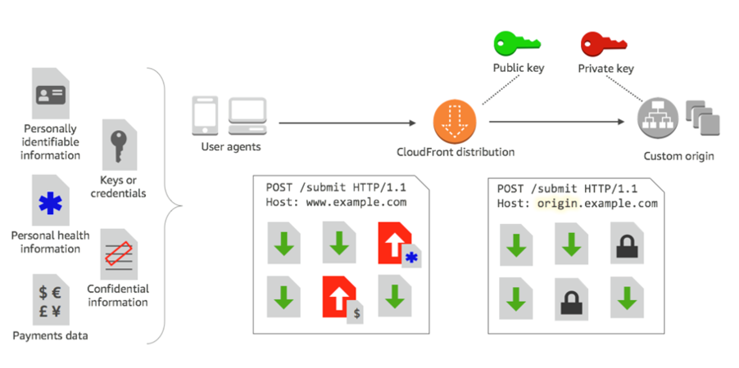

**References:**

<https://docs.aws.amazon.com/AmazonCloudFront/latest/DeveloperGuide/field-level-encryption.html>

#### **Question 268:**

An on-premises server runs a MySQL database and will be migrated to the AWS Cloud. The company require a managed solution that supports high availability and automatic failover in the event of the outage of an Availability Zone (AZ). Which solution is the BEST fit for these requirements?

1. Use the AWS Database Migration Service (DMS) to directly migrate the database to Amazon RDS MySQL. Use the Schema Conversion Tool (SCT) to enable conversion from MySQL to Amazon RDS
2. Use the AWS Database Migration Service (DMS) to directly migrate the database to an Amazon EC2 MySQL Multi-AZ deployment
3. Create a snapshot of the MySQL database server and use AWS DataSync to migrate the data Amazon S3. Launch a new Amazon RDS MySQL Multi-AZ deployment from the snapshot
4. Use the AWS Database Migration Service (DMS) to directly migrate the database to an Amazon RDS MySQL Multi-AZ deployment

**Answer :** Use the AWS Database Migration Service (DMS) to directly migrate the database to an Amazon RDS MySQL Multi-AZ deployment

**Explanation**

The AWS DMS service can be used to directly migrate the MySQL database to an Amazon RDS Multi-AZ deployment. The entire process can be online and is managed for you. There is no need to perform schema translation between MySQL and RDS (assuming you choose the MySQL RDS engine).

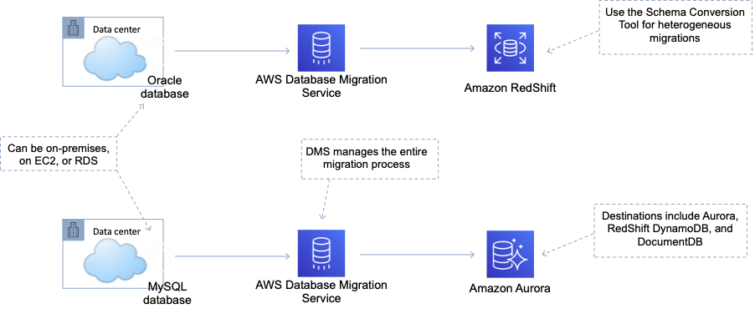

**References:**

<https://aws.amazon.com/rds/features/multi-az/>

<https://docs.aws.amazon.com/dms/latest/userguide/CHAP_Introduction.html>

#### **Question 269:**

An organization in the agriculture sector is deploying sensors and smart devices around factory plants and fields. The devices will collect information and send it to cloud applications running on AWS. Which AWS service will securely connect the devices to the cloud applications?

1. AWS Glue
2. AWS IoT Core
3. AWS Lambda
4. AWS DMS

**Answer :** AWS IoT Core

**Explanation**

AWS IoT Core is a managed cloud service that lets connected devices easily and securely interact with cloud applications and other devices. AWS IoT Core can support billions of devices and trillions of messages, and can process and route those messages to AWS endpoints and to other devices reliably and securely.

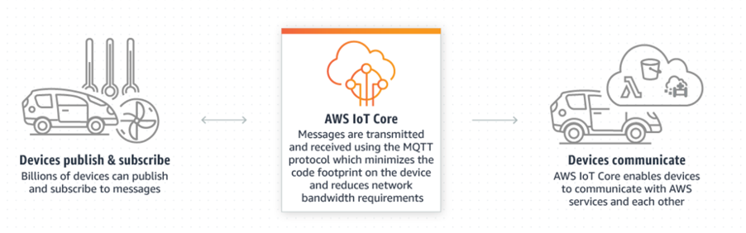

**References:**

<https://aws.amazon.com/iot-core/>

#### **Question 270:**

A Solutions Architect has created a VPC and is in the process of formulating the subnet design. The VPC will be used to host a two-tier application that will include Internet facing web servers, and internal-only DB servers. Zonal redundancy is required. How many subnets are required to support this requirement?

1. 4 subnets
2. 2 subnets
3. 6 subnets
4. 1 subnet

**Answer :** 4 subnets

**Explanation**

Zonal redundancy indicates that the architecture should be split across multiple Availability Zones. Subnets are mapped 1:1 to AZs. A public subnet should be used for the Internet-facing web servers and a separate private subnet should be used for the internal-only DB servers. Therefore you need 4 subnets – 2 (for redundancy) per public/private subnet.

#### **Question 271:**

Some data has become corrupted in an Amazon RDS database. A Solutions Architect plans to use point-in-time restore to recover the data to the last known good configuration. Which of the following statements is correct about restoring an RDS database to a specific point-in-time? (choose 2)

1. The database restore overwrites the existing database
2. You can restore up to the last 5 minutes
3. Custom DB security groups are applied to the new DB instance
4. You can restore up to the last 1 minute
5. The default DB security group is applied to the new DB instance

**Answer :** You can restore up to the last 5 minutes

**Answer :** The default DB security group is applied to the new DB instance

**Explanation**

You can restore a DB instance to a specific point in time, creating a new DB instance. When you restore a DB instance to a point in time, the default DB security group is applied to the new DB instance. If you need custom DB security groups applied to your DB instance, you must apply them explicitly using the AWS Management Console, the AWS CLI modify-db-instance command, or the Amazon RDS API ModifyDBInstance operation after the DB instance is available. Restored DBs will always be a new RDS instance with a new DNS endpoint and you can restore up to the last 5 minutes.

**References:**

<https://docs.aws.amazon.com/AmazonRDS/latest/UserGuide/USER_PIT.html>

#### **Question 272:**

A company is investigating ways to analyze and process large amounts of data in the cloud faster, without needing to load or transform the data in a data warehouse. The data resides in Amazon S3. Which AWS services would allow the company to query the data in place? (choose 2)

1. Amazon RedShift Spectrum
2. Amazon Elasticsearch
3. Amazon Kinesis Data Streams
4. Amazon S3 Select
5. Amazon SWF

**Answer :** Amazon S3 Select

**Answer :** Amazon RedShift Spectrum

**Explanation**

Amazon S3 Select is designed to help analyze and process data within an object in Amazon S3 buckets, faster and cheaper. It works by providing the ability to retrieve a subset of data from an object in Amazon S3 using simple SQL expressions Amazon Redshift Spectrum allows you to directly run SQL queries against exabytes of unstructured data in Amazon S3. No loading or transformation is required.

**References:**

<https://aws.amazon.com/blogs/aws/s3-glacier-select/>

<https://aws.amazon.com/about-aws/whats-new/2017/11/amazon-redshift-spectrum-is-now-available-in-four-additional-aws-regions-and-enhances-query-performance-in-all-available-aws-regions/>

#### **Question 273:**

An Amazon EC2 instance behind an Elastic Load Balancer (ELB) is in the process of being de-registered. Which ELB feature is used to allow existing connections to close cleanly?

1. Proxy Protocol
2. Deletion Protection
3. Sticky Sessions
4. Connection Draining

**Answer :** Connection Draining

**Explanation**

Connection draining is enabled by default and provides a period of time for existing connections to close cleanly. When connection draining is in action an CLB will be in the status “InService: Instance deregistration currently in progress”.

**References:**

<https://aws.amazon.com/about-aws/whats-new/2014/03/20/elastic-load-balancing-supports-connection-draining/>

#### **Question 274:**

An Amazon EC2 instance is generating very high packets-per-second and performance of the application stack is being impacted. A Solutions Architect needs to determine a resolution to the issue that results in improved performance. Which action should the Architect take?

1. Configure a RAID 1 array from multiple EBS volumes
2. Create a placement group and put the EC2 instance in it
3. Use enhanced networking
4. Add multiple Elastic IP addresses to the instance

**Answer :** Use enhanced networking

**Explanation**

Enhanced networking provides higher bandwidth, higher packet-per-second (PPS) performance, and consistently lower inter-instance latencies. If your packets-per-second rate appears to have reached its ceiling, you should consider moving to enhanced networking because you have likely reached the upper thresholds of the VIF driver. It is only available for certain instance types and only supported in VPC. You must also launch an HVM AMI with the appropriate drivers. AWS currently supports enhanced networking capabilities using SR-IOV. SR-IOV provides direct access to network adapters, provides higher performance (packets-per-second) and lower latency.

**References:**

<https://aws.amazon.com/premiumsupport/knowledge-center/enable-configure-enhanced-networking/>

#### **Question 275:**

A company needs to ensure that they can failover between AWS Regions in the event of a disaster seamlessly with minimal downtime and data loss. The applications will run in an active-active configuration. Which DR strategy should a Solutions Architect recommend?

1. Pilot light
2. Warm standby
3. Backup and restore
4. Multi-site

**Answer :** Multi-site

**Explanation**

A multi-site solution runs on AWS as well as on your existing on-site infrastructure in an active- active configuration. The data replication method that you employ will be determined by the recovery point that you choose. This is either Recovery Time Objective (the maximum allowable downtime before degraded operations are restored) or Recovery Point Objective (the maximum allowable time window whereby you will accept the loss of transactions during the DR process).

**References:**

<https://aws.amazon.com/blogs/publicsector/rapidly-recover-mission-critical-systems-in-a-disaster/>

#### **Question 276:**

A Solutions Architect is designing the system monitoring and deployment layers of a serverless application. The system monitoring layer will manage system visibility through recording logs and metrics and the deployment layer will deploy the application stack and manage workload changes through a release management process. The Architect needs to select the most appropriate AWS services for these functions. Which services and frameworks should be used for the system monitoring and deployment layers? (choose 2)

1. Use AWS X-Ray to package, test, and deploy the serverless application stack
2. Use AWS SAM to package, test, and deploy the serverless application stack
3. Use AWS CloudTrail for consolidating system and application logs and monitoring custom metrics
4. Use AWS Lambda to package, test, and deploy the serverless application stack
5. Use Amazon CloudWatch for consolidating system and application logs and monitoring custom metrics

**Answer :** Use AWS SAM to package, test, and deploy the serverless application stack

**Answer :** Use Amazon CloudWatch for consolidating system and application logs and monitoring custom metrics

**Explanation**

AWS Serverless Application Model (AWS SAM) is an extension of AWS CloudFormation that is used to package, test, and deploy serverless applications. With Amazon CloudWatch, you can access system metrics on all the AWS services you use, consolidate system and application level logs, and create business key performance indicators (KPIs) as custom metrics for your specific needs.

**References:**

<https://docs.aws.amazon.com/lambda/latest/dg/serverless_app.html>

#### **Question 277:**

A company has launched a multi-tier application architecture. The web tier and database tier run on Amazon EC2 instances in private subnets within the same Availability Zone. Which combination of steps should a Solutions Architect take to add high availability to this architecture? (Select TWO.)

1. Create new public subnets in the same AZ for high availability and move the web tier to the public subnets
2. Create new private subnets in the same VPC but in a different AZ. Migrate the database to an Amazon RDS multi-AZ deployment
3. Create new private subnets in the same VPC but in a different AZ. Create a database using Amazon EC2 in one AZ
4. Add the existing web application instances to an Auto Scaling group behind an Application Load Balancer (ALB)
5. Create an Amazon EC2 Auto Scaling group and Application Load Balancer (ALB) spanning multiple AZs

**Answer :** Create an Amazon EC2 Auto Scaling group and Application Load Balancer (ALB) spanning multiple AZs

**Answer :** Create new private subnets in the same VPC but in a different AZ. Migrate the database to an Amazon RDS multi-AZ deployment

**Explanation**

The Solutions Architect can use Auto Scaling group across multiple AZs with an ALB in front to create an elastic and highly available architecture. Then, migrate the database to an Amazon RDS multi-AZ deployment to create HA for the database tier. This results in a fully redundant architecture that can withstand the failure of an availability zone.

**References:**

<https://docs.aws.amazon.com/AWSEC2/latest/UserGuide/ec2-increase-availability.html>

<https://docs.aws.amazon.com/AmazonRDS/latest/UserGuide/Concepts.MultiAZ.html>

#### **Question 278:**

An Auto Scaling group of Amazon EC2 instances behind an Elastic Load Balancer (ELB) is running in an Amazon VPC. Health checks are configured on the ASG to use EC2 status checks. The ELB has determined that an EC2 instance is unhealthy and has removed it from service. A Solutions Architect noticed that the instance is still running and has not been terminated by EC2 Auto Scaling. What would be an explanation for this behavior?

1. The health check grace period has not yet expired
2. The ASG is waiting for the cooldown timer to expire before terminating the instance
3. Connection draining is enabled and the ASG is waiting for in-flight requests to complete
4. The ELB health check type has not been selected for the ASG and so it is unaware that the instance has been determined to be unhealthy by the ELB and has been removed from service

**Answer :** The ELB health check type has not been selected for the ASG and so it is unaware that the instance has been determined to be unhealthy by the ELB and has been removed from service

**Explanation**

If using an ELB it is best to enable ELB health checks as otherwise EC2 status checks may show an instance as being healthy that the ELB has determined is unhealthy. In this case the instance will be removed from service by the ELB but will not be terminated by Auto Scaling

More information on ASG health checks:

- By default uses EC2 status checks.

- Can also use ELB health checks and custom health checks.

- ELB health checks are in addition to the EC2 status checks.

- If any health check returns an unhealthy status the instance will be terminated.

- With ELB an instance is marked as unhealthy if ELB reports it as OutOfService

- A healthy instance enters the InService state.

- If an instance is marked as unhealthy it will be scheduled for replacement.

- If connection draining is enabled, Auto Scaling waits for in-flight requests to complete or timeout before terminating instances.

- The health check grace period allows a period of time for a new instance to warm up before performing a health check (300 seconds by default).

**References:**

<https://docs.aws.amazon.com/autoscaling/ec2/userguide/AutoScalingGroupLifecycle.html>

#### **Question 279:**

A company is transitioning their web presence into the AWS cloud. As part of the migration the company will be running a web application both on-premises and in AWS for a period of time. During the period of co-existence the client would like 80% of the traffic to hit the AWS-based web servers and 20% to be directed to the on-premises web servers. What method can a Solutions Architect use to distribute traffic as requested?

1. Use Route 53 with a simple routing policy
2. Use Route 53 with a weighted routing policy and configure the respective weights
3. Use an Application Load Balancer to distribute traffic based on IP address
4. Use a Network Load Balancer to distribute traffic based on Instance ID

**Answer :** Use Route 53 with a weighted routing policy and configure the respective weights

**Explanation**

Route 53 weighted routing policy is similar to simple but you can specify a weight per IP address. You create records that have the same name and type and assign each record a relative weight which is a numerical value that favours one IP over another (values must total 100). To stop sending traffic to a resource you can change the weight of the record to 0.

**References:**

<https://docs.aws.amazon.com/Route53/latest/DeveloperGuide/routing-policy.html>

#### **Question 280:**

A Solutions Architect has created an AWS Organization with several AWS accounts. Security policy requires that use of specific API actions are limited across all accounts. The Solutions Architect requires a method of centrally controlling these actions. What is the SIMPLEST method of achieving the requirements?

1. Create an IAM policy in the root account and attach it to users and groups in each account
2. Create cross-account roles in each account to limit access to the services and actions that are allowed
3. Create a Network ACL that limits access to the services or actions and attach it to all relevant subnets
4. Create a service control policy in the root organizational unit to deny access to the services or actions

**Answer :** Create a service control policy in the root organizational unit to deny access to the services or actions

**Explanation**

Service control policies (SCPs) offer central control over the maximum available permissions for all accounts in your organization, allowing you to ensure your accounts stay within your organization’s access control guidelines. In the example below a policy in OU1 restricts all users from launching EC2 instance types other than a t2.micro:

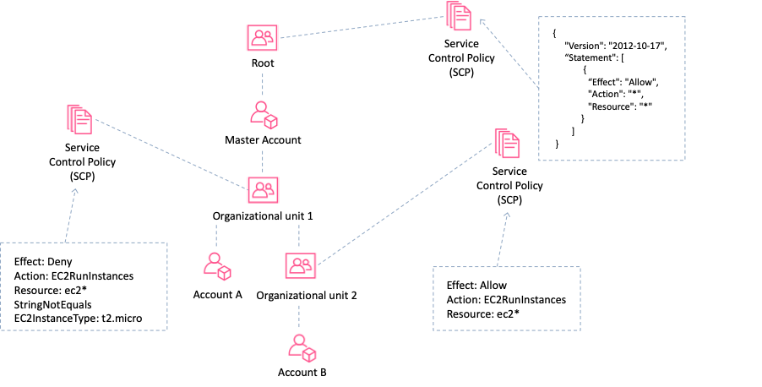

**References:**

<https://docs.aws.amazon.com/organizations/latest/userguide/orgs_manage_policies_about-scps.html>

#### **Question 281:**

The database layer of an on-premises web application is being migrated to AWS. The database currently uses an in-memory cache. A Solutions Architect must deliver a solution that supports high availability and replication for the caching layer. Which service should the Solutions Architect recommend?

1. Amazon ElastiCache Memcached
2. Amazon RDS Multi-AZ
3. Amazon ElastiCache Redis
4. Amazon DynamoDB

**Answer :** Amazon ElastiCache Redis

**Explanation**

Amazon ElastiCache Redis is an in-memory database cache and supports high availability through replicas and multi-AZ. The table below compares ElastiCache Redis with Memcached:

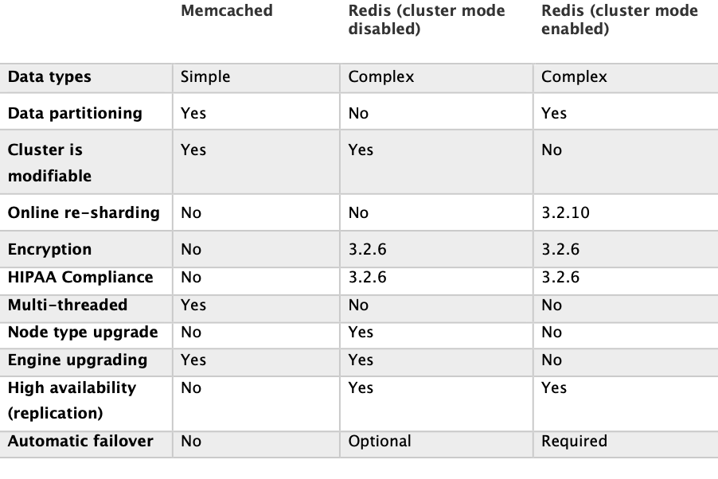

**References:**

<https://aws.amazon.com/elasticache/redis-vs-memcached/>

#### **Question 282:**

An application receives a high traffic load between 7:30am and 9:30am daily. The application uses an Auto Scaling group to maintain three instances most of the time but during the peak period it requires six instances. How can a Solutions Architect configure Auto Scaling to perform a daily scale-out event at 7:30am and a scale-in event at 9:30am to account for the peak load?

1. Use a Dynamic scaling policy
2. Use a Simple scaling policy
3. Use a Scheduled scaling policy
4. Use a Step scaling policy

**Answer :** Use a Scheduled scaling policy

**Explanation**

The following scaling policy options are available:

**Simple** – maintains a current number of instances, you can manually change the ASGs min/desired/max and attach/detach instances.

**Scheduled** – Used for predictable load changes, can be a single event or a recurring schedule

**Dynamic** (event based) – scale in response to an event/alarm.

**Step** – configure multiple scaling steps in response to multiple alarms.

**References:**

<https://docs.aws.amazon.com/autoscaling/ec2/userguide/schedule_time.html>

#### **Question 283:**

An Amazon DynamoDB table has a variable load, ranging from sustained heavy usage some days, to only having small spikes on others. The load is 80% read and 20% write. The provisioned throughput capacity has been configured to account for the heavy load to ensure throttling does not occur. What would be the most efficient solution to optimize cost?

1. Use DynamoDB DAX to increase the performance of the database
2. Create a CloudWatch alarm that triggers an AWS Lambda function that adjusts the provisioned throughput
3. Create a DynamoDB Auto Scaling scaling policy
4. Create a CloudWatch alarm that notifies you of increased/decreased load, and manually adjust the provisioned throughput

**Answer :** Create a DynamoDB Auto Scaling scaling policy

**Explanation**

Amazon DynamoDB auto scaling uses the AWS Application Auto Scaling service to dynamically adjust provisioned throughput capacity on your behalf, in response to actual traffic patterns. This is the most efficient and cost-effective solution to optimizing for cost.

**References:**

<https://docs.aws.amazon.com/amazondynamodb/latest/developerguide/AutoScaling.html>

#### **Question 284:**

A large multi-national client has requested a design for a multi-region database. The master database will be in the EU (Frankfurt) region and databases will be located in 4 other regions to service local read traffic. The database should be a managed service including the replication. The solution should be cost-effective and secure. Which AWS service can deliver these requirements?

1. RDS with cross-region Read Replicas
2. ElastiCache with Redis and clustering mode enabled
3. EC2 instances with EBS replication
4. RDS with Multi-AZ

**Answer :** RDS with cross-region Read Replicas

**Explanation**

Amazon RDS Read replicas are used for read heavy databases and the replication is asynchronous. Read replicas are used for workload sharing and offloading. Read replicas can be in another region. This solution will enable better performance for users in the other AWS regions for database queries and is a managed service.

**References:**

<https://aws.amazon.com/blogs/aws/cross-region-read-replicas-for-amazon-rds-for-mysql/>

#### **Question 285:**

A tool needs to analyze data stored in an Amazon S3 bucket. Processing the data takes a few seconds and results are then written to another S3 bucket. Less than 256 MB of memory is needed to run the process. What would be the MOST cost-effective compute solutions for this use case?

1. Amazon EC2 spot instances
2. AWS Fargate tasks
3. Amazon Elastic Beanstalk
4. AWS Lambda functions

**Answer :** AWS Lambda functions

**Explanation**

AWS Lambda lets you run code without provisioning or managing servers. You pay only for the compute time you consume. Lambda has a maximum execution time of 900 seconds and memory can be allocated up to 3008 MB. Therefore, the most cost-effective solution will be AWS Lambda.

**References:**

<https://aws.amazon.com/lambda/>

#### **Question 286:**

Several Amazon EC2 Spot instances are being used to process messages from an Amazon SQS queue and store results in an Amazon DynamoDB table. Shortly after picking up a message from the queue AWS terminated the Spot instance. The Spot instance had not finished processing the message. What will happen to the message?

1. The message will become available for processing again after the visibility timeout expires
2. The message will be lost as it would have been deleted from the queue when processed
3. The results may be duplicated in DynamoDB as the message will likely be processed multiple times
4. The message will remain in the queue and be immediately picked up by another instance

**Answer :** The message will become available for processing again after the visibility timeout expires

**Explanation**

The visibility timeout is the amount of time a message is invisible in the queue after a reader picks up the message. If a job is processed within the visibility timeout the message will be deleted. If a job is not processed within the visibility timeout the message will become visible again (could be delivered twice). The maximum visibility timeout for an Amazon SQS message is 12 hours.

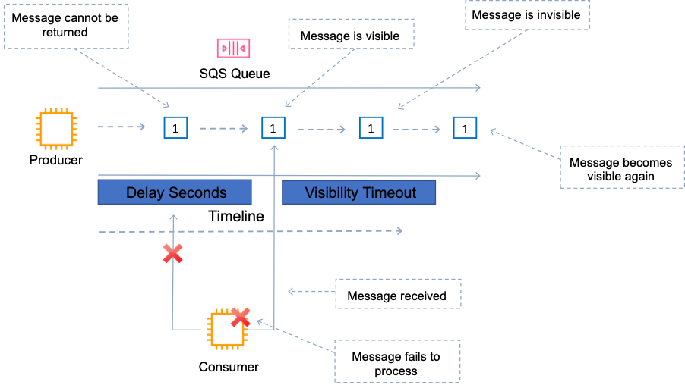

**References:**

<https://docs.aws.amazon.com/AWSSimpleQueueService/latest/SQSDeveloperGuide/sqs-visibility-timeout.html>

#### **Question 287:**

The application development team in a company have developed a Java application and saved the source code in a .war file. They would like to run the application on AWS resources and are looking for a service that can handle the provisioning and management of the underlying resources it will run on. Which AWS service should a Solutions Architect recommend the Developers use to upload the Java source code file?

1. AWS Elastic Beanstalk
2. AWS CloudFormation
3. AWS OpsWorks
4. AWS CodeDeploy

**Answer :** AWS Elastic Beanstalk

**Explanation**

AWS Elastic Beanstalk can be used to quickly deploy and manage applications in the AWS Cloud. Developers upload applications and Elastic Beanstalk handles the deployment details of capacity provisioning, load balancing, auto-scaling, and application health monitoring

Elastic Beanstalk supports applications developed in Go, Java, .NET, Node.js, PHP, Python, and Ruby, as well as different platform configurations for each language. To use Elastic Beanstalk, you create an application, upload an application version in the form of an application source bundle (for example, a Java .war file) to Elastic Beanstalk, and then provide some information about the application.

**References:**

<https://docs.aws.amazon.com/elasticbeanstalk/latest/dg/Welcome.html>

#### **Question 288:**

A Solutions Architect enabled Access Logs on an Application Load Balancer (ALB) and needs to process the log files using a hosted Hadoop service. What configuration changes and services can be leveraged to deliver this requirement?

1. Configure Access Logs to be delivered to DynamoDB and use EMR for processing the log files
2. Configure Access Logs to be delivered to S3 and use Kinesis for processing the log files
3. Configure Access Logs to be delivered to EC2 and install Hadoop for processing the log files
4. Configure Access Logs to be delivered to S3 and use EMR for processing the log files

**Answer :** Configure Access Logs to be delivered to S3 and use EMR for processing the log files

**Explanation**

Access Logs can be enabled on ALB and configured to store data in an S3 bucket. Amazon EMR is a web service that enables businesses, researchers, data analysts, and developers to easily and cost-effectively process vast amounts of data. EMR utilizes a hosted Hadoop framework running on Amazon EC2 and Amazon S3.

**References:**

<https://docs.aws.amazon.com/emr/latest/ManagementGuide/emr-what-is-emr.html>

#### **Question 289:**

A web application receives order processing information from customers and places the messages on an Amazon SQS queue. A fleet of Amazon EC2 instances are configured to pick up the messages, process them, and store the results in a DynamoDB table. The current configuration has been resulting in a large number of empty responses to ReceiveMessage API requests. A Solutions Architect needs to eliminate empty responses to reduce operational overhead. How can this be done?

1. Configure Short Polling to eliminate empty responses by reducing the length of time a connection request remains open
2. Use a Standard queue to provide at-least-once delivery, which means that each message is delivered at least once
3. Configure Long Polling to eliminate empty responses by allowing Amazon SQS to wait until a message is available in a queue before sending a response
4. Use a FIFO (first-in-first-out) queue to preserve the exact order in which messages are sent and received

**Answer :** Configure Long Polling to eliminate empty responses by allowing Amazon SQS to wait until a message is available in a queue before sending a response

**Explanation**

The correct answer is to use Long Polling which will eliminate empty responses by allowing Amazon SQS to wait until a message is available in a queue before sending a response. The problem does not relate to the order in which the messages are processed in and there are no concerns over messages being delivered more than once so it doesn’t matter whether you use a FIFO or standard queue.

**Long Polling:**

– Uses fewer requests and reduces cost.

– Eliminates false empty responses by querying all servers.

– SQS waits until a message is available in the queue before sending a response.

**Short Polling:**

– Does not wait for messages to appear in the queue.

– It queries only a subset of the available servers for messages (based on weighted random execution).

– Short polling is the default.

– ReceiveMessageWaitTime is set to 0.

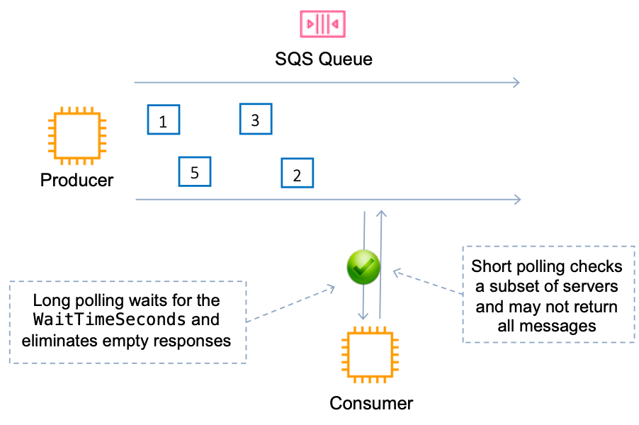

**References:**

<https://docs.aws.amazon.com/AWSSimpleQueueService/latest/SQSDeveloperGuide/sqs-short-and-long-polling.html>

#### **Question 290:**

An application makes calls to a REST API running on Amazon EC2 instances behind an Application Load Balancer (ALB). Most API calls complete quickly. However, a single endpoint is making API calls that require much longer to complete and this is introducing overall latency into the system. What steps can a Solutions Architect take to minimize the effects of the long-running API calls?

1. Create an Amazon SQS queue and decouple the long-running API calls
2. Change the EC2 instance to one with enhanced networking to reduce latency
3. Change the ALB to a Network Load Balancer (NLB) and use SSL/TLS termination
4. Increase the ALB idle timeout to allow the long-running requests to complete

**Answer :** Create an Amazon SQS queue and decouple the long-running API calls

**Explanation**

An Amazon Simple Queue Service (SQS) can be used to offload and decouple the long-running requests. They can then be processed asynchronously by separate EC2 instances. This is the best way to reduce the overall latency introduced by the long-running API call.

**References:**

<https://docs.aws.amazon.com/AWSSimpleQueueService/latest/SQSDeveloperGuide/welcome.html>

#### **Question 291:**

A company is working with a strategic partner that has an application that must be able to send messages to one of the company’s Amazon SQS queues. The partner company has its own AWS account. How can a Solutions Architect provide least privilege access to the partner?

1. Create a cross-account role with access to all SQS queues and use the partner's AWS account in the trust document for the role.
2. Create a user account that and grant the sqs:SendMessage permission for Amazon SQS. Share the credentials with the partner company.
3. Update the permission policy on the SQS queue to grant the sqs:SendMessage permission to the partner’s AWS account.
4. Update the permission policy on the SQS queue to grant all permissions to the partner’s AWS account.

**Answer :** Update the permission policy on the SQS queue to grant the sqs:SendMessage permission to the partner’s AWS account

**Explanation**

Amazon SQS supports resource-based policies. The best way to grant the permissions using the principle of least privilege is to use a resource-based policy attached to the SQS queue that grants the partner company’s AWS account the sqs:SendMessage privilege.

The following policy is an example of how this could be configured:

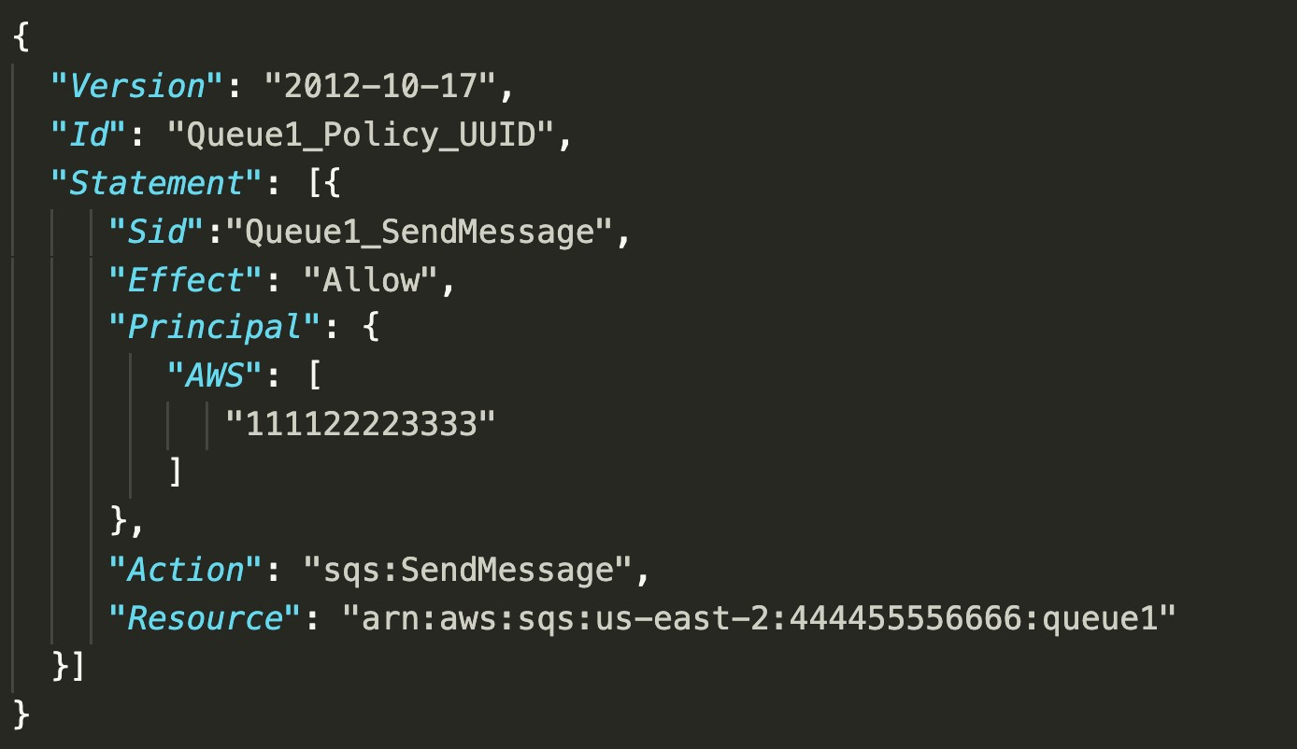

**References:**

<https://docs.aws.amazon.com/AWSSimpleQueueService/latest/SQSDeveloperGuide/sqs-basic-examples-of-sqs-policies.html>

#### **Question 292:**

A company runs an application that uses an Amazon RDS PostgreSQL database. The database is currently not encrypted. A Solutions Architect has been instructed that due to new compliance requirements all existing and new data in the database must be encrypted. The database experiences high volumes of changes and no data can be lost. How can the Solutions Architect enable encryption for the database without incurring any data loss?

1. Create a snapshot of the existing RDS DB instance. Create an encrypted copy of the snapshot. Create a new RDS DB instance from the encrypted snapshot. Configure the application to use the new DB endpoint.
2. Create an RDS read replica and specify an encryption key. Promote the encrypted read replica to primary. Update the application to point to the new RDS DB endpoint.
3. Create a snapshot of the existing RDS DB instance. Create an encrypted copy of the snapshot. Create a new RDS DB instance from the encrypted snapshot and update the application. Use AWS DMS to synchronize data between the source and destination RDS DBs
4. Update the RDS DB to Multi-AZ mode and enable encryption for the standby replica. Perform a failover to the standby instance and then delete the unencrypted RDS DB instance.

**Answer :** Create a snapshot of the existing RDS DB instance. Create an encrypted copy of the snapshot. Create a new RDS DB instance from the encrypted snapshot and update the application. Use AWS DMS to synchronize data between the source and destination RDS DBs

**Explanation**

You cannot change the encryption status of an existing RDS DB instance. Encryption must be specified when creating the RDS DB instance. The best way to encrypt an existing database is to take a snapshot, encrypt a copy of the snapshot and restore the snapshot to a new RDS DB instance. This results in an encrypted database that is a new instance. Applications must be updated to use the new RDS DB endpoint.

In this scenario as there is a high rate of change, the databases will be out of sync by the time the new copy is created and is functional. The best way to capture the changes between the source (unencrypted) and destination (encrypted) DB is to use AWS Database Migration Service (DMS) to synchronize the data.

The slide below depicts the process for encrypting an unencrypted RDS DB instance:

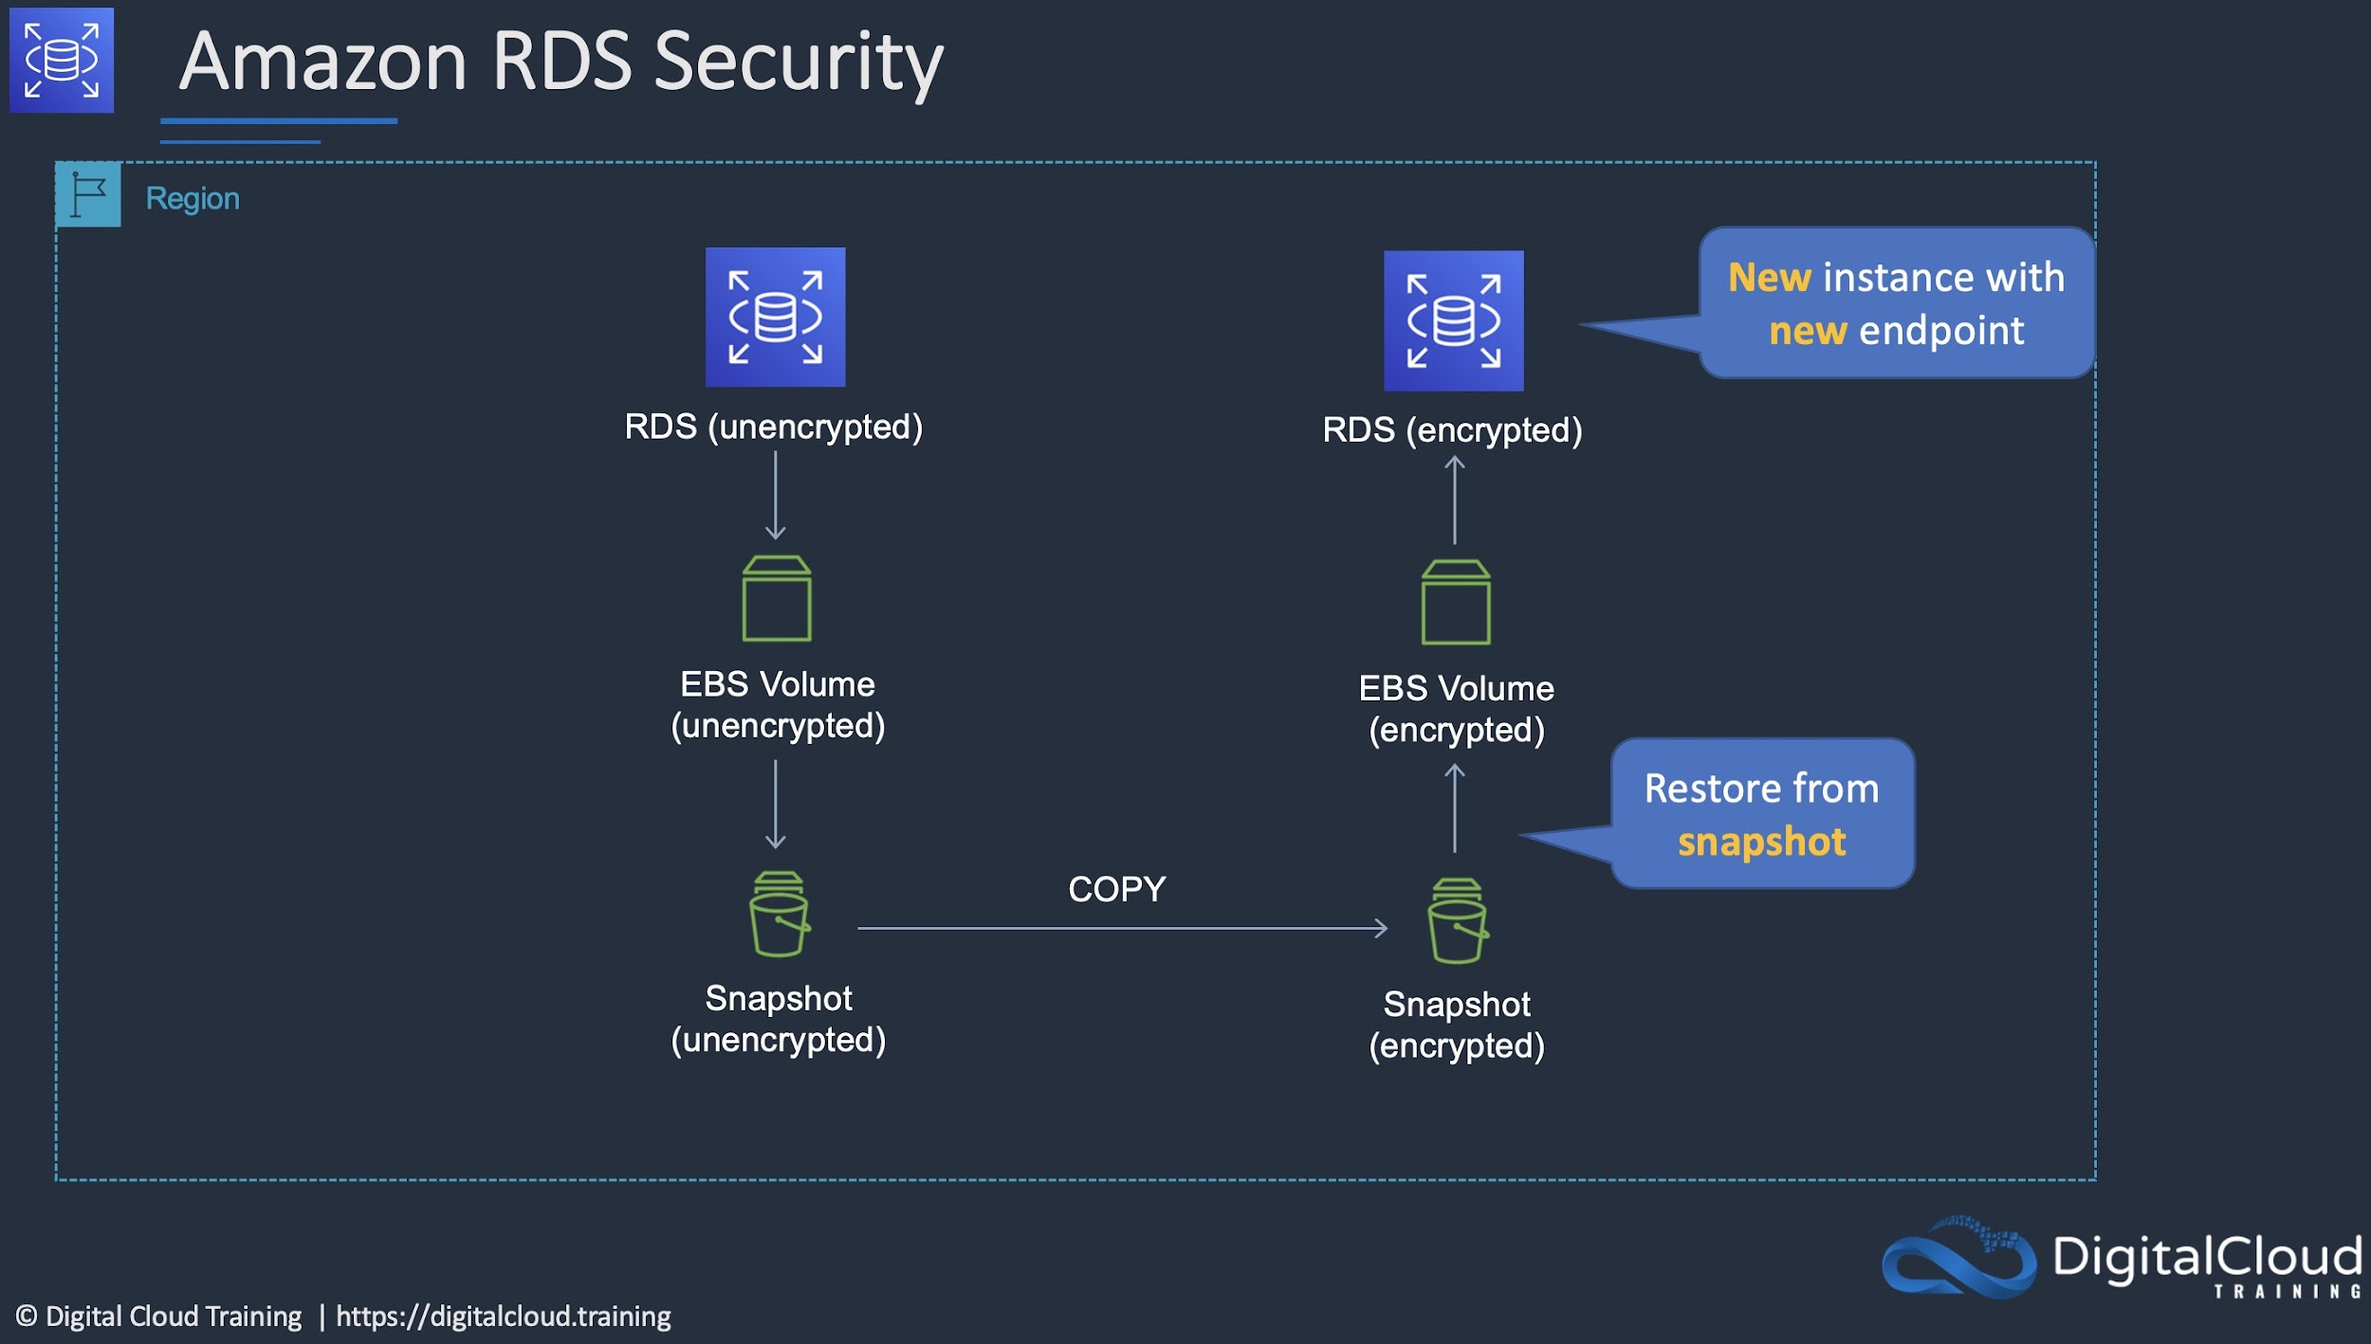

**References:**

<https://docs.aws.amazon.com/prescriptive-guidance/latest/patterns/encrypt-an-existing-amazon-rds-for-postgresql-db-instance.html>

#### **Question 293:**

A web application allows users to upload photos and add graphical elements to them. The application offers two tiers of service: free and paid. Photos uploaded by paid users should be processed before those submitted using the free tier. The photos are uploaded to an Amazon S3 bucket which uses an event notification to send the job information to Amazon SQS. How should a Solutions Architect configure the Amazon SQS deployment to meet these requirements?

1. Use one SQS standard queue. Use batching for the paid photos and short polling for the free photos.
2. Use a separate SQS FIFO queue for each tier. Set the free queue to use short polling and the paid queue to use long polling.
3. Use a separate SQS Standard queue for each tier. Configure Amazon EC2 instances to prioritize polling for the paid queue over the free queue.
4. Use one SQS FIFO queue. Assign a higher priority to the paid photos so they are processed first.

**Answer :** Use a separate SQS Standard queue for each tier. Configure Amazon EC2 instances to prioritize polling for the paid queue over the free queue

**Explanation**

AWS recommend using separate queues when you need to provide prioritization of work. The logic can then be implemented at the application layer to prioritize the queue for the paid photos over the queue for the free photos.

**References:**

<https://docs.aws.amazon.com/AWSSimpleQueueService/latest/SQSDeveloperGuide/sqs-how-it-works.html>

#### **Question 294:**

A website runs on Amazon EC2 instances in an Auto Scaling group behind an Application Load Balancer (ALB) which serves as an origin for an Amazon CloudFront distribution. An AWS WAF is being used to protect against SQL injection attacks. A review of security logs revealed an external malicious IP that needs to be blocked from accessing the website. What should a solutions architect do to protect the application?

1. Modify the configuration of AWS WAF to add an IP match condition to block the malicious IP address
2. Modify the network ACL on the CloudFront distribution to add a deny rule for the malicious IP address
3. Modify the security groups for the EC2 instances in the target groups behind the ALB to deny the malicious IP address.
4. Modify the network ACL for the EC2 instances in the target groups behind the ALB to deny the malicious IP address

**Answer :** Modify the configuration of AWS WAF to add an IP match condition to block the malicious IP address

**Explanation**

A new version of the AWS Web Application Firewall was released in November 2019. With AWS WAF classic you create “IP match conditions”, whereas with AWS WAF (new version) you create “IP set match statements”. Look out for wording on the exam.

The IP match condition / IP set match statement inspects the IP address of a web request's origin against a set of IP addresses and address ranges. Use this to allow or block web requests based on the IP addresses that the requests originate from.

AWS WAF supports all IPv4 and IPv6 address ranges. An IP set can hold up to 10,000 IP addresses or IP address ranges to check.

**References:**

<https://docs.aws.amazon.com/waf/latest/developerguide/waf-rule-statement-type-ipset-match.html>

#### **Question 295:**

A legacy tightly-coupled High Performance Computing (HPC) application will be migrated to AWS. Which network adapter type should be used?

1. Elastic Network Adapter (ENA)
2. Elastic IP Address
3. Elastic Fabric Adapter (EFA)
4. Elastic Network Interface (ENI)

**Answer :** Elastic Fabric Adapter (EFA)

**Explanation**

An Elastic Fabric Adapter is an AWS Elastic Network Adapter (ENA) with added capabilities. The EFA lets you apply the scale, flexibility, and elasticity of the AWS Cloud to tightly-coupled HPC apps. It is ideal for tightly coupled app as it uses the Message Passing Interface (MPI).

**References:**

<https://aws.amazon.com/blogs/aws/now-available-elastic-fabric-adapter-efa-for-tightly-coupled-hpc-workloads/>

#### **Question 296:**

A financial services company has a web application with an application tier running in the U.S and Europe. The database tier consists of a MySQL database running on Amazon EC2 in us-west-1. Users are directed to the closest application tier using Route 53 latency-based routing. The users in Europe have reported poor performance when running queries. Which changes should a Solutions Architect make to the database tier to improve performance?

1. Migrate the database to an Amazon Aurora global database in MySQL compatibility mode. Configure the application tier in Europe to use the local reader endpoint.
2. Migrate the database to Amazon RDS for MySQL. Configure Multi-AZ in one of the European Regions.
3. Migrate the database to Amazon RedShift. Use AWS DMS to synchronize data. Configure applications to use the RedShift data warehouse for queries.
4. Create an Amazon RDS Read Replica in one of the European regions. Configure the application tier in Europe to use the read replica for queries.

**Answer :** Migrate the database to an Amazon Aurora global database in MySQL compatibility mode. Configure the application tier in Europe to use the local reader endpoint

**Explanation**

Amazon Aurora Global Database is designed for globally distributed applications, allowing a single Amazon Aurora database to span multiple AWS regions. It replicates your data with no impact on database performance, enables fast local reads with low latency in each region, and provides disaster recovery from region-wide outages.

A global database can be configured in the European region and then the application tier in Europe will need to be configured to use the local database for reads/queries. The diagram below depicts an Aurora Global Database deployment.

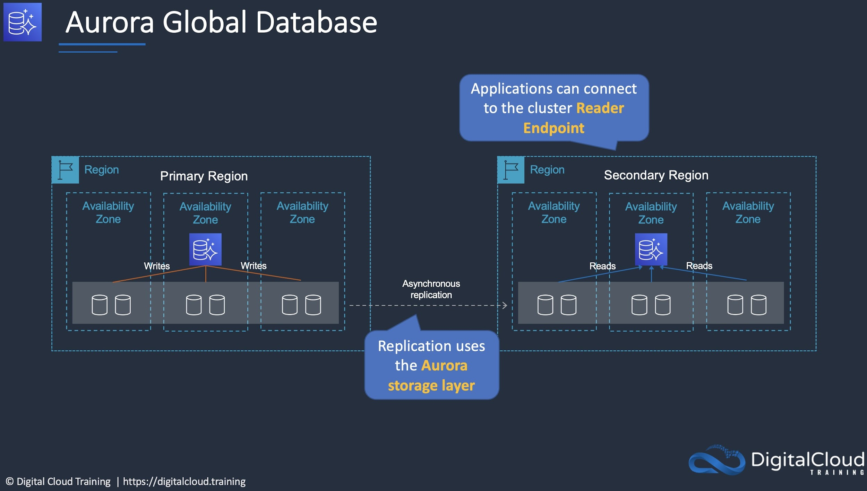

**References:**

<https://aws.amazon.com/rds/aurora/global-database/>

#### **Question 297:**

A company runs an application in a factory that has a small rack of physical compute resources. The application stores data on a network attached storage (NAS) device using the NFS protocol. The company requires a daily offsite backup of the application data. Which solution can a Solutions Architect recommend to meet this requirement?

1. Create an IPSec VPN to AWS and configure the application to mount the Amazon EFS file system. Run a copy job to backup the data to EFS.
2. Use an AWS Storage Gateway volume gateway with stored volumes on premises to replicate the data to Amazon S3.
3. Use an AWS Storage Gateway volume gateway with cached volumes on premises to replicate the data to Amazon S3.
4. Use an AWS Storage Gateway file gateway hardware appliance on premises to replicate the data to Amazon S3.

**Answer :** Use an AWS Storage Gateway file gateway hardware appliance on premises to replicate the data to Amazon S3

**Explanation**

The AWS Storage Gateway Hardware Appliance is a physical, standalone, validated server configuration for on-premises deployments. It comes pre-loaded with Storage Gateway software, and provides all the required CPU, memory, network, and SSD cache resources for creating and configuring File Gateway, Volume Gateway, or Tape Gateway. A file gateway is the correct type of appliance to use for this use case as it is suitable for mounting via the NFS and SMB protocols.

**References:**

<https://aws.amazon.com/storagegateway/hardware-appliance/>

#### **Question 298:**

A new application will run across multiple Amazon ECS tasks. Front-end application logic will process data and then pass that data to a back-end ECS task to perform further processing and write the data to a datastore. The Architect would like to reduce-interdependencies so failures do no impact other components. Which solution should the Architect use?

1. Create an Amazon Kinesis Firehose delivery stream and configure the front-end to add data to the stream and the back-end to read data from the stream
2. Create an Amazon SQS queue and configure the front-end to add messages to the queue and the back-end to poll the queue for messages
3. Create an Amazon SQS queue that pushes messages to the back-end. Configure the front-end to add messages to the queue
4. Create an Amazon Kinesis Firehose delivery stream that delivers data to an Amazon S3 bucket, configure the front-end to write data to the stream and the back-end to read data from Amazon S3

**Answer :** Create an Amazon SQS queue and configure the front-end to add messages to the queue and the back-end to poll the queue for messages

**Explanation**

This is a good use case for Amazon SQS. SQS is a service that is used for decoupling applications, thus reducing interdependencies, through a message bus. The front-end application can place messages on the queue and the back-end can then poll the queue for new messages. Please remember that Amazon SQS is pull-based (polling) not push-based (use SNS for push-based).

**References:**

<https://docs.aws.amazon.com/AmazonECS/latest/developerguide/common_use_cases.html>[;['

#### **Question 299:**

There are two applications in a company: a sender application that sends messages containing payloads, and a processing application that receives messages containing payloads. The company wants to implement an AWS service to handle messages between these two different applications. The sender application sends on average 1,000 messages each hour and the messages depending on the type sometimes take up to 2 days to be processed. If the messages fail to process, they must be retained so that they do not impact the processing of any remaining messages. Which solution meets these requirements and is the MOST operationally efficient?

1. Subscribe the processing application to an Amazon Simple Notification Service (Amazon SNS) topic to receive notifications. Write to the SNS topic using the sender application.
2. Provide an Amazon Simple Queue Service (Amazon SQS) queue for the sender and processor applications. Set up a dead-letter queue to collect failed messages.
3. Receive the messages from the sender application using an Amazon Kinesis data stream. Utilize the Kinesis Client Library (KCL) to integrate the processing application.
4. Set up a Redis database on Amazon EC2. Configure the instance to be used by both applications. The messages should be stored, processed, and deleted, respectively.

**Answer :** Provide an Amazon Simple Queue Service (Amazon SQS) queue for the sender and processor applications. Set up a dead-letter queue to collect failed messages

**Explanation**

Amazon Simple Queue Service (SQS) is a fully managed message queuing service that enables you to decouple and scale microservices, distributed systems, and serverless applications. SQS eliminates the complexity and overhead associated with managing and operating message-oriented middleware and empowers developers to focus on differentiating work.

**References:**

<https://aws.amazon.com/sqs/>

#### **Question 300:**

An eCommerce application consists of three tiers. The web tier includes EC2 instances behind an Application Load balancer, the middle tier uses EC2 instances and an Amazon SQS queue to process orders, and the database tier consists of an Auto Scaling DynamoDB table. During busy periods customers have complained about delays in the processing of orders. A Solutions Architect has been tasked with reducing processing times. Which action will be MOST effective in accomplishing this requirement?

1. Replace the Amazon SQS queue with Amazon Kinesis Data Firehose.
2. Use Amazon DynamoDB Accelerator (DAX) in front of the DynamoDB backend tier.
3. Add an Amazon CloudFront distribution with a custom origin to cache the responses for the web tier.
4. Use Amazon EC2 Auto Scaling to scale out the middle tier instances based on the SQS queue depth.

**Answer :** Use Amazon EC2 Auto Scaling to scale out the middle tier instances based on the SQS queue depth

**Explanation**

The most likely cause of the processing delays is insufficient instances in the middle tier where the order processing takes place. The most effective solution to reduce processing times in this case is to scale based on the backlog per instance (number of messages in the SQS queue) as this reflects the amount of work that needs to be done.

**References:**

<https://docs.aws.amazon.com/autoscaling/ec2/userguide/as-using-sqs-queue.html>

#### **Question 301:**

An Amazon RDS Read Replica is being deployed in a separate region. The master database is not encrypted but all data in the new region must be encrypted. How can this be achieved?

1. Enable encryption using Key Management Service (KMS) when creating the cross-region Read Replica
2. Encrypt a snapshot from the master DB instance, create a new encrypted master DB instance, and then create an encrypted cross-region Read Replica
3. Enable encryption on the master DB instance, then create an encrypted cross-region Read Replica
4. Encrypt a snapshot from the master DB instance, create an encrypted cross-region Read Replica from the snapshot

**Answer :** Encrypt a snapshot from the master DB instance, create a new encrypted master DB instance, and then create an encrypted cross-region Read Replica

**Explanation**

You cannot create an encrypted Read Replica from an unencrypted master DB instance. You also cannot enable encryption after launch time for the master DB instance. Therefore, you must create a new master DB by taking a snapshot of the existing DB, encrypting it, and then creating the new DB from the snapshot. You can then create the encrypted cross-region Read Replica of the master DB.

**References:**

<https://docs.aws.amazon.com/AmazonRDS/latest/UserGuide/USER_ReadRepl.html>

<https://docs.aws.amazon.com/AmazonRDS/latest/UserGuide/Overview.Encryption.html>

#### **Question 302:**

A company runs a web application that serves weather updates. The application runs on a fleet of Amazon EC2 instances in a Multi-AZ Auto scaling group behind an Application Load Balancer (ALB). The instances store data in an Amazon Aurora database. A solutions architect needs to make the application more resilient to sporadic increases in request rates. Which architecture should the solutions architect implement? (Select TWO.)

1. Add an AWS Global Accelerator endpoint
2. Add and AWS WAF in front of the ALB
3. Add an Amazon CloudFront distribution in front of the ALB
4. Add Amazon Aurora Replicas
5. Add an AWS Transit Gateway to the Availability Zones

**Answer :** Add Amazon Aurora Replicas

**Answer :** Add an Amazon CloudFront distribution in front of the ALB

**Explanation**

The architecture is already highly resilient but the may be subject to performance degradation if there are sudden increases in request rates. To resolve this situation Amazon Aurora Read Replicas can be used to serve read traffic which offloads requests from the main database. On the frontend an Amazon CloudFront distribution can be placed in front of the ALB and this will cache content for better performance and also offloads requests from the backend.

**References:**

<https://docs.aws.amazon.com/AmazonRDS/latest/AuroraUserGuide/Aurora.Replication.html>

<https://docs.aws.amazon.com/AmazonCloudFront/latest/DeveloperGuide/Introduction.html>

#### **Question 303:**

An application running on Amazon EC2 needs to asynchronously invoke an AWS Lambda function to perform data processing. The services should be decoupled. Which service can be used to decouple the compute services?

1. AWS Step Functions
2. Amazon MQ
3. Amazon SNS
4. AWS Config

**Answer :** Amazon SNS

**Explanation**

You can use a Lambda function to process Amazon Simple Notification Service notifications. Amazon SNS supports Lambda functions as a target for messages sent to a topic. This solution decouples the Amazon EC2 application from Lambda and ensures the Lambda function is invoked.

**References:**

<https://docs.aws.amazon.com/lambda/latest/dg/with-sns.html>

<https://aws.amazon.com/sns/features/>

#### **Question 304:**

A company runs a dynamic website that is hosted on an on-premises server in the United States. The company is expanding to Europe and is investigating how they can optimize the performance of the website for European users. The website’s backed must remain in the United States. The company requires a solution that can be implemented within a few days. What should a Solutions Architect recommend?

1. Launch an Amazon EC2 instance in an AWS Region in the United States and migrate the website to it.
2. Migrate the website to Amazon S3. Use cross-Region replication between Regions and a latency-based Route 53 policy.
3. Use Amazon CloudFront with Lambda@Edge to direct traffic to an on-premises origin.
4. Use Amazon CloudFront with a custom origin pointing to the on-premises servers.

**Answer :** Use Amazon CloudFront with a custom origin pointing to the on-premises servers

**Explanation**

A custom origin can point to an on-premises server and CloudFront is able to cache content for dynamic websites. CloudFront can provide performance optimizations for custom origins even if they are running on on-premises servers. These include persistent TCP connections to the origin, SSL enhancements such as Session tickets and OCSP stapling. Additionally, connections are routed from the nearest Edge Location to the user across the AWS global network. If the on-premises server is connected via a Direct Connect (DX) link this can further improve performance.

**References:**

<https://aws.amazon.com/cloudfront/dynamic-content/>

#### **Question 305:**

An organization has a large amount of data on Windows (SMB) file shares in their on-premises data center. The organization would like to move data into Amazon S3. They would like to automate the migration of data over their AWS Direct Connect link. Which AWS service can assist them?

1. AWS CloudFormation
2. AWS DataSync
3. AWS Database Migration Service (DMS)
4. AWS Snowball

**Answer :** AWS DataSync

**Explanation**

AWS DataSync can be used to move large amounts of data online between on-premises storage and Amazon S3 or Amazon Elastic File System (Amazon EFS). DataSync eliminates or automatically handles many of these tasks, including scripting copy jobs, scheduling and monitoring transfers, validating data, and optimizing network utilization. The source datastore can use file servers that communicate using the Server Message Block (SMB) protocol.

**References:**

<https://aws.amazon.com/datasync/faqs/>

#### **Question 306:**

A company uses Docker containers for many application workloads in an on-premise data center. The company is planning to deploy containers to AWS and the chief architect has mandated that the same configuration and administrative tools must be used across all containerized environments. The company also wishes to remain cloud agnostic to safeguard mitigate the impact of future changes in cloud strategy. How can a Solutions Architect design a managed solution that will align with open-source software?

1. Launch the containers on Amazon Elastic Kubernetes Service (EKS) and EKS worker nodes.
2. Launch the containers on Amazon Elastic Container Service (ECS) with AWS Fargate instances.
3. Launch the containers on a fleet of Amazon EC2 instances in a cluster placement group.
4. Launch the containers on Amazon Elastic Container Service (ECS) with Amazon EC2 instance worker nodes.

**Answer :** Launch the containers on Amazon Elastic Kubernetes Service (EKS) and EKS worker nodes

**Explanation**

Amazon EKS is a managed service that can be used to run Kubernetes on AWS. Kubernetes is an open-source system for automating the deployment, scaling, and management of containerized applications. Applications running on Amazon EKS are fully compatible with applications running on any standard Kubernetes environment, whether running in on-premises data centers or public clouds. This means that you can easily migrate any standard Kubernetes application to Amazon EKS without any code modification. This solution ensures that the same open-source software is used for automating the deployment, scaling, and management of containerized applications both on-premises and in the AWS Cloud.

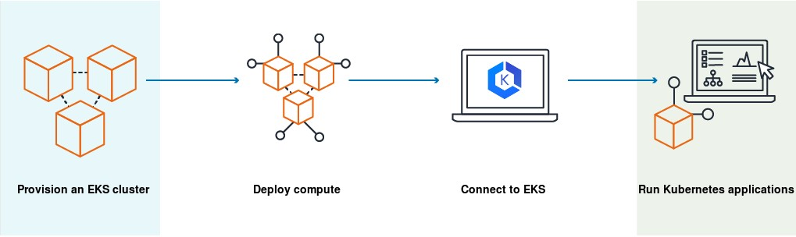

**References:**

<https://docs.aws.amazon.com/eks/latest/userguide/what-is-eks.html>

#### **Question 307:**

A solutions architect is designing a new service that will use an Amazon API Gateway API on the frontend. The service will need to persist data in a backend database using key-value requests. Initially, the data requirements will be around 1 GB and future growth is unknown. Requests can range from 0 to over 800 requests per second. Which combination of AWS services would meet these requirements? (Select TWO.)

1. Amazon RDS
2. AWS Fargate
3. Amazon DynamoDB
4. Amazon EC2 Auto Scaling
5. AWS Lambda

**Answer :** AWS Lambda

**Answer :** Amazon DynamoDB

**Explanation**

In this case AWS Lambda can perform the computation and store the data in an Amazon DynamoDB table. Lambda can scale concurrent executions to meet demand easily and DynamoDB is built for key-value data storage requirements and is also serverless and easily scalable. This is therefore a cost effective solution for unpredictable workloads.

**References:**

<https://aws.amazon.com/lambda/features/>

<https://aws.amazon.com/dynamodb/>

#### **Question 308:**

A web application runs in public and private subnets. The application architecture consists of a web tier and database tier running on Amazon EC2 instances. Both tiers run in a single Availability Zone (AZ). Which combination of steps should a solutions architect take to provide high availability for this architecture? (Select TWO.)

1. Create new public and private subnets in the same VPC, each in a new AZ. Migrate the database to an Amazon RDS multi-AZ deployment
2. Create new public and private subnets in a new AZ. Create a database using Amazon EC2 in one AZ
3. Create an Amazon EC2 Auto Scaling group and Application Load Balancer (ALB) spanning multiple AZs
4. Create new public and private subnets in the same AZ for high availability
5. Add the existing web application instances to an Auto Scaling group behind an Application Load Balancer (ALB)

**Answer :** Create an Amazon EC2 Auto Scaling group and Application Load Balancer (ALB) spanning multiple AZs

**Answer :** Create new public and private subnets in the same VPC, each in a new AZ. Migrate the database to an Amazon RDS multi-AZ deployment

**Explanation**

To add high availability to this architecture both the web tier and database tier require changes. For the web tier an Auto Scaling group across multiple AZs with an ALB will ensure there are always instances running and traffic is being distributed to them. The database tier should be migrated from the EC2 instances to Amazon RDS to take advantage of a managed database with Multi-AZ functionality. This will ensure that if there is an issue preventing access to the primary database a secondary database can take over.

**References:**

<https://docs.aws.amazon.com/autoscaling/ec2/userguide/autoscaling-load-balancer.html>

<https://aws.amazon.com/rds/features/multi-az/>

#### **Question 309:**

A company runs an application in an on-premises data center that collects environmental data from production machinery. The data consists of JSON files stored on network attached storage (NAS) and around 5 TB of data is collected each day. The company must upload this data to Amazon S3 where it can be processed by an analytics application. The data must be transferred securely. Which solution offers the MOST reliable and time-efficient data transfer?

1. AWS Database Migration Service over the Internet.
2. AWS DataSync over AWS Direct Connect.
3. Multiple AWS Snowcone devices.
4. Amazon S3 Transfer Acceleration over the Internet.

**Answer :** AWS DataSync over AWS Direct Connect

**Explanation**

The most reliable and time-efficient solution that keeps the data secure is to use AWS DataSync and synchronize the data from the NAS device directly to Amazon S3. This should take place over an AWS Direct Connect connection to ensure reliability, speed, and security.

AWS DataSync can copy data between Network File System (NFS) shares, Server Message Block (SMB) shares, self-managed object storage, AWS Snowcone, Amazon Simple Storage Service (Amazon S3) buckets, Amazon Elastic File System (Amazon EFS) file systems, and Amazon FSx for Windows File Server file systems.

**References:**

<https://aws.amazon.com/datasync/>

#### **Question 310:**

A company provides a REST-based interface to an application that allows a partner company to send data in near-real time. The application then processes the data that is received and stores it for later analysis. The application runs on Amazon EC2 instances. The partner company has received many 503 Service Unavailable Errors when sending data to the application and the compute capacity reaches its limits and is unable to process requests when spikes in data volume occur. Which design should a Solutions Architect implement to improve scalability?

1. Use Amazon API Gateway in front of the existing application. Create a usage plan with a quota limit for the partner company.
2. Use Amazon Kinesis Data Streams to ingest the data. Process the data using AWS Lambda functions.
3. Use Amazon SNS to ingest the data and trigger AWS Lambda functions to process the data in near-real time.
4. Use Amazon SQS to ingest the data. Configure the EC2 instances to process messages from the SQS queue.

**Answer :** Use Amazon Kinesis Data Streams to ingest the data. Process the data using AWS Lambda functions

**Explanation**

Amazon Kinesis enables you to ingest, buffer, and process streaming data in real-time. Kinesis can handle any amount of streaming data and process data from hundreds of thousands of sources with very low latencies. This is an ideal solution for data ingestion. To ensure the compute layer can scale to process increasing workloads, the EC2 instances should be replaced by AWS Lambda functions. Lambda can scale seamlessly by running multiple executions in parallel.

**References:**

<https://aws.amazon.com/kinesis/>

<https://docs.aws.amazon.com/lambda/latest/dg/invocation-scaling.html>

#### **Question 311:**

A new application is to be published in multiple regions around the world. The Architect needs to ensure only 2 IP addresses need to be whitelisted. The solution should intelligently route traffic for lowest latency and provide fast regional failover. How can this be achieved?

1. Launch EC2 instances into multiple regions behind an ALB and use Amazon CloudFront with a pair of static IP addresses
2. Launch EC2 instances into multiple regions behind an NLB and use AWS Global Accelerator
3. Launch EC2 instances into multiple regions behind an ALB and use a Route 53 failover routing policy
4. Launch EC2 instances into multiple regions behind an NLB with a static IP address

**Answer :** Launch EC2 instances into multiple regions behind an NLB and use AWS Global Accelerator

**Explanation**

AWS Global Accelerator uses the vast, congestion-free AWS global network to route TCP and UDP traffic to a healthy application endpoint in the closest AWS Region to the user. This means it will intelligently route traffic to the closest point of presence (reducing latency). Seamless failover is ensured as AWS Global Accelerator uses anycast IP address which means the IP does not change when failing over between regions so there are no issues with client caches having incorrect entries that need to expire.

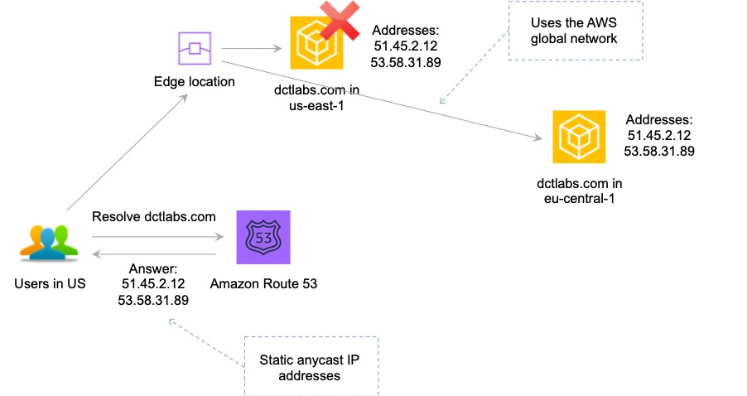

This is the only solution that provides deterministic failover.

**References:**

<https://aws.amazon.com/global-accelerator/>

<https://aws.amazon.com/global-accelerator/faqs/>

<https://docs.aws.amazon.com/global-accelerator/latest/dg/what-is-global-accelerator.html>

#### **Question 312:**

A retail company with many stores and warehouses is implementing IoT sensors to gather monitoring data from devices in each location. The data will be sent to AWS in real time. A solutions architect must provide a solution for ensuring events are received in order for each device and ensure that data is saved for future processing. Which solution would be MOST efficient?

1. Use Amazon Kinesis Data Streams for real-time events with a shard for each device. Use Amazon Kinesis Data Firehose to save data to Amazon EBS
2. Use Amazon Kinesis Data Streams for real-time events with a partition key for each device. Use Amazon Kinesis Data Firehose to save data to Amazon S3
3. Use an Amazon SQS standard queue for real-time events with one queue for each device. Trigger an AWS Lambda function from the SQS queue to save data to Amazon S3
4. Use an Amazon SQS FIFO queue for real-time events with one queue for each device. Trigger an AWS Lambda function for the SQS queue to save data to Amazon EFS

**Answer :** Use Amazon Kinesis Data Streams for real-time events with a partition key for each device. Use Amazon Kinesis Data Firehose to save data to Amazon S3

**Explanation**

Amazon Kinesis Data Streams collect and process data in real time. A *Kinesis data stream* is a set of [shards](https://docs.aws.amazon.com/streams/latest/dev/key-concepts.html#shard). Each shard has a sequence of data records. Each data record has a [sequence number](https://docs.aws.amazon.com/streams/latest/dev/key-concepts.html#sequence-number) that is assigned by Kinesis Data Streams. A *shard* is a uniquely identified sequence of data records in a stream. A *partition key* is used to group data by shard within a stream. Kinesis Data Streams segregates the data records belonging to a stream into multiple shards. It uses the partition key that is associated with each data record to determine which shard a given data record belongs to.

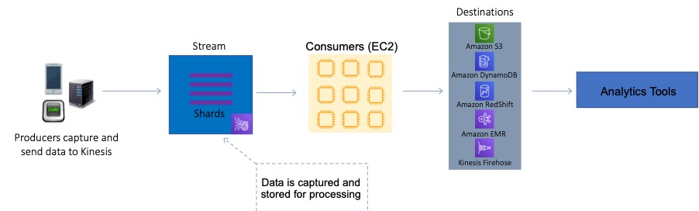

For this scenario, the solutions architect can use a partition key for each device. This will ensure the records for that device are grouped by shard and the shard will ensure ordering. Amazon S3 is a valid destination for saving the data records.

**References:**

<https://docs.aws.amazon.com/streams/latest/dev/key-concepts.html>

#### **Question 313:**

A Solutions Architect has been tasked with re-deploying an application running on AWS to enable high availability. The application processes messages that are received in an ActiveMQ queue running on a single Amazon EC2 instance. Messages are then processed by a consumer application running on Amazon EC2. After processing the messages the consumer application writes results to a MySQL database running on Amazon EC2. Which architecture offers the highest availability and low operational complexity?

1. Deploy Amazon MQ with active/standby brokers configured across two Availability Zones. Create an Auto Scaling group for the consumer EC2 instances across two Availability Zones. Use an Amazon RDS MySQL database with Multi-AZ enabled.
2. Deploy Amazon MQ with active/standby brokers configured across two Availability Zones. Launch an additional consumer EC2 instance in another Availability Zone. Use MySQL database replication to another Availability Zone.
3. Deploy a second Active MQ server to another Availability Zone. Launch an additional consumer EC2 instance in another Availability Zone. Use MySQL database replication to another Availability Zone.
4. Deploy Amazon MQ with active/standby brokers configured across two Availability Zones. Launch an additional consumer EC2 instance in another Availability Zone. Use Amazon RDS for MySQL with Multi-AZ enabled.

**Answer :** Deploy Amazon MQ with active/standby brokers configured across two Availability Zones. Create an Auto Scaling group for the consumer EC2 instances across two Availability Zones. Use an Amazon RDS MySQL database with Multi-AZ enabled

**Explanation**

The correct answer offers the highest availability as it includes Amazon MQ active/standby brokers across two AZs, an Auto Scaling group across two AZ,s and a Multi-AZ Amazon RDS MySQL database deployment. This architecture not only offers the highest availability it is also operationally simple as it maximizes the usage of managed services.

**References:**

<https://aws.amazon.com/architecture/well-architected/>

#### **Question 314:**

A company is investigating methods to reduce the expenses associated with on-premises backup infrastructure. The Solutions Architect wants to reduce costs by eliminating the use of physical backup tapes. It is a requirement that existing backup applications and workflows should continue to function. What should the Solutions Architect recommend?

1. Connect the backup applications to an AWS Storage Gateway using the iSCSI protocol.
2. Create an Amazon EFS file system and connect the backup applications using the iSCSI protocol.
3. Create an Amazon EFS file system and connect the backup applications using the NFS protocol.
4. Connect the backup applications to an AWS Storage Gateway using an iSCSI-virtual tape library (VTL).

**Answer :** Connect the backup applications to an AWS Storage Gateway using an iSCSI-virtual tape library (VTL)

**Explanation**

The AWS Storage Gateway Tape Gateway enables you to replace using physical tapes on premises with virtual tapes in AWS without changing existing backup workflows. Tape Gateway emulates physical tape libraries, removes the cost and complexity of managing physical tape infrastructure, and provides more durability than physical tapes.

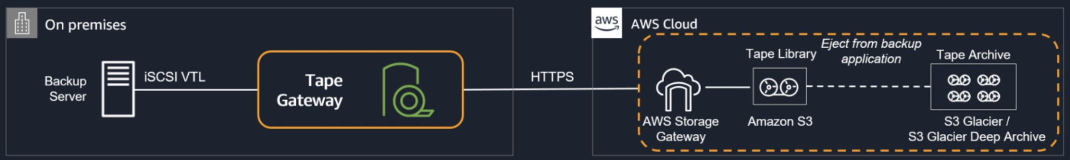

**References:**

<https://aws.amazon.com/storagegateway/vtl/>

#### **Question 315:**

An application running on an Amazon ECS container instance using the EC2 launch type needs permissions to write data to Amazon DynamoDB. How can you assign these permissions only to the specific ECS task that is running the application?

1. Modify the *AmazonECSTaskExecutionRolePolicy* policy to add permissions for DynamoDB
2. Use a security group to allow outbound connections to DynamoDB and assign it to the container instance
3. Create an IAM policy with permissions to DynamoDB and assign It to a task using the *taskRoleArn* parameter
4. Create an IAM policy with permissions to DynamoDB and attach it to the container instance

**Answer :** Create an IAM policy with permissions to DynamoDB and assign It to a task using the *taskRoleArn* parameter

**Explanation**

To specify permissions for a specific task on Amazon ECS you should use IAM Roles for Tasks. The permissions policy can be applied to tasks when creating the task definition, or by using an IAM task role override using the AWS CLI or SDKs. The *taskRoleAr*n parameter is used to specify the policy.

**References:**

<https://docs.aws.amazon.com/AmazonECS/latest/developerguide/task-iam-roles.html>

#### **Question 316:**

A company uses an Amazon RDS MySQL database instance to store customer order data. The security team have requested that SSL/TLS encryption in transit must be used for encrypting connections to the database from application servers. The data in the database is currently encrypted at rest using an AWS KMS key. How can a Solutions Architect enable encryption in transit?

1. Enable encryption in transit using the RDS Management console and obtain a key using AWS KMS.
2. Download the AWS-provided root certificates. Use the certificates when connecting to the RDS DB instance.
3. Add a self-signed certificate to the RDS DB instance. Use the certificates in all connections to the RDS DB instance.
4. Take a snapshot of the RDS instance. Restore the snapshot to a new instance with encryption in transit enabled.

**Answer :** Download the AWS-provided root certificates. Use the certificates when connecting to the RDS DB instance

**Explanation**

Amazon RDS creates an SSL certificate and installs the certificate on the DB instance when Amazon RDS provisions the instance. These certificates are signed by a certificate authority. The SSL certificate includes the DB instance endpoint as the Common Name (CN) for the SSL certificate to guard against spoofing attacks. You can download a root certificate from AWS that works for all Regions or you can download Region-specific intermediate certificates.

**References:**

<https://docs.aws.amazon.com/AmazonRDS/latest/UserGuide/UsingWithRDS.SSL.html>

#### **Question 317:**

An insurance company has a web application that serves users in the United Kingdom and Australia. The application includes a database tier using a MySQL database hosted in eu-west-2. The web tier runs from eu-west-2 and ap-southeast-2. Amazon Route 53 geoproximity routing is used to direct users to the closest web tier. It has been noted that Australian users receive slow response times to queries. Which changes should be made to the database tier to improve performance?

1. Migrate the database to an Amazon Aurora global database in MySQL compatibility mode. Configure read replicas in ap-southeast-2
2. Migrate the database to Amazon RDS for MySQL. Configure Multi-AZ in the Australian Region
3. Migrate the database to Amazon DynamoDB. Use DynamoDB global tables to enable replication to additional Regions
4. Deploy MySQL instances in each Region. Deploy an Application Load Balancer in front of MySQL to reduce the load on the primary instance

**Answer :** Migrate the database to an Amazon Aurora global database in MySQL compatibility mode. Configure read replicas in ap-southeast-2

**Explanation**

The issue here is latency with read queries being directed from Australia to UK which is great physical distance. A solution is required for improving read performance in Australia.

An Aurora global database consists of one primary AWS Region where your data is mastered, and up to five read-only, secondary AWS Regions. Aurora replicates data to the secondary AWS Regions with typical latency of under a second. You issue write operations directly to the primary DB instance in the primary AWS Region.

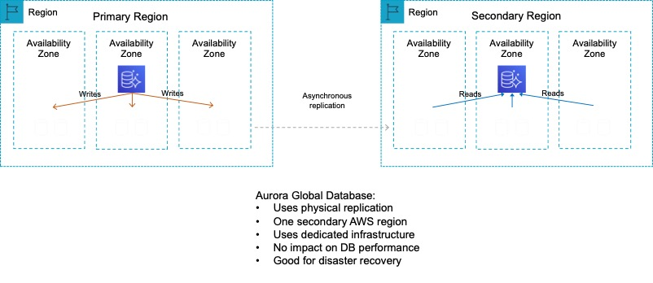

This solution will provide better performance for users in the Australia Region for queries. Writes must still take place in the UK Region but read performance will be greatly improved.

**References:**

<https://docs.aws.amazon.com/AmazonRDS/latest/AuroraUserGuide/aurora-global-database.html>

#### **Question 318:**

An eCommerce company runs an application on Amazon EC2 instances in public and private subnets. The web application runs in a public subnet and the database runs in a private subnet. Both the public and private subnets are in a single Availability Zone. Which combination of steps should a solutions architect take to provide high availability for this architecture? (Select TWO.)

1. Create an EC2 Auto Scaling group and Application Load Balancer that spans across multiple AZs.
2. Create new public and private subnets in a different AZ. Create a database using Amazon EC2 in one AZ.
3. Create an EC2 Auto Scaling group in the public subnet and use an Application Load Balancer.
4. Create new public and private subnets in a different AZ. Migrate the database to an Amazon RDS multi-AZ deployment.
5. Create new public and private subnets in the same AZ but in a different Amazon VPC.

**Answer :** Create an EC2 Auto Scaling group and Application Load Balancer that spans across multiple AZs

**Answer :** Create new public and private subnets in a different AZ. Migrate the database to an Amazon RDS multi-AZ deployment

**Explanation**

High availability can be achieved by using multiple Availability Zones within the same VPC. An EC2 Auto Scaling group can then be used to launch web application instances in multiple public subnets across multiple AZs and an ALB can be used to distribute incoming load. The database solution can be made highly available by migrating from EC2 to Amazon RDS and using a Multi-AZ deployment model. This will provide the ability to failover to another AZ in the event of a failure of the primary database or the AZ in which it runs.

**References:**

<https://aws.amazon.com/ec2/autoscaling/>

#### **Question 319:**

The database tier of a web application is running on a Windows server on-premises. The database is a Microsoft SQL Server database. The application owner would like to migrate the database to an Amazon RDS instance. How can the migration be executed with minimal administrative effort and downtime?

1. Use the AWS Database Migration Service (DMS) to directly migrate the database to RDS
2. Use the AWS Server Migration Service (SMS) to migrate the server to Amazon EC2. Use AWS Database Migration Service (DMS) to migrate the database to RDS
3. Use AWS DataSync to migrate the data from the database to Amazon S3. Use AWS Database Migration Service (DMS) to migrate the database to RDS
4. Use the AWS Database Migration Service (DMS) to directly migrate the database to RDS. Use the Schema Conversion Tool (SCT) to enable conversion from Microsoft SQL Server to Amazon RDS

**Answer :** Use the AWS Database Migration Service (DMS) to directly migrate the database to RDS

**Explanation**

You can directly migrate Microsoft SQL Server from an on-premises server into Amazon RDS using the Microsoft SQL Server database engine. This can be achieved using the native Microsoft SQL Server tools, or using AWS DMS as depicted below:

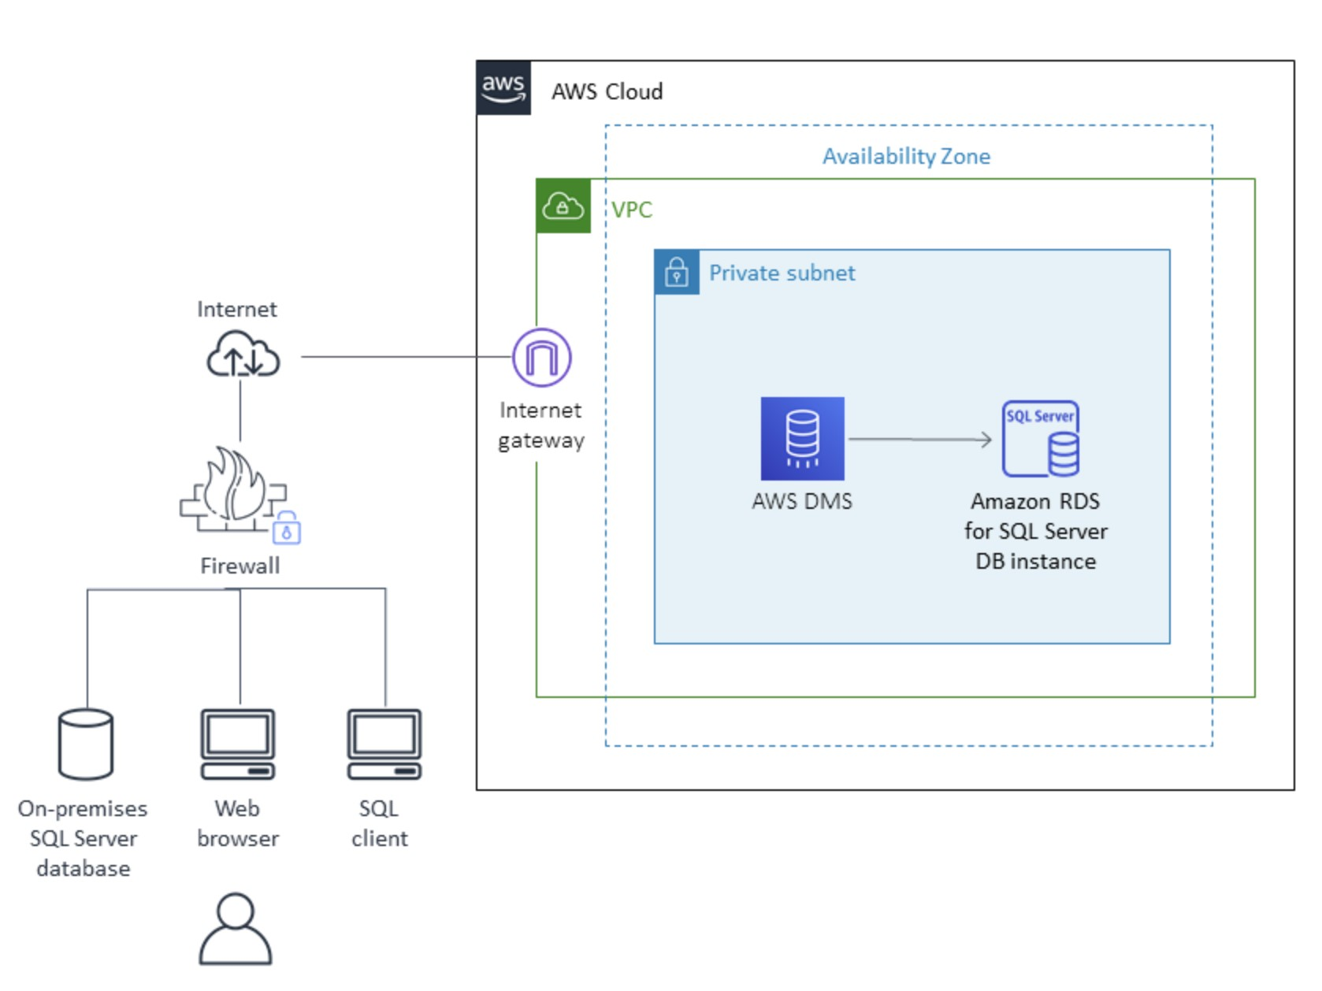

**References:**

<https://docs.aws.amazon.com/prescriptive-guidance/latest/patterns/migrate-an-on-premises-microsoft-sql-server-database-to-amazon-rds-for-sql-server.html>

<https://docs.aws.amazon.com/dms/latest/userguide/CHAP_Source.html>

<https://docs.aws.amazon.com/dms/latest/userguide/CHAP_Target.html>

<https://aws.amazon.com/dms/schema-conversion-tool/>

#### **Question 320:**

A company needs to connect its on-premises data center network to a new virtual private cloud (VPC). There is a symmetrical internet connection of 100 Mbps in the data center network. The data transfer rate for an on-premises application is multiple gigabytes per day. Processing will be done using an Amazon Kinesis Data Firehose stream. What should a solutions architect recommend for maximum performance?

1. Get an AWS Snowball Edge Storage Optimized device. Data must be copied to the device after several days and shipped to AWS for expedited transfer to Kinesis Data Firehose. Repeat as necessary.
2. Kinesis Data Firehose can be connected to the VPC using AWS PrivateLink. Install a 1 Gbps AWS Direct Connect connection between the on-premises network and AWS. To send data from on-premises to Kinesis Data Firehose, use the PrivateLink endpoint.
3. Establish a peering connection between the on-premises network and the VPC. Configure routing for the on-premises network to use the VPC peering connection.
4. Establish an AWS Site-to-Site VPN connection between the on-premises network and the VPC. Set up BGP routing between the customer gateway and the virtual private gateway. Send data to Kinesis Data Firehose using a VPN connection.

**Answer :** Kinesis Data Firehose can be connected to the VPC using AWS PrivateLink. Install a 1 Gbps AWS Direct Connect connection between the on-premises network and AWS. To send data from on-premises to Kinesis Data Firehose, use the PrivateLink endpoint

**Explanation:**

Using AWS PrivateLink to create an interface endpoint will allow your traffic to traverse the AWS Global Backbone to allow maximum performance and security. Also by using an AWS Direct Connect cable you can ensure you have a dedicated cable to provide maximum performance and low latency to and from AWS.

**References:**

<https://aws.amazon.com/privatelink/>

#### **Question 321:**

A company has a file share on a Microsoft Windows Server in an on-premises data center. The server uses a local network attached storage (NAS) device to store several terabytes of files. The management team require a reduction in the data center footprint and to minimize storage costs by moving on-premises storage to AWS. What should a Solutions Architect do to meet these requirements?

1. Create an Amazon EFS volume and use an IPSec VPN.
2. Create an Amazon S3 bucket and an S3 gateway endpoint.
3. Configure an AWS Storage Gateway as a volume gateway.
4. Configure an AWS Storage Gateway file gateway.

**Answer :** Configure an AWS Storage Gateway file gateway

**Explanation**

An AWS Storage Gateway File Gateway provides your applications a file interface to seamlessly store files as objects in Amazon S3, and access them using industry standard file protocols. This removes the files from the on-premises NAS device and provides a method of directly mounting the file share for on-premises servers and clients.

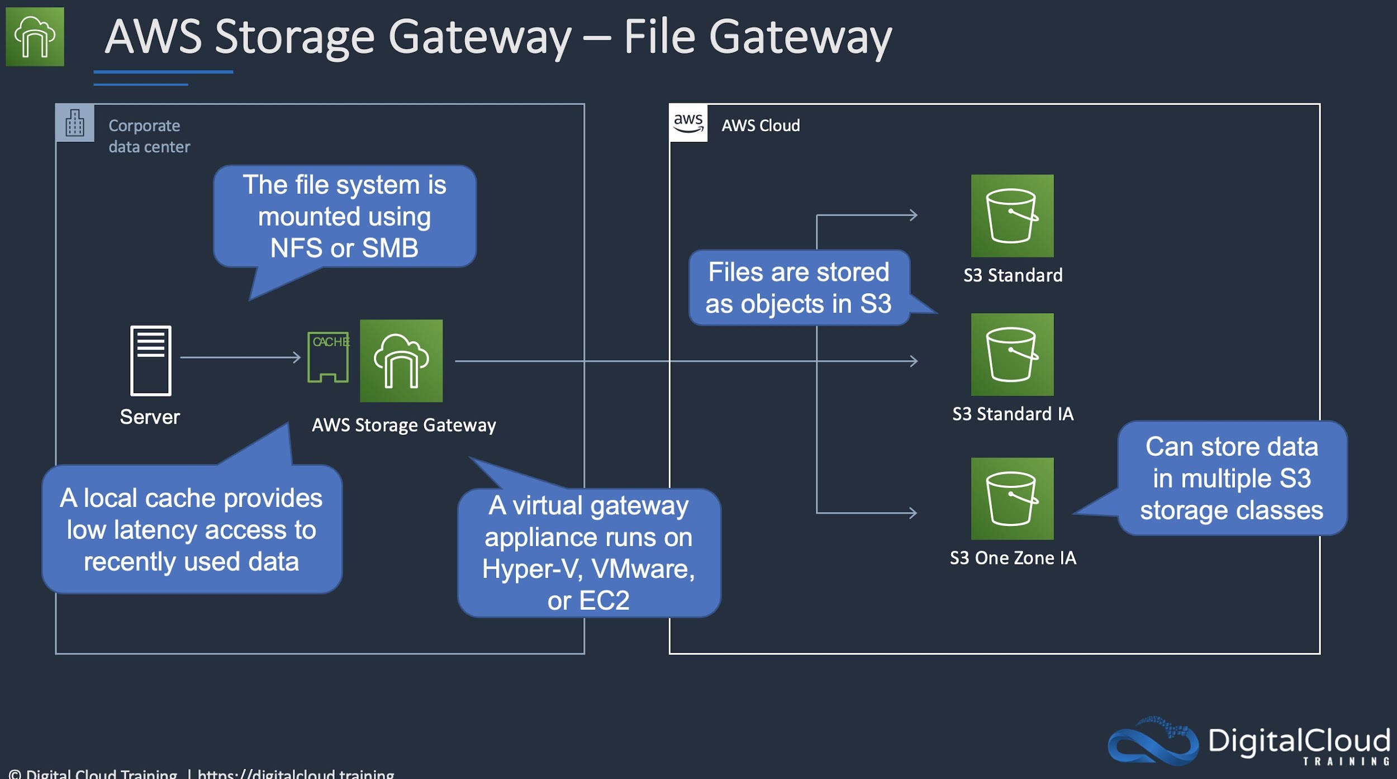

**References:**

<https://aws.amazon.com/storagegateway/faqs/>

#### **Question 322:**

An application is hosted on the U.S west coast. Users there have no problems, but users on the east coast are experiencing performance issues. The users have reported slow response times with the search bar autocomplete and display of account listings. How can you improve the performance for users on the east coast?

1. Create a DynamoDB Read Replica in the U.S east region
2. Create an ElastiCache database in the U.S east region
3. Host the static content in an Amazon S3 bucket and distribute it using CloudFront
4. Setup cross-region replication and use Route 53 geolocation routing

**Answer :** Create an ElastiCache database in the U.S east region

**Explanation**

ElastiCache can be deployed in the U.S east region to provide high-speed access to the content. ElastiCache Redis has a good use case for autocompletion (see links below).

**References:**

<https://aws.amazon.com/blogs/database/creating-a-simple-autocompletion-service-with-redis-part-one-of-two/>

#### **Question 323:**

An organization is migrating data to the AWS cloud. An on-premises application uses Network File System shares and must access the data without code changes. The data is critical and is accessed frequently. Which storage solution should a Solutions Architect recommend to maximize availability and durability?

1. Amazon Elastic File System
2. Amazon Elastic Block Store
3. Amazon Simple Storage Service
4. AWS Storage Gateway – File Gateway

**Answer :** AWS Storage Gateway – File Gateway

**Explanation**

The solution must use NFS file shares to access the migrated data without code modification. This means you can use either Amazon EFS or AWS Storage Gateway – File Gateway. Both of these can be mounted using NFS from on-premises applications. However, EFS is the wrong answer as the solution asks to maximize availability and durability. The File Gateway backs off of Amazon S3 which has much higher availability and durability than EFS which is why it is the best solution for this scenario.

**References:**

<https://docs.aws.amazon.com/storagegateway/latest/userguide/CreatingAnNFSFileShare.html>

#### **Question 324:**

A company wants to migrate a legacy web application from an on-premises data center to AWS. The web application consists of a web tier, an application tier, and a MySQL database. The company does not want to manage instances or clusters. Which combination of services should a solutions architect include in the overall architecture? (Select TWO.)

1. Amazon DynamoDB
2. AWS Fargate
3. Amazon RDS for MySQL
4. Amazon EC2 Spot Instances
5. Amazon Kinesis Data Streams

**Answer :** AWS Fargate

**Answer :** Amazon RDS for MySQL

**Explanation**

Amazon RDS is a managed service and you do not need to manage the instances. This is an ideal backend for the application and you can run a MySQL database on RDS without any refactoring. For the application components these can run on Docker containers with AWS Fargate. Fargate is a serverless service for running containers on AWS.

**References:**

<https://aws.amazon.com/rds/>

<https://aws.amazon.com/fargate/>

#### **Question 325:**

A solutions architect is designing an application on AWS. The compute layer will run in parallel across EC2 instances. The compute layer should scale based on the number of jobs to be processed. The compute layer is stateless. The solutions architect must ensure that the application is loosely coupled and the job items are durably stored. Which design should the solutions architect use?

1. Create an Amazon SNS topic to send the jobs that need to be processed. Create an Amazon EC2 Auto Scaling group for the compute application. Set the scaling policy for the Auto Scaling group to add and remove nodes based on the number of messages published to the SNS topic
2. Create an Amazon SQS queue to hold the jobs that need to be processed. Create an Amazon EC2 Auto Scaling group for the compute application. Set the scaling policy for the Auto Scaling group to add and remove nodes based on network usage
3. Create an Amazon SNS topic to send the jobs that need to be processed. Create an Amazon EC2 Auto Scaling group for the compute application. Set the scaling policy for the Auto Scaling group to add and remove nodes based on CPU usage
4. Create an Amazon SQS queue to hold the jobs that needs to be processed. Create an Amazon EC2 Auto Scaling group for the compute application. Set the scaling policy for the Auto Scaling group to add and remove nodes based on the number of items in the SQS queue

**Answer :** Create an Amazon SQS queue to hold the jobs that needs to be processed. Create an Amazon EC2 Auto Scaling group for the compute application. Set the scaling policy for the Auto Scaling group to add and remove nodes based on the number of items in the SQS queue

**Explanation**

In this case we need to find a durable and loosely coupled solution for storing jobs. Amazon SQS is ideal for this use case and can be configured to use dynamic scaling based on the number of jobs waiting in the queue. To configure this scaling you can use the *backlog per instance* metric with the target value being the *acceptable backlog per instance* to maintain. You can calculate these numbers as follows: Backlog per instance: To calculate your backlog per instance, start with the ApproximateNumberOfMessages queue attribute to determine the length of the SQS queue (number of messages available for retrieval from the queue). Divide that number by the fleet's running capacity, which for an Auto Scaling group is the number of instances in the InService state, to get the backlog per instance. Acceptable backlog per instance: To calculate your target value, first determine what your application can accept in terms of latency. Then, take the acceptable latency value and divide it by the average time that an EC2 instance takes to process a message. This solution will scale EC2 instances using Auto Scaling based on the number of jobs waiting in the SQS queue.

**References:**

<https://docs.aws.amazon.com/autoscaling/ec2/userguide/as-using-sqs-queue.html>

#### **Question 326:**

A Solutions Architect must design a storage solution for incoming billing reports in CSV format. The data will be analyzed infrequently and discarded after 30 days. Which combination of services will be MOST cost-effective in meeting these requirements?

1. Import the logs to an Amazon Redshift cluster
2. Write the files to an S3 bucket and use Amazon Athena to query the data
3. Use AWS Data Pipeline to import the logs into a DynamoDB table
4. Import the logs into an RDS MySQL instance

**Answer :** Write the files to an S3 bucket and use Amazon Athena to query the data

**Explanation**

Amazon S3 is great solution for storing objects such as this. You only pay for what you use and don’t need to worry about scaling as it will scale as much as you need it to. Using Amazon Athena to analyze the data works well as it is a serverless service so it will be very cost-effective for use cases where the analysis is only happening infrequently. You can also configure Amazon S3 to expire the objects after 30 days.

**References:**

<https://aws.amazon.com/athena/>

#### **Question 327:**

A website is running on Amazon EC2 instances and access is restricted to a limited set of IP ranges. A solutions architect is planning to migrate static content from the website to an Amazon S3 bucket configured as an origin for an Amazon CloudFront distribution. Access to the static content must be restricted to the same set of IP addresses. Which combination of steps will meet these requirements? (Select TWO.)

1. Create an AWS WAF web ACL that includes the same IP restrictions that exist in the EC2 security group. Associate this new web ACL with the CloudFront distribution.
2. Create an origin access identity (OAI) and associate it with the distribution. Generate presigned URLs that limit access to the OAI.
3. Attach the existing security group that contains the IP restrictions to the Amazon CloudFront distribution.
4. Create an origin access identity (OAI) and associate it with the distribution. Change the permissions in the bucket policy so that only the OAI can read the objects.
5. Create an AWS WAF web ACL that includes the same IP restrictions that exist in the EC2 security group. Associate this new web ACL with the Amazon S3 bucket.

**Answer :** Create an origin access identity (OAI) and associate it with the distribution. Change the permissions in the bucket policy so that only the OAI can read the objects

**Answer :** Create an AWS WAF web ACL that includes the same IP restrictions that exist in the EC2 security group. Associate this new web ACL with the CloudFront distribution

**Explanation**

To prevent users from circumventing the controls implemented on CloudFront (using WAF or presigned URLs / signed cookies) you can use an origin access identity (OAI). An OAI is a special CloudFront user that you associate with a distribution. The next step is to change the permissions either on your Amazon S3 bucket or on the files in your bucket so that only the origin access identity has read permission (or read and download permission). This can be implemented through a bucket policy.

To control access at the CloudFront layer the AWS Web Application Firewall (WAF) can be used. With WAF you must create an ACL that includes the IP restrictions required and then associate the web ACL with the CloudFront distribution.

**References:**

<https://docs.aws.amazon.com/AmazonCloudFront/latest/DeveloperGuide/private-content-restricting-access-to-s3.html>

<https://docs.aws.amazon.com/waf/latest/developerguide/cloudfront-features.html>

#### **Question 328:**

A highly sensitive application runs on Amazon EC2 instances using EBS volumes. The application stores data temporarily on Amazon EBS volumes during processing before saving results to an Amazon RDS database. The company’s security team mandate that the sensitive data must be encrypted at rest. Which solution should a Solutions Srchitect recommend to meet this requirement?

1. Configure encryption for the Amazon EBS volumes and Amazon RDS database with AWS KMS keys.
2. Use AWS Certificate Manager to generate certificates that can be used to encrypt the connections between the EC2 instances and RDS.
3. Configure SSL/TLS encryption using AWS KMS customer master keys (CMKs) to encrypt database volumes.
4. Use Amazon Data Lifecycle Manager to encrypt all data as it is stored to the EBS volumes and RDS database.

**Answer :** Configure encryption for the Amazon EBS volumes and Amazon RDS database with AWS KMS keys

**Explanation**

As the data is stored both in the EBS volumes (temporarily) and the RDS database, both the EBS and RDS volumes must be encrypted at rest. This can be achieved by enabling encryption at creation time of the volume and AWS KMS keys can be used to encrypt the data. This solution meets all requirements.

**References:**

<https://docs.aws.amazon.com/AWSEC2/latest/UserGuide/EBSEncryption.html>

<https://docs.aws.amazon.com/AmazonRDS/latest/UserGuide/Overview.Encryption.html>

#### **Question 329:**

A High Performance Computing (HPC) application will be migrated to AWS. The application requires low network latency and high throughput between nodes and will be deployed in a single AZ. How should the application be deployed for best inter-node performance?

1. In a spread placement group
2. In a cluster placement group
3. In a partition placement group
4. Behind a Network Load Balancer (NLB)

**Answer :** In a cluster placement group

**Explanation**

A cluster placement group provides low latency and high throughput for instances deployed in a single AZ. It is the best way to provide the performance required for this application.

**References:**

<https://docs.aws.amazon.com/AWSEC2/latest/UserGuide/placement-groups.html>

#### **Question 330:**

A company runs an eCommerce application that uses an Amazon Aurora database. The database performs well except for short periods when monthly sales reports are run. A Solutions Architect has reviewed metrics in Amazon CloudWatch and found that the Read Ops and CPUUtilization metrics are spiking during the periods when the sales reports are run. What is the MOST cost-effective solution to solve this performance issue?

1. Create an Aurora Replica and use the replica endpoint for reporting.
2. Modify the Aurora database to use an instance class with more CPU.
3. Enable storage Auto Scaling for the Amazon Aurora database.
4. Create an Amazon Redshift data warehouse and run the reporting there.

**Answer :** Create an Aurora Replica and use the replica endpoint for reporting

**Explanation**

The simplest and most cost-effective option is to use an Aurora Replica. The replica can serve read operations which will mean the reporting application can run reports on the replica endpoint without causing any performance impact on the production database.

**References:**

<https://docs.aws.amazon.com/AmazonRDS/latest/AuroraUserGuide/Aurora.Overview.StorageReliability.html>

#### **Question 331:**

A company has refactored a legacy application to run as two microservices using Amazon ECS. The application processes data in two parts and the second part of the process takes longer than the first. How can a solutions architect integrate the microservices and allow them to scale independently?

1. Implement code in microservice 1 to publish data to an Amazon SNS topic. Implement code in microservice 2 to subscribe to this topic
2. Implement code in microservice 1 to send data to an Amazon SQS queue. Implement code in microservice 2 to process messages from the queue
3. Implement code in microservice 1 to send data to Amazon Kinesis Data Firehose. Implement code in microservice 2 to read from Kinesis Data Firehose
4. Implement code in microservice 1 to send data to an Amazon S3 bucket. Use S3 event notifications to invoke microservice 2

**Answer :** Implement code in microservice 1 to send data to an Amazon SQS queue. Implement code in microservice 2 to process messages from the queue

**Explanation**

This is a good use case for Amazon SQS. The microservices must be decoupled so they can scale independently. An Amazon SQS queue will enable microservice 1 to add messages to the queue. Microservice 2 can then pick up the messages and process them. This ensures that if there’s a spike in traffic on the frontend, messages do not get lost due to the backend process not being ready to process them.

**References:**

<https://docs.aws.amazon.com/AWSSimpleQueueService/latest/SQSDeveloperGuide/welcome.html>

#### **Question 332:**

An AWS workload in a VPC is running a legacy database on an Amazon EC2 instance. Data is stored on a 2000GB Amazon EBS (gp2) volume. At peak load times, logs show excessive wait time. What should be implemented to improve database performance using persistent storage?

1. Change the EC2 instance type to one with burstable performance
2. Change the EC2 instance type to one with EC2 instance store volumes
3. Migrate the data on the Amazon EBS volume to an SSD-backed volume
4. Migrate the data on the EBS volume to provisioned IOPS SSD (io1)

**Answer :** Migrate the data on the EBS volume to provisioned IOPS SSD (io1)

**Explanation**

The data is already on an SSD-backed volume (gp2), therefore to improve performance the best option is to migrate the data onto a provisioned IOPS SSD (io1) volume type which will provide improved I/O performance and therefore reduce wait times.

**References:**

<https://docs.aws.amazon.com/AWSEC2/latest/UserGuide/EBSVolumeTypes.html>

<https://docs.aws.amazon.com/AWSEC2/latest/UserGuide/burstable-performance-instances.html>

#### **Question 333:**

A company runs a number of core enterprise applications in an on-premises data center. The data center is connected to an Amazon VPC using AWS Direct Connect. The company will be creating additional AWS accounts and these accounts will also need to be quickly, and cost-effectively connected to the on-premises data center in order to access the core applications. What deployment changes should a Solutions Architect implement to meet these requirements with the LEAST operational overhead?

1. Configure AWS Transit Gateway between the accounts. Assign Direct Connect to the transit gateway and route network traffic to the on-premises servers.
2. Create a VPN connection between each new account and the Direct Connect VPC. Route the network traffic to the on-premises servers.
3. Configure VPC endpoints in the Direct Connect VPC for all required services. Route the network traffic to the on-premises servers.
4. Create a Direct Connect connection in each new account. Route the network traffic to the on-premises servers.

**Answer :** Configure AWS Transit Gateway between the accounts. Assign Direct Connect to the transit gateway and route network traffic to the on-premises servers

**Explanation**

AWS Transit Gateway connects VPCs and on-premises networks through a central hub. With AWS Transit Gateway, you can quickly add Amazon VPCs, AWS accounts, VPN capacity, or AWS Direct Connect gateways to meet unexpected demand, without having to wrestle with complex connections or massive routing tables. This is the operationally least complex solution and is also cost-effective. The image below depicts how transit gateway can assist with simplifying network deployments:



**References:**

<https://aws.amazon.com/transit-gateway/>

#### **Question 334:**

A group of business analysts perform read-only SQL queries on an Amazon RDS database. The queries have become quite numerous and the database has experienced some performance degradation. The queries must be run against the latest data. A Solutions Architect must solve the performance problems with minimal changes to the existing web application. What should the Solutions Architect recommend?

1. Create a read replica of the primary database and instruct the business analysts to direct queries to the replica.
2. Load the data into an Amazon Redshift cluster and instruct the business analysts to run their queries against the cluster.
3. Export the data to Amazon S3 and instruct the business analysts to run their queries using Amazon Athena.
4. Load the data into Amazon ElastiCache and instruct the business analysts to run their queries against the ElastiCache endpoint.

**Answer :** Configure AWS Transit Gateway between the accounts. Assign Direct Connect to the transit gateway and route network traffic to the on-premises servers

**Explanation**

The performance issues can be easily resolved by offloading the SQL queries the business analysts are performing to a read replica. This ensures that data that is being queries is up to date and the existing web application does not require any modifications to take place.

**References:**

<https://docs.aws.amazon.com/AmazonRDS/latest/UserGuide/USER_ReadRepl.html>

#### **Question 335:**

A solutions architect has created a new AWS account and must secure AWS account root user access. Which combination of actions will accomplish this? (Select TWO.)

1. Enable multi-factor authentication for the root user
2. Delete the root user account
3. Add the root user to a group containing administrative permissions
4. Ensure the root user uses a strong password
5. Store root user access keys in an encrypted Amazon S3 bucket

**Answer :** Ensure the root user uses a strong password

**Answer :** Enable multi-factor authentication to the root user

**Explanation**

There are several security best practices for securing the root user account:

· Lock away root user access keys OR delete them if possible

· Use a strong password

· Enable multi-factor authentication (MFA)

The root user automatically has full privileges to the account and these privileges cannot be restricted so it is extremely important to follow best practice advice about securing the root user account.

**References:**

<https://docs.aws.amazon.com/IAM/latest/UserGuide/best-practices.html>

#### **Question 336:**

A web application has recently been launched on AWS. The architecture includes two tier with a web layer and a database layer. It has been identified that the web server layer may be vulnerable to cross-site scripting (XSS) attacks. What should a solutions architect do to remediate the vulnerability?

1. Create an Application Load Balancer. Put the web layer behind the load balancer and enable AWS WAF
2. Create an Application Load Balancer. Put the web layer behind the load balancer and use AWS Shield Standard
3. Create a Classic Load Balancer. Put the web layer behind the load balancer and enable AWS WAF
4. Create a Network Load Balancer. Put the web layer behind the load balancer and enable AWS WAF

**Answer :** Create an Application Load Balancer. Put the web layer behind the load balancer and enable AWS WAF

**Explanation**

The AWS Web Application Firewall (WAF) is available on the Application Load Balancer (ALB). You can use AWS WAF directly on Application Load Balancers (both internal and external) in a VPC, to protect your websites and web services. Attackers sometimes insert scripts into web requests in an effort to exploit vulnerabilities in web applications. You can create one or more cross-site scripting match conditions to identify the parts of web requests, such as the URI or the query string, that you want AWS WAF to inspect for possible malicious scripts.

**References:**

<https://docs.aws.amazon.com/waf/latest/developerguide/classic-web-acl-xss-conditions.html>

#### **Question 337:**

An Amazon RDS PostgreSQL database is configured as Multi-AZ. A solutions architect needs to scale read performance and the solution must be configured for high availability. What is the most cost-effective solution?

1. Deploy a read replica in a different AZ to the master DB instance
2. Deploy a read replica using Amazon ElastiCache
3. Deploy a read replica in the same AZ as the master DB instance
4. Create a read replica as a Multi-AZ DB instance

**Answer :** Create a read replica as a Multi-AZ DB instance

**Explanation**

You can create a read replica as a Multi-AZ DB instance. Amazon RDS creates a standby of your replica in another Availability Zone for failover support for the replica. Creating your read replica as a Multi-AZ DB instance is independent of whether the source database is a Multi-AZ DB instance.

**References:**

<https://aws.amazon.com/about-aws/whats-new/2018/01/amazon-rds-read-replicas-now-support-multi-az-deployments/>

#### **Question 338:**

A Solutions Architect must select the most appropriate database service for two use cases. A team of data scientists perform complex queries on a data warehouse that take several hours to complete. Another team of scientists need to run fast, repeat queries and update dashboards for customer support staff. Which solution delivers these requirements MOST cost-effectively?

1. RDS for both use cases
2. RedShift for both use cases
3. RedShift for the analytics use case and RDS for the customer support dashboard
4. RedShift for the analytics use case and ElastiCache in front of RedShift for the customer support dashboard

**Answer :** RedShift for both use cases

**Explanation**

RedShift is a columnar data warehouse DB that is ideal for running long complex queries. RedShift can also improve performance for repeat queries by caching the result and returning the cached result when queries are re-run. Dashboard, visualization, and business intelligence (BI) tools that execute repeat queries see a significant boost in performance due to result caching.

**References:**

<https://aws.amazon.com/about-aws/whats-new/2017/11/amazon-redshift-introduces-result-caching-for-sub-second-response-for-repeat-queries/>

#### **Question 339:**

An application uses Amazon EC2 instances and an Amazon RDS MySQL database. The database is not currently encrypted. A solutions architect needs to apply encryption to the database for all new and existing data. How should this be accomplished?

1. Enable encryption for the database using the API. Take a full snapshot of the database. Delete old snapshots
2. Create an RDS read replica with encryption at rest enabled. Promote the read replica to master and switch the application over to the new master. Delete the old RDS instance
3. Take a snapshot of the RDS instance. Create an encrypted copy of the snapshot. Restore the RDS instance from the encrypted snapshot
4. Create an Amazon ElastiCache cluster and encrypt data using the cache nodes

**Answer :** Take a snapshot of the RDS instance. Create an encrypted copy of the snapshot. Restore the RDS instance from the encrypted snapshot

**Explanation**

There are some [limitations for encrypted Amazon RDS DB Instances](https://docs.aws.amazon.com/AmazonRDS/latest/UserGuide/Overview.Encryption.html#Overview.Encryption.Limitations): you can't modify an existing unencrypted Amazon RDS DB instance to make the instance encrypted, and you can't create an encrypted read replica from an unencrypted instance. However, you can use the Amazon RDS snapshot feature to encrypt an unencrypted snapshot that's taken from the RDS database that you want to encrypt. Restore a new RDS DB instance from the encrypted snapshot to deploy a new encrypted DB instance. Finally, switch your connections to the new DB instance.

**References:**

<https://docs.aws.amazon.com/AmazonRDS/latest/UserGuide/Overview.Encryption.html>

<https://aws.amazon.com/premiumsupport/knowledge-center/rds-encrypt-instance-mysql-mariadb/>

#### **Question 340:**

A company is storing a large quantity of small files in an Amazon S3 bucket. An application running on an Amazon EC2 instance needs permissions to access and process the files in the S3 bucket. Which action will MOST securely grant the EC2 instance access to the S3 bucket?

1. Create an IAM user for the application with specific permissions to the S3 bucket.
2. Create an IAM role with least privilege permissions and attach it to the EC2 instance profile.
3. Generate access keys and store the credentials on the EC2 instance for use in making API calls.
4. Create a bucket ACL on the S3 bucket and configure the EC2 instance ID as a grantee.

**Answer :** Create an IAM role with least privilege permissions and attach it to the EC2 instance profile.

**Explanation**

IAM roles should be used in place of storing credentials on Amazon EC2 instances. This is the most secure way to provide permissions to EC2 as no credentials are stored and short-lived credentials are obtained using AWS STS. Additionally, the policy attached to the role should provide least privilege permissions.

**References:**

<https://docs.aws.amazon.com/AWSEC2/latest/UserGuide/iam-roles-for-amazon-ec2.html>

#### **Question 341:**

A DynamoDB database you manage is randomly experiencing heavy read requests that are causing latency. What is the simplest way to alleviate the performance issues?

1. Create DynamoDB read replicas
2. Enable DynamoDB DAX
3. Create an ElastiCache cluster in front of DynamoDB
4. Enable EC2 Auto Scaling for DynamoDB

**Answer :** Enable DynamoDB DAX

**Explanation**

DynamoDB offers consistent single-digit millisecond latency. However, DynamoDB + DAX further increases performance with response times in microseconds for millions of requests per second for read-heavy workloads. The DAX cache uses cluster nodes running on Amazon EC2 instances and sits in front of the DynamoDB table as you can see in the diagram below:

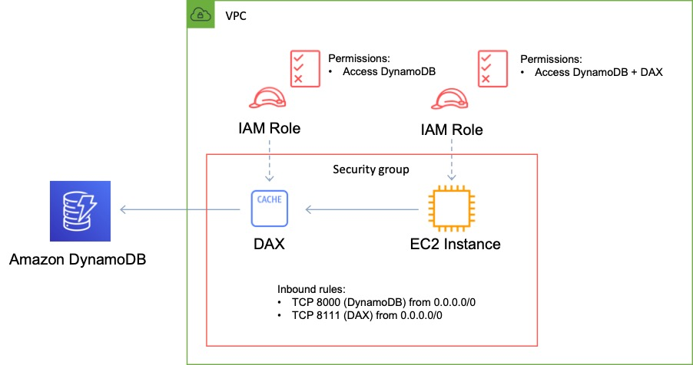

**References:**

<https://aws.amazon.com/dynamodb/dax/>

#### **Question 342:**

A company requires a solution for replicating data to AWS for disaster recovery. Currently, the company uses scripts to copy data from various sources to a Microsoft Windows file server in the on-premises data center. The company also requires that a small amount of recent files are accessible to administrators with low latency. What should a Solutions Architect recommend to meet these requirements?

1. Update the script to copy data to an Amazon EBS volume instead of the on-premises file server.
2. Update the script to copy data to an Amazon S3 Glacier archive instead of the on-premises file server.
3. Update the script to copy data to an Amazon EFS volume instead of the on-premises file server.
4. Update the script to copy data to an AWS Storage Gateway for File Gateway virtual appliance instead of the on-premises file server.

**Answer :** Update the script to copy data to an AWS Storage Gateway for File Gateway virtual appliance instead of the on-premises file server

**Explanation**

The best solution here is to use an AWS Storage Gateway File Gateway virtual appliance in the on-premises data center. This can be accessed the same protocols as the existing Microsoft Windows File Server (SMB/CIFS). Therefore, the script simply needs to be updated to point to the gateway. The file gateway will then store data on Amazon S3 and has a local cache for data that can be accessed at low latency. The file gateway provides an excellent method of enabling file protocol access to low cost S3 object storage.

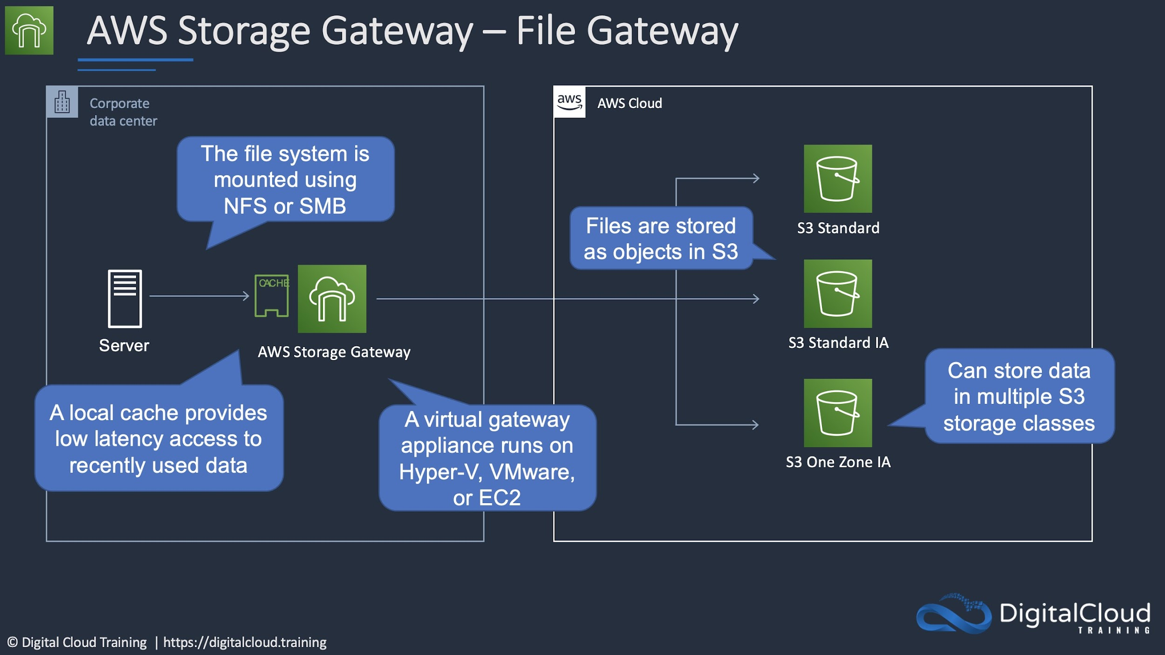

**References:**

<https://aws.amazon.com/storagegateway/file/>

#### **Question 343:**

A web application is deployed in multiple regions behind an ELB Application Load Balancer. You need deterministic routing to the closest region and automatic failover. Traffic should traverse the AWS global network for consistent performance. How can this be achieved?

1. Configure AWS Global Accelerator and configure the ALBs as target
2. Use a CloudFront distribution with multiple custom origins in each region and configure for high availability
3. Place an EC2 Proxy in front of the ALB and configure automatic failover
4. Create a Route 53 Alias record for each ALB and configure a latency-based routing policy

**Answer :** Configure AWS Global Accelerator and configure the ALBs as targets

**Explanation**

AWS Global Accelerator is a service that improves the availability and performance of applications with local or global users. You can configure the ALB as a target and Global Accelerator will automatically route users to the closest point of presence.

Failover is automatic and does not rely on any client side cache changes as the IP addresses for Global Accelerator are static anycast addresses. Global Accelerator also uses the AWS global network which ensures consistent performance.



**References:**

<https://aws.amazon.com/global-accelerator/>

<https://aws.amazon.com/global-accelerator/faqs/>

<https://docs.aws.amazon.com/global-accelerator/latest/dg/what-is-global-accelerator.html>

#### **Question 344:**

An automotive company plans to implement IoT sensors in manufacturing equipment that will send data to AWS in real time. The solution must receive events in an ordered manner from each asset and ensure that the data is saved for future processing. Which solution would be MOST efficient?

1. Use an Amazon SQS standard queue for real-time events with one queue for each equipment asset. Trigger an AWS Lambda function from the SQS queue to save data to Amazon S3.
2. Use Amazon Kinesis Data Streams for real-time events with a partition for each equipment asset. Use Amazon Kinesis Data Firehose to save data to Amazon S3.
3. Use Amazon Kinesis Data Streams for real-time events with a shard for each equipment asset. Use Amazon Kinesis Data Firehose to save data to Amazon EBS.
4. Use an Amazon SQS FIFO queue for real-time events with one queue for each equipment asset. Trigger an AWS Lambda function for the SQS queue to save data to Amazon EFS.

**Answer :** Use Amazon Kinesis Data Streams for real-time events with a partition for each equipment asset. Use Amazon Kinesis Data Firehose to save data to Amazon S3

**Explanation**

Amazon Kinesis Data Streams is the ideal service for receiving streaming data. The Amazon Kinesis Client Library (KCL) delivers all records for a given partition key to the same record processor, making it easier to build multiple applications reading from the same Amazon Kinesis data stream. Therefore, a separate partition (rather than shard) should be used for each equipment asset. Amazon Kinesis Firehose can be used to receive streaming data from Data Streams and then load the data into Amazon S3 for future processing.

**References:**

<https://aws.amazon.com/kinesis/data-streams/faqs/>

<https://aws.amazon.com/kinesis/data-firehose/>

#### **Question 345:**

An application has been deployed on Amazon EC2 instances behind an Application Load Balancer (ALB). A Solutions Architect must improve the security posture of the application and minimize the impact of a DDoS attack on resources. Which of the following solutions is MOST effective?

1. Enable access logs on the Application Load Balancer and configure Amazon CloudWatch to monitor the access logs and trigger a Lambda function when potential attacks are identified. Configure the Lambda function to modify the ALBs security group and block the attack.
2. Enable VPC Flow Logs and store them in Amazon S3. Use Amazon Athena to parse the logs and identify and block potential DDoS attacks.
3. Create a custom AWS Lambda function that monitors for suspicious traffic and modifies a network ACL when a potential DDoS attack is identified.
4. Configure an AWS WAF ACL with rate-based rules. Enable the WAF ACL on the Application Load Balancer.

**Answer :** Configure an AWS WAF ACL with rate-based rules. Enable the WAF ACL on the Application Load Balancer

**Explanation**

A rate-based rule tracks the rate of requests for each originating IP address, and triggers the rule action on IPs with rates that go over a limit. You set the limit as the number of requests per 5-minute time span. You can use this type of rule to put a temporary block on requests from an IP address that's sending excessive requests. By default, AWS WAF aggregates requests based on the IP address from the web request origin, but you can configure the rule to use an IP address from an HTTP header, like X-Forwarded-For, instead.

**References:**

<https://docs.aws.amazon.com/waf/latest/developerguide/waf-rule-statement-type-rate-based.html>

#### **Question 346:**

A company runs several NFS file servers in an on-premises data center. The NFS servers must run periodic backups to Amazon S3 using automatic synchronization for small volumes of data. Which solution meets these requirements and is MOST cost-effective?

1. Set up an AWS Direct Connect connection between the on-premises data center and AWS and copy the data to Amazon S3.
2. Set up an SFTP sync using AWS Transfer for SFTP to sync data from on premises to Amazon S3.
3. Set up an AWS DataSync agent on the on-premises servers and sync the data to Amazon S3.
4. Set up AWS Glue to extract the data from the NFS shares and load it into Amazon S3.

**Answer :** Set up an AWS DataSync agent on the on-premises servers and sync the data to Amazon S3

**Explanation**

AWS DataSync is an online data transfer service that simplifies, automates, and accelerates copying large amounts of data between on-premises systems and AWS Storage services, as well as between AWS Storage services. DataSync can copy data between Network File System (NFS) shares, or Server Message Block (SMB) shares, self-managed object storage, [AWS Snowcone](https://aws.amazon.com/snowcone/), [Amazon Simple Storage Service (Amazon S3)](https://aws.amazon.com/s3/) buckets, [Amazon Elastic File System (Amazon EFS)](https://aws.amazon.com/efs/) file systems, and [Amazon FSx for Windows File Server](https://aws.amazon.com/fsx/windows/) file systems. This is the most cost-effective solution from the answer options available.

**References:**

<https://aws.amazon.com/datasync/features/>

#### **Question 347:**

An IoT sensor is being rolled out to thousands of a company’s existing customers. The sensors will stream high volumes of data each second to a central location. A solution must be designed to ingest and store the data for analytics. The solution must provide near-real time performance and millisecond responsiveness. Which solution should a Solutions Architect recommend?

1. Ingest the data into an Amazon Kinesis Data Stream. Process the data with an AWS Lambda function and then store the data in Amazon DynamoDB.
2. Ingest the data into an Amazon SQS queue. Process the data using an AWS Lambda function and then store the data in Amazon DynamoDB.
3. Ingest the data into an Amazon SQS queue. Process the data using an AWS Lambda function and then store the data in Amazon RedShift.
4. Ingest the data into an Amazon Kinesis Data Stream. Process the data with an AWS Lambda function and then store the data in Amazon RedShift.

**Answer :** Ingest the data into an Amazon Kinesis Data Stream. Process the data with an AWS Lambda function and then store the data in Amazon DynamoDB

**Explanation**

A Kinesis data stream is a set of shards. Each shard contains a sequence of data records. A consumer is an application that processes the data from a Kinesis data stream. You can map a Lambda function to a shared-throughput consumer (standard iterator), or to a dedicated-throughput consumer with enhanced fan-out. Amazon DynamoDB is the best database for this use case as it supports near-real time performance and millisecond responsiveness.

**References:**

<https://docs.aws.amazon.com/lambda/latest/dg/with-kinesis.html>

#### **Question 348:**

A company is deploying a new web application that will run on Amazon EC2 instances in an Auto Scaling group across multiple Availability Zones. The application requires a shared storage solution that offers strong consistency as the content will be regularly updated. Which solution requires the LEAST amount of effort?

1. Create an Amazon S3 bucket to store the web content and use Amazon CloudFront to deliver the content
2. Create a shared Amazon Block Store (Amazon EBS) volume and mount it on the individual Amazon EC2 instances
3. Create an Amazon Elastic File System (Amazon EFS) file system and mount it on the individual Amazon EC2 instances
4. Create a volume gateway using AWS Storage Gateway to host the data and mount it to the Auto Scaling group

**Answer :** Create an Amazon Elastic File System (Amazon EFS) file system and mount it on the individual Amazon EC2 instances

**Explanation**

Amazon EFS is a fully-managed service that makes it easy to set up, scale, and cost-optimize file storage in the Amazon Cloud. EFS file systems are accessible to Amazon EC2 instances via a file system interface (using standard operating system file I/O APIs) and support full file system access semantics (such as strong consistency and file locking). EFS is a good solution for when you need to attach a shared filesystem to multiple EC2 instances across multiple Availability Zones.

**References:**

<https://aws.amazon.com/efs/faq/>

#### **Question 349:**

Your Business Intelligence team use SQL tools to analyze data. What would be the best solution for performing queries on structured data that is being received at a high velocity?

1. EMR running Apache Spark
2. Kinesis Firehose with RDS
3. Kinesis Firehose with RedShift
4. EMR using Hive

**Answer :** Kinesis Firehose with RedShift

**Explanation**

Kinesis Data Firehose is the easiest way to load streaming data into data stores and analytics tools. Firehose Destinations include: Amazon S3, Amazon Redshift, Amazon Elasticsearch Service, and Splunk. Amazon Redshift is a fast, fully managed data warehouse that makes it simple and cost-effective to analyze all your data using standard SQL and existing Business Intelligence (BI) tools. RDS is a transactional database and is not a supported Kinesis Firehose destination.

**References:**

<https://aws.amazon.com/kinesis/data-firehose/>

#### **Question 350:**

A web app allows users to upload images for viewing online. The compute layer that processes the images is behind an Auto Scaling group. The processing layer should be decoupled from the front end and the ASG needs to dynamically adjust based on the number of images being uploaded. How can this be achieved?

1. Create a scheduled policy that scales the ASG at times of expected peak load
2. Create a target tracking policy that keeps the ASG at 70% CPU utilization
3. Create an Amazon SNS Topic to generate a notification each time a message is uploaded. Have the ASG scale based on the number of SNS messages
4. Create an Amazon SQS queue and custom CloudWatch metric to measure the number of messages in the queue. Configure the ASG to scale based on the number of messages in the queue

**Answer :** Create an Amazon SQS queue and custom CloudWatch metric to measure the number of messages in the queue. Configure the ASG to scale based on the number of messages in the queue

**Explanation**

The best solution is to use Amazon SQS to decouple the front end from the processing compute layer. To do this you can create a custom CloudWatch metric that measures the number of messages in the queue and then configure the ASG to scale using a target tracking policy that tracks a certain value.

**References:**

<https://docs.aws.amazon.com/autoscaling/ec2/userguide/as-using-sqs-queue.html>

#### **Question 351:**

A company is migrating an on-premises 10 TB MySQL database to AWS. The company expects the database to quadruple in size and the business requirement is that replicate lag must be kept under 100 milliseconds. Which Amazon RDS engine meets these requirements?

1. Amazon Aurora
2. Oracle
3. Microsoft SQL Server
4. MySQL

**Answer :** Amazon Aurora

**Explanation**

Aurora cluster volumes automatically grow as the amount of data in your database increases. An Aurora cluster volume can grow to a maximum size of 64 tebibytes (TiB). Table size is limited to the size of the cluster volume. That is, the maximum table size for a table in an Aurora DB cluster is 64 TiB.

Aurora Replicas are independent endpoints in an Aurora DB cluster, best used for scaling read operations and increasing availability. Up to 15 Aurora Replicas can be distributed across the Availability Zones that a DB cluster spans within an AWS Region. The DB cluster volume is made up of multiple copies of the data for the DB cluster. However, the data in the cluster volume is represented as a single, logical volume to the primary instance and to Aurora Replicas in the DB cluster.

As a result, all Aurora Replicas return the same data for query results with minimal replica lag—usually much less than 100 milliseconds after the primary instance has written an update. Replica lag varies depending on the rate of database change. That is, during periods where a large amount of write operations occur for the database, you might see an increase in replica lag.

**References:**

<https://docs.aws.amazon.com/AmazonRDS/latest/AuroraUserGuide/CHAP_Limits.html>

#### **Question 352:**

An application requires a MySQL database which will only be used several times a week for short periods. The database needs to provide automatic instantiation and scaling. Which database service is most suitable?

1. Amazon EC2 instance with MySQL database installed
2. Amazon Aurora Serverless
3. Amazon Aurora
4. Amazon RDS MySQL

**Answer :** Amazon Aurora Serverless

**Explanation**

Amazon Aurora Serverless is an on-demand, auto-scaling configuration for Amazon Aurora. The database automatically starts up, shuts down, and scales capacity up or down based on application needs. This is an ideal database solution for infrequently-used applications.

**References:**

<https://aws.amazon.com/rds/aurora/serverless/>

#### **Question 353:**

A Solutions Architect is designing a solution for a financial application that will receive trading data in large volumes. What is the best solution for ingesting and processing a very large number of data streams in near real time?

1. Kinesis Firehose
2. EMR
3. RedShift
4. Kinesis Data Streams

**Answer :** Amazon Kinesis Data Streams

**Explanation**

Kinesis Data Streams enables you to build custom applications that process or analyze streaming data for specialized needs. It enables real-time processing of streaming big data and can be used for rapidly moving data off data producers and then continuously processing the data. Kinesis Data Streams stores data for later processing by applications (key difference with Firehose which delivers data directly to AWS services).

**References:**

<https://docs.aws.amazon.com/streams/latest/dev/introduction.html>

#### **Question 354:**

A Solutions Architect is migrating a small relational database into AWS. The database will run on an EC2 instance and the DB size is around 500 GB. The database is infrequently used with small amounts of requests spread across the day. The DB is a low priority and the Architect needs to lower the cost of the solution. What is the MOST cost-effective storage type for the data volume?

1. Amazon EBS Throughput Optimized HDD
2. Amazon EFS
3. Amazon EBS General Purpose SSD
4. Amazon EBS Provisioned IOPS SSD

**Answer :** Amazon EBS Throughput Optimized HDD

**Explanation**

Throughput Optimized HDD is the most cost-effective storage option and for a small DB with low traffic volumes it may be sufficient. Note that the volume must be at least 500 GB in size.

A breakdown of EBS volume types is provided below:



**References:**

<https://docs.aws.amazon.com/AWSEC2/latest/UserGuide/ebs-volume-types.html>

#### **Question 355:**

An online store uses an Amazon Aurora database. The database is deployed as a Multi-AZ deployment. Recently, metrics have shown that database read requests are high and causing performance issues which result in latency for write requests. What should the solutions architect do to separate the read requests from the write requests?

1. Update the application to read from the Multi-AZ standby instance
2. Create a second Amazon Aurora database and link it to the primary database as a read replica
3. Create a read replica and modify the application to use the appropriate endpoint
4. Enable read through caching on the Amazon Aurora database

**Answer :** Update the application to read from the Multi-AZ standby instance

**Explanation**

Aurora Replicas are independent endpoints in an Aurora DB cluster, best used for scaling read operations and increasing availability. Up to 15 Aurora Replicas can be distributed across the Availability Zones that a DB cluster spans within an AWS Region.

The DB cluster volume is made up of multiple copies of the data for the DB cluster. However, the data in the cluster volume is represented as a single, logical volume to the primary instance and to Aurora Replicas in the DB cluster.

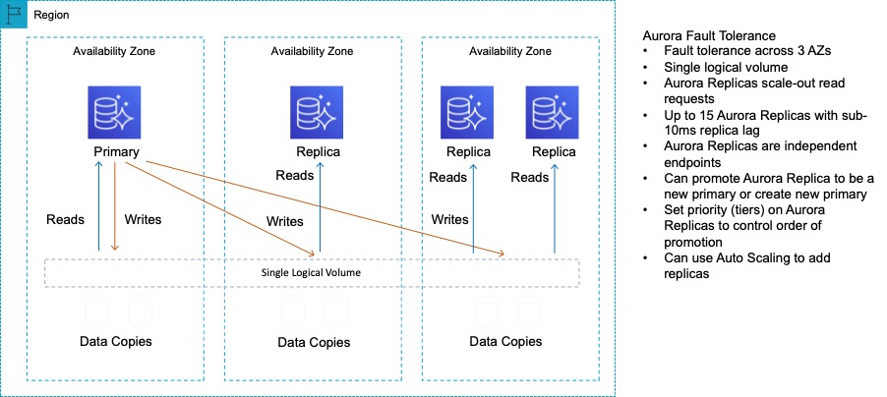

As well as providing scaling for reads, Aurora Replicas are also targets for multi-AZ. In this case the solutions architect can update the application to read from the Multi-AZ standby instance.

**References:**

<https://docs.aws.amazon.com/AmazonRDS/latest/AuroraUserGuide/Aurora.Replication.html>

#### **Question 356:**

There is expected to be a large increase in write intensive traffic to a website you manage that registers users onto an online learning program. You are concerned about writes to the database being dropped and need to come up with a solution to ensure this does not happen. Which of the solution options below would be the best approach to take?

1. Update the application to write data to an SQS queue and provision additional EC2 instances to process the data and write it to the database
2. Update the application to write data to an S3 bucket and provision additional EC2 instances to process the data and write it to the database
3. Use CloudFront to cache the writes and configure the database as a custom origin
4. Use RDS in a multi-AZ configuration to distribute writes across AZs

**Answer :**  Update the application to write data to an SQS queue and provision additional EC2 instances to process the data and write it to the database

**Explanation**

This is a great use case for Amazon Simple Queue Service (Amazon SQS). SQS is a web service that gives you access to message queues that store messages waiting to be processed and offers a reliable, highly-scalable, hosted queue for storing messages in transit between computers. SQS is used for distributed/decoupled applications. In this circumstance SQS will reduce the risk of writes being dropped and it the best option presented.

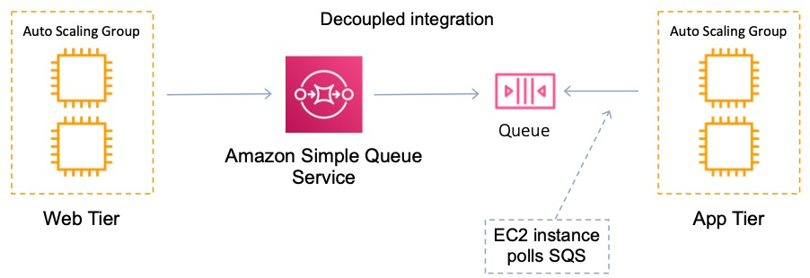

**References:**

<https://aws.amazon.com/sqs/features/>

#### **Question 357:**

A Kinesis consumer application is reading at a slower rate than expected. It has been identified that multiple consumer applications have total reads exceeding the per-shard limits. How can this situation be resolved?

1. Increase the number of read transactions per shard
2. Increase the number of shards in the Kinesis data stream
3. Implement read throttling for the Kinesis data stream
4. Implement API throttling to restrict the number of requests per-shard

**Answer :** Increase the number of shards in the Kinesis data stream

**Explanation**

One shard provides a capacity of 1MB/sec data input and 2MB/sec data output. One shard can support up to 1000 PUT records per second. The total capacity of the stream is the sum of the capacities of its shards.

In a case where multiple consumer applications have total reads exceeding the per-shard limits, you need to increase the number of shards in the Kinesis data stream.

**References:**

<https://docs.aws.amazon.com/streams/latest/dev/troubleshooting-consumers.html#consumer-app-reading-slower>

<https://docs.aws.amazon.com/streams/latest/dev/kinesis-record-processor-additional-considerations.html>

#### **Question 358:**

A company is generating large datasets with millions of rows that must be summarized by column. Existing business intelligence tools will be used to build daily reports. Which storage service meets the requirements?

1. Amazon RDS
2. Amazon ElastiCache
3. Amazon RedShift
4. Amazon DynamoDB

**Answer :** Amazon RedShift

**Explanation**

Amazon Redshift is a fast, fully managed, petabyte-scale data warehouse service that makes it simple and cost-effective to efficiently analyze all your data using your existing business intelligence tools. It is optimized for datasets ranging from a few hundred gigabytes to a petabyte or more. Amazon RedShift uses columnar storage.

**References:**

<https://docs.aws.amazon.com/redshift/index.html>

#### **Question 359:**

The development team at your company has created a new mobile application that will be used by users to access confidential data. The developers have used Amazon Cognito for authentication, authorization, and user management. Due to the sensitivity of the data, there is a requirement to add another method of authentication in addition to a username and password. You have been asked to recommend the best solution. What is your recommendation?

* Integrate a third-party identity provider (IdP)
* Use multi-factor authentication (MFA) with a Cognito user pool
* Enable multi-factor authentication (MFA) in IAM
* Integrate IAM with a user pool in Cognito

**Answer :** Use multi-factor authentication (MFA) with a Cognito user pool

**Explanation**

You can use MFA with a Cognito user pool (not in IAM) and this satisfies the requirement. A user pool is a user directory in Amazon Cognito. With a user pool, your users can sign in to your web or mobile app through Amazon Cognito. Your users can also sign in through social identity providers like Facebook or Amazon, and through SAML identity providers.

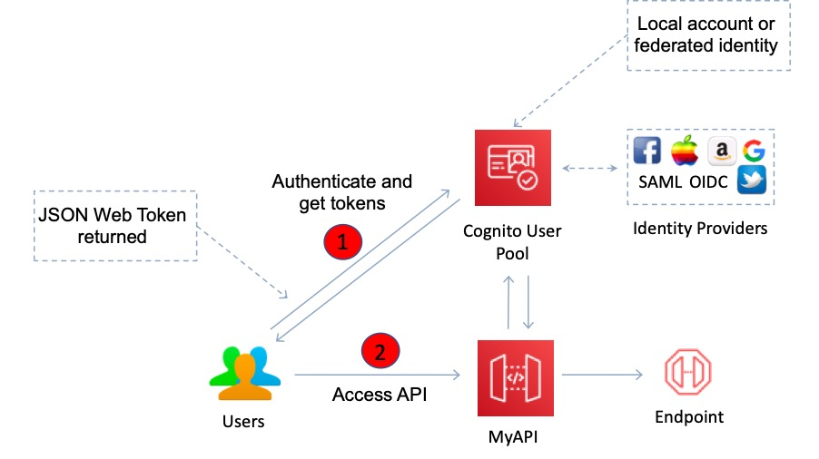

**References:**

<https://docs.aws.amazon.com/cognito/latest/developerguide/user-pool-settings-mfa.html>

#### **Question 360:**

An e-commerce web application needs a highly scalable key-value database. Which AWS database service should be used?

1. Amazon ElastiCache
2. Amazon DynamoDB
3. Amazon RDS
4. Amazon RedShift

**Answer :** Amazon DynamoDB

**Explanation**

A key-value database is a type of nonrelational (NoSQL) database that uses a simple key-value method to store data. A key-value database stores data as a collection of key-value pairs in which a key serves as a unique identifier. Amazon DynamoDB is a fully managed NoSQL database service that provides fast and predictable performance with seamless scalability – this is the best database for these requirements.

**References:**

<https://aws.amazon.com/nosql/key-value/>

#### **Question 361:**

A gaming company collects real-time data and stores it in an on-premises database system. The company are migrating to AWS and need better performance for the database. A solutions architect has been asked to recommend an in-memory database that supports data replication. Which database should a solutions architect recommend?

1. Amazon RDS for PostgreSQL
2. Amazon ElastiCache for Memcached
3. Amazon ElastiCache for Redis
4. Amazon RDS for MySQL

**Answer :** Amazon ElastiCache for Redis

**Explanation**

Amazon ElastiCache is an in-memory database. With ElastiCache Memcached there is no data replication or high availability. As you can see in the diagram, each node is a separate partition of data:

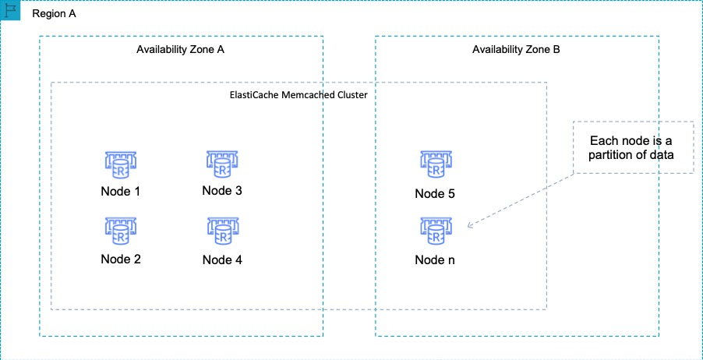

Therefore, the Redis engine must be used which does support both data replication and clustering. The following diagram shows a Redis architecture with cluster mode enabled:

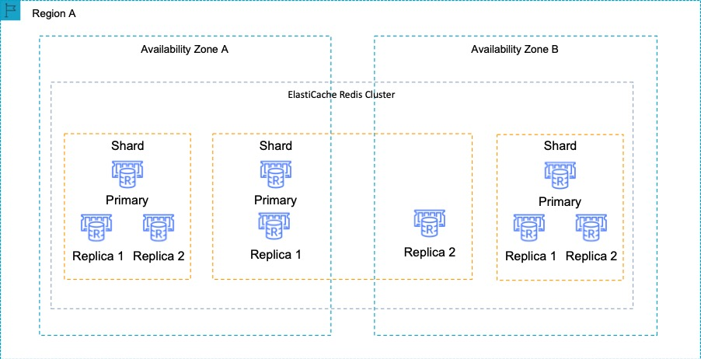

**References:**

<https://aws.amazon.com/elasticache/redis/>

#### **Question 362:**

An application on Amazon Elastic Container Service (ECS) performs data processing in two parts. The second part takes much longer to complete. How can an Architect decouple the data processing from the backend application component?

1. Process each part using a separate ECS task. Create an Amazon SNS topic and send a notification when the processing completes
2. Process each part using a separate ECS task. Create an Amazon SQS queue
3. Create an Amazon DynamoDB table and save the output of the first part to the table
4. Process both parts using the same ECS task. Create an Amazon Kinesis Firehose stream

Answer : Process each part using a separate ECS task. Create an Amazon SQS queue

Explanation

Processing each part using a separate ECS task may not be essential but means you can separate the processing of the data. An Amazon Simple Queue Service (SQS) is used for decoupling applications. It is a message queue on which you place messages for processing by application components. In this case you can process each data processing part in separate ECS tasks and have them write an Amazon SQS queue. That way the backend can pick up the messages from the queue when they’re ready and there is no delay due to the second part not being complete.

**References:**

<https://digitalcloud.training/certification-training/aws-solutions-architect-associate/application-integration/amazon-sqs/>

#### **Question 363:**

A critical database runs in your VPC for which availability is a concern. Which RDS DB instance events may force the DB to be taken offline during a maintenance window?

1. Selecting the Multi-AZ feature
2. Promoting a Read Replica
3. Updating DB parameter groups
4. Security patching

**Answer :** Security patching

**Explanation**

Periodically, Amazon RDS performs maintenance on Amazon RDS resources. Maintenance most often involves updates to the DB instance's underlying hardware, underlying operating system (OS), or database engine version. Updates to the operating system most often occur for security issues and should be done as soon as possible.

Some maintenance items require that Amazon RDS take your DB instance offline for a short time. Maintenance items that require a resource to be offline include required operating system or database patching. Required patching is automatically scheduled only for patches that are related to security and instance reliability. Such patching occurs infrequently (typically once every few months) and seldom requires more than a fraction of your maintenance window.

Enabling Multi-AZ, promoting a Read Replica and updating DB parameter groups are not events that take place during a maintenance window.

**References:**

<https://digitalcloud.training/certification-training/aws-solutions-architect-associate/database/amazon-rds/>

#### **Question 364:**

You need to scale read operations for your Amazon Aurora DB within a region. To increase availability you also need to be able to failover if the primary instance fails. What should you implement?

1. Aurora Replicas
2. Aurora Global Database
3. An Aurora Cluster Volume
4. A DB cluster

**Answer :** Aurora Replicas

**Explanation**

Aurora Replicas are independent endpoints in an Aurora DB cluster, best used for scaling read operations and increasing availability. Up to 15 Aurora Replicas can be distributed across the Availability Zones that a DB cluster spans within an AWS Region. To increase availability, you can use Aurora Replicas as failover targets. That is, if the primary instance fails, an Aurora Replica is promoted to the primary instance. The graphic below provides an overview of Aurora Replicas:

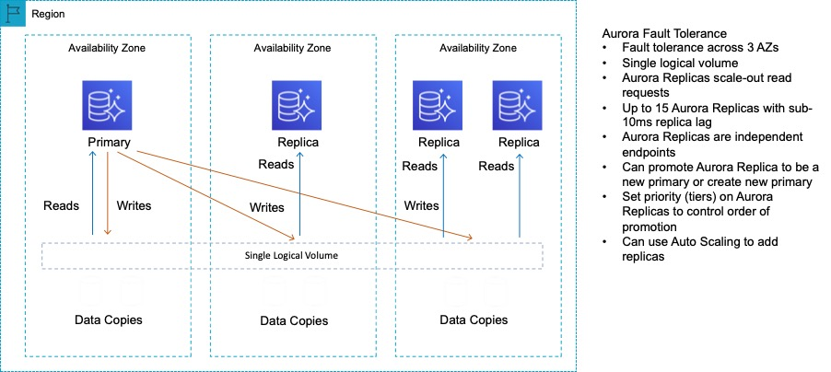

**References:**

<https://docs.aws.amazon.com/AmazonRDS/latest/AuroraUserGuide/Aurora.Replication.html>

#### **Question 365:**

A company operates a production web application that uses an Amazon RDS MySQL database. The database has automated, non-encrypted daily backups. To increase the security of the data, it has been recommended that encryption should be enabled for backups. Unencrypted backups will be destroyed after the first encrypted backup has been completed. What should be done to enable encryption for future backups?

1. Modify the backup section of the database configuration to toggle the Enable encryption check box
2. Enable an encrypted read replica on RDS for MySQL. Promote the encrypted read replica to primary. Remove the original database instance
3. Create a snapshot of the database. Copy it to an encrypted snapshot. Restore the database from the encrypted snapshot
4. Enable default encryption for the Amazon S3 bucket where backups are stored

**Answer :** Create a snapshot of the database. Copy it to an encrypted snapshot. Restore the database from the encrypted snapshot

**Explanation**

Amazon RDS uses snapshots for backup. Snapshots are encrypted when created only if the database is encrypted and you can only select encryption for the database when you first create it. In this case the database, and hence the snapshots, ad unencrypted.

However, you can create an encrypted copy of a snapshot. You can restore using that snapshot which creates a new DB instance that has encryption enabled. From that point on encryption will be enabled for all snapshots.

**References:**

<https://docs.aws.amazon.com/AmazonRDS/latest/UserGuide/Overview.Encryption.html>

#### **Question 366:**

A production application runs on an Amazon RDS MySQL DB instance. A solutions architect is building a new reporting tool that will access the same data. The reporting tool must be highly available and not impact the performance of the production application. How can this be achieved?

1. Create a Single-AZ RDS Read Replica of the production RDS DB instance. Create a second Single-AZ RDS Read Replica from the replica
2. Create a cross-region Multi-AZ deployment and create a read replica in the second region
3. Create a Multi-AZ RDS Read Replica of the production RDS DB instance
4. Use Amazon Data Lifecycle Manager to automatically create and manage snapshots

**Answer :** Create a Multi-AZ RDS Read Replica of the production RDS DB instance

**Explanation**

You can create a read replica as a Multi-AZ DB instance. Amazon RDS creates a standby of your replica in another Availability Zone for failover support for the replica. Creating your read replica as a Multi-AZ DB instance is independent of whether the source database is a Multi-AZ DB instance.

**References:**

<https://docs.aws.amazon.com/AmazonRDS/latest/UserGuide/USER_MySQL.Replication.ReadReplicas.html#USER_MySQL.Replication.ReadReplicas.MultiAZ>

#### **Question 367:**

One of the applications you manage on RDS uses the MySQL DB and has been suffering from performance issues. You would like to setup a reporting process that will perform queries on the database but you’re concerned that the extra load will further impact the performance of the DB and may lead to poor customer experience. What would be the best course of action to take so you can implement the reporting process?

1. Deploy a Read Replica to setup a secondary read and write database instance
2. Configure Multi-AZ to setup a secondary database instance in another region
3. Configure Multi-AZ to setup a secondary database instance in another Availability Zone
4. Deploy a Read Replica to setup a secondary read-only database instance

**Answer :** Deploy a Read Replica to setup a secondary read-only database instance

**Explanation**

The reporting process will perform queries on the database but not writes. Therefore you can use a read replica which will provide a secondary read-only database and configure the reporting process to use the read replica. Multi-AZ is used for implementing fault tolerance. With Multi-AZ you can failover to a DB in another AZ within the region in the event of a failure of the primary DB. However, you can only read and write to the primary DB so still need a read replica to offload the reporting job

**References:**

<https://aws.amazon.com/rds/features/read-replicas/>

#### **Question 368:**

Several environments are being created in a single Amazon VPC. The Solutions Architect needs to implement a system of categorization that allows for identification of Amazon EC2 resources by business unit, owner, or environment. Which AWS feature can be used?

1. Tags
2. Parameters
3. Metadata
4. Custom filters

**Answer :** Tags

**Explanation**

A tag is a label that you assign to an AWS resource. Each tag consists of a key and an optional value, both of which you define. Tags enable you to categorize your AWS resources in different ways, for example, by purpose, owner, or environment.

**References:**

<https://docs.aws.amazon.com/AWSEC2/latest/UserGuide/Using_Tags.html>

#### **Question 369:**

A Solutions Architect is creating an AWS CloudFormation template that will provision a new EC2 instance and new EBS volume. What must be specified to associate the block store with the instance?

1. The EC2 physical ID
2. Both the EC2 physical ID and the EBS physical ID
3. Both the EC2 logical ID and the EBS logical ID
4. The EC2 logical ID

**Answer :** Both the EC2 logical ID and the EBS logical ID

**Explanation**

The logical ID is used to reference the resource in parts of the template. For example, if you want to map an Amazon Elastic Block Store volume to an Amazon EC2 instance, you reference the logical IDs to associate the block stores with the instance. In addition to the logical ID, certain resources also have a physical ID, which is the actual assigned name for that resource, such as an EC2 instance ID or an S3 bucket name. Use the physical IDs to identify resources outside of AWS CloudFormation templates, but only after the resources have been created. Think of logical IDs as being used to reference resources within the template and Physical IDs being used to identify resources outside of AWS CloudFormation templates after they have been created.

**References:**

<https://docs.aws.amazon.com/AWSCloudFormation/latest/UserGuide/resources-section-structure.html>

#### **Question 370:**

A Solutions Architect is rearchitecting an application with decoupling. The application will send batches of up to 1000 messages per second that must be received in the correct order by the consumers. Which action should the Solutions Architect take?

1. Create an Amazon SQS FIFO queue
2. Create an AWS Step Functions state machine
3. Create an Amazon SNS topic
4. Create an Amazon SQS Standard queue

**Answer :** Create an Amazon SQS FIFO queue

**Explanation**

Only FIFO queues guarantee the ordering of messages and therefore a standard queue would not work. The FIFO queue supports up to 3,000 messages per second with batching so this is a supported scenario.

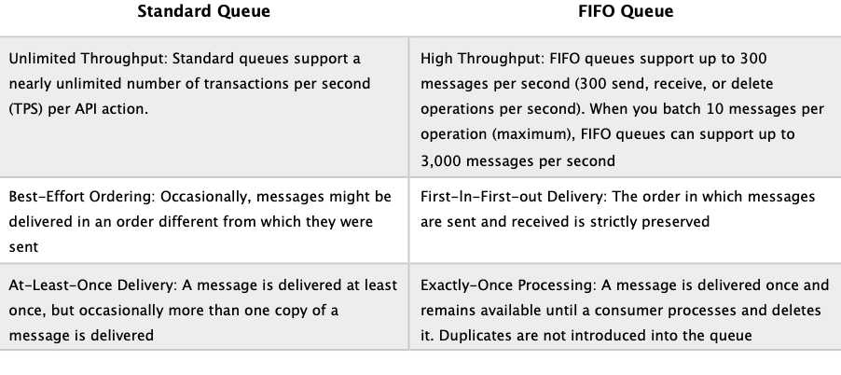

**References:**

<https://docs.aws.amazon.com/AWSSimpleQueueService/latest/SQSDeveloperGuide/sqs-quotas.html>

#### **Question 371:**

An Amazon CloudWatch alarm recently notified a Solutions Architect that the load on an Amazon DynamoDB table is getting close to the provisioned capacity for writes. The DynamoDB table is part of a two-tier customer-facing application and is configured using provisioned capacity. What will happen if the limit for the provisioned capacity for writes is reached?

1. The requests will succeed, and an HTTP 200 status code will be returned
2. The requests will be throttled, and fail with an HTTP 400 code (Bad Request) and a ProvisionedThroughputExceededException
3. The requests will be throttled, and fail with an HTTP 503 code (Service Unavailable)
4. DynamoDB scales automatically so there’s no need to worry

**Answer :** The requests will be throttled, and fail with an HTTP 400 code (Bad Request) and a ProvisionedThroughputExceededException

**Explanation**

Amazon DynamoDB can throttle requests that exceed the provisioned throughput for a table. When a request is throttled it fails with an HTTP 400 code (Bad Request) and a ProvisionedThroughputExceeded exception (not a 503 or 200 status code).

When using the provisioned capacity pricing model DynamoDB does not automatically scale. DynamoDB can automatically scale when using the new on-demand capacity mode, however this is not configured for this database.

**References:**

<https://docs.aws.amazon.com/amazondynamodb/latest/developerguide/Programming.Errors.html>

#### **Question 372:**

An application stores encrypted data in Amazon S3 buckets. A Solutions Architect needs to be able to query the encrypted data using SQL queries and write the encrypted results back the S3 bucket. As the data is sensitive fine-grained control must be implemented over access to the S3 bucket. What combination of services represent the BEST options support these requirements? (choose 2)

1. Use AWS Glue to extract the data, analyze it, and load it back to the S3 bucket
2. Use Athena for querying the data and writing the results back to the bucket
3. Use IAM policies to restrict access to the bucket
4. Use bucket ACLs to restrict access to the bucket
5. Use the AWS KMS API to query the encrypted data, and the S3 API for writing the results

**Answer :** Use IAM policies to restrict access to the bucket

**Answer :** Use Athena for querying the data and writing the results back to the bucket

**Explanation**

Athena allows you to easily query encrypted data stored in Amazon S3 and write encrypted results back to your S3 bucket. Both, server-side encryption and client-side encryption are supported. AWS IAM policies can be used to grant IAM users’ with fine-grained control to Amazon S3 buckets.

**References:**

<https://aws.amazon.com/athena/>

#### **Question 373:**

An organization has a data lake on Amazon S3 and needs to find a solution for performing in-place queries of the data assets in the data lake. The requirement is to perform both data discovery and SQL querying, and complex queries from a large number of concurrent users using BI tools. What is the BEST combination of AWS services to use in this situation? (choose 2)

1. Amazon Kinesis for the complex queries
2. RedShift Spectrum for the complex queries
3. AWS Glue for the ad hoc SQL querying
4. AWS Lambda for the complex queries
5. Amazon Athena for the ad hoc SQL querying

**Answer :** RedShift Spectrum for the complex queries

**Answer :** Amazon Athena for the ad hoc SQL querying

**Explanation**

Performing in-place queries on a data lake allows you to run sophisticated analytics queries directly on the data in S3 without having to load it into a data warehouse. You can use both Athena and Redshift Spectrum against the same data assets. You would typically use Athena for ad hoc data discovery and SQL querying, and then use Redshift Spectrum for more complex queries and scenarios where a large number of data lake users want to run concurrent BI and reporting workloads.

**References:**

<https://docs.aws.amazon.com/aws-technical-content/latest/building-data-lakes/in-place-querying.html>

<https://aws.amazon.com/redshift/>

<https://aws.amazon.com/athena/>

#### **Question 374:**

A Solutions Architect is designing an application that consists of AWS Lambda and Amazon RDS Aurora MySQL. The Lambda function must use database credentials to authenticate to MySQL and security policy mandates that these credentials must not be stored in the function code. How can the Solutions Architect securely store the database credentials and make them available to the function?

1. Store the credentials in AWS Key Management Service and use environment variables in the function code pointing to KMS
2. Create an IAM policy and store the credentials in the policy. Attach the policy to the Lambda function execution role
3. Store the credentials in Systems Manager Parameter Store and update the function code and execution role
4. Use the AWSAuthenticationPlugin and associate an IAM user account in the MySQL database

**Answer :** Store the credentials in Systems Manager Parameter Store and update the function code and execution role

**Explanation**

In this case the scenario requires that credentials are used for authenticating to MySQL. The credentials need to be securely stored outside of the function code. Systems Manager Parameter Store provides secure, hierarchical storage for configuration data management and secrets management. You can easily reference the parameters from services including AWS Lambda as depicted in the diagram below:

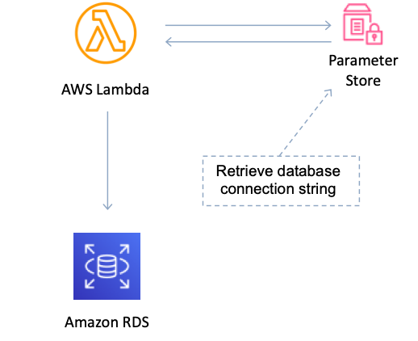

**References:**

<https://docs.aws.amazon.com/systems-manager/latest/userguide/systems-manager-parameter-store.html>

#### **Question 375:**

A new application you are designing will store data in an Amazon Aurora MySQL DB. You are looking for a way to enable inter-region disaster recovery capabilities with fast replication and fast failover. Which of the following options is the BEST solution?

1. Create an EBS backup of the Aurora volumes and use cross-region replication to copy the snapshot
2. Use Amazon Aurora Global Database
3. Enable Multi-AZ for the Aurora DB
4. Create a cross-region Aurora Read Replica

**Answer :** Use Amazon Aurora Global Database

**Explanation**

Amazon Aurora Global Database is designed for globally distributed applications, allowing a single Amazon Aurora database to span multiple AWS regions. It replicates your data with no impact on database performance, enables fast local reads with low latency in each region, and provides disaster recovery from region-wide outages.

Aurora Global Database uses storage-based replication with typical latency of less than 1 second, using dedicated infrastructure that leaves your database fully available to serve application workloads. In the unlikely event of a regional degradation or outage, one of the secondary regions can be promoted to full read/write capabilities in less than 1 minute.

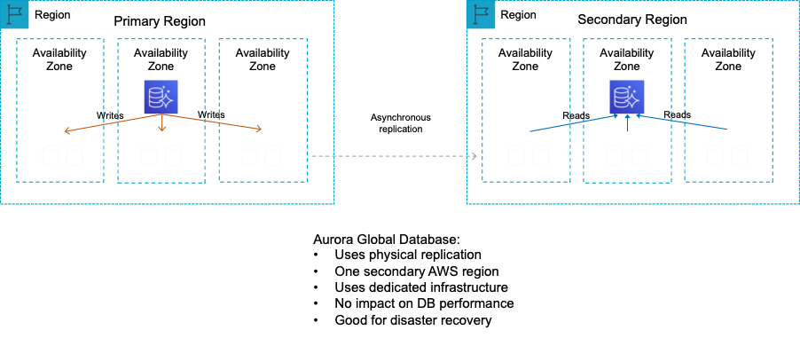

**References:**

<https://docs.aws.amazon.com/AmazonRDS/latest/UserGuide/Aurora.Replication.html>

#### **Question 376:**

Every time an item in an Amazon DynamoDB table is modified a record must be retained for compliance reasons. What is the most efficient solution to recording this information?

1. Enable DynamoDB Global Tables. Enable DynamoDB streams on the multi-region table and save the output directly to an Amazon S3 bucket
2. Enable Amazon CloudTrail. Configure an Amazon EC2 instance to monitor activity in the CloudTrail log files and record changed items in another DynamoDB table
3. Enable Amazon CloudWatch Logs. Configure an AWS Lambda function to monitor the log files and record deleted item data to an Amazon S3 bucket
4. Enable DynamoDB Streams. Configure an AWS Lambda function to poll the stream and record the modified item data to an Amazon S3 bucket

**Answer :** Enable DynamoDB Streams. Configure an AWS Lambda function to poll the stream and record the modified item data to an Amazon S3 bucket

**Explanation**

Amazon DynamoDB Streams captures a time-ordered sequence of item-level modifications in any DynamoDB table and stores this information in a log for up to 24 hours. Applications can access this log and view the data items as they appeared before and after they were modified, in near-real time. For example, in the diagram below a DynamoDB stream is being consumed by a Lambda function which processes the item data and records a record in CloudWatch Logs:

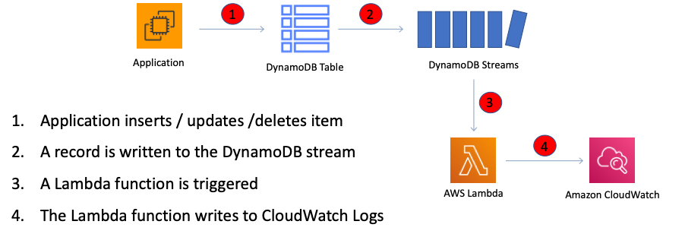

**References:**

<https://docs.aws.amazon.com/amazondynamodb/latest/developerguide/Streams.html>

#### **Question 377:**

A company is deploying an Amazon ElastiCache for Redis cluster. To enhance security a password should be required to access the database. What should the solutions architect use?

1. Redis AUTH command
2. AWS IAM Policy
3. AWS Directory Service
4. VPC Security Group

**Answer :** Redis AUTH command

**Explanation**

Redis authentication tokens enable Redis to require a token (password) before allowing clients to execute commands, thereby improving data security. You can require that users enter a token on a token-protected Redis server. To do this, include the parameter --auth-token (API: AuthToken) with the correct token when you create your replication group or cluster. Also include it in all subsequent commands to the replication group or cluster.

**References:**

<https://docs.aws.amazon.com/AmazonElastiCache/latest/red-ug/auth.html>

#### **Question 378:**

A company are finalizing their disaster recovery plan. A limited set of core services will be replicated to the DR site ready to seamlessly take over the in the event of a disaster. All other services will be switched off. Which DR strategy is the company using?

1. Warm standby
2. Multi-site
3. Backup and restore
4. Pilot light

**Answer :** Pilot light

**Explanation**

In this DR approach, you simply replicate part of your IT structure for a limited set of core services so that the AWS cloud environment seamlessly takes over in the event of a disaster. A small part of your infrastructure is always running simultaneously syncing mutable data (as databases or documents), while other parts of your infrastructure are switched off and used only during testing. Unlike a backup and recovery approach, you must ensure that your most critical core elements are already configured and running in AWS (the pilot light). When the time comes for recovery, you can rapidly provision a full-scale production environment around the critical core.

**References:**

<https://aws.amazon.com/blogs/publicsector/rapidly-recover-mission-critical-systems-in-a-disaster/>

#### **Question 379:**

A membership website has become quite popular and is gaining members quickly. The website currently runs on Amazon EC2 instances with one web server instance and one database instance running MySQL. A Solutions Architect is concerned about the lack of high-availability in the current architecture. What can the Solutions Architect do to easily enable high availability without making major changes to the architecture?

1. Enable Multi-AZ for the MySQL instance
2. Install MySQL on an EC2 instance in the same availability zone and enable replication
3. Create a Read Replica in another availability zone
4. Install MySQL on an EC2 instance in another availability zone and enable replication

**Answer :** Install MySQL on an EC2 instance in another availability zone and enable replication

**Explanation**

If you are installing MySQL on an EC2 instance you cannot enable read replicas or multi-AZ. Instead you would need to use Amazon RDS with a MySQL DB engine to use these features. In this example a good solution is to use the native HA features of MySQL. You would want to place the second MySQL DB instance in another AZ to enable high availability and fault tolerance. Migrating to Amazon RDS may be a good solution but is not presented as an option.

**References:**

<https://docs.aws.amazon.com/AWSEC2/latest/UserGuide/ec2-increase-availability.html>

#### **Question 380:**

An Auto Scaling Group is unable to respond quickly enough to load changes resulting in lost messages from another application tier. The messages are typically around 128KB in size. What is the best design option to prevent the messages from being lost?

1. Store the messages on Amazon S3
2. Launch an Elastic Load Balancer
3. Use larger EC2 instance sizes
4. Store the messages on an SQS queue

**Answer :** Store the messages on an SQS queue

**Explanation**

In this circumstance the ASG cannot launch EC2 instances fast enough. You need to be able to store the messages somewhere so they don’t get lost whilst the EC2 instances are launched. This is a classic use case for decoupling and SQS is designed for exactly this purpose. Amazon Simple Queue Service (Amazon SQS) is a web service that gives you access to message queues that store messages waiting to be processed. SQS offers a reliable, highly-scalable, hosted queue for storing messages in transit between computers. An SQS queue can be used to create distributed/decoupled applications.

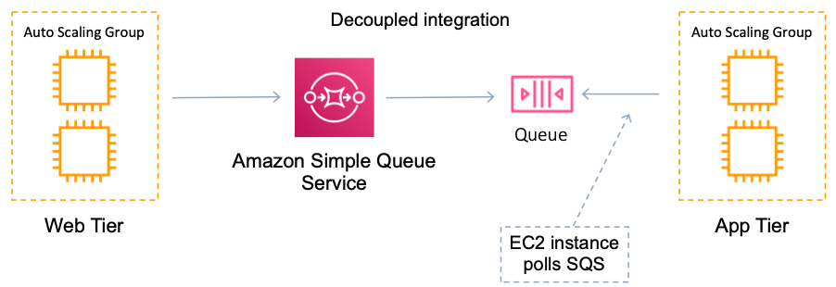

**References:**

<https://docs.aws.amazon.com/AWSSimpleQueueService/latest/SQSDeveloperGuide/welcome.html>

#### **Question 381:**

To increase performance and redundancy for an application a company has decided to run multiple implementations in different AWS Regions behind network load balancers. The company currently advertise the application using two public IP addresses from separate /24 address ranges and would prefer not to change these. Users should be directed to the closest available application endpoint. Which actions should a solutions architect take? (Select TWO.)

1. Assign new static anycast IP addresses and modify any existing pointers
2. Create an Amazon Route 53 geolocation based routing policy
3. Migrate both public IP addresses to the AWS Global Accelerator
4. Create an AWS Global Accelerator and attach endpoints in each AWS Region
5. Create PTR records to map existing public IP addresses to an Alias

**Answer :** Create an AWS Global Accelerator and attach endpoints in each AWS Region

**Answer :** Migrate both public IP addresses to the AWS Global Accelerator

**Explanation**

AWS Global Accelerator uses static IP addresses as fixed entry points for your application. You can migrate up to two /24 IPv4 address ranges and choose which /32 IP addresses to use when you create your accelerator. This solution ensures the company can continue using the same IP addresses and they are able to direct traffic to the application endpoint in the AWS Region closest to the end user. Traffic is sent over the AWS global network for consistent performance.

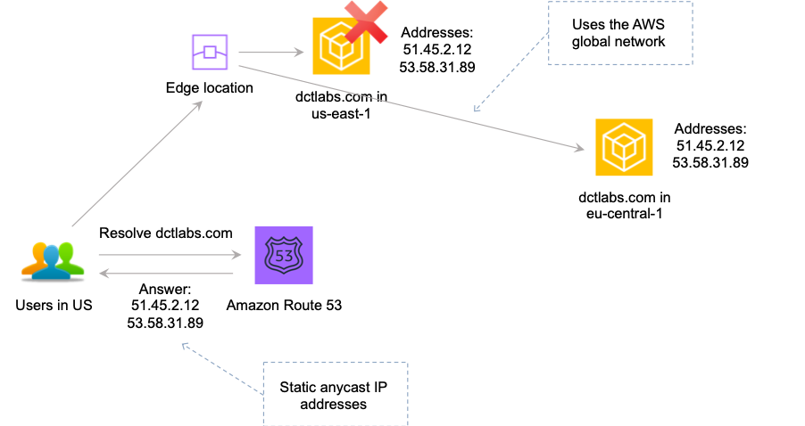

**References:**

<https://aws.amazon.com/global-accelerator/features/>

#### **Question 382:**

An Amazon RDS Multi-AZ deployment is running in an Amazon VPC. An outage occurs in the availability zone of the primary RDS database instance. What actions will take place in this circumstance? (choose 2)

1. The failover mechanism automatically changes the DNS record of the DB instance to point to the standby DB instance
2. The primary DB instance will switch over automatically to the standby replica
3. Due to the loss of network connectivity the process to switch to the standby replica cannot take place
4. A manual failover of the DB instance will need to be initiated using Reboot with failover
5. A failover will take place once the connection draining timer has expired

**Answer :** The failover mechanism automatically changes the DNS record of the DB instance to point to the standby DB instance

**Answer :** The primary DB instance will switch over automatically to the standby replica

**Explanation**

Multi-AZ RDS creates a replica in another AZ and synchronously replicates to it (DR only).

A failover may be triggered in the following circumstances:

- Loss of primary AZ or primary DB instance failure

- Loss of network connectivity on primary

- Compute (EC2) unit failure on primary

- Storage (EBS) unit failure on primary

- The primary DB instance is changed

- Patching of the OS on the primary DB instance

- Manual failover (reboot with failover selected on primary)

During failover RDS automatically updates configuration (including DNS endpoint) to use the second node.

**References:**

<https://docs.aws.amazon.com/AmazonRDS/latest/UserGuide/Concepts.MultiAZ.html>

#### **Question 383:**

Over 500 TB of data must be analyzed using standard SQL business intelligence tools. The dataset consists of a combination of structured data and unstructured data. The unstructured data is small and stored on Amazon S3. Which AWS services are most suitable for performing analytics on the data?

1. Amazon DynamoDB with Amazon DynamoDB Accelerator (DAX)
2. Amazon RDS MariaDB with Amazon Athena
3. Amazon Redshift with Amazon Redshift Spectrum
4. Amazon ElastiCache for Redis with cluster mode enabled

**Answer :** Amazon Redshift with Amazon Redshift Spectrum

**Explanation**

Amazon Redshift is an enterprise-level, petabyte scale, fully managed data warehousing service. An Amazon Redshift data warehouse is an enterprise-class relational database query and management system. Redshift supports client connections with many types of applications, including business intelligence (BI), reporting, data, and analytics tools.

Using Amazon Redshift Spectrum, you can efficiently query and retrieve structured and semistructured data from files in Amazon S3 without having to load the data into Amazon Redshift tables. Redshift Spectrum queries employ massive parallelism to execute very fast against large datasets.

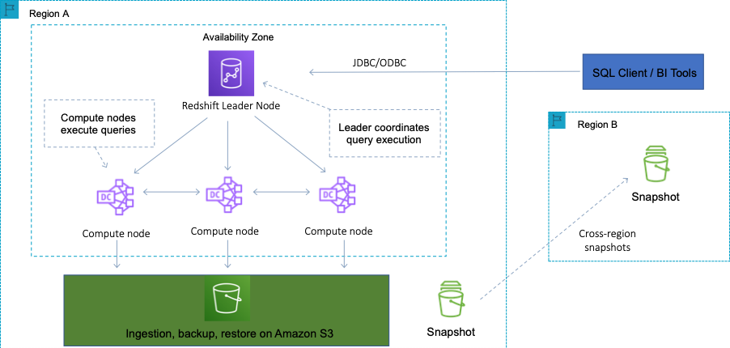

Used together, RedShift and RedShift spectrum are suitable for running massive analytics jobs on both the structured (RedShift data warehouse) and unstructured (Amazon S3) data.

**References:**

<https://docs.aws.amazon.com/redshift/latest/dg/c_redshift_system_overview.html>

<https://docs.aws.amazon.com/redshift/latest/dg/c-using-spectrum.html>

#### **Question 384:**

Some Amazon ECS containers are running on a cluster using the EC2 launch type. The current configuration uses the container instance’s IAM roles for assigning permissions to the containerized applications. A Solutions Architect needs to implement more granular permissions so that some applications can be assigned more restrictive permissions. How can this be achieved?

1. This cannot be changed as IAM roles can only be linked to container instances
2. This can be achieved using IAM roles for tasks, and splitting the containers according to the permissions required to different task definition profiles
3. This can only be achieved using the Fargate launch type
4. This can be achieved by configuring a resource-based policy for each application

**Answer :** This can be achieved using IAM roles for tasks, and splitting the containers according to the permissions required to different task definition profiles

**Explanation**

With IAM roles for Amazon ECS tasks, you can specify an IAM role that can be used by the containers in a task. Using this feature you can achieve the required outcome by using IAM roles for tasks and splitting the containers according to the permissions required to different task profiles.

**References:**

<https://docs.aws.amazon.com/AmazonECS/latest/userguide/task-iam-roles.html>

<https://docs.aws.amazon.com/IAM/latest/UserGuide/reference_aws-services-that-work-with-iam.html>

#### **Question 385:**

An application that runs a computational fluid dynamics workload uses a tightly-coupled HPC architecture that uses the MPI protocol and runs across many nodes. A service-managed deployment is required to minimize operational overhead. Which deployment option is MOST suitable for provisioning and managing the resources required for this use case?

1. Use AWS CloudFormation to deploy a Cluster Placement Group on EC2
2. Use AWS Elastic Beanstalk to provision and manage the EC2 instances
3. Use Amazon EC2 Auto Scaling to deploy instances in multiple subnets
4. Use AWS Batch to deploy a multi-node parallel job

**Answer :** Use AWS Batch to deploy a multi-node parallel job

**Explanation**

AWS Batch Multi-node parallel jobs enable you to run single jobs that span multiple Amazon EC2 instances. With AWS Batch multi-node parallel jobs, you can run large-scale, tightly coupled, high performance computing applications and distributed GPU model training without the need to launch, configure, and manage Amazon EC2 resources directly. An AWS Batch multi-node parallel job is compatible with any framework that supports IP-based, internode communication, such as Apache MXNet, TensorFlow, Caffe2, or Message Passing Interface (MPI). This is the most efficient approach to deploy the resources required and supports the application requirements most effectively.

**References:**

<https://d1.awsstatic.com/whitepapers/architecture/AWS-HPC-Lens.pdf>

<https://docs.aws.amazon.com/batch/latest/userguide/multi-node-parallel-jobs.html>

#### **Question 386:**

A three-tier web application that is deployed in an Amazon VPC has been experiencing heavy load on the database layer. The database layer uses an Amazon RDS MySQL instance in a multi-AZ configuration. Customers have been complaining about poor response times. During troubleshooting it has been noted that the database layer is experiencing high read contention during peak hours of the day. What are two possible options that could be used to offload some of the read traffic from the database to resolve the performance issues? (choose 2)

1. Use an ELB to distribute load between RDS instances
2. Deploy ElastiCache in each AZ
3. Add RDS read replicas in each AZ
4. Use a larger RDS instance size
5. Migrate to DynamoDB

**Answer :** Add RDS read replicas in each AZ

**Answer :** Deploy ElastiCache in each AZ

**Explanation**

Amazon ElastiCache is a web service that makes it easy to deploy and run Memcached or Redis protocol-compliant server nodes in the cloud. The in-memory caching provided by ElastiCache can be used to significantly improve latency and throughput for many read-heavy application workloads or compute-intensive workloads. Read replicas are used for read heavy DBs and replication is asynchronous. They are for workload sharing and offloading and are created from a snapshot of the master instance

**References:**

<https://aws.amazon.com/rds/features/read-replicas/>

<https://aws.amazon.com/elasticache/>

#### **Question 387:**

A Solutions Architect has deployed a number of AWS resources using CloudFormation. Some changes must be made to a couple of resources within the stack. Due to recent failed updates, the Solutions Architect is a little concerned about the effects that implementing updates to the resources might have on other resources in the stack. What is the easiest way to proceed cautiously?

1. Create and execute a change set
2. Use a direct update
3. Deploy a new stack to test the changes
4. Use OpsWorks to manage the configuration changes

**Answer :** Create and execute a change set

**Explanation**

AWS CloudFormation provides two methods for updating stacks: direct update or creating and executing change sets. When you directly update a stack, you submit changes and AWS CloudFormation immediately deploys them. Use direct updates when you want to quickly deploy your updates. With change sets, you can preview the changes AWS CloudFormation will make to your stack, and then decide whether to apply those changes.

**References:**

<https://docs.aws.amazon.com/AWSCloudFormation/latest/UserGuide/using-cfn-updating-stacks.html>

#### **Question 388:**

The AWS Acceptable Use Policy describes permitted and prohibited behavior on AWS and includes descriptions of prohibited security violations and network abuse. According to the policy, what is AWS’s position on penetration testing?

1. AWS do not allow any form of penetration testing
2. AWS allow penetration testing for all resources
3. AWS allow penetration testing by customers on their own VPC resources
4. AWS allow penetration for some resources without prior authorization

**Answer :** AWS allow penetration for some resources without prior authorization

**Explanation**

AWS customers are welcome to carry out security assessments or penetration tests against their AWS infrastructure without prior approval for 8 services. Please check the AWS link below for the latest information.

**References:**

<https://aws.amazon.com/security/penetration-testing/>

#### **Question 389:**

A client has requested a design for a fault tolerant database that can failover between AZs. You have decided to use RDS in a multi-AZ configuration. What type of replication will the primary database use to replicate to the standby instance?

1. Scheduled replication
2. Synchronous replication
3. Asynchronous replication
4. Continuous replication

**Answer :** Synchronous replication

**Explanation**

Multi-AZ RDS creates a replica in another AZ and synchronously replicates to it (DR only). Multi-AZ deployments for the MySQL, MariaDB, Oracle and PostgreSQL engines utilize synchronous physical replication. Multi-AZ deployments for the SQL Server engine use synchronous logical replication (SQL Server-native Mirroring technology).

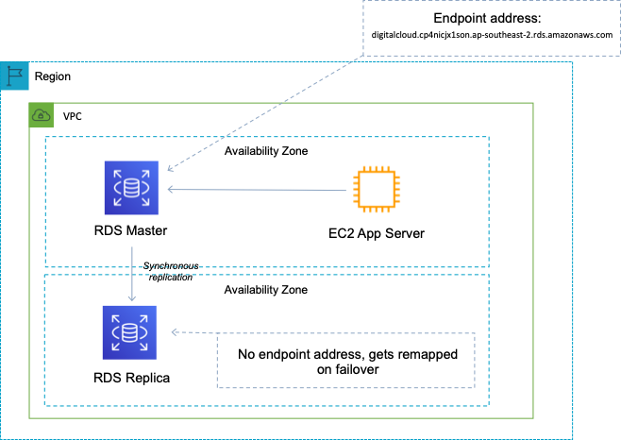

**References:**

<https://aws.amazon.com/rds/features/multi-az/>

#### **Question 390:**

An organization in the agriculture sector is deploying sensors and smart devices around factory plants and fields. The devices will collect information and send it to cloud applications running on AWS. Which AWS service will securely connect the devices to the cloud applications?

1. AWS Glue
2. AWS IoT Core
3. AWS Lambda
4. AWS DMS

**Answer :** AWS IoT Core

**Explanation**

AWS IoT Core is a managed cloud service that lets connected devices easily and securely interact with cloud applications and other devices. AWS IoT Core can support billions of devices and trillions of messages, and can process and route those messages to AWS endpoints and to other devices reliably and securely.



**References:**

<https://aws.amazon.com/iot-core/>

#### 